XMAS DECOY-RATIONS No.1
Somewhere in the solutions to the following positions, but in various ways, the same tactic is used by white to achieve victory. The positions gradually get harder and harder so should help you to recognise this tactic in the future.

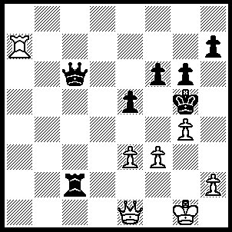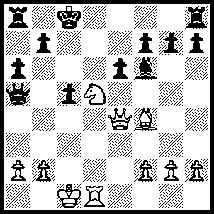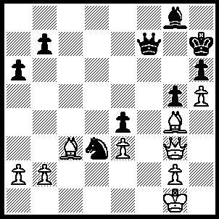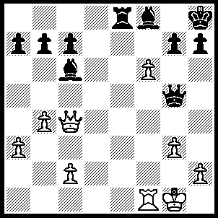
1 2 3 4
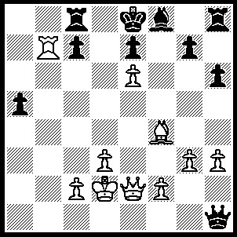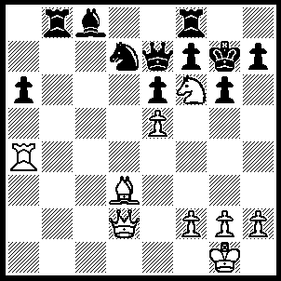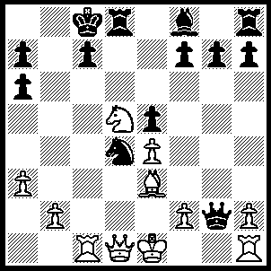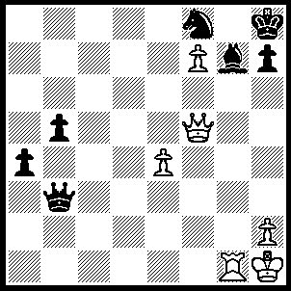
5 6 7 8
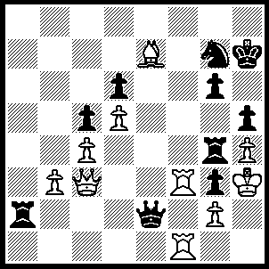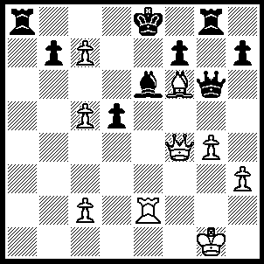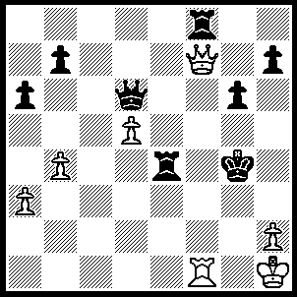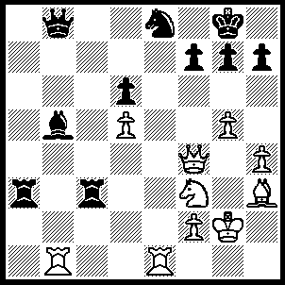
9 10 11 12
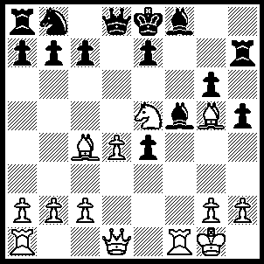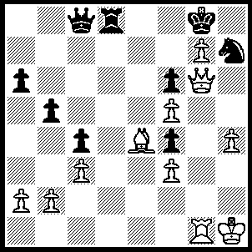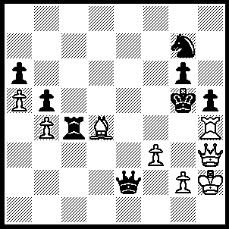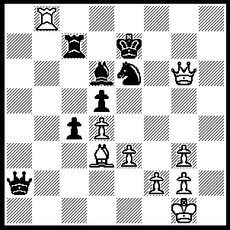
13 14 15 16
1---1.Qh4+ Kxh4, 2.Rxh7+ Kg5, 3.h4++.
2---1,Qa4 Qd8 (1…..Qxa4, 2.Nb6++), 2,Nb6+ Qxb6, 3.Qd7++.
3---1.Qc7 Ne5 (1…..Qxc7, 2.Bf5++), 2.Bxe5 a5, 3.Bf5++.
4---1.Qg8+ Kxg8, 2.f7+ Kh8, 3.fxe8(Q) Qe3+ (3…..h6 OR Bxe8, 4.Rxf8 mates), 4.Qxe3.
5---1.Qh5+ g6, 2.Qxg6+ Kd8, 3.Bxc7+ Rxc7, 4.Qe8+ Kxe8, 5.Rb8+ Rc8, 6,Rxc8++.
6---1.Qh6+ Kxh6, 2.Rh4+ Kg5, 3.f4+ Kxh4, 4.g3+ Kh3. 5.Bf1++.
7---1.Rxc7+ Kb8, 2.Qb3+ Nxb3/Nb5, 3.Bxa7+ Ka8, 4.Nb6++.
8---1.Qf6 Qxf7 (1…..Ng6, 2.f8(Q)+ Nxf8 [2…..Qg8, 3.Q(6)xg7++], 3.Qxg7++), 2.Qxf7, Ng6, 3.Rc1 Nf8, 4.Rc7 Bh6. 5.Rc8 a3, 6.Rxf8+ mates.
9---1.Qxg7+ Rxg7, 2.Rf7+ Kg8 (2…..Kh6, 3.Bf8++), 3.Rf8+ Kg7, 4.R(1)f7+ mates.
10---1.Qa4+ b5 (1…..Rxa4, 2.C8(Q)++),2.Qxa8+ Kd7, 3.Qd8+ Rxd8, 4.cxd8(Q)+ Kc6, 5.Rxe6+ Kxc5 (5…..fxe6, 6.Qc8++), 6.Qe7+ Kc4, 7.Rc6++.

11---1.Rg1+ Kh3, 2.Qxh7+ Rh4, 3.Qd7+ Rf5 (3…..Qxd7, 4.Rg3++), 4.Qxd6 Rg4, 5.Rg3+ Kh4, 6.Qe7+ R(5)g5, 7.d6 Rxg3, 8.hxg3+ Kg4, 9.Qxg5+, Kxg5, 10.d7.
12---1.Rxb5 Qxb5 (1…..Qd8, 2.Qb4 R[c]b3, 3.Qxb3 Rxb3, 4.Rxb3 h6, 5.Rc3 Nc7, 6.R(1)c1), 2.Qb4 Rc1, 3.Qxb5, Rxe1, 4.Nxe1.
13---1.Rxf5 gxf5 (1…..Nd7, 2.Bf7+ Rxf7, 3.Nxf7 Qc8, 4.Nh8 Nf6, 5.Re5 Ng4, 6.Nxg6), 2.Qxh5+ Rxh5, 3.Bf7++.
14---1.Qe8+ Rxe8, 2.Bd5+ Re6, 3.Bxe6+ Qxe6, 4.fxe6 f5, 5.h5 Nf6, 6.h6 b4, 7.Rg6 Nh7, 8.e7 Nf6, 9.Rxf6.
15---1.Bxg7 Rxh4 (1…..Rc2, 2.f4++ OR 1…..Qd2, 2.Qg3+ OR 1…..Qe3, 2.Rxc4 bxc4, 3.Qh4+ mates), 2.Qxh4+ Kxh4, 3.Bf6+ g5, 4.Bc3 Qf2. 4.Be5 wins.
16---1.Re8+ Kd7, 2.Qxe6+ Kc6, 3.Qxd5+ Kd7 (3…..Kb6, 4.Rb8+), 4.Qe6+ Kc6, 5.Be4+ Kb6 (5…..Kb5, 6.Rb8+), 6.Qxd6+ Ka5, 7.Ra8+ Kb5, 8.Rb8+ Rb7, 9.Rxb7+ Ka5, 10..b6+ Ka4, 11.Qb4++.

