XMAS DECOY-RATIONS No.2
And now another Xmas Special. The solutions to the following positions use, in various ways, the same tactic for white to achieve victory. The positions gradually get harder and harder so should help you to recognise this tactic in the future.

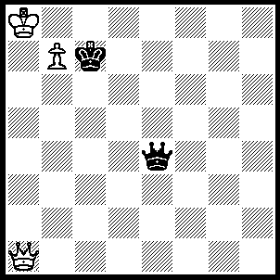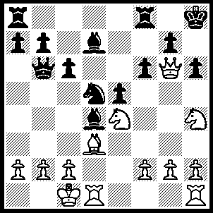
- 2
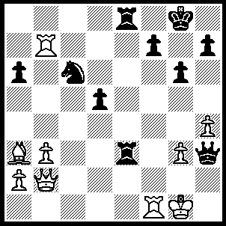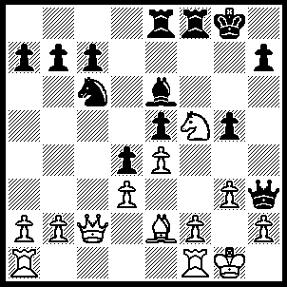
- 6
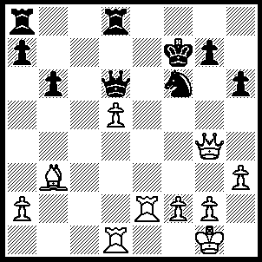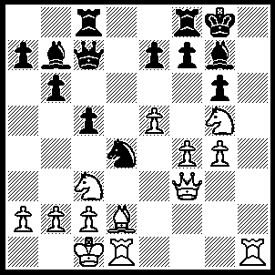
- 10
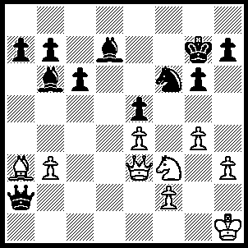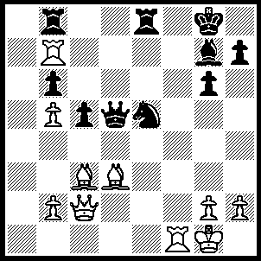
- 14
1----1.Qe5+ Qxe5, 2.b8(Q)+ Kc6, 3.Qxe5.
2----1.Qh7+ Kxh7, 2.Nxf6+ Kh8, 3.Ng6++.
3----1.Qh8+ Kxh8, 2.Rxh6+Kg8, 3.Rh8++.
4----1.Bxg4+ Kxg4, 2.f3+ Kh5 (2…..Kg3, 3.Qg5++), 3.g4++.
5----1.Qg7+ Kxg7, 2.R(1)xf7+ Kg8, 3.Rg7+ Kh8, 4.Rxh7+ Kg8, 5.R(b)g7++.
6----1.Bg4 Qxg4, 2.Nh6+ Kh8, 3.Nxg4 Bxg4, 4.R(f)c1.
7----1.g5+ Kxg5, 2.Qf4+ Kh5, 3.g4+ Qxg4+, 4.Qxg4+.
8----1.Rh8+ Kxh8, 2.Nxg6+ Kg8, 3.Nxh4.
9----1.Re7+ Qxe7 (1…..Kxe7, 2.Qxg7+ Ke8, 3.Re1+ mates), 2.d6+ Ke8 (2…..Qe6, 3.Qxe6+ Kg6, 4.Bc2+ mates), 3.Qg6+ Kf8 (3…..Kd7, 4.dxe7+ Kc7 [4…..Kxe7, 5.Qf7++], 5.exd8(Q)+ Rxd8, 6.Qc2+), 4.dxe7+ Kxe7, 5.Qf7++.
10----1.Rh8+ Bxh8, 2.Qh3 Ne2+, 3.Kb1 Nxc3+, 4.Bxc3 R(f)e8, 5.Qh7+ Kf8, 6.Qxf7++.
11----1.Rxc5 Qxc5, 2.Ne6 fxe6, 3.Bxe6+ Kf8, 4.Qf6+ Ke8, 5.Qf7+ mates.
12----1.f5+ Kxf5 (1…..Ke5, 2.Qe7+ Kd5, 3.Nc3+), 2.Ng3+ Ke5, 3.Nxe4 Nxe4, 4.Qb5+ Nc5, 5.Qe2+ Kd5, 6.Qxh5+.
13----1.Qh6+ Kh8 (1…..Kxh6, 2.Bf8+ OR 1…..Kf7, 2.Qf8+ Ke6, 3.We7++), 2.Qf8+ Ng8, 3.Be7 Qb1+, 4.Kg2 Bd8, 5.Bxd8 h6, 6.Bf6+ Kh7, 7.Qg7++.

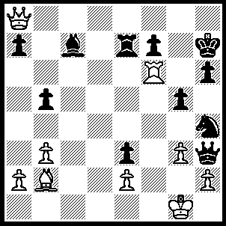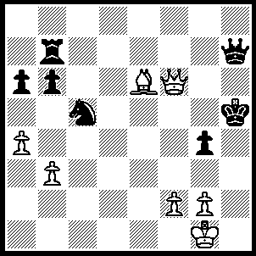
3 4
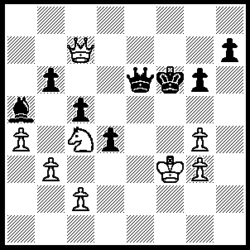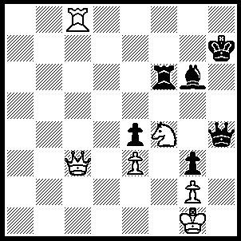
7 8
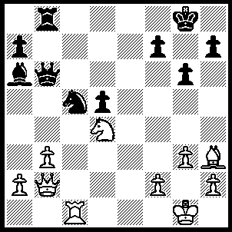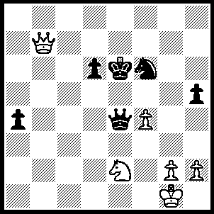
11 12
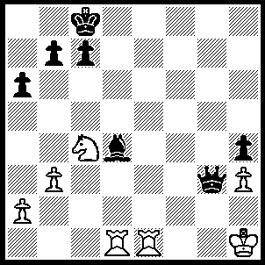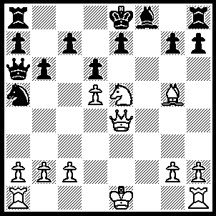
15 16
14----1.Bc4 Qxc4 (1…..Nxc4, 2.Rxg7+ Kh8, 3.Rd7+ Qe5, 4.Qf2 mates), 2.Rxg7+ Kh8 (2…..Kxg7, 3.Bxe5+ Rxe5, 4.Qxc4), 3.Bxe5 Qxf1+ (3…..Qxc2, 4.Rf8+ Rxf8, 5.Rxg6+ mates OR 3…..Qe6, 4.Rf6 Qxf6 [4…..Qxe5, 5.Rxh7+ mates], 5.Bxf6 OR 3…..Qd5, 4.Bc3 Re5, 5.Re7), 4.Kxf1 Rxe5, 5.Qc3 Rf8+, 6.Kg1 R(8)e8, 7.Rb7.
15----1.Re8+ Kd7, 2.Re3 Qf4, 3.Rxd4+ Qxd4, 4.Rd3 Qxd3, 5.Ne5+ Kd6, 6.Nxd3.
16----1.Nf7 Kxf7 (1…..Rg8, 2.Rf1 b5 [2…..Qxf1+, 3.Kxf1 Kxf7, 4.Ke2 Ke8, 5.Rf1 Kd8, 6.Qe6 c6, 7.dxc6 Nxc6, 8.Qxd6+ IF 2…..g6, 3.Nxd6+ Kd7 [[3…..cxd6, 4.Rxf8+ mates]], 4.Qe6+ Kd8, 5.Rxf8+ Rxf8, 6.Qxe7++], 3.Qxh7 c6, 4.Qxg8 Kd7, 5.Ne5+ dxe5, 6.Qe6+ Kc7, 7.Rxf8 Rxf8, 8.Qxe7+ Kb8 [8…..Kb6, 9.Be3+ mates], 9.Qxf8+ Qc8, 10.Qxg7), 2.Rf1+ Qxf1+ (2…..Ke8, 3.Rxf8+ Kxf8, 4.Bxe7+ Ke8, 5.Bxd6+ Kd8, 6.Qe7+ mates), 3.Kxf1 Nb7, 4.Kg1 Nc5, 5.Rf1+ Ke8 (5…..Kg8, 6.Qf5 h6, 7.Rf3 Re8 [7…..Ne4, 8.Qe6+ Kh7, 9.Qxe4+ Kg8, 10.Qf5 h5, 11.Qf7+ Kh7, 12.Qxh5+ Kg8, 13.Qf7+ ], 8.Qf7+ Kh7, 9.Rh3 mates), 6.Qe2 h6, 7.Bxe7 Bxe7, 8.Re1 Kd7(8…..Kf8, 9.Qxe7+ Kg8, 10.b4 Na6, 11.Qe6+ Kh7, 12.Qe4+ Kg8, 13.Qg6 Rf8, 14.Re7 Rh7, 15.Qe6+ Kh8, 16.Re8), 9.Qxe7+ Kc8, 10.Qxg7 Kb7 (10…..Rd8, 11.Re7 Nd7,12.Qf7 a5,13.Re8), 11.b4 R(a)g8, 12.Qc3 Na6, 13.Re3 Rh7, 14.Qc6+ Kb8, 15.Qa4 Kb7, 16.Ra3 Nb8, 17.Qxa7+ Kc8, 18.Rc3.

