FROM THE TWO HARD SPECIAL
By Vern Stannard
I do these Too Hard Box pages and the CAWA publishes them in the hope they will be played over by members so that they will improve their grasp of chess tactics. The variations and sub variations of the positions given generally contain a variety of tactical motives and frequently some surprise moves. Playing them through is simple if you or a group can do it on a computer with a reasonable chess program. Just set it to enable moves to be retaken, go down a variation then backtrack to the mainline and continue on.
When I told Mike Partis I was analysing the Kasparov- Topalov game as published in the July 99 issue of the CAWA newsletter he kindly sent me a 24-page printout on the game from the Kasparov fan club. This was a great help in showing me the way.
Kasparov---Topalov, Wijk aan Zee 1999
1.e4 d6, 2.d4 Nf6, 3.Nc3 g6, 4.Be3 Bg7, 5.Qd2 c6, 6.f3 b5, 7.N(g)e2 N(8)d7, 8.Bh6 Bxh6,9.Qxh6 Bb7, 10.a3 e5, 11.0-0-0 Qe7, 12.Kb1 a6, 13.Nc1 0-0-0, 14.Nb3 exd4, 15.Rxd4 c5, 16.Rd1 Nb6, 17.g3 Kb8, 18.Na5 Ba8, 19.Bh3 d5, 20.Qf4+ Ka7, 21.R(h)e1 d4, 22.Nd5 N(b)xd5, 20.exd5 Qd6, 24.Rxd4
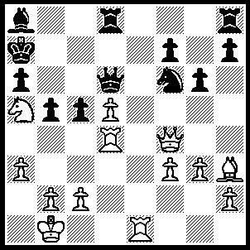24…..cxd4 (better is 24…..Qxf4, 25.Rxf4 Rd6 Also 24…..Bxd5.
Best is 24…..Kb6, 25.Nb3
[not 25.b4 Qxf4, 26.Rxf4 Nxd5, 27.Rxf7 cxb4, 28.axb4 Nxb4, 27.Nb3 Rd6], (25…..Bxd5
[a possibility is 25…..g5, 26.Qxd6 [not 26.Qd2 Ka7], Rxd6 27.Rd2 Nxd5, R(h)d1, R(h)d8]
but not 25…..cxd4, 26.Qxd4 Kc7
[If 26…..Kb7, 27.Re7 Nd7
(27…..Qxe7, 28.Na5+ Kb8 [28…..Kc7, 29.d6+ mates], 29.Qb6+ Bb7 [29…..Qb7, 30.Nc6++] 30.Nc6+ Ka8, 31.Qa7++
OR 27…..Rd7, 28.Nc5+ Kc7 ---- [[[28…..Kc8, 29.Bxd7+ Kd8 {{29…..Kc7, 30.Rxf7 Nxd7, 31.Ne6+ Kb7, 32.Qxh8 and if 29…..Kb8, 30.Nxa6+ Qxa6 [30…..Kb7, 31.Bc6+ Kc8, 32.Qb6], 31.Qe5+Ka7, 32.Bxb5+ Qb7, 33..Qxf6}} OR 28…..Kb8, 29.Nxd7+ Kc7 {{29…..Nxd7, 30.Rxd7 OR 29…..Kb7, 30.Nc5+ Kb8 [30…..Kb6, 31.Nb7+ mates], 31.Nxa6+ Qxa6, 32.Qe5+ mates OR 29…..Kc8, 30.Nxf6+ Kd8, 31.Qa7 Bc6, 32.Rxf7 mates}}, 30.Qa7+ Bb7, 31.Nc5+ Qxe7, 32.Nxa6+ Kd6, 33.Qc5+ Ke5, 34.Qxe7+ Kd4, 35.c3+ mates]]], ---- 29.Nxd7 Kd8 [29…..Qxe7, 30.Qb6+ Kc8, 31.Qb8++], 30.Rxf7 Bxd5, 31.b3 Ne8, 32.Ne5),

28.Nc5+ Kc7, 29.Nxd7 R(d)e8, 30.Qa7+ Bb7, 31.Nc5+ Qxe7, 32.Qxb7+ Kd6, 33.Qc6+ Ke5, 34.f4+ Kd4, 35.Nb3+ Ke3, 36.Qb6+ Kf3 (36…..Ke2, 37.Qg1 Qe4, 38.Nd4+ Kd2 [38…..Qxd4, 39.Bg4+ Kd2, 40.Qc1++], 39.Qc1++), 37.Nd2+ Ke2, 38.Bg4+ Kxd2, 39.Qd4+ Ke1, 40.Qg1+ mates]

27.Qa7+ Bb7, 28.Nc5 Rb8 (28…..Qb6, 29.Re7+ Rd7 [29…..Nd7, 30.d6+ Kc6, 31.Bd7+ ],, 30.d6+ Kc6 [30…..Qxd6, 31.Qxb7+ Kd8, 32.Rxd7+ Nxd7, 33.Nxd7 Ke7, 34.Ne5+ Kf6, 35.Qxf7+ Kxe5, 36.Qg7+], 31.Qxb6 Kxb6+, 32.Nxd7),
29.Re7+ Kd8 (29…..Qxe7, 30.Nxa6+ Kd6, 31.Qc5+ Ke5, 32.Qxe7+ Kd4, 33.c3+ mates),
30.Rxb7 Rc8 [30…..Rxb7, 31.Nxb7+ Ke7, 32.Nxd6 Kxd6, 33.Qb6+], 31.Bxc8 Ke8, 32.Bh3 Kf8, 33.Rxf7+ Ke8, 34.Rg7 Nxd5, 35.Qf7+ Kd8, Nb7++],

26.Qxd6 Rxd6, 27.Rd2 R(h)d8, 28.R(e)d1=)

25.Re7+ [not 25.Qxd4+ Qb6, 26.Re7+ Nd7, 27.Nb3 f5],
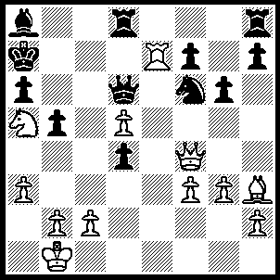 25…..Kb6, (25…..Qxe7, 26.Qxd4+ Kb8, 27.Qb6+ Bb7 [27……Qb7, 28.Nc6++] 28.Nc6+ Ka8, 29.Qa7++
OR 25…..Kb8, 26.Qxd4 Nd7, 27.Bxd7 Bxd5 [27……Rxd7, 28.Rxd7 Qxd7, 29.Qxh8+], 28.c4 [not yet 28.Nc6+ else Qxc6, 29.Bxc6 Ba2+] Qxe7 [28…..bxc4 29.Nc6+], 29.Qb6+ Ka8, 30.Qxa6+ Kb8, 31.Qb6+ Ka8, 32.Bc6+ Bxc6, 33.Nxc6 Rd7, 34,Nxe7),

26.Qxd4+
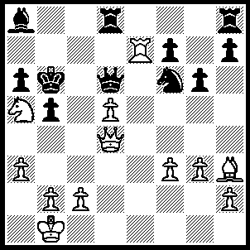26…..Kxa5 (26…..Qc5, 27.Qxf6+ Qd6
[27…..Rd6, 28.Qxh8 Qg1+ [28….Bxd5, 29.b4], 29.Ka2 Bxd5+, 30.c4 bxc4 [30…..Be4, 31.c5+ Qxc5 [31…..Kxc5, 32.Qc3+ mates], 32.Nb3 Rd1 {{32…..Qd5, 33.Qb8+ Qb7, 34.Qxd6+ Qc6, 35.Qd8+ mates}},, 33.Qb8+ Kc6, 34.Na5+ mates
OR 30…..Kxa5, 31.Qc3+ Kb6, 32.cxd5, 33.Rb7+], 31.Qb8+ Kc5 [31…..Bb7, 32.Qxb7+ Kc5, 33.Qb4+ mates], 32.Qb4+ Kd4, 33.Nb3+ Kd3, 34.Qc3++],
28.Be6 Bxd5 [28…..Kxa5, 29.b4 Kb6 [29…..Ka4, 30.Qc3 Bxd5, 31.Kb2 mates], 30.Qd4+ mates OR 28…..R(h)e1, 29.b4 Rc8 [29…..Rxe7, 30.Qd4+ mates], 30.Qd4+ Rc5, 31.Rxe8],
29.b4 Ba8 [29….Bxe6, 30.Rb7++],
30.Qxf7 Qd1+
[IF 30…..Rb8, 31. Rd7 Qe5
[ 31…..Qf8, 32.c4 bxc4, 33.Nxc4+ Kb5 [33.Kc6, 34.Rc7+ Kb5, 35.Bd7+ Bc6, 36.Bxc6++], 34.Rc7 Bc6 [34…..a5, 35Qd7+ Ka6, 36.Ra7++] 35.Rxc6 Kxc6, 36.Qd7++],
32.f4 Qe1+, 33.Ka2 R(h)c8, 34.Rd6+ Rc6
[34…..Bc6, 35.Bxc8 Qe4, 35.Rxc6+ Qxc6, 37.Nxc6 Rxc8, 38.Na5 Rxc2+, 39.Kb3 Rc7, 40.Qf6+ Ka7, 41.Qd4+ Kb8, 42.Qd8+ mates}],
35.Nxc6 Bxc6, 36.Rxc6 Kxc6, 37.Qd7+ Kb6 38.Qd6+ Ka7 [38…..Kb7, 39.Qe7+ Kb6, 40.Qc5+ Kb7, 41.Bd5++],, 39.Qc5+ Ka8 [39…..Rb6, 40.Bd5 a5, 41.Qc7+ Ka6, 42.Qc8+ Ka7, 43.Qa8++], 40.Bd5+ Rb7, 41.Qc8+mates],
31.Kb2 Qxf3 31…..Qd4+ 32.Ka2 Rb8, 33.Rd7 Qe5, 34.f4 Qe4, 35.Rd6+],
32.Bf5 Rd6, 33.Ra7 Rc8, 34Bxc8 Qxf7, 35.Rxf7 Bd5, 36.Rxh7.
27.b4+ Ka4,

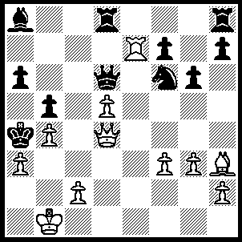28.Qc3
here Kavalek demonstrates a more precise way to conduct play for white (28.Ra7 Bb7 [28…..Bxd5, 29.Qc3 R(h)e8 [29…..Rc8, 30.Bxc8 Rxc8,31.Qxc8 Bb7, 32.Qc3 mates] 30.Kb2 Re2, 31.Qc7 Qb6, 32.Qxb6 Rxc2+ 33.Kxc2 Bb3+ 34.Kc3 Ne4+, 35.fxe4 mates], 29.Rxb7 Qxd5 [29…..Nxd5, 30.Bd7 Rxd7, 31.Qb2 Nxb4, 32.Rxd7 Qf8 [32…..Qc5, 33.Rd4], 33.axb4 Qxb4, Rd4],
30.Rb6 a5 [30…..Ra8, 31.Qxf6 a5, 32.Bf1 R(h)b8, 33.Rd6 wins], 31.Ra6 Ra8, 32.Qe3 Rxa6, 33.Kb2 axb4, 34. axb4 Qa2+ [34…..Kxb4, 35.Qc3+ mates],
35.Kxa2 Kxb4+, 36.Kb2 Rc6 [36…..Ka5, 37.Qc3+ Kb6, 38.Qxf6+ OR 36…..Kc4, 37.Qf4+ Kd5, 38.Qg5+ Kd4 [38…..Kc4, 39.Bf1+ Kd4, 40.c3++], 39.c3+ Kd3, 40.Bf1++],
37.Bf1 Ka5 [37…..Ra8, 38.Qe7+ Ka5, 39.Qb7],
38.Qa7+ Ra6, 39.Qc5 Rb8, 40.Qc7+ R(8)b6, [40…..Kb4, 41.Qc3+], 41.Qc3+ b4, 42.Qc5+ Ka4, 43.Bc4),
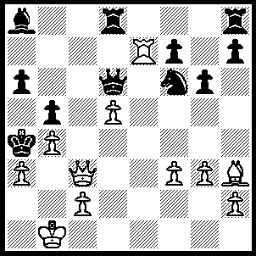
28…..Qxd5 (28…..Bxd5, 29.Kb2 mates),
29.Ra7 Bb7 (29…..Rd3, 30.Kb2 Qd4, 31.Qxd4 Nd5, 32.Bd7 Rc8 [32…..Rb8, 33.Qc4], 33.Qd3 Nc3, 34.Bxb5+, Nxb5, 35.Qb3++),

30.Rxb7

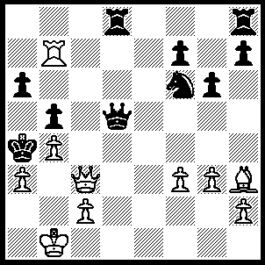30…..Qc4
(30…..Rd6, 31.Rb6 Rxb6 [31…..R(h)d8, 32.Kb2 Qd4, 33.Qxd4], 32.Kb2

OR 30…..Ne4, 31.fxe4 Qc4, 32.Ra7 Rd1+ [32…..Ra8, 33.Qe3 so as to play Kb2],
33.Kb2 Qxc3+ 34.Kxc3 Rd6, 35.e5 Rb6, 36.Kb2 f5
[the fan club only gives 36…..Rd8, 37.Bd7 as winning
by possibly 37…..h6, 38.c4 Rxd7, 39.Rxd7 bxc4, 40.Rd6 Rb7, 41.Rxa6 Kb5, 42.Ra5+ Kb6, 43.Rc5
ALSO 36…..Re8, 37.Bg2 Rd8 [37…..Rxe5, 38.Bb7 Re3, 39Bxa6 Rxa3 40.Bc8+], 38.Bb7 Rd7, 39.Bc6 Rxc6
[[[39…..Rxa7, 40.Bd5 mates OR 39…..Rd8, 40.Bd7 g5, 41.c4 Rxd7, 42. Rxd7 bxc4, 43.Rd6 as before OR 39…..Rd2, 40.Be8]]]
40.Rxd7 Rc8, 41.Ra7 Rc6, 42.Rxf7]
37.Rd7 R(6)b8 [37…..Rc8, 38.Bg2 Re6, 39.Rd6 Rxd6, 40 exd6 a5, 41.c3 Re8, 42.Bf3 Re1, 43.d7],
38.Bg2 R(h)c8, 39.c3 Rxc3, 40.Kxc3 Kxa3,41.Bb7 Re8, 42.Rd1 Rc8+ Bxc8 Ka2, 44.Be6+).

The move 30…..R(h)e8 was put forward by Topalov as at least maintaining an even game.
Lichterink later demonstrated how white could win.
31.Rb6 Ra8, 32.Bf1 Nd7

[IF 32…..Re6, 33.Rxe6 and Kb2
OR 32…..Ng8, 33.Rd6 R(e)c8
[33.Re1+ 34.Kb2 Qe5, 35.Rd4 Qxd4, 36.Qxd4, R(1)e8, 37.Bxb5+],
34.Qb2 Rxc2 [34…..Qc4, 35.Bxv4 bxc4, 36b5], 35.Qxc2+ Qb3+, 36.Qxb3+ Kxb3, 37.Rd3+ Kc4 [37 Ka4, 38.Be2], 38.Kc2
OR 32…..R(e)d8, 33.Rxf6
[[Lichterink gives 33.Rc6 Nd7, as a win for white possibly by 34.Rd6 Rdc8, 35.Qb2 Qxf3 [35….Rxc2, 36.Qxc2 Qb3+, 37.Qxb3+ Kxb3, 38.Rd3+ Ka4 [38…..Kc4, 39.Kc2],39.Be2 Nc5, 40.Bd1+ Nb3, 41.Rxb3 mates] 36.Bd3 Nc5, 37.Bxc5 Qh1+ 38.Ka2 Qe1, 39.Rxa6+ Rxa6, 40.Qxb5++]]
33…..Rd7 [33…..g5, 34.Bd3 g4, 35.Rf5 R(a)c8 [35…..R(d)c8, 36.Qb2 Qe3, 37 Re5], 36.Qb2 Qe3, 37.Rf6], 34.Rf4 Re8, 35.Re4 Rxe4, fxe4 Qe6, 37.Kb2 Rd2, 38.Qxd2 a5 [38…..Qe5+, c3], 39.Qc3.

OR 32…..Re1+, 33.Qxe1 Nd7
[[33…..Qd4, 34.c3 Qd5, 35.Qc1 Nd7, 36.Rd6 Qb3+, 37.Qb2 Qxb2 [37…..Nc5, 38.Be2 a5, 39.bxc5 f5 [39.Rb8, 40.Rb6], 40.Bxb5+ Qxb5, 41.Rd4+ mates IF 37…..Ne5, 38.Rxa6+ Rxa6, 39.Bxb5+ Kxb5, 40.Qxb3], 38.Kxb2 Ne5, 39.Rd5 Rc8, 40.Be2 Nc4+, 41.Bxc4 Rxc4, 42.Rd6 mates]]
34.Rb7 Qxb7, 35.Qd1 Nc5 [35…..Kxa3, 36.c3 with mate by Qc1 Qc2 and a2 Lichterink], 36.c3+ Nb3, 37.Kb2 Qd5, 38.Qxd5],

33.Rd6 Re1 [33…..R(e)c8, 34.Qb2 Qc4, 35.Bxc4 bxc4, 36.b5], 34.Kb2 Qe5, 35.Rd4 Qxd4, 36.Qxd4 Rxf1, 37.Qc3 mates.
31.Qxf6
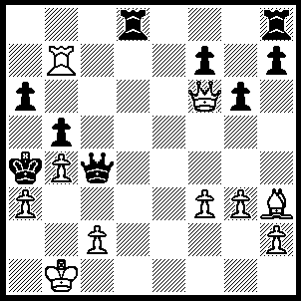31…..Kxa3 (31…..Rd1+, 32.Kb2 Ra8
[32…..Qd4+, 33.Qxd4 Rxd4, 34.Rxf7 Rd6 [34…..Re8, 35.Rf6], 35.Re7 Ra8, 36.Be6],

33.Qb6 Qd4+ [33…..a5, 34.Bd7], 34.Qxd4 Rxd4, 35.Rxf7 a5

[35.Rd6, 36.Rd7 Rf6, 37.f4 a5, 38.Bg2 R(8)a6, 39.c3 R(f)e6, 40.Bf3 R(a)d6, 41.Rxd6 Rxd6, 42.Be4 Rd2+ , 43.Bc2+ Rxc2, 44.Kxc2],
36.Be6 axb4, 37.Bb3+ Ka5, 38.axb4+ Kb6, 39.Rxh7) is given as winning by Kasparov.

32.Qxa6+ Kxb4, 33.c3+
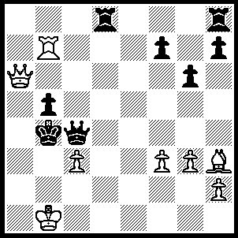33…..Kxc3
(33…..Qxb3, 34.Qxb5+ mates

OR 33…..Kb3, 34.Qa2+ Kxc3, 35.Qb2+ Kd3, 36.Bf1+

OR 33…..Kc5, 34.Rc7+ Kd5, 35.Qb7+ Kd6

[35…..Ke5, 36.Rxc4 bxc4, 37.Qc6 g5, 38.Qc5+ Kf6 [38.Kf5, 39.Qc6 g5 to stop f4 mate 40.Be4+ Kg4 41.Bf3+ Kf5 [41…..Kh3, 42.Qh6++], 42.g4+ Kxf4, 43.Qe4++], 39.Qf5+ wins R],
36.Qb6+ Kd5 [36…..Ke5, 37.Rxc4 bxc4, 38.Qc6 as before],
37.Rxc4 bxc4, 38.f4 Ke4 [38…..Rb7, 39.Bg2++],
39.Bg2+ Kd3, 40.Bf1+ Ke4 [40…..Kd2, 41.Qf2+ Kxc3, 42.Qb2++ OR 40…..Kxc3, 41.Qb2++],

41.Qb7+ Kf5, 42.Qxf7+ Kg4 or Ke4, 43.Qe6+ mates.

34.Qa1+
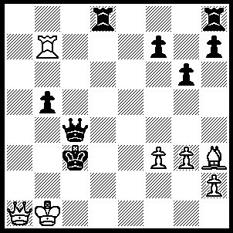34…..Kd2,
(34…..Kb4, 35.Qb2+ Ka5 [35…..Qb3, 36.Rxb5+], 36.Qa3+ Qa4, 37.Rxb5+ Kxb5, 38.Bf1+ Qc4 [38…..Ka5, Qc5+ mates], 39.Qb3+),

35.Qb2+
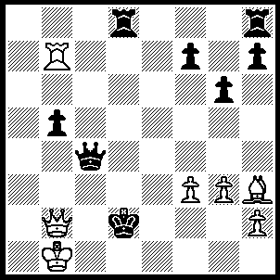35…..Kd1
(35…..Ke3, 36.Re7+ Kd3, 37.Bf1+

OR 35…..Ke1, 36.Re7+ Kd1, 37.Bf1 as in game),

36.Bf1 Rd2, 37.Rd7 Rxd7, 38.Bxc4 bxc4, 39.Qxh8 Rd6

(39…..Rb7+, 40.Ka2 Kc2, 41.Qd4),

40.Qa8 c3, 41.Qa4+ Ke1, 42.f4 f5, 43.Kc1 Rd2, 44.Qa7 resigns.

