TACTICAL AWARENESS 1
By Vern Stannard
The following positions are all to do with the fact that a Knight’s coverage of the board almost doubles if it can deliver check and they get progressively harder. However, each one increases your awareness, I hope, so the answers are all at the bottom of the column in the hope you will solve them all.

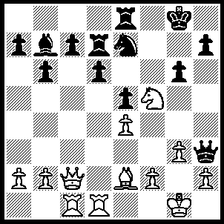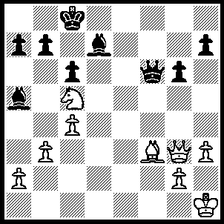
1 2
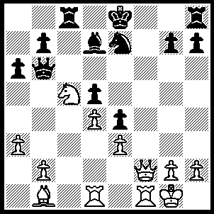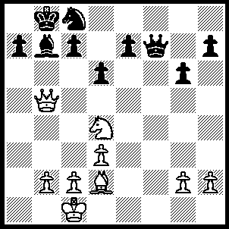
3 4
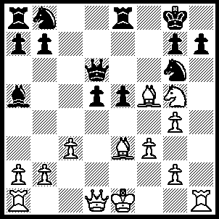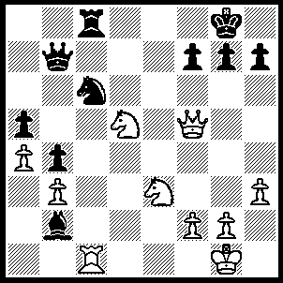
5 6

1----1.Bg4 gxf5 (1…..Qxg4, 2.Nh6+), 2.Bxh3 Bxe4, 3.Qxe4 fxe4, 4.Bxd7 wins.
2----1.Qb8+ Kxb8, 2.Nxd7+ Kc7, 3.Nxf6 wins.
3----1.Qf8+ Rxf8, 2.Rxf8+ Kxf8, 3.Nxd7+ Ke8, 4.Nxb6 wins.
4----1.Nc6+ Ka8, 2.Qxb7+ Kxb7, 3.Nd8+ Ka8, 4.Nxf7+ wins.
5----1.Bxg6 hxg6 (1…..Qxg6, 2.Qxd5+ Kh8 [[2…..Kf8, 3.Nxh7+ Ke7, 4.Bc5+ OR 2…..Re6, 3.Nxe6 Qf7, 4.Rxh7 wins]], 3.Nxh7 Qxh7, 4.Ke2 Bd8, 5.Rxh7+ Kxh7, 6.Qf7 mates), 2.Rh8+ Kxh8, 3.Nf7+ Kh7, 4.Nxd6 wins.
6----1.Qxc8+ Qxc8, 2.Rxc6 Qb8, 3.Rc8+ Qxc8, 4.Ne7+ Kf8, 5.Nxc8 wins.

TACTICAL AWARENESS 2
by Vern Stannard
When your opponent leaves a piece unprotected always look for a way to win it. In the case of the queen sacrificing minor pieces becomes a distinct possibility. The hardest to visualise are those that first force the removal of any protection or obstruction so that a double attack can be launched.

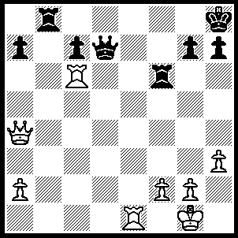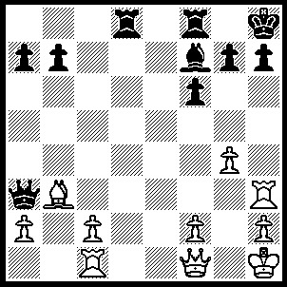
1 2
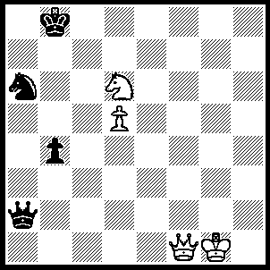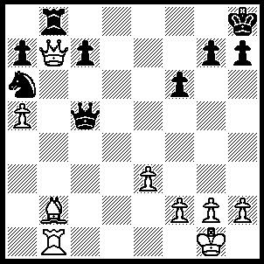
` 3 4
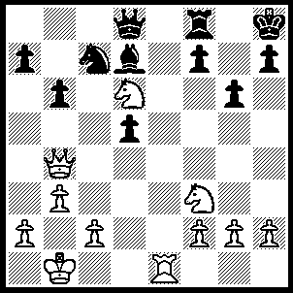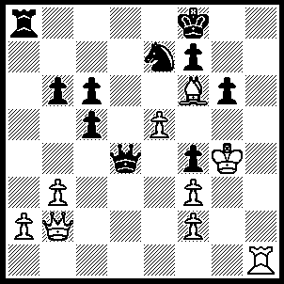
- 6

1---1.Rb6 Qc8, 2.Rxb8, Qxb8, 3.Re8+.
2---1.Rxh7+ Kg8 (1…..Kxh7, 2.Qh3+ Kg8 [2…..Kg6, 3.Qh5++], 3.Bxf7+), 2.Rh8+ Kxh8, 3.Qh3+ Kg8 (3…..Bh5, 4.Qxh5++), 4.Bxf7+ wins.
3.---1.Qb5+ Kc7, 2.Qc6+ Kd8, 3.Qc8+ Ke7, 4.Qe6+ Kd8, 5.Nf7+ Kc7, 6.d6+ wins.
4---1.Qxb8+ Nxb8, 2.Ba3 wins.
5---1.Re8 Nxe8 (1…..Rxe8, 2.Nxf7+ Kg8, 3.Nxd8, Rxd8, 4.Qe7 OR 1…..Bxd8, 2.Nb7 Bb5, 3.Nxd8 Rxd8, 4.Qc3+),
2.Nb7 Nf6 (2…..Nc7, 3.Nxd8 Rxd8, 4.Qc3+), 3.Nxd8 Rxd8, 4.Qe7 Re8, 5.Qxf7 Ne4, 6.Qxd7.
6---1.Rh8+ Ng8, 2.e6 Qxb2 (2…..Qd6, 3.e7+ Ke8, 4.Rxg8+ Kd7, 5.Rd8+ Kc7, 6.e8(N)+ Kb7, 7.Nxd6+ Kc7, 8.Rxa8 mates OR 2…..Qd1, 3.e7+ Ke8, 4.Rxg8+ Kd7, 5.Rd8+ OR …..Qb4, 3.e7+ Ke8, 4.Rxg8+ Kd7, 5.Rd8+ Kc7, 6.Qe5+ Kb7, 7.Rxa8 mates), 3.e7+ Ke8, 4.Rxg8+ Kd7, 5.Rd8+ Ke6, 6.Bxb2 wins.

