TACTICAL AWARENESS 3
BY Vern Stannard
After you have played through the moves to position No.1 you should not have too big a problem solving the others whose answers are given at the bottom of the column.

1---1.Bxh7+ Kf8 (1…..Kh8, 2.Bf6 Bxf6 [2…..gxf6, 3.Rd3 Qc6, 4.Be4], 3.exf6 g6, 4.Qh3), OR 1…..Kxh7, 2.Bf6 gxf6 [2…..Bxf6, 3.exf6 gxf6 [[3…..g6. 4.Qh4+ Kg8, 5.Qh6]], 4.Rd3 mates], 3.Rd3 Bf8, 4.Rh3+ Bh6, 5.Qh4 mates), 2.Bh6 Bg5, 3.Bxg5 c4, 4.Bf6 g6, 5.Qh4 Qc5+ (5…..R(e)c8, 6.Bxg6 fxg6, 7.Qh8+ Kf7, 8.Qg7+ Ke8, 9.Qg8++), 6.Kh1 R(e)c8, 7.Bxg6 Ke8, 8.Qh8+ Qf8, Bxf7+ Kxf7, 10.Rd7+ mates.

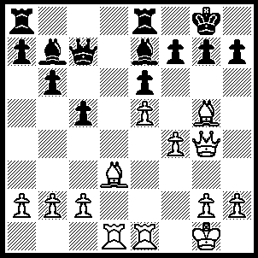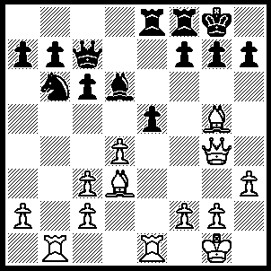
- 2
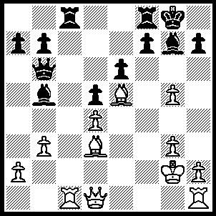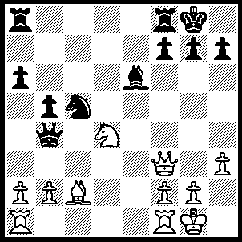
3 4
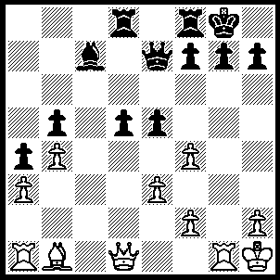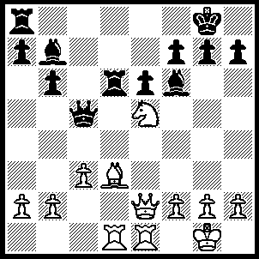
- 6

2---1.Bxh7+ Kxh7 (1…..Kh8, 2.Qh5 mates),2.Bf6 gxf6, 3.Qh4+ Kg7, 4.Qg3+ Kh6, 5.Re4 mates.
3---1.Bxh7+ Kxh7 (1…..Kh8, 2.Qh5 Re8, 3.Bxg7+ Kxg7, 4.Qh6+ Kh8, 5.Bg6+ mates), 2.Qh5+ Kg8, 3.g6 fxg6, 4.Qxg6 Rc7, 5.Rxc7 Qxc7, 6.Bxc7.
4---1.Bxh7+ Kh8 (1…..Kxh7, 2.Qh5+ Kg8, 3.Nc6 wins Q+P for N+B), 2.Qh5 Qd2, 3.Be4+ Qh6, 4.Qxh6+ qxh6, 5.Bxa8 Rxa8, 6.Nxe6.
5---1.Bxh7+ Kxh7, 2.Qh5+ Kg8, 3.Rxg7+ Kxg7, 4.Rg1+ Kf6, 5.f5 Rg8, 6.Qh4+ Kxf5, 7.Qxe7 Rxg1+ 8.Kxg1 Bb6, 9.Qxf7+ Kg5, 10.h4+ Kxh4, 11.Qf6+ Kh5, 12.Qxb6.
6---1.Bxh7+ Kxh7 (1…..Kh8, 2.Nxf7+ Kxh7, 3.Nxd6 OR 1…..Kf8, 2.Nd7+), 2.Qh5+ Kg8, 3.Qxf7+ Kh7 (3…..Kh8, 4.Qxb7), 4.Qxb7 Rxd1, 5.Rxd1 Rd8, 6.Qe4+ Kg8, 7.Nd7 Kf7, 8.Re1 Qd5, 9.Nxf6 gxf6, 10.Qh7+ Kf8 (10….Ke8, 11.Qg6+),11.Qxa7 Qd2, 12.Qa3+ Kf7, 13.Rf1.

TACTICAL AWARENESS 4
By Vern Stannard
The first position is one I had earmarked for my Too Hard section. Play through the moves to this position and the rest should be easy. However the last one has a twist to it. The answers are given below.

1.Rxh7 Nf8 (1…..Kxh7, 2.Qh5+ Kg8, 3,Bxg6 Bf6, 4.Qh7+ Kf8, 5.Bg5 Qc7 [5…..Bxg5, 6.Qh8+ Ke7, 7.Qxg7++], 6.Qh8+ Ke7, 7.Bxf6+ gxf6, 8.Qxf6++), 2.Qh5 Nxh7 (2…..g6, 3.Bxg6 wins), 3.Qxh7+ Kf8, 4.Bg6 Bf6, 5.Bg5 Qc7, 6.Qh8+ Ke7, 7.Bxf6+ gxf6, 8.Qxf6++.

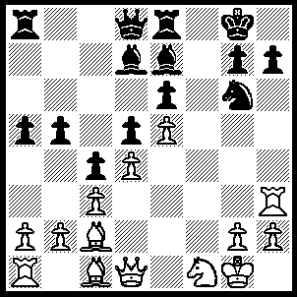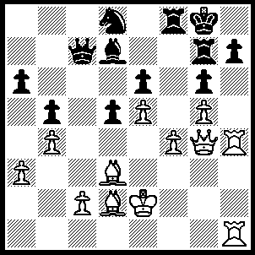
- 2
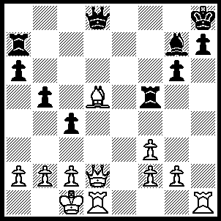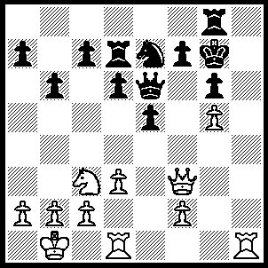
- 4
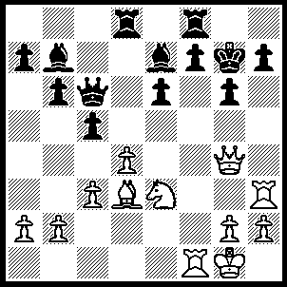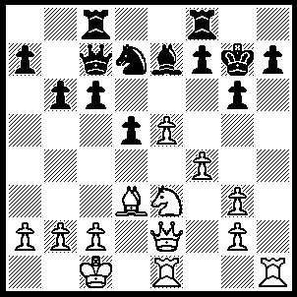
- 6
2-----1.Rxh7 Rxh7, 2.Rxh7 Rf7 (2…..Kxh7, 3.Qh5+ mates), 3.Rh6 wins 2P.
3-----1.Rxh7+ Kxh7, 2.Rh1+ Rh5, 3.Rxh5+ gxh5, 4.Be4+ Kg8, 5.Qxd8+.
4-----1.Rh7+ Kf8 (1…..Kxh7, 2.Qh1+ mates), 2.Qa8+ Nc8, 3.Qxc8+ Qe8, 4.Qxe8+ Kxe8, 5.Nd5.
5----1.Rxh7+ Kxh7 (1…..Kg8, 2.R(1)xf7 mates), 2.Rxf7+ Rxf7, 3.Qxg6+ Kh8, 4.Qxf7 wins.
6-----1.Nf5+ gxf5 (1…..Kh8, 2.Nxe7 R(c)e8, 3.Rxh7+ Kxh7, 4.Qh5+ Kg7, 5.Nf5+ Kg8 [5…..gxf5, 6.Qg5+ mates], 6.Qh6 mates OR 1…..Kg8, 2.Nxe7+ Kg7, 3.Rxh7+ as before), 2.Rxh7+ Kxh7 (2…..Kg8, 3.Qh5 mates), 3.Bxf5+ mates.

