TACTICAL AWARENESS 5
By Vern Stannard
This time it is a batch of easy ones. Easy that is if you follow the dictum—everything stops for check so examine each check for a possible combination no matter how unlikely that appears at first sight.
When it is check all the way it is relatively easy to see. It is that quite move down the track that makes a combination work that is hard to see.

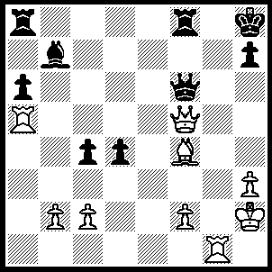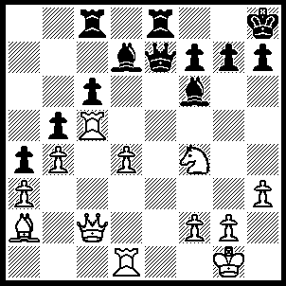
- 2
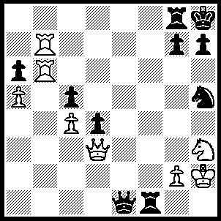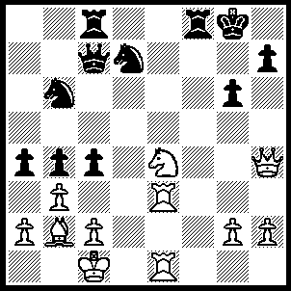
3 4
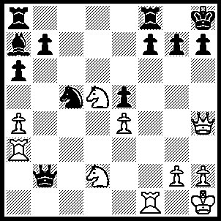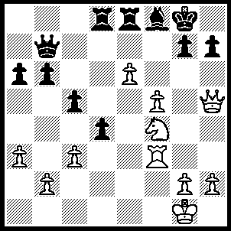
- 6

1----1.Qxh7+ Kxh7, 2.Rh5+ Qh6, 3.Rxh6++
2----1.Qxh7+ Kxh7, 2.Rh5+ Kg8, 3.Ng6 mates.
3----1Qxh7+ Kxh7, 2.Ng5+Kh8, 3.Rh6+ gxh6, 4.Rh7++.
4----1.Qxh7+ Kxh7, 2.Rh3+ Kg8, 3.Rh8+ Kf7, 4.Ng5++.
5----1.Qxh7+ Kxh7, 2.Rh3+ Kg6, 3.Ne7+ Kg5, 4.Rf5+ Kg4, 5.Rg3+ Kh4, 6.Nf3++.
6----1.Qxh7+ Kxh7, 2.Rh3+ Kg8, 3.Ng6 Rxe6, 4.fxe6 mates.

TACTICAL AWARENESS 6
By Vern Stannard
This week some easy ones each using the same basic tactic to enable a pawn promote to queen.

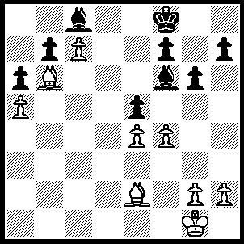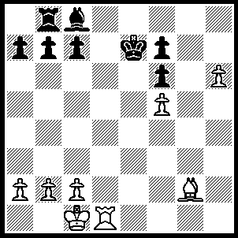
- 2
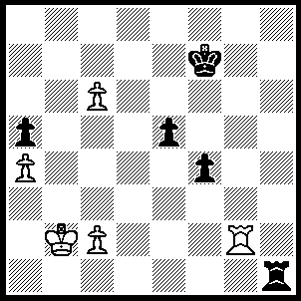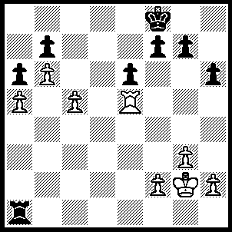
- 4
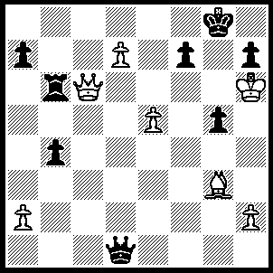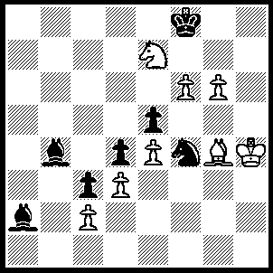
- 6
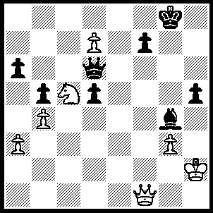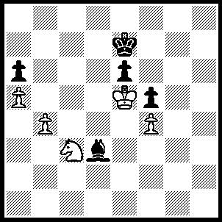
7 8
1----1.Bg4 Bxg4, f5.
2----1.Rd8 wins.
3----1. Rg8 wins.
4----1.c6 bxc6, 2.Rb5 wins.
5----1.Qd6 Rxd6+, 2.exd6 wins.
6----1.g7+ Ke8, 2.Bd7+ Kxd7, 3.Nd5 wins.
7----1.Qf4 Qe7, 2.Ne6 Bxe6 (2…..Qxd7, 3.Qg5+ mates), 3.Qb8+ wins.
8----1.b5 axb5 (1…..Kd7, 2.b6 Bc2, 3.Ne2 Bd3, 4.Nd4 Bc4, 5.Nxe6 Bxe6, 6.b7 wins), 2.a6 Bf1, 3.Nd5+ wins.

