TACTICAL AWARENESS 7
By Vern Stannard
Here again the first one is a position that I had earmarked for the Too Hard Box mainly because of the many variations that were not listed in the book I found it in. Play it through and the rest will be easy.

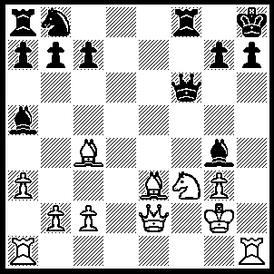
1.Rxh7+ Kxh7, 2.Rh1+ Qh6 (2…..Kg6, 3.Ne5+ Kf5 [3…..Qxe5, 4.Qxg4+ Kf6 [[4…..Kg6, 5.Be7+]], 5.Bg5+ Qxg5, 6.Qe6++], 4.Qd3+ Kxe5, 5.Qd5++), 3.Ng5+ Kg6 (3…..Kh8, 4.Rxh6+ gxh6, 5.Bd4+ mates),4.Qxg4 Rf5 (4…..Qxh8+, 5.Kxh8 Nc6, 6.Nh7+ mates), 5.Nh7+ Qg5 (5…..Kxh7, 6.Rxh6+ gxh6, 7.Qg8++ OR 5…..Rg5, 6.Nf8+ Kf6, 7.Qe6++), 6.Nf8+ Kf6, 7.Bxg5+ Ke5 (7…..Rxg5, 8.Qe6++), 8.Qe2+ Kd6 (8…..Kd4, 9.Ne6++), 9.Be7+ Kc6, 10.Qe6++.
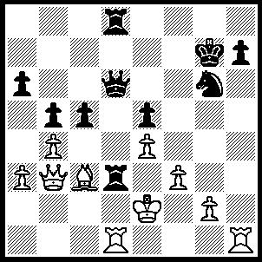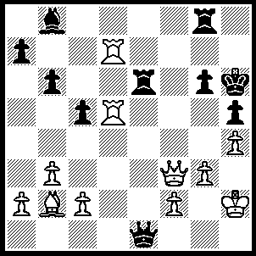
- 2
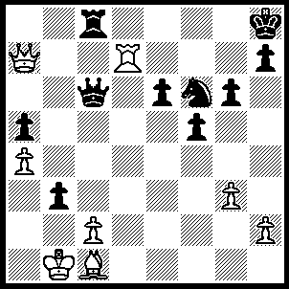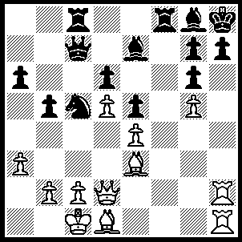
3 4
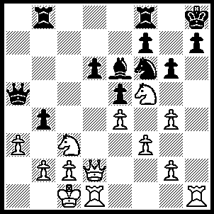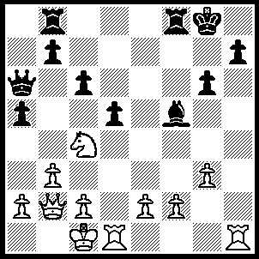
- 6
1----1.Rxh7+ Kxh7 (1…..Kf6, 2.Qf7+ Kg5, 3.Qf5++), 2.Qf7+ Kh6, 3.Rh1+ Nh4, 4.Rxh4+ Kg5, 5.Rh5++.
2----1.Rh7+ Kxh7, 2.Rxh5+ gxh5, 3.Qxh5+ Rh6, 4.Qf7+ mates.
3----1.Rxh7+ Nxh7, 2.Bb2+ Qc3, 3.Bxc3+ Rxc3, 4.Qd4+ Kg8,
5.Qxc3.
4----1.Rxh7+ Bxh7, 2.Qh2 Kg8, 3.Qxh7+ Kf7, 4.Qxg6+ Kxg6 (4…..Kg8, 5.Qh7+ Kf7, 6.Bh5++)
,5 Bh5+ Kh7, 6.Bf7++.
5----1.Rxh7+ Nxh7, 2.Qh6 Bxf5 (2…..Rg8, 3.Qxh7+ Kxh7, 4.Rh1++)
3.Rh1 g5, 4.gxf5 mates.
1----1,Rxh7 Kxh7, 2.Rh1+ Kg8,
3.Qh8+ Kf7, 4.Rh7+ Ke8 (4…..Ke6
5.Qe5++), 5.Nd6+ Kd8, 6.Qxf8++.

TACTICAL AWARENESS 8
By Vern Stannard
Play through the first position as a guide to solving the others whose answers appear in the box at the bottom.

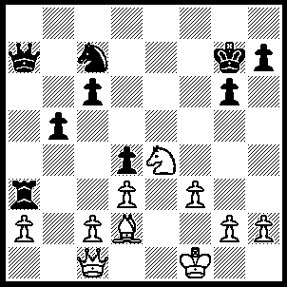
1.Bb4 wins R for if Rxa2, 2.Qh6+ Kxh6 (2…..Kf7, 3.Qxh7+ Ke6, 4.Qe7+ mates), 3.Bf8+ Kh5, 4.g4+ Kh4, 5.Be7+ g5, 6.Bxg5+ Kh3, 7.Nf2+ Kxh2, 8.Bf4++.

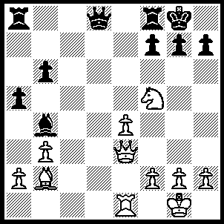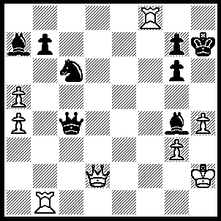
- 2
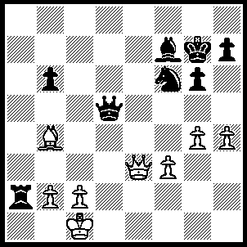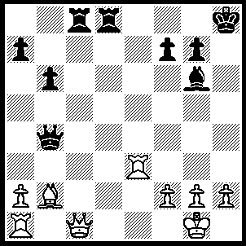
- 4
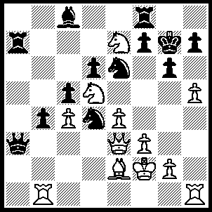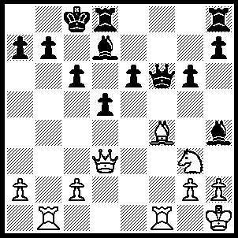
- 6
1---1.Qh6 mates.
2---1.Qh6+ gxh6 (1…..Kxh6, 2.Rh8++), 2.Rxb7+ mates.
3---1.Qh6+ Kh8, 2.Qf8+ Ng8 (2…..Bg8, 3.Qxf6++), 3.Bc3+ mates.
4---1.Rh3+ Kg8 (1…..Bh7, 2.Qh6), 2.Rh8+ Kxh8, 3.Qh6+ mates.
5---1.Qh6 Kxh6 (1…..Kh8, 2.Qxh7+ Kxh7, 3.hxg7+ Kg7, 4.Rh7++), 2.hxg6+ Kg5, 3.Rh5+ Kxh5, 4.f4+ Nxe2 (4…..Kh4/6, 5.Rh1+ mates), 5.Nf6+ Kh6 (5…..Kh4, 6.Nf5++), 6.Rh1+ Kg7, 7.Ne8+ Rxe8, 8.Rxh7+ Kf6, 9.Rxf7++.
6---1.Qa6 R(d)f8 (1…..bxa6, 2.Rb8++), 2.Qxb7+ Kd8, 3.Qb8+ Bc8 (3.Ke7, 4.Bd6+ Kf7, 5.Rxf6+), 4.Qc7+ Ke8, 5.Qxc8+ Kf7 (5…..Qd8, 6.Qxe6+ Be7 [6…..Qe7, 7.Rb8++], 7.Qxc6+ Qd7 [7…..Kf7, 8.Be5+ Bf6, 9.Rb7+], 8.Rb8+ Bd8, 9.Re1+), 6.Qd7+ Kg8, 7.Bh6 Qe7, 8.Rxf8+ Qxf8, 9.Qxe6+ Qf7, 10.Rb8+ mates.

