TACTICAL AWARENESS No.9
By Vern Stannard
The first position is one I was going to use as a filler on another article. Play through this one as a guide to solving the rest whose answers appears in the box below.

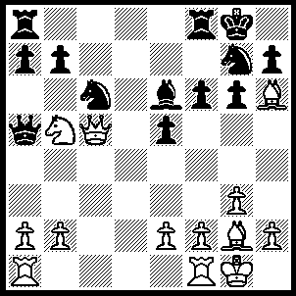
1.Bxg7 R(f)e8 (1…..Kxg7, 2.Bxc6 bxc6, 3.Nd4 Qxc5, 4.Nxe6+), 2.b4 Nxb4, 3.Bxf6 R(a)c8 (3…..b6, 4.c7),5.Be7 Qd8 (5…..Bxb5, 6.Bh3 Rc6, 7.Be6+ Rxe6, 8.Qxe6+ Kg7, 9.Bf6+ Kf8, 10.Qd6+ Kg8, 11.Bc3), 6.R(f)c1 Rxe7, 7.Qd6 Nc2, 8.Rxc2 Rd7, 9.Rxc4 Rxd6, 10.Nxd6 Rxc4, Nxc4.
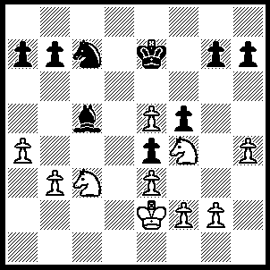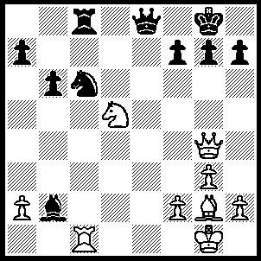
- 2
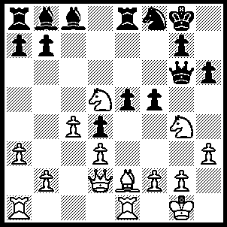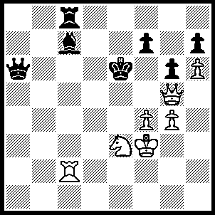
- 4
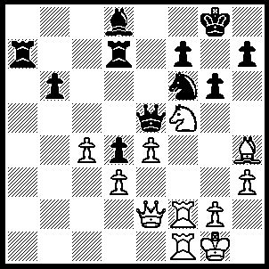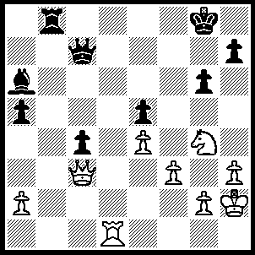
5 6

1----1.b4 Bxb4, 2.N(3)d5+ Nxd5, 3.Nxd5+ Ke6, 4.Nxb4 Kxe5, 5.Kd2.
2----1.Qxc8 Qxc8, 2.Rxc6 Qf8, 3.Rc8 Ba3, 4.Rxf8+.
3----1.N(4)f6+ gxf6, 2.Bh5 Qg7 (2…..Qxh5, 3.Nf6+), Bxe8.
4----1.Rxc7 Rxc7 (1…..Qa8+, 2.Qd5+), 2.Qf6+ Kxf6, 3.Nd5+ Ke6, 4.Nxc7+ Ke7, 5.Nxa6.
5----1.Nh6+ Kg7, 2.Bxf6+ Bxf6, 3.Ng4 Qh5, 4.Nxf6 Qxe2, 5.Rxe2 R(d)b7, 6.Ne8+ Kg8, 7.Nd6 Rd7, 8.Nb5.
6----1.Rd7 Qc6 (1…..Qxd7, 2.Nf6+ OR 1…..Qc8, 2.Nh6+ Kf8, 3.Rf7+ Ke8, 4.Qxe5+ Qe6, 5.Qh8++), 2.Nh6+ Kf8, 3.Rf7+ Ke8, 4.Qxe5+ Kd8, 5.Qd4+ Kc8, 6.Qh8+ Qe8, 7.Qxe8++

TACTICAL AWARENESS No.10
By Vern Stannard
Back rank weakness can be hard to see and is often not looked for. Play over the first one as a guide to solving the remaining positions whose answers appear below.

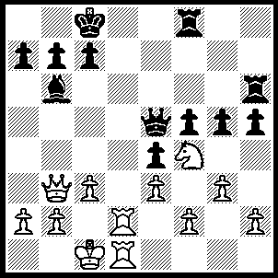
1.Qf7 Qe8 (1…..R(6)c6 or h8, 2.Qd7+ mates), 2.Ne6 c6 (2…..Rxe6, 3.Rd8+ Qxd8, 4.Qxe6+ Kb8, 5.Rxd8+ Rxd8, 6.Qxf5), 3.Qxf8 Rxe6, 4.Qxf5 Qg6, 5.Qxg6 Rxg6, 6.Rd6 Rg8, 7.Re6.

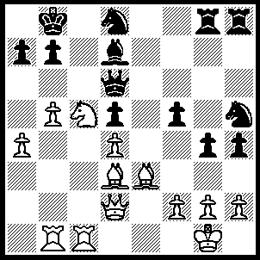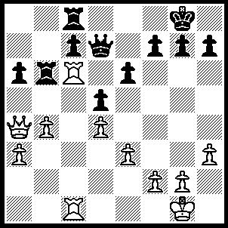
- 2
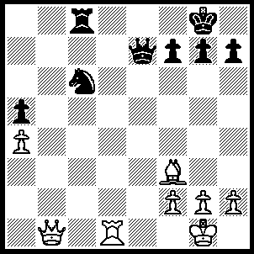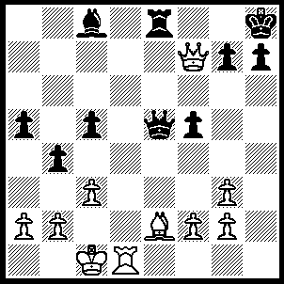
- 4
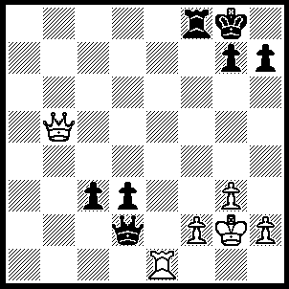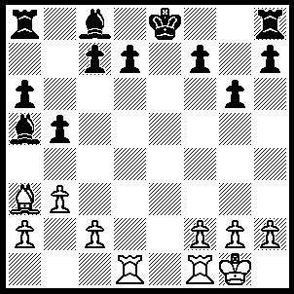
5 6
1----1.Bf4 Nxf4, 2.Qxf4 Nf7 (2…..Qxf4, 3.Nd7+ mates), 3.Nxd7+ Ka8, 4.Qxd6 Nxd6, 5.Nf6 Rd8, 6.Nxd5.
2----1.Rxc7 Rxc7, 2.Rxc7 Qd8, 3.Rc6 Rb8 (3…..Rxc6, 4.Qxc6 a5, 5.b5), 4.Qxa6 g6, 5.Qd3.
3-----1.Bxc6 Rxc6, 2.Qb7 Kf8 (2….. Qd6, 3.Qa8+ OR 2…..Rd6, 3.Qb8+ OR 2…..Rc1, 3.Qa8+), 3.Qxc6 g6, 4.Qc8+ Kg7, 5.Qc3+.
4----1.Bh5 Rg8 (1…..g6, 2.Bxg6 Qe7 [2…..hxg6, 3.Rh1++], 3.Qxe8+), 2.Qxg8+ Kxg8, 3.Rd8+ Qe8, 4.Rxe8++.
5----1.Qd5+ Kh8, 2.Qf7 Qxf2+ (2…..Rg8, 3.Re8 OR 2…..h6, 3.Qxf8+ Kh7, 4.Qf5+ mates), 3.Qxf2 Rxf2+, 4.Kxf2 g5, 5.Re8+ Kg7, 6.Rc8.
6----1.R(a)e1+ Bxe1, 2.Rxe1+ Kd8, 3.Be7+ Ke8, 4.Bg5+ Kf8, 5.Bh6+ Kg8, 6.Re8++.

