TACTICAL AWARENESS No.11
By Vern Stannard
After castling the square in front of the rook can become a weak square often over-looked when the Rook is moved away. Play over the first position and then have a go at the rest. The answers are at the bottom of the column.

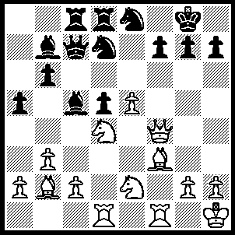
1.Qxf7+ Kxf7 (1…..Kh8, 2.Ne6 Nxe5 [2…..Qc6, 3.Nxd8 Rxd8, 4.Bxd5 IF 2…..Qb8, 3.Bxd5 Bxd5, 4.Rxd5 h6, 5.Nxd8 Rxd8, 6.Rxd7 Rxd7, 7.Qxd7], 3.Qxc7 Nxc7, 4.Nxd8 Nxf3, 5.Nxb7 Ng5, 6.Nxc5), 2.Bxd5+ Kg6 (2…..Ke7, 3.Rf7++), 3.Bf7+ Kg5, 4.Bc1+ Kh4, 5.Nf5+ Kg4, 6.h3++

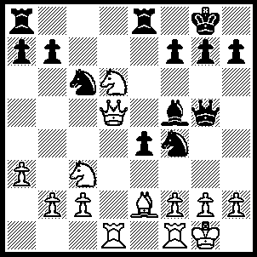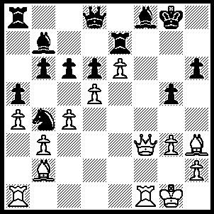
- 2
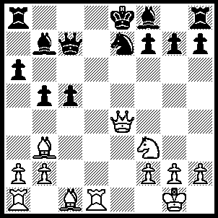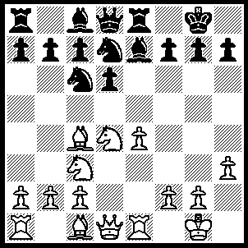
3 4
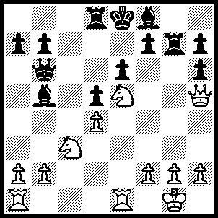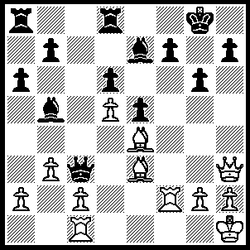
- 6
1---1.Qxf7+ Kh8, 2.Qxe8+ Rxe8, 3.Nf7+ Kg8, 4.Nxg5 h6, 5.Bc4+ Kf8, 6.Nf7.
2---1.Qf7+ Rxf7, 2.exf7+ Kh7, 3.Bf5++.
3---1.Bxf7+ Kxf7, 2.Ng5+ Ke8 (2…..Kf6, 3.Qe6++), 3.Qe6 mates.
4---1.Bxf7+ Kxf7, 2.Ne6 Kxe6, 3.Qd5+ Kf6, 4.Qf5++.
5---1.Nxb5 Qxb5, 2.Nxf7 Rxf7, 3.Rxe6+ Be7 (3…..Kd7, 4.Qxf7+ Kc8, 5.Rc1+), 4.Rxe7+ Kxe7, 5.Re1+ Kf8, (5…..Kd6, 6.Qxf7 Kc6 [6…..Rd7, 7.Qf4+ mates IF 6…..Qd7, 7.Qf6+ wins Q], 7.Re6+ Rd6, 8.Qe8+ wins Q), 6.Qxh6+ Kg8, 7.Qg5+ Kh8, 8.Qxd8+ Kg7, 9.Re8 h6, 10.Rg8+ Kh7, 11.Rh8+ Kg7 (11…..Kg6, 12.Qd6+ Rf6, 13.Qg3+ Kf5, 14.Qh3+ mates),12.Qg8+ Kf6, 13.Qg3 Qe2,14.Rxh6+mates.
6---1.Rxf7 Kxf7, 2.Qxh7+ Ke8, 3.Bg5 Qc7 (3…..Kf8, 4.Bxg6 OR 3…..Rd7, 4.Qg8+ Bf8, 5.Bxg6+ OR 3…..Kd7, 4.Qxe7+ OR 3…..Bxg5, 4.Bxg6++), 4.Bxg6+ Kf8, 5.Bh6++.

TACTICAL AWARENESS No.12
By Vern Stannard
The knight is in its element when it can attack while itself is immune. When a knight moves to a square where it can do this, particularly against a K or Q, its coverage of the board is widely extended. Play through the first position then try and find how white extends the knight’s field of influence in the rest.
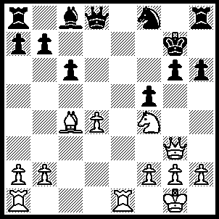
1.Re8 Qxe8 (1…..Qg5, 2.Qe3 h5 [2…..Nd7, 3.Re7+ Kf8, 4.Rf7+ Kg8, 5.Rf6+ mates], 3.Qe5+ Kh7, 4.Re7+ Qxe7, 5.Qxe7+), 2.Nh5+ Kh7, 3.Nf6 Kg7, 4.Nxe8+ Kh7, 5.Qe5 Ne6, 6.Qg7+ Nxg7, 7.Nf6++.

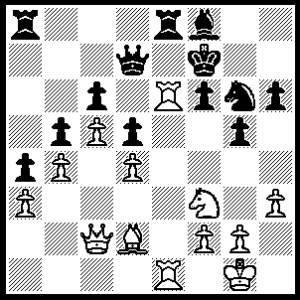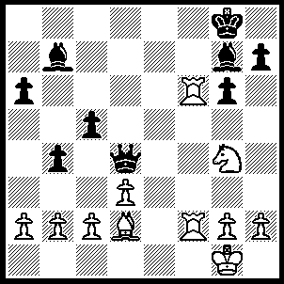
- 2
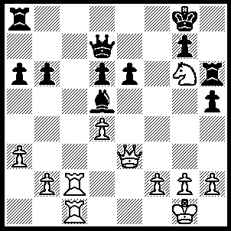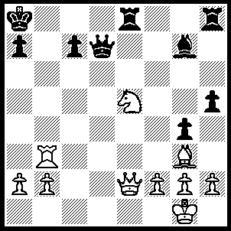
- 4
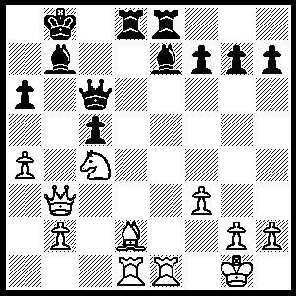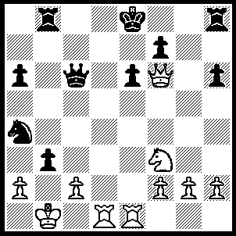
- 6
1---1.Qxg6+ Kxg6, 2.N25+ Kg7, 3.Nxd7 Rxe6, 4.Rxe6 wins.
2---1.Nh6+ Kh8 (1….Bxh6, 2.Bxh6), 2.Rd6 Qxd6, 3.Nf7+.
3---1.Rc8+ Rxc8 (1…..Kf7, 2.R[8]c7), 2.Rxc8+ Kf7, 3.Rf8+ Kxg6, 4.Qd3+ Be4 (4….Kg5, 5.Qg3++), 5.Qxe4+ Kg5, 6.h4++.
4---1.Rb8+ Kxb8 (1…..Rxb8, 2.Nxd7 wins), 2.Nxd7+ Kc8, 3.Ne5 Rxe5, 4.Bxe5 Re8, 5.Qa6+ Kd8, 6.Bf6+.
5---1.Bf4+ Ka8 (or Ka7. If Kc8, 2.Nb6+ wins Q), 2.Rxd8+ Bxd8, 3.Rxe8 Qxe8, 4.Qxb7+ Kxb7, 5.Nd6+ Kc7, 6.Nxe8+ Kd7, 7.Nxg7.
6---1.Qxh8 Ke7, 2.Rd7+ Kxd7 (2….Qxd7, 3.Qxb8 bxc2+, 4.Kxc2 Qc6+, 5.Kb1 Nc3+, 6.Ka1 Nb5, 7.Qe5), 3.Ne5+ Kc7, 4.Qxb8+ Kxb8, 5.Nxc6+ Kc7, 6.axb3 Nc3+, 7.Kb2.

