TACTICAL AWARENESS No.13
Double attack comes in many forms and if you are not awake to the signs in a position it can easily be missed.
Play through the first position and then see if you can interpret the signs in the others. Actually in this position white actually could have forced mate in 11 moves at the most but double attacks are what we are interested in.
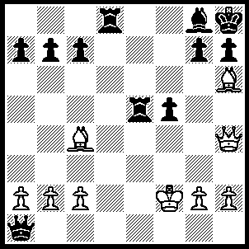
1.Bxg7+ [not 1.Qxd8 else Qe1+], Kxg7, 2.Qg5+ Kf8, 3.Qxd8+ Kg7, 4.Qxg5+ Kf8, 5.Qf6+ Ke8, 6.Qxe5+ Kd8, 7.Bxg8.
{4.Qxg8+ Kh6, 5.Qf8+ Kg6, 6.Qf7+ Kh6, 7.Qf6+ Kh5, 8.Bf7+ Kg4, 9.h3+ Kf4, 10.Qh6+ Ke4, 11.Qe3++}.

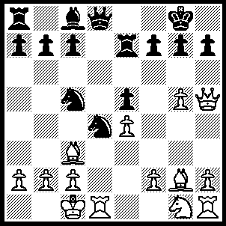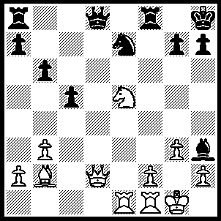
- 2
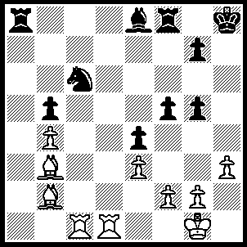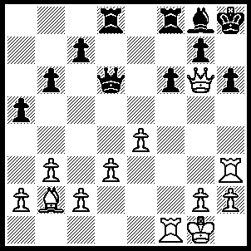
- 4
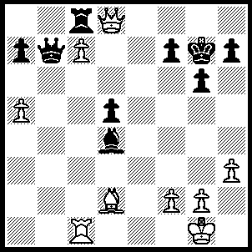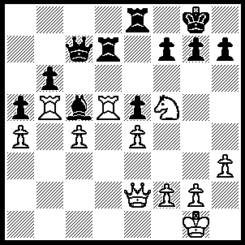
- 6
1---1.Bxd4 exd4 (1…..g6, 2.Bxc5), 2.g6 wins N.
2---1.Qh6 gxh6 (1…..Nf5, 2.Qxh3), 2.Nf7+ Kg8, 3.Nxh6++.
3---1.Rxc6 Bxc6, 2.Rd6 Kh7, 3.R(d)xc6.
4---1.Rxf6 Rxf6 (1…..Bh7, 2.Rxh6 gxh6, 3.Rxf8++ OR 1…..Qe7, 2.Qxh6+ gxh6, 3.Rxh6++), 2.Rxh6+ gxh6, 3.Bxf6+ Qxf6, 4.Qxf6+.
5---1.Qh4 Bxf2+ (1…..Bb2, Or Qb2 Or Rxc7, 2.Bh6+ Kg8, Qd8+ mates), 2.Qxf2 wins B.
6---1.R(b)xc5 bxc5, 2.Rxd7 Qxd7, 3.Qg4 f6, 4.Nh6+ Kf8, 5.Qxd7.

TACTICAL AWARENESS No.14
When you can see that your opponent’s defence appears overloaded it is time to look for the tactics to take advantage of it. Unfortunately such a weakness in your opponent’s game can be hard to spot. Play over the first position and then see if you can solve the rest whose answers are given below.

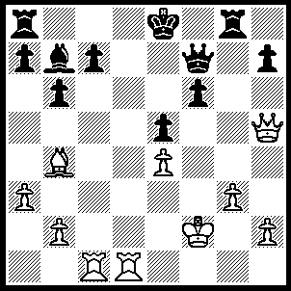
1.Rxc7 Qxh5 (1…..Rg7, 2.Re7+ Kf8, 3.Rxf7+), 2.Re7+ Kf8, 3.Rxb7+ Ke8, 4.Re7+ Kf8, 5.Rxa7+ Ke8, 6.Re7+ Kf8, 7.Rxh7+ Ke8, 8.Re7+ Kf8, 9.Rxe5+ and 10.Rxh5.

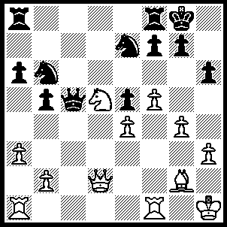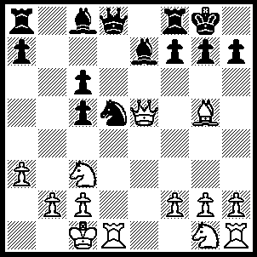
- 2
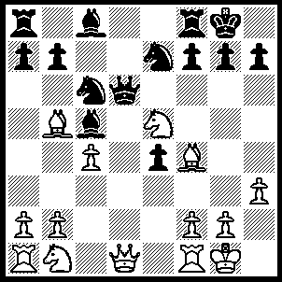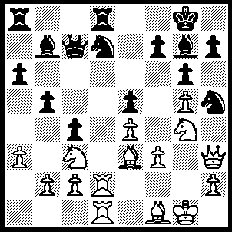
- 4
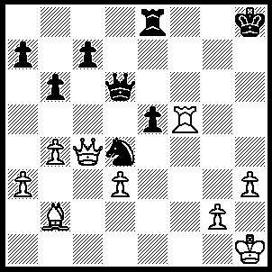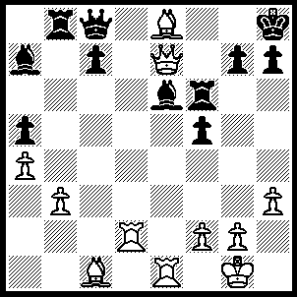
5 6
1---1.Qf2 wins one of the Ns.
2---1.Bxe7 Qxe7, 2.Rxd5 wins a piece.
3---1.Qxd6 Bxd6, 2.Nxc6 bxc6, 3.Bxd6 cxb5, 4.Bxe7.
4---1.Rxd7 Rxd7, 2.Rxd7 Qxd7, 3.Nh6+ Bxh6, 4.Qxd7.
5---1.Rxe5 Rxe5, 2.Qxd4 Qxd4, 3.Bxd4 and 4.Bxe5.
6---1.Rd7 Bxd7 (1…..Rf7, 2.Qxe6 Rxd7, 3.Bxd7 Qf8, 4.Re5 OR 1…..Rg6, 2.Qf8++), 2.Bh6 gxh6, 3.Qxf6+ Kg8, 4.Qf7+ Kh8, 5.Qf8++.

