TACTICAL AWARENESS No.15
By Vern Stannard
Mates by two knights are real a rarity. So play over the first position and have a go at the rest. In the first position Korchnoi missed? (So have the authors of the book I read, and who knows how many more)---2.Nf6+---. Most likely Korchnoi wanted to play for the following two knights mates. After all, two knights mates are so rare they make holes-in-one look commonplace

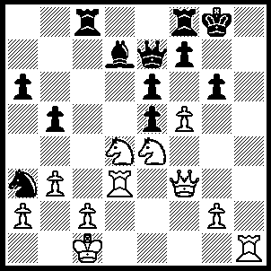
1.Qh5 f6 (1…..Rxc2+, 2.Nxc2 f6, forces 3.Nf6+ mates), 2.Qxg6+ Qg7, 3.Qxg7+ Kxg7, 4.Rg3+ Kf7, 5.Rh7+ Ke8, 6.R(3)g7 Rc7 (6…..Rxc2+, 7.Kd1 Bc8, 8.fxe6 Rd2, 9.Kxd2 Nb1+, 10.Kc1 Rf7, 11.Rxf7 Bxe6, 12.Nd6+ Kd8, 13.Nc6++), 7.Nd6+ Kd8, 8.Rxd7+ Rxd7, 9.Nxe6++.

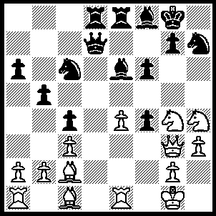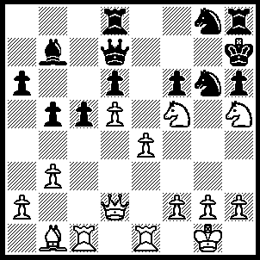
- 2
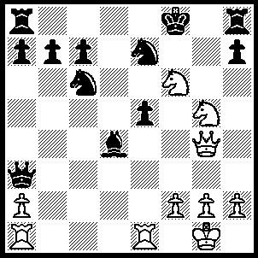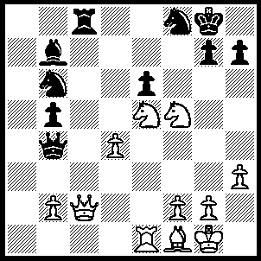
3 4
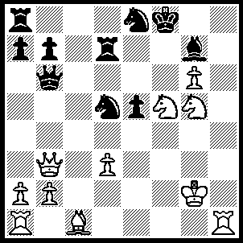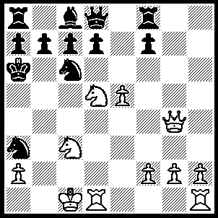
- 6

1---1.Nh6+ Kh8. 2.Ng6++.
2---1.Qxh6+ Nxh6, 2.Nxf6++.
3---1.Qe6 Nd8 (1…..Kg7, 2.Nh5+), 2.Qf7+ Nxf7, 3.Ne6++.
4---1.Qb3 Nd5, 3.Qxb4 Nxb4, 3.Ne7+ Kh8, 4.Nf7++.
5…1.Qxb6+ axb6, 2.Rh8+ Bxh8, 3.Ne6+ Kg8, 4.Nh6++.
6---1.Qa4+ Na5, 2.Qb5+ Nxb5, 3.Nb4+ Kb6, 4.Na4++.
[moves 2 and 3 can be reversed]

TACTICAL AWARENESS No.16
Knights are at their strongest when they can move to an undefended square to attack an opponent’s piece of more value than itself. Play through the first position and then try and solve the following positions. Answers are below.

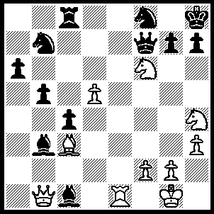
1.Re7 Ba2 (1…..Qxe7, 2.Qxh7+ Nxh7, 3.Ng6++), 2.Qf5 Nd6, 3.Rxf7 Nxf5 (3…..Nxf7, 4.Qxh7+ mates), 4.Nxf5 Bg5 (4…..gxf6, 5.Bxf6+ Kg8, 6.Nh6++), 5.Rxg7 Bxf6, 6.Bxf6 Nd7, 7.Rxd7+ Kg8, 8.Nh6+ Kf8, 9.Rf7+ Ke8, 10.d6 Rd8, 11.Re7+ Kf8, 12.Bg7++.

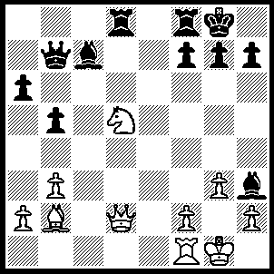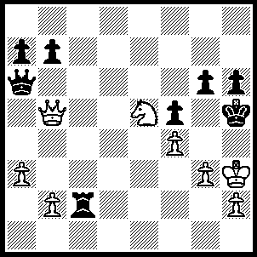
1 2
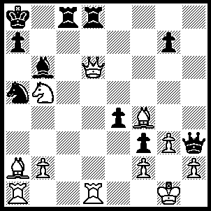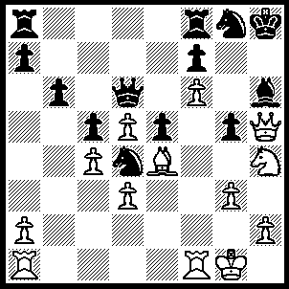
3 4
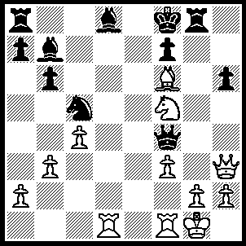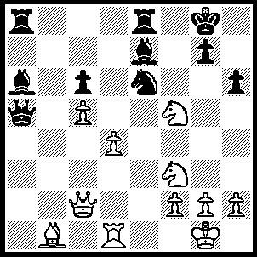
5 6
1---1.Ne7+ Kh8, 2.Bxg7+ Kxg7, 3.Qg5+ Kh8, 4.Qf6++.
2---1.g4+ fxg4+, 2.Nxg4+ g5, 3.Qe8+ Qg6, 4.Nf6++.
3---1.Bd5+ Nb7, 2.Qb8+ Rxb8, 3.Rxa7+ Bxa7, 4.Nc7++.
4---1.Qxf7 Rxf7, 2.Ng6+ Kh7, 3.Nxe5+ Nf5, 4.Bxf5+ Kh8, 5.Nxf7++.
5---1.Rd4 Qc7 (1…..Qxd4+, 2.Nxd4 Rg6 [2…..Bxf6, 3.Qxh6+ Bg7, 4.Qd6+ Ke8, 5.Re1+ Ne4 [[5…..Be4, 6.Nf5]], 6.Rxe4 Nxe4, 7.Qc6+ Ke7, 8.Nf5+], 3.Bxd8 Rxd8, 4.Qh4 Rd7, 5.Qf4 Ne6, 6.Nxe6 Rxe6, 7.Qg3 R(7)e7, 8.Rd1 Bc6, 9.Kf1 Be8, 10.Rd6), 2.Qxh6+ Ke8, 3.Ng7+ Kf8, 4.Ne6+ Ke8, 5.Qf*= Rxf8, 6,Ng7++.
6---1.Nxh6+ Kf8 (1…..gxh6, 2.Qh7+ Kf8, 3.Qh8+ Kf7, 4.Ne5++), 2.Qg6 Nd8 (2…..gxh6, 3.Ne5 mates), 3.Ne5 Qe1+ 4.Rxe1 Bc8, 5.Qf7+ Nxf7, 6.Ng6++.

