TACTICAL AWARENESS No.17
Sacrificing your pieces as battering rams to get at your opponent’s king is often possible when its defenders are absent on other duties or are not defending all points of entry. Play through the first position and then have a go at the others. The answers are given below.

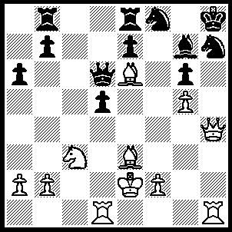
1.Qxh7+ Nxh7, 2.Rxh7+ Kxh7, 3.Rh1+ Bh6, 4.Rxh6+ Kg7, 5.Bd4+ Qe5+, 6.Bxe5+ Kf8, 6.Rh8++.

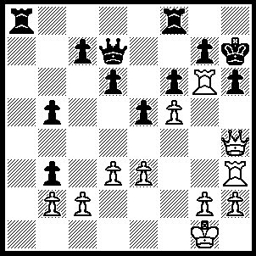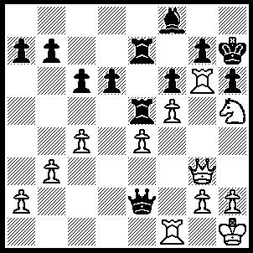
1 2
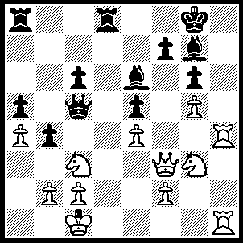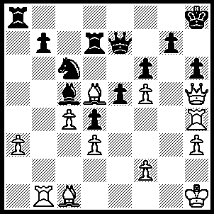
3 4
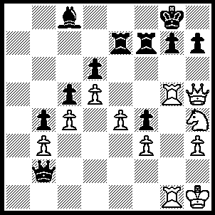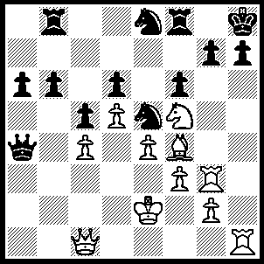
- 6
1----1.Qxh6+ Kg8, 2.Qh7+ Kf7, 3.Rxg7+ Ke8, 4.Rxd7 mates.
2----1.Rxh6+ gxh6 (1…..Kg8, 2.Nxf6+ Kf7, 3.Qg6++), 2.Nxf6+ Kh8, 3.Qg8++.
3----1.Qf6 mates.
4----1.Bxh6 gxh6 (1…..Rxd5, 2.Bxg7+ Kg8, 3.Qh7+ Kf7, 4.Qg6+ Kg8, 5.Rh8++), 2.Qxh6+ Qh7, 3.Qxf6+ Rg7, 4.Rxh7+ Kxh7, 5.Qh4++.
5----1.Qxh7+ Kxh7, 2.Rh5+ Kg8, 3.Ng6 Rf6, 4.Rh8+ Kf7, 5.Rf8++.
6.----Bxe5 dxe5 (1….Rb7, 2.Bxd6), 2.Rxh7+ Kg8, 3.R(7)xg7+ Nxg7, 4.Rxg7+ Kh8, 5.Qh6++.

TACTICAL AWARENESS No.18
Back rank weakness is something you should always be on the lookout for, both your back rank and your opponent’s. Play through the first one which leads to a small but winning advantage.

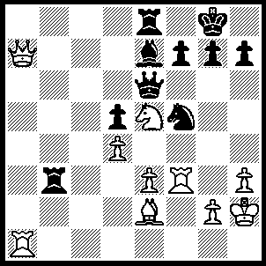
1.Rxf5 Qxf5, 2.Qxe7 Qe6, 3.Qxe6 fxe6, 4.Ra7 g6 (4…..Rxe3, 5.Bh5 Rd8 [5…..g6, 6.Ng4], 6.Bf7+ Kf8, 7.Bxe6 Rd6, 8.Bg8, Re4, 9.Bxh7 Rxd4, 10.Rf7+ Ke8, 11.Rxg7), 5.Bf3 Rc3, 6.Ng4 Rf8, 7.Re7 h5, 8.Nh6+ Kh8, 9.Nf7+ Kg8, 10.Ng5 Rf5, 11.Nxe6 Rxe3, 12.Rg7+ Kh8, 13.Rxg6 Kh7, 14.Rg5, R(5)xf3, 15.gxf3 Rxe6, 16.Rxh5+ Kg7, 17.Rxd5.

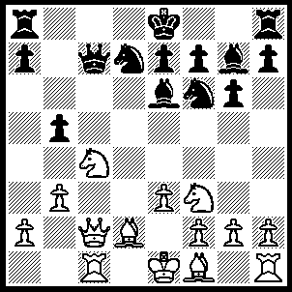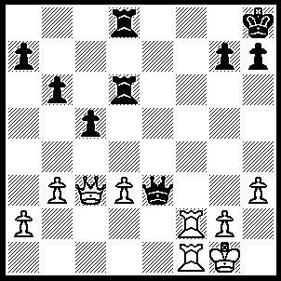
1 2
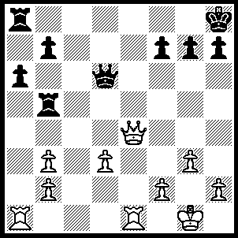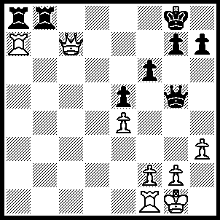
3 4
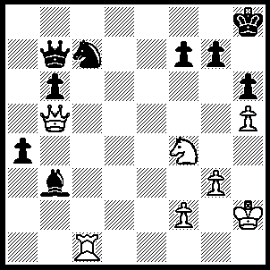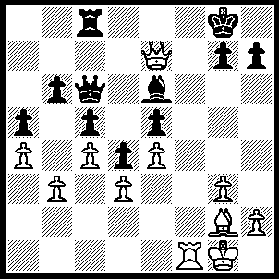
5 6
1---1.Nd6+ wins Q as Qxd6 allows 2.Qc8+.
2---1.Qe5 Qxf2+ (1…..Qxe5, 2.Rf8+ mates), 2.Rxf2.
3---1.Rxa6 bxa6 (1…..R or Qxa3, 2.Qe1+ mates), 2.Qxa8+ Rb8, 3.Re8+ mates.
4---1.Qxf7+ Kh8, 2.Qb7 h6, 3.Rxa8 Rxa8, 4.Qxa8+.
5---1.Rxc7 Qb8 (1…..Qxc7, 2.Qe8+ Kh7, 3.Ng6 Qc8, 4.Nf8+ Kg8, 5.Qxc8), 2.Qc6 Kh7, 3.Rc8 Qxc8 (3…..Qe5, 4.Qg6+ mates), 4.Qxc8 g6, 5.hxg6+.
6---1.Bh3 Kh8 (1…..Bxh3, 2.Qf7+ mates OR 1…..Re8, 2.Bxe6+ Qxe6, 3.Rf8+ Rxf8, 4.Qxe6), 2.Bxe6 Qe8, 3.Qd6 Ra8, 4.Qxe5 h6, 5.Rf7 Qg8, 6.Ra7 Re8, 7.Bxg8 Rxe5, 8.Ra8.

