TACTICAL AWARENESS----final one
And finally here are some positions to test your horse sense. The first two are there to get you into the right gear to tackle the rest.
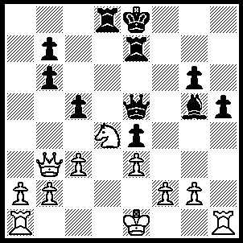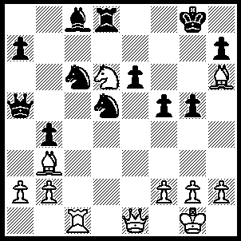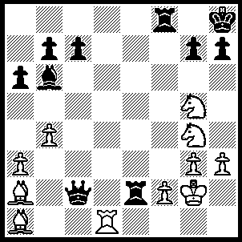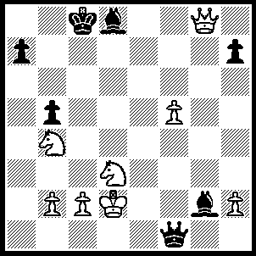
1 2 3 4

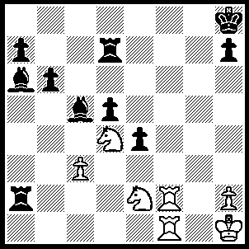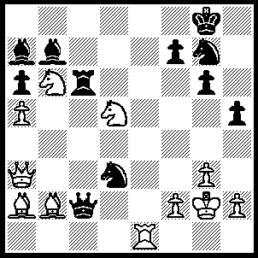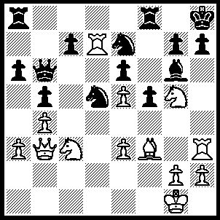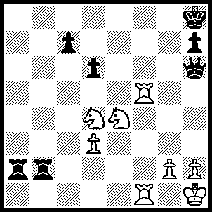
5 6 7 8
1---1.Nc6 bxc6 (1….Qd5, 2.Nxd8), 2.Qg8+ Kd7, 3.0-0-0 Kc7 (3…..Qd5, 4.Rxd5 cxd5, 5.Qxd5+ Ke8, 6.Qxg5), 4.Qxd8+ Kb7, 5.Rd7+ Rxd7, 6.Qxd7+ Qc7, 7.Rd1.

2---1.Nb7 Bxb7 (1…..Qc7, 2.Nxd8 Qxd8, 3.Rxc6 OR 1…..Qb6, 2.Nxd8 Nxd8, 3.Qe5 Kf7 [3…..Qb7, 4.Rxc8], 4.Qg7+ Ke8, 5.Ba4+ Nc6, 6.Rxc6), 2.Qxe6+ Kh8, 3.Bxd5 Rf8, 4.Bxf8 Qxd5, 5.Qf6+ Kg8, 6.Qg7++.

3---1.Nf7+ Kg8 (1…..Rxf7, 2.Rd8+), 2.N(g)h6+ gxh6, 3.Nxh6++.

4---1.Qe6+ Kb7 (1…..Kc7/b8, 2.Na6+ Kb7, 3.N(d)c5+ Ka8, 4.Qc8++), 2.Nc5+ Kc7 (2…..Kh8, 3.N(b)a6+ Ka8, 4.Qc8++), 3.N(b)a6++.

5---1.Rf8+ Bxf8 (1…..Kg7, 2.Ne6+ as in game), 2.Rxf8+ Kg7, 3.Ne6+ Kh6 (3…..Kg6, 4.Nf5+ Kh6, 5.Rf6++), 4.Rf6+ Kh5, 5.Ng3+ Kg4/h4, 6.Rf4+ Kh3, 7.Ng5++.

6---1.Re8+ Nxe8 (1…..Kh7, 2.Rh8+ Kxh8, 3.Qf8+ Kh7, 4.Qxg7++), 2.Qf8+ Kxf8, 3.Nd7+ Kg8, 4.Ne7+ Kh7, 5.Nf8+ Kh6, 6.Ng8+ Kg5, 7.Nh7+ Kf5, 8.Nh6+ Ke4, 9.Ng5++.

7---1.Bxd5 Nxd5, 2.Rxd5 exd5 (2…..f4, 3.Rc5), 3.Nxd5 Qc6, 4.Ne7 Qe8, 5.Qg8+ Rxg8, 6.Nxg6+ Qxg6, 7.Rxh7+ Qxh7, 8.Nf7++.

8---1.Rf8+ Kg7 (2…..Qxf8, 2.Rxf8+ Kg7, 3.Ne6+ Kh6/g6, 4.Rf6+ Kh5, 5.Ng3+ Kg4, 6.Rf4++), 2..R(1)f7+ Kg6, 3.Rf6+ Kh5 (3…..Kg7, 4.Ne6++), 4.Rf5+ Kh4 (4…..Kg6, 5.Rg8+ Qg7, 6.Rg5+ Kf7, 7.R(5)xg7++ OR 4…..Qg5, 5.Rxg5+ Kh4/6, 6.Nf5++), 5..Nf3+ Kg4, 6.h3+ Qxh3_, 7.gxh3+ Kxh3, 8.Rh5+ Kg4, 9.Rh4++.

