FROM THE TOO HARD BASKET 1
By Vern Stannard
Some positions are too long and too complicated for the problem page. I put them in the too hard basket.
Here are some from the too-hard basket.
As usual I have made them all white to move.

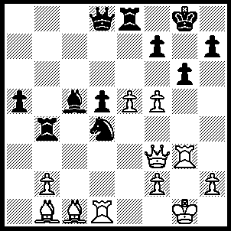1.Rxd4 Bxd4 (1.....Rxd4 fxg6 wins). 2.fxg6 f6 (2.....fxg6 3.Bxg6), 3.Qh5 [I automatically chose 3.gxh7+ before I saw what was played and so had to analyse this to see if it was sound. I found 3.....Kh8 (3.....Kf7,4.Bg6+ Ke6, 5.Bf5+ Kf7, 6.Qh5+ Ke7, 7.Rg7+ Kf8, 8.h8(Q)++), 4.Bh6 Rb7, 5.Qg4 Bxf2+, 6.Kxf2 Rxb2+, 7.Kf3 Rb3+ 8.Kg2 Rxg3+ 9.hxg3 Qe7, 10.Qg6 Rb8, 11.Ba2 Rf8 (11.....Qxh7, 12.Qxf6+ Kg8, 13.Bxd5+), 12.Bxf8 Qxf8, 13.exf6 a4, 14.Bxd5 a3, 15.Qg8+ Qxg8, 16.hxg8++] h6 (the game went 3.....Rb7, 4.g7 resigns. It is amazing how often players freeze and miss best defence where the win is not clear cut) 4.g7 Bxf2+ 5.Kxf2 f5 (5.....Re4, 6.Qxh6 fxe5, 7.Bg5 Qd7, 8.Qh8+ Kf7, 9.Rf3+ Rf4, 10.Qh5+ Kg8, 11.Qh7+ Kf7, 12g8(Q)++), 6.Bxf5 Rb6, 7.Bh7+ Kxh7, 8.Qf7 Rf6+, 9.exf6 Qb6+, 10Kg2 Re2+, 11.Kh3 Rxh2+, 12.Kxh2 Qf2+, 13.Kh3 Qf5+, 14.Kg2 (Qc2+ 15.Bd2) 15.Kf1 Qh1+, 16.Kf2 Qh2+, 17.Kf3 Qh1+, 18.Kg4 Qe4+, 19.Bf4 Qe2+, 20.Rf3 Qg2+, 21.Bg3 wins

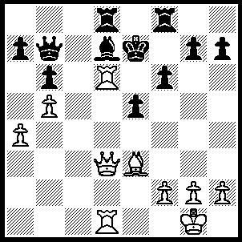1.Bc1 Ke8, 2.Ba3 Qc8 (2.....g6, 3.Qb3 Qc8, 4.Qd5 Rh8, 5.Rxf6 mates OR 2.....h6, 3.Qg6+ Rf7, 4.Qh7 Qc8, 5.Re6+ Bxe6, 6.Qh8+ mates),3.Qd5 [3.Rxd7 Rxd7, 4.Qxd7+ Qxd7, 5.Rxd7 Kxd7, 6.Bxf8 was played] Rf7 (3.....h6 4.Rc1 Qb8, 5.Re6+ Kf7, 6.Rxb6 wins Q OR 3.g6, 4.Rxf6 Rxf6, 5.Qg8 mates), 4.Rc1 Qxc1+ (4.....Qb8, 5.Re6 mates), 5.Bxc1 Rc8, 6.Ba3 Bf5 (6.....Rc7, 7.Rxd7 R(c)xd7, 8.Qa8+ Rd8, 9.Qc6+ R(8)d7, 10.Qc8+ Rd8, 11.Qe6+ mates),7.Re6+ Bxe6, 8.Qxe6+ Kd8, 9.Qxf7 Rc3, 10.Qxa7 Rxa3, 11.Qxb6+ Ke8, 12.Qe6+ Kd8, 13.Qd6+ and 14.Qxa3.

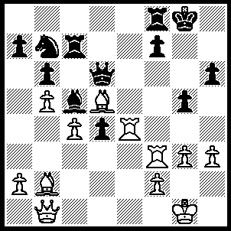
1.Re6 fxe6, (1.....Qxe6, 2.Bxe6 fxe6, 3.Qg6+ Rg7 [3.....Kh8, 4.Bxd4+], 4.Qxe6+ R(7)f7, [4.....R(8)f7, 5.Bxd4 Bxd4, 6.Qe8+ Kh7, 7.Rxf7 OR 4.....Kh8, 5.Bxd4 Rxf3, 5.Qxh6+ OR 4.....Kh7, 5.Rxf8 Bxf8, 6.Qe4+ Kg8, 7.Bxd4]. 5.Rf6 Nd8, 6.Rg6+ Kh8, 7.Rxh6+ Kg8 [7.....Rh7, 8.Qe5+ Kg8, 9.Rg6+ Kf7, 10.Rf6+ Kg8, 11.Qxg5+ Rg7, 12.Rxf8+ Kxf8, 13.Qxd8+], 8.Qd5 Re8 [8.....Nb7, 9.Rg6+ Kh8, 10.Qxg5 Be7, 11.Rh6+ Rh7, 12 Bxd4+ Bf6, 13.Bxf6+ Rxf6, 14.Qxf6+ Kg8, 15.Rg6+], 9.Qxg5+ Rg7, 10.Rh8+ Kxh8, 11.Qh5+ Kg8, 12.Qxe8+ and 13.Qxd8), 2.Qg6+ Kh8 (3.....Rh7, 4.Bxd4+) (the game went 2.....Rg7, 3.Bxe6+ Kh8, 4.Qxh6+ Rh7, 5.Rxf8+ Qxf8, 6.Bxd4+ Bxd4, 7.Qxf8++), 3.Qxh6+ Kg8, 4.Bxe6+ R(8)f7, 5.Rxf7 Rxf7, 6.Qg6+ Kh8, 7.Qh5+ Rh7 (7.....Kg7, 8.Qxf7+ Kh6, 9.Bf5 g4, 10.Bc1+), 8.Qe8+ Kg7 (8.....Qf8, 9.Bxd4+), 9.Qf7+ Kh6, 10.Qf6+ Kh5, 11.Bg4++.

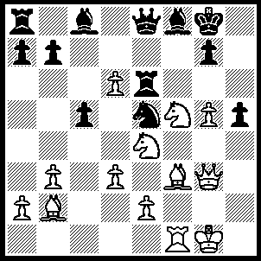1.Bxe5 Rxe5, 2.Bxh5 Qe6 (2.....Qxh5, 3.Qxe5 Bxf5, 4.Rxf5 Re8 [4.....Qg4+, 5.Kf1 Rd8, 6.g6], 5.Qd5+ Kh8, 6.g6), 3.Ne7+ Bxe7, 4.dxe7 [the game went 4.Bf7+ Qxf7, 5.Rxf7 Rxe4, 6.Rxe7 Rg4 7.Re8+ Kf2, 8.Qxg4 Bxg4, 9.Rxa8] Qxe7 (4.....Bd7, 5.Bf7+ Qxf7, 6.Rxf7 Rxe4, 7.Rf8+),5.Nf6+ Kh8, 6.Qh4 gxf6, 7.Bf7+ Kg7, 8.gxf6+ Kxf7, 9.fxe7.

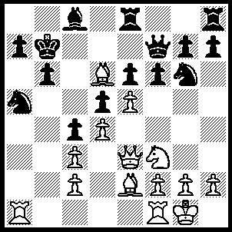 Perth, WA 1952
1.Rxa5 bxa5, 2.Rb1+ Kc6 (2.....Ka6, 3.Bxc5+ dxc4, 4.Qe2), 3.Bxc4 a6, (3.....dxc4, 4d5+ Kd7, 5.Qxa7 mates the game went 3.....Kd7, 4.Bb5+ Kd8, 5.c4 R(e)g8 [5.....Qb7, 6.Qe1 Re7, 7.c5 Rc7, 8.Bd3 Qc6, 9.Qxa5 Rg8, 10.Rb8 Qd7, 11.Bb5 Qf7, 12Ba6, Ke8 [[12.....-Qd7, 13.Rxc8+ Qxc8, 14.Bxc8]], 13Bxc7 OR 5.....Ne7, 6.Bc7+ Kxc7, 7.Qa3 OR 5.....Re7, 6.Qe1 dxc4, 7.Qxa5+ Rc7, 8.Bc6 Nf4, 9.Rb8 Nd5, 10.Bxd5 exd5, 11.e6], 6.Qe1 Qb7, 7.c5 Bd7, 8.Bxd7 resigns), 4.Bb3 Kd7, 5.Ba4+ Kd8, 6.c4 Re7, 7.Qc3 Rc7, 8.Qxa5 Rf8 (8.....dxc4, 9.exf6 exf6, 10.Ng5 fxg5, 11.Qxg5+ Ne7, 12Bxc7+ Kxc7, 13.Qa5+ Kd6, 14.Qe5++),9.Rb8 Nf4, 10.Qa6 dxc4, 11.Bxc7 Qxc7, 12.Rxc8+ Qxc8, 13.Qd6+ Qd7, 14.Qxd7++.

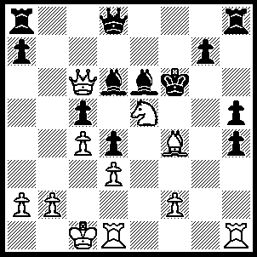
1.Rhg1 Bg4 (1.....Bxe5, 2.Bxe5+ Kxe5 [2.....Ke7, 3.Rxg7+ and 4.Qe6 mates]3.R(d)e1+ mates OR 1.Qc7, 2.Bg5+ and 3.Qe4++] 2.Nxg4+ hxg4, 3.Rxg4 Rh5 (3.....Rc8, 4.Be5+ Kf5 [4.Kxe5, 5.Re1+ mates OR 4.Ke7, 5.Rg7+ Ke6 (5.....Kf8, Qf3+ mates), 6.Qd5+ Kf5, 7.Bxd3 mates],5.Qe4+ Ke6, 6.Qd5+ Kf5 [6.....Kd7, 7.Rxg7+ mates], 7.Bxd6+ Kxg4, 8.Rg1+ mates), 4.Bxd6 Qe8 (4.....Rc8, 5.Be5+ Kf7 [5....Kxe5, 6.f4+ Kf5, 7.Qg6+ Kxf5, 8.Qe4++ OR 4.....Kf7, 5.Qf3+ Ke8 (5.....Ke6, 6.Rg6+ Kd7, 7.Qb7 mates), 6.Re1+ Kd7, 7.Qb7+ Kxd6, 8.Rg6+ Qf6, 9.Qe7+ Kc6, 10.Re6+ Qxe6, 11.Rxe6++], 6.Rxg7+ Kf8, 7.Qf3+ mates0, 5.Be5+ Kf5, 6.Rf4+ Kxe5, 7.Qc7+ Ke6, 8.Re1+ Re5, 9.Rxe5++.

An easy one? to fill the page.
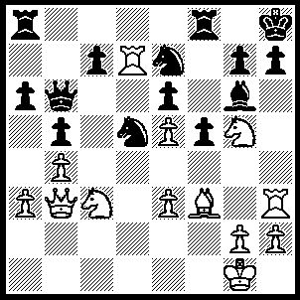
Composed 1951
1.Bxd5 Nxd5, 2.Rxd5 exd5, 3.Nxd5 Qc6, 4.Ne7 Qe8, 5.Qg8+ Rxg8, 6.Nxg6+ Qxg6, 7.Rxh7+ Qxh7, 8.Nf7++.

.

