FROM THE TOO HARD BASKET 2
By Vern Stannard
In the following position GMs pointed out that Nigel Short missed playing 1.gxh5 Nxh5, 2.Rxf7 Rxf7, 3.Rxf7 Kxf7, 4.Qxf6+ Kf8, 5.Qh6+ Ng7, 6.Bg6 mates. The almost infinite variety of variations in this position could be beyond over the board play and to play 1.gxh5 would have to be pure instinct . Who would back their instinct against Kasparov in such complications.

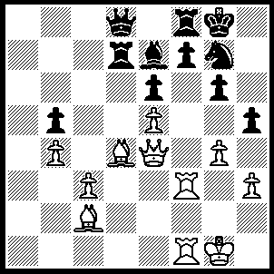Short-Kasparov April 1996
1.gxh5 Bxb4 (1.....Nf5, 2.hxg6, Nxd4 [2.....fxg6, 3.Bb3 Rd5, 4.Bxd5], 3.gxf7+ Rxf7, 4.Rxf7 Nf5, 5.Qg2+ Kxf7 [5.....Bg5, 6.Rxd7], 6.Rxf5+ exf5, 7.Bb3+ Rd5, 8.Bxd5+ Ke8, 9.Qg6+ and 10.Qc6++),2.hxg6 Nf5 (2.....Qg5+, 3.Kh1 Qxg6, 4.Qe2 Qg5 [4.....Qh5, 5.Qxb5 Rxd4, 6.cxd4 Be7, 7.Qb7], 5.Rg1 Qh6 [5.....Qh4, 6.R(3)g3 f5, 7.exf6 Rxf6, 8.Bxf6 Qxf6, 9.Rg6 OR 5.....Qh5, 6R(3)g3], 6.Be3 Qh4, 7.Rg4 Qh5 [7.....Qh8, 8.Qxb5], 8.Rxg7+ Kh8 [8....Kxg7, 9.Rg3+ Qg6, 10.Bxg6], 9.R(3)g3 Rd1+ [9.....Qh4, 10.Qg4 Rd1+, 11.Bg1 Rxg1, 12.Rxg1 Qxg4, 13.Rh7+ Kg8, 14.Rxg4++], 10.Bg1 Qh6 [10.....Rxg1, 11.Rxg1], 11.Rh7+ Qxh7, 12.Bxh7), 3.g7 my instinct at work again Re8 (3.....Kxg7, 4.Qg4+Kh6, 5.Be3+ Kh7, 6.Rxf5 exf5, 7.Qxf5+ and Qh7++), 4.Be3 Ba3 (4.....Bxc3 5.Rxf5 exf5 [5.....f6, 6.exf6 Bxf6, 7.Rxf6 Rxg7+, 8.Rg6 Qe7, 9.Bh6 Rxg6, 10.Qxg6+], 6.Qxf5 Qh4, 7.Qxd7 Re7, 8.Qd8+ Kxg7, 9.Bh6+ Qxh6 [9.....Kxh6, 10.Qh8+ Kg5 11.Qg7+ Kh5, 12.Rf5+ Qg5, 13.Qxg5++], 10.Qxe7 Qe6, 11.Qxe6 fxe6, 12.Rf6), 5.Rxf5 exf5, 6.Qxf5 Qh4 (6.....Kxg7, 7.Bh6+ Kxh6, 8.Qh7+ Kg5, 9.Rf5++), 7.Qxd7 Re7, 8.Qd8+ Kxg7, 9.Rf2 Qxh3, 10.Rg2+ Qxg2, 11.Kxg2.

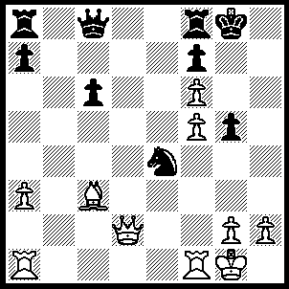1.Qd1 Rd8 (1.....Nxc3, 2.Qh5 Ne4, 3.Qh6 Nxf6, 4.Qxg5+ Kh7, 5.Rf4 mates OR 1.....Qd8, 2.Qh5 Qb6+, 3.Kh1 c5, 4.Qh6 Nxf6, 5.Qxg5+ Kh7, 5.Rf4 mates), 2.Qg4 Rd3 (2.....Rd6, 3.R(a)e1 Qf8, 4.Rxe4 Qh6, 5.Qg3), 3.Rf4 Qf8, 4.Rxe4 Qh6, 5.Bb4 Qxf6, 6.R(1)e1 R(3)d8, 7.Be7 Qh6, 8.Bxg5 Qg7, 9.Bxd8 Qxg4 (9.....Rxd8, 10.Re8+ Rxe8, 11.Rxe8+ Kh7, 12.Qh5+ Qh6, 13.Qxf7+ Qg7, 14.Qh5+ Qh6, 15.Re7+ mates), 10Rxg4+ Kf8 (10.....Kh7, 11.Bf6 mates), 11.Be7+ Ke8, 12.Bc5+ Kd8, 13.Rg8+ Kg7, 14.Re7++.

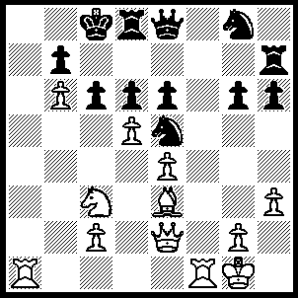Perth WA, 1952
1.Rf8 Qxf8 (1.....Qe7, 2.Ra8+ Kd7, 3.dxe6+ wins), 2.dxe6 Nd7 (2.....Kb8, 3.Qd1 Nd7, 4.exd7 mates), 3.Ra8+ Nb8, 4.Qc4 Rf7 (4.....Qf6, 5.Nb5 Re8 [5.....Rf8,.Na7+ Kd8, 7.Rxb8+ Ke7, 8.Rxb7+ Kd8 [8.....Ke8, 9.Qxc6+] 9.Rb8+ Ke7, 10.Nxc6++], 6.Nxd6+ Kd8, 7.Rxb8+ Ke7, 8. Rxe8+Kxd6, 9.Qc5++ OR 4.....Nf6, 5.Rxb8+ Kxb8, 6.Qa4 Nd7, 7.exd7 mates), 5.Nb5 Rf1+ (5.....Re8, 6.Na7+ Kd8, 7.Rxb8+ Ke7, 8.Rxb7+ Kf6, 9.Rxf7+ wins),6.Kh2 Ra1, 7.Na7+ Rxa7, 8.bxa7 Kc7, 9.Bb6+ Kxb6, 10.Qb4+ Kc7, 11.Qa5+ b6, 12.axb8(Q)+ Rxb8, 13.Qa7+ Rb7, 14.Qxb7+ Kxb7, 15.Rxf8 Ne7, 16.Rf7 and 17.Rxe7.

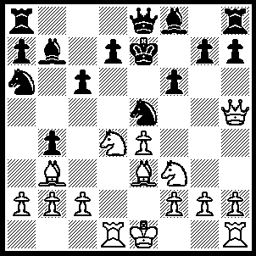1.Qxe5+ Kd8 (1.....fxe5, 2.Bg5+ Kd6, 3.Ne6++), 2.Qa5+ Kc8 (2.....Ke2, 3.Nf5++), 3.Ne6 g6 (3.....dxe6, 4.Bxe6+ Kb8, 5.Bf4+), 4.0-0 Be7, 5.Nc5 Bxc5 (5.....Bd8, 6.Nxb7 Bxa5, 7.Nd6+ and 8Nxe8), 6.Bxc5 Qxe4 (6.....Nxc5, 7.Qxc5 Qxe4, 8.Qd6 Rd8, 9.R(f)e1 Qg4, 10.Be6), 7.R(f)e1 Qf5 (7.....Qg4, 8.Rxd7),8.Bxb4 Nxb4, 9.Qxb4 c5, 10.Qa4 Bxf3 (10.....Bc6, 11.Qxc6 and 12.Be6), 11.gxf3 Qg5+, 12.Kf1 Qf5, 13.Be6.

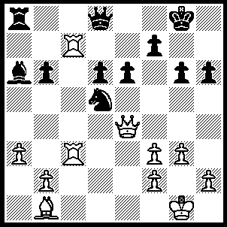1.Rxf7 Kxf7 (1.....Qg5, 2.Qxe6 wins), 2.Qxg6+ Kf8 (2.....Ke7, 3.Qg7+ and 4,Bg6++), 3.Qxh6+ Kf7 (3.....Ke8, 4.Qxe6+ Kf8 [4.....Ne7, 5.Bg6 mates OR 4.....Qe7, 5.Qg8+ Qf8 6.Qxd5 Ra7, 7.Qe6+], 5.Qxd5 wins), 4.Bg6+ Kf6, 5.Bh7+ Ke5 (5.....Kf7, 6.Qg6+ Kf8, 7.Qg8+ Ke7, 8.Qg7+ Ke8, 9.Bg6++), 6.Qh5+ Kd4 (6.....Kf6, 7.Qg6+ Ke5, 8.f4+ Kd4, 9.Qe4++), 7.Qg4+ Ke5, 8.f4+ Kd4, 9.Qd1+ Bd3, 10.Qxd3++.

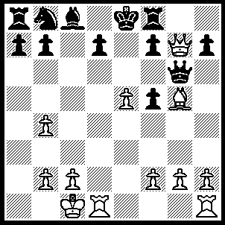1.e6 d5 (1.....Qxg7, 2.exd7+ Bxd7, 3.R(h)e1+ Be6, 4.Rd8++), 2.Rxd5 Nc6 (2.....f6, 3.Rd8+ Kxd8, 4.Qxf8+ Kc7, 5.Bf4+ Kb6, 6.Qc5+ Ka6, 7.Qa5++), 3.exf7+ [3.e7 Qxg5+, 4.Qxg5 wins material] 3.....Qxf7 (3.....Rxf7, 4.Re1+ Be6, 5.Rxe6+ Qxe6 [5.....Ne7, 6.Rxe7+ Rxe7, 7.Qxe7++], 6.Qg8+ Rf8, 7.Qxe6++ Ne7, 8.Qxe7++), 4.Re1+ Be6, 5.Qh6 Ne7 (5.....Qg6, 6.Rxe6+ Kf7, 7.Rxg6 hxg6, 8.Qh7+ Ke8, 9.Qd7++), 6.Rxe6 Rg8, 7.Rxe7+ Qxe7, 8.Bxe7 Kxe7, 9.Qd6+ Kf7, 10.Rxf5+ Ke8, 11.Re5+ Kf7, 12.Re7+ Kf8, 13.Qf6++.
An easy one? to finish off
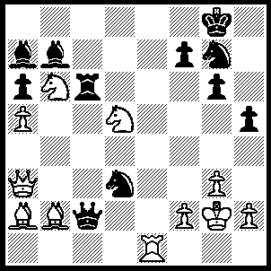
Composed V. Stannard 1953
1.Re8+ Nxe8, [1.....Kh7 2.Rh8+] 2.Qf8+ Kxf8, 3.Nd7+ Kg8, 4.Ne7+ Kh7, 5.Nf8+ Kh6, 6.Ng8+ Kg5, 7.Nh7+ kf5, 8.Nh6+ Ke4, 9.Ng5++.

.

