FROM THE TOO HARD BOX 4
By Vern Stannard
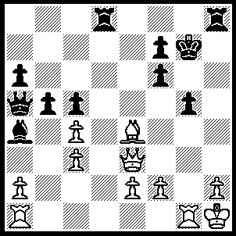1.Rxg5+ fxg5 (1.....Kf8, 2.Qxc5+ Ke8, 3.Bc6+ Rd7, 4.Bxd7+ Kxd7, 5.Rd5+ Ke8, 6.Qc8+ Ke7, 7.Rd7+ Ke6, 8.Rd8+ Ke5, 9.Rd5+ Ke4, 10.Qf5++), 2.Qxg5+ Kf8 (2.....Kh6, 3.Qf6+ Kh4, 4.Bf3++), 3.Qxc5+ Kg7 (3.....Ke8, 4.Bc6+ Rd7, 5.Qe5+ Kd8, 6.Qxh8+ and 7.Bxd7), 4.Qe5+ Kf8, 5.Qxh8+ Ke7, 6.Qe5+ Kd7 (6.....Kf8, 7.Qc5+ Kg7, 8.Rg1+ Kf6, 9.f4 Re8, 10.Qd6+ Re6, 11.Rg6+ fxg6, 12.Qf8++), 7.Bf5+ Kc6, 8.Qe7 bxc4, 9.Be4+ Rd5 (9.....Kb5, 10.Rb1+ Bb3, 11.Qe5+ Kb6, 12.Qf6+ mates), 10.Qxf7 and 11.Qxd5+.
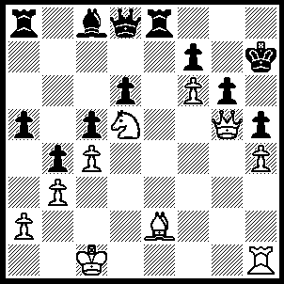1.Bxh5 Re5 (1.....Bf5, 2.Bxg6 fxg6+ fxg6, 3.h5 Kg8, 4.hxg6), 2.Ne7 Rxe7 (2.....Rxg5, 3.hxg5 Qxe7, 4.fxe7 Bb7, 5.Bf3+ Kg7 6.Bxb7), 3.Bxg6+ fxg6 (3.....Kg8, 4.Bh7+), 4.h5 R(8)a7 (4.....Kg8, 5.hxg6 OR 4.....Qf8, 5.hxg6+ Kg8, 6.Qh4 OR 4.....Qe8, 5.hxg6, Kg8, 6.f7+ Rxf7 gxf7+ Kxf7, 8.Rh7+ Ke6, 9.Qe3+), 5.hxg6+ Kg8, 6.f7+ Rxf7 (6.....Kg7, 7.Rh7+ Kf8, 8.Qh6++), 7.Qxd8+ Rf8 (7.....Kg7, 8.gxf7 Rxf7, 9.Qg5+ Kf8, 10.Rh8++), 8.Rh8+ Kg7 (8.....Kxh8, 9.Qf8++), 9.Qxf8+ Kxg6, 10.Rh6+ Kg5, 11.Qf6+ Kg4, 12.Rh4+ Kg3, 13.Qf4+ Kg2, 14.Rh2+ mates.

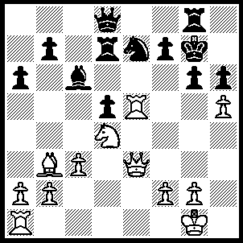1.Re1 Nc8 (1.....Nf5, 2.Rxf5 gxf5, 3.Nxf5+ OR 1.....Re8, 2.hxg6 Kxg6, 3.Bc2+ Kg7 [3.....Kf6, 4.Qxh6+ Ng6, 5.Rf5++], 4.Rxe7 R(8)xe7, 5.Nf5+), 2.hxg6 Nd6 (2.....Qf6, 3.Nf5+ Qxf5, 4.Rxf5 OR 2.....Kxg6, 3.Bc2+ Kg7, 4.Nf5+ Kf8, 5.Re8+ Qxe8, 6.Qxe8++), 3.gxf7 Kxf7, 4.Rxd5 Bxd5, 5.Bxd5+ Kg6 6.Qd3+ Kf6(6.....Kg5, 7.Qg3+ Kf6, 8.Re6+ Kf7, 9.Rg6+ Kf8, 10.Rxg8+ Ke7, 11.Qh4++ OR 6.....Kh5, 7.Re5+ Rg5, 8.Bf3+ Kh4, 9.Re4+ Rg4, 10.Rxg4+ Kh5, 11.Qg6++), 7.Re6+ Kf7 (7.....Kg7, 8.Rg6+ Kh8, 9.Rxh6+ Kg7, 10. Qg6+ Kf8, 11.Qxg8+ Ke7, 12.Re6++), 8.Rg6+ Kf8 (8.....Ke7, 9.Qe3+ Ne4, 10.Qxe4+ Kf8, mates), 9.Rxg8+ Ke7, 10.Qe3+ Ne4, 11.Nf5+ Kf6, 12.Qxh6+ Kxf5, 13.Qe6+ Kf4, 14.Rg4++.
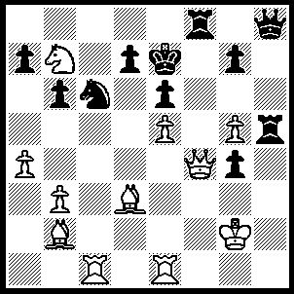1.Qf6+ gxf6 (1.....Rxf6, 2.exf6+ Kf7 [2.....Ke8, 3.Nd6+ Kd8, 4.Nf7+],3.g6+ Kg8, 4.f7+ Kf8, 5.Ba3+ Rc5 [5..... Ne7, 6.Rc8++],6.Bxc5+ bxc5, 7.Rh1), 2.exf6+ Ke8 (2.....Kf7, 3.Nd6+ Kg8, 4.f7+ Rxf7, 5.Bxh8), 3.Bg6+ Rf7, 4.Bxh5 Qxh5 (4.....Qg8, 5.Rxc6 dxc6, 6.Rd1 mates), 5.Rh1 Qg6, 6.Rh8+ Rf8, 7.Nd6+ Kd8, 8.Rxf8+ Kc7, 9.Be5 b5, 10.b4 bxa4 (10.....Kb6, 11.Rb8+ Nxb8, 12.Bd4+ Ka6, 13.axb5++ OR 10.....a6, 11.Rc8+ Kb6, 12.Rb8+ Ka7 [12.....Kc7, 13.Ne8++], 13.Nc8++ OR Qe4+, 11.Nxe4+ d6, 12.Nxd6 Kd7, 13.Nb7 Nxe5 [13.....bxa5, 14.Nc5++].14.Rd8++), Rc8+ Kb6, 12.R(1)xc6 dxc6, 13.Bd4+ c5, 14.Bxc5+ Ka6, 15.Rc6++.

Nigel Short had no problems with the next position.
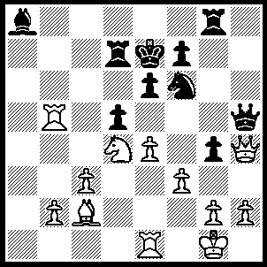1.Nf5+ exf5 (1.....Kf8, 2.Qxf6 OR 1....Kd8, 2.Rb8+ Kc7, 3.Qg3+ Kc6, 4.Ba4+ Kc5, 5.Qf2+ OR 1.....Ke8, 2.Rb8+ Rd8, 3.Ba4+ Kf8, 4.Rxd8+ mates), 2.exf5+ Kf8, (2.....Kd6, 3.Qxf6+ Kc7, 4.Qb6+ mates OR 2.....Kd8, 3Qxf6+ Ke8, 4.Rc5+ Kc8, 4.Rc5+ Rc7, 5.Qa6+ Bb7, 6.Rxc7+ Kxc7, 7.Re7+ Kd8, 8.Qd6+ mates), 3.Qxf6 Bb7, 4.Rxb7 Rxb7, 5.Qd8+ Kg7, 6.f6+ Kh6 (6.....Kh8, 7.Qxg8+ mates), 7.Qxg8 wins.

No problems for Kasparov with the following position.
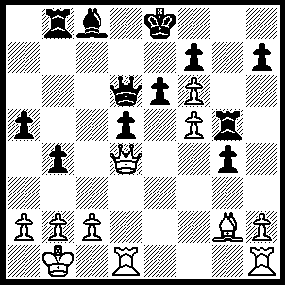1.Bxd5 Bd7 (1.....exd5, 2.Qe3+ and 3.Qxg5 OR 1.....Qxd5, 2.Qf4), 2.R(h)e1 Rc8 (2.....Rxf5, 3.Bxe6 OR 2.Kf8, 3.Qe3 h7, 4.Bxe6 OR 2.....Kd8, 3.Bxe6 Qxd4, 4.Rxd4 Rb7, R(1)d1 fxe6, 6.fxe6 Rf5, 7.f7 Ke7, 8.exd7 Kd8, 9.Rxg4 Rxd7, 10.Rg8+ Ke7, 11.Rxd7+ Kxd7, 12f8Q), 3.fxe6 Bxe6, 4.Qa7 Qc5 (4.....Rc7, 5.Qa8+ Kd7, 6.Bxe6+ OR 4.....Qc7, 5.Bc6+ Kf8, 6.Qxc7), 5.Bc6+ Kf8 (5.....Rxc6, 6.Qd7+ mates OR 5.....Qxe6, 6.Qe7++), 6.Qc7 Re8, 7.Rd8 wins.
As their opponents resigned almost immediately the beauty of their attack remained hidden to all but those analysing them.

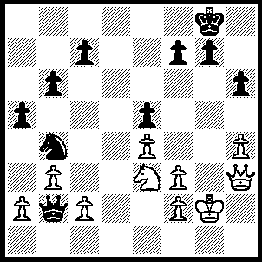1.Qc8+ Kh7, 2.Nf5 Nd5 (2.....Kg6, 3.Ne7+ Kf6 [3.....Kh5, 4.Qg4++], 4.Ng8+ Kg6, 5.Qf5++ OR 2.....g6, 3.Nxh6 g5 [3.....Kxh6, 4.Qh8++ OR 3.....Kg7, 4.Qg8+ Kf6, 5.Qxf7++], 4.Qg8+ Kxh6, 5.Qh8+ Kg6, 6.h5++), 3.exd5 Qa3, 4.d6 g6, 5.Nxh6 g5, 6.hxg5 Kg6, 7.Qg8+ Kh5, 8.Nxf7 Qxd6, 9.Qh7+ Qh6, 10.Qxh6++.

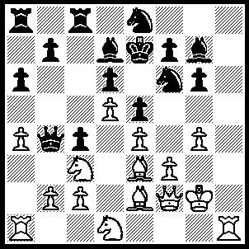
1Ra3 R(a)b8 (1.....Qa5, 2.Bb6 Qb4, 3.Qe3 Rc5, 4.a5 R(c)c8, 5.Qc1 traps Q OR 1.....Rc5, 2.Bxc5 dxc5 [2.....Qxc5, 3.Qxc5 dxc5, Ne3], 3.Na2 Qa5, 4.Ne3), 2.a5 Nc7, 3.Na2 Qb5, 4.N(1)c3 Qxb2, 5.Bc1 Qxc2, 6.Nb4 Qb3, 7.Rxb3 cxb3, 8.Bb2.

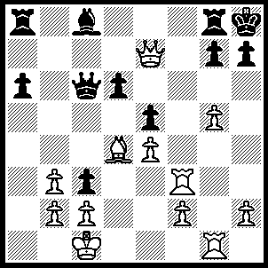
1.g6 h6 (1.....hxg6, 2.Qh4++ OR 1.....Qxe4, 2.Qxg7+ Rxg7 [2.....Kxg7, 3.Rf7+ K moves, 4.Rh7++], 3.Rxf8+ Rg8, 4.g7++), 2.Rf7 Bh3, 3.Qh4 cxb2+ 4.Kb1 R(g)e8, 5.Be3 R(a)c8, 6.c4 Bf5, 7.exf5 Qf3, 8.Rxg7 Qxf5+, 9.Kxb2 Kxg7, 10.Bxh6+ Kg8, 11.Bg7 Kxg7, 12.Qh7+ Kf8, 13.g7+ Ke7, 14.Qxf5.

