FROM THE TOO HARD BOX 5
By Vern Stannard
All White to play
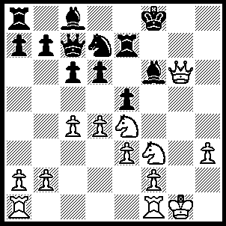1.Nxf6 Nxf6 (1.....Rg7, 2.Qxg7+ Kxg7, 3.Ne8+ and 4.Nxc7), 2.Qxf6+ Rf7 (2.....Kg8, 3.Kh2 Rf7 [3.....Rg7, 4.Rg1 Bxh3, 5.Rxg7+ Qxg7, 6.Rg1 Bg4, 7.Qxg7+ and 8.Rxg4+], 4.Rg1+ Kf8, 5.Qh8+ Ke7, 6.Rg7 Rxg7 [6.....Qd7, 7.R(1)g1 Qxh3+, 8.Qxh3 Bxh3, 9.Rxf7+ Kxf7, 10.Kxh3 OR 6.....Qb6, 7.Rxf7+ Kxf7, 8.Rg1 Bg4, 9.Qh7+ Kf6, 10.Rxg4], 7.Qxg7+ Kd8, 8.Qf8+ Kd7, 9.Rg1) , 3.Qh8+ Ke7, 4.Ng5 Rf5, 5.Qg7+ Kd8, 6.Qg8+ Ke7, 7.dxe5 d5 (7.....b5 8.c5 d5, 9.e4 Rf4 [9.....dxe4, 10.Qg7+ Kd8, 11.R(a)d1+], 10.exd5 cxd5, 11.Qxd5 Rb8, 12.Qd6+ Qxd6, 13.cxd6+ Ke8, 14.e6 OR 7.....Rxe5, 8.Qg7+ Kd8, 9.Nf7+ Ke8, 10.Qg7+ Ke7, 11.Nxe5 OR 7.....dxe5, 8.Qg7+ Kd8, 9.R(a)d1+ Bd7, 10.Ne6+), 8.e4 Rf4, 9.Qg7+ Kd8, 10.Qh8+ Ke7, 11.exd5 cxd5, 12.cxd5 Qc4, (12.....Qc5, 13.Qg7+ Kd8, 14.d6 Bd7, 15.Ne6+ Kc8 [15.....Bxe6, 16.Qg7+ mates], 16.Qg8+ mates), 13.d6+ Kd7, 14.Qg7+ Kc6, 15.R(a)d1.

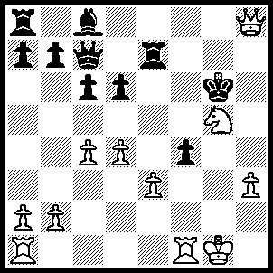1.Rxf4 Bf5 (1.....Kxg5, 2.Qf6+ mates OR 1.....Rg7, 2.Rh4 Kf6 [2.....Kxg5, 3.Rf1 OR 2.....Kf5, 3.Rf1++ OR 2.....Qe7, 3.Qh6+ Kf5, 4.Rf1++], 3.Qh6+ Rg6, 4.Qf8+ Kxg5, 5.Qf4++), 2.Qh4 Rf8 (2.....Rxe3, 3.Rxf5 Kxf5, 4.Qg4+ Kf6, 5.Rf1+ Kg7, 6.Nf7+ Kf8, 7.Nxd6+ Ke7, 8.Rf7+ Ksd6, 9.Qf4+ Re5, 10.Qxe5++), 3.Qg3 Rg7, (3.....Qa5, 4.b4 Qxb4, 5.Nh7+ Kf7, 6.Rxf5+ and 7.Rxf8+), 4.R(1)f1 R(7)g8, 5.Ne4+ Kf7, 6.Rxf5+ Ke7, 7.Rg5 Rxf1+ 8.Kxf1, Rxg5, 9.Qxg5+ Kd7, 10.Qg7+
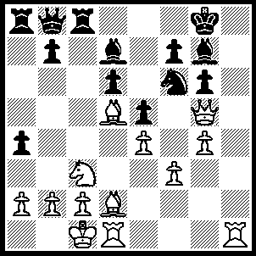1.Qxg6 Nxd5 (1.....Be6, 2.Bxe6 fxe6, 3.g5 Ne8, 4.Qxe6+ Kf8, 5.Nd5 Rc7, 6.Bb4 Ra6, 7.Nf6 Bxf6 [7.....Nxf6, 8.gxf6 Qe8, 9.fxg7+ mates], 8.gxf6 Nxf6, 9.Qxf6+ Ke8, 10.Rh8+ Kd7, Rxd6 mates), 2.Qh7+ Kf8, 3.Bh6 Nf6 (3.....Nxc3, 4.Qxg7+ Ke7, 5.Bg5+ mates OR 3.....Ke8, 4.Qg8+ Ke7, 5.Nxd5+ Ke6, 6.Qh7 f6, 7.Qf5+ Kf7, 8.Qxd7+ mates OR 3.....Ke7, 4.Nd5+ Kd8, 5.Bg5+ f6, 6.Qxg7 mates), 4.Qxg7+ Ke7, 5.Nd5+ Nxd5, 6.Bg5+ Nf6 (6.....Ke6, 7.exd5++), 7.Qxf6+ Kf8, 8.Rh8++.

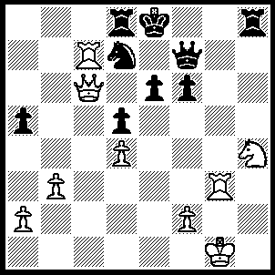1.Nf5 exf5 (1.....Kf8, 2.Qd6+ Ke8, 3.Ng7+ OR 1.....Qh7, 2.Qxe6+ Kf8, 3.Qd6+ Ke8 [3.....Kf7, 4.Qe7++], 4.Re3+ Kf7, 5.Rxd7+ Rxd7 [5.....Kg6, 6.Qg3+ Kxf5, 7.Rf3+ Ke6, 8.Qd6++], 6.Qe6+ Kg6 [6.....Kg8, 7.Qe8++], 7.Rg3+ Kh5, 8.Qe2++),2.Re3+ Kf8 (2.....Qe7, 3.Qxd5 f4, 4.Rxe7+ Kxe7, 5.Qxa5 Kd6, 6.Ra7), 3.Qd6+ Kg7, 4.Rg3+ Qg6 (4.....Kh7, 5.Rc1 Qh5 [5.....Kh6, 6.Rh1+ Qh5, 7.Qf4+ mates], 6.Qe7+ mates), 5.Rxd7+ Rxd7, 6.Qxd7+ Kh6, 7.Qh3+ Qh5, 8.Qxh5+ Kxh5, 9.Rh3+ and 10.Rxh8.

The following position was arrived at as follows---
1.e4 Nf6, 2.e5 Nd5, 3.Nc3 e6, 4.d4 Nxc3, 5.bxc3 d5, 6.f4 Be7, 7.Nf3 0-0, 8.Bd3 c5, 9.0-0 Nc6, 10.Be3 Bd7, 11.Kh1 c4, 12.Be2 Qc7, 13.h4 Ba3, 14.Qe1 Ne7, 15.g4 R(f)e8, 16.Rg1 Nc6, 17.Rg2 a6, 18.Rb1 b6, 19.Qg3 R(a)c8, 20.f5 Ra8, 21.Bg5 h6,
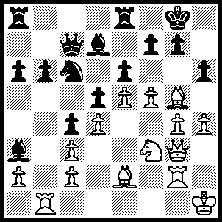22.f6 gxf6 (22.....hxg5, 23.hxg5 gxf6, 24.gxf6 Nxd4 [24.....Ne7, 25.Qh3 Ng6, 26.Rh2], 25.cxd4 Be7, 26.Qh3 Bxf6, 27.exf6 Qf4, 28.Ne5 Qxf6, 29.Nxd7), 23.Bxf6 Kh7 (23.....Ne7, 24.g5 Nf5, 26.gxh6+ Nxg3+, 27.Rxg3+ Kh7, 28.Ng5+ Kxh6 [28.....Kg6, 29.h5+ Kf4, 30.Rf1++], 29.Nxf7+ Kh7, 30.Rg7++), 24.Ng5+ Kg8, 25.Qe3 Be7, (25.....Bf8, 26.Bd3 cxd3, 27.Qxd3 hxg5, 28.hxg5), 26.Bd3 Bxf6 (26.....cxd3, 27.Qxd3 hxg5, 28.hxg5, Bxf6, 29.gxf6 Ne7, 30.Qh3), 27.Bh7+ Kg7 27.....Kf8, 28.,exf6 R(e)c8, 29.Nf3 e5 [29.....Ke8, 30.Qxh6 Kd8, 31.Qf8+ Be8, 32.Bg8 Qf4, 33.Bxf7 Qxf3, 34.Bxe8 Kc7, 35.Qf7+ Kb8, 36.Rxb6++], 30.Qxh6+ Ke8, 31.Re1 Be6, 32.dxe5 Kd7, 33.Bf5 Rh8, 34.Bxe6+ Kxe6, 35.Ng5+ Kd7, 36.e6+ fxe6, 37.Qg7+ Kd6, 38.Rxe6+ Kc5, 39.Qxc7), 28.exf6+ Kxf6, 29.Rf2+ Ke7, 30.Nxf7 Bc8 (30.....Rf8, 31.Qxh6 Rxf7, 32.Qg5+ Ke8, 33Rxf7 Kxf7, 34.Rf1+ Ke8, 35.Bg6++), 31.Nxh6 Kd8, 32.Bg6 Qe7, 33.Bxe8 Kxe8, 34.Rxb6 Nd8, 35.Ng8 Qg7, 36.Nf6+ Ke7, 37.Qe5 Qg6, 38.Nxd5+ Ke8, 39.Nc7+ Ke7, 40.Qd6++
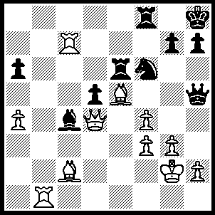1R(1)b7 Rg8 (1.....Be2, 2.Qe3 OR 1.....g6, 2.Bxf6+ R(3)xf6, 3.Qxf6+ mates OR 1.....Qh6, 2.g4 Rxe5 [2.....Ne8, 3.Rxg7 OR 2.....Qh4, 3.Rxg7], 3.Qxe5 Re8 [3....Ne8, 4.Rb8], 4.Re7 Rxe7, 5.Rxe7 d4, 6.g5 Qh5, 7.Qb8+ Ng8, 8.Qf8 Bf7, 9.Rxf7), 2.g4 Qh4 (2.....Qe8, 3.Rf7 [not 3.Bxf6 Rxf6, 4.Qxf6 as Qe2+ wins WQ] h6, 4.Bxf6 Rxf6, 5.Rxf6 Qe2+, 6.Kg3 Qe1+, 7.Qf2), 3.Bf5 R(6)e8 (3.....Qe1, 4.Rxc4), 4.Qc3 [stops Qe1] a5, 5.Rf7 h5, 6.g5 Rxe5, 7.Qxe5 Bf1+, 8.Kxf1 Qxh2, 9.gxf6 [keeping the E-file closed] Qh1+, 10.Kf2 Qh2+ (10.....Qh4+ 11.Kg2), 11.Ke1 Qg1+, 12.Kd2 Qf2+, 13.Qe2 Qd4+, 14.Bd3 Qxf4+ 15.Qe3 Qxe3+ (15.....Qh2, 16.Be2), 16.Kxe3 Re8+, 17.Kd4 gxf6, 18.Rh7+ Kg8, 19.R(h)g7+ Kh8, 20.Rg2.
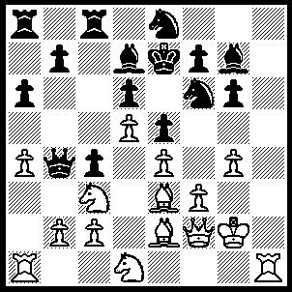
1.Ra3 R(a)b8 (1.....Nc7, 2.Na2 Qa5, 3.Bxc4 N(c)xd5, 4.Bxd5 Nxd5, 5.exd5 OR 1.....Qa5, 2.Bb6 Qb4, 3.Qe3 Rc5, 4.a5 R(c)c8, 5.Qc1), 2.a5 Nc7, 3.Na2 Qb5, 4.N(1)c3 Qxb2, 5.Bc1 Qxc2, 6.Nb4, Qb3, 7.Rxb3 cxb3, 8.Bb2.

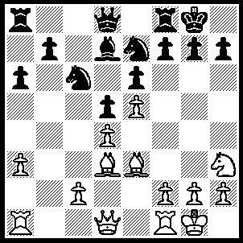1.Bxh7+ Kxh7 (1…..Kh8, 2.Qh5 Ng8, 3.Bxg8+ Kxg8, 4.Ng5 Re8, 5.Qxf7+ Kh8, 6.Qh5+ Kg8, 7.Qh7+ Kf8, 8.Qh8+ Ke7, 9.Qxg7++). 2.Qh5+ Kg8, 3.Ng5 Re8, 4.Qh7+ Kf8, 5.Qh8+ Ng8, 6.Nh7+ Ke7, 7.Bg5+ f6, 8.Qxg7++.
.

