FROM THE TOO HARD BOX No.6
By Vern Stannard
In the following position white played 1.Bxg6 which wins another pawn because if as in the game 1.....fxg6, there follows 2.Qxg6+ Ke7, 3.Rb8. However checking out the possible alternative 1.Nxg6 I unlocked a pandora box of tactical variations.
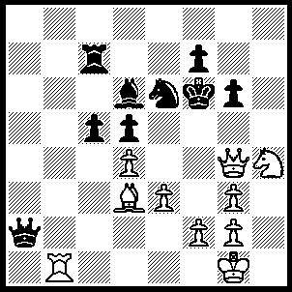1.Nxg6 fxg6 [A ,B], 2.Qxg6 Ke7, 3.Rb8 Qa1+, 4.Kh2 Qa5 (4.c4, 5.Re8+ Kd7, 6.Qxe6+ Kc6, 7.Qxd5+ Kd7 [7.....Kb6, 8.Rb8+ Ka6, 9.Bxc4+ Ka7, 10.Qa8++], 8.Qe6+ Kc6, 9.Qxc4+ Kd7 [9.....Kb7, 10.Qb5+ Ka7, 11.Qb8++], 10.Qe6+ Kc6, 11.Qe4+ Kd7 [11.....Kb6, 12.Rb8+ Ka5, 13.Qa8+ Ra7, 14.Qxa7++], 12.Bb5+ Rc6, 13.Qxc6++ Or 4.....cxd4, 5.Re8+ Kd7, 6.Bb5+ OR 4.....Nxd4, 5.exd4 c4, 6.Qg7+ Ke6, 7.Re8+ Be7 [7.....Re7, 8.Qg4+ Kf7, 9.Qg6++], 8.Qg6+ Kd7, 9.Bf5++), 5.Re8+ Kd7, 6.Rxe6 Kc8, 7.Rxd6 c4, 8.Rb6 Rh7+, 9.Qxh7 Qxb6, 10.Bxc4 dxc4, 11.Qg8+ Kd7, 12.Qxc4.
A. 1.....c4 [cxd4 is similar],2.Qh4+ Ng5, 3.Qh8+ Ke6, 4.Qe8+ Re7 (4.....Be7, 5.Rb6+ mates OR 4.....Kf6, 5.Qd8+ Ke6 [5.....Re7, 6.Qh8+ Ke6, 7.Nf8++ OR 5.....Be7, 6.Qh8+ Ke6, 7.Qe5+ Kd7, 8.Qxe7+ Kc6, Ne5++], 6.Nf8+ Bxf8, 7.Rb6+ mates), 5.Nxe7 cxd3 (5.....Kf6, 6.Qh8+ Ke6 [6.....Kxe7, 7.Rb7+ Ke6, 8.Qc8+ Kf6, 9.Qf5+ Kg7, 10.Qxg5+ mates], 7.Bf5+ Kxe7, 8.Rb7+ Bc7, 9.Rxc7+ Kd6, 10.Qe5++), 6.Nxd5+ Kf5 (6.....Kxd5, 7.Rb5+ mates), 7.Qd7+ Ne6 (7.....Kg6, 8.Qxd6+ OR 7.....Ke4, 8.Nf6++), 8.Qxf7+ Kg5 (8.....Kg4, 9.Qg6+ Ng5, 10.Nf6++), 9.Qf6+ Kg4, 10.Qg6+ mates.
B. 1.....Qd2, 2.Qh4+ Ng5, 3.Qh8+ Ke6, 4.Nf4+Bxf4 (4.....Ke7, 5.Nxd5+ Kd7 [5.....Ke6, 6.Qf6+ Kd7, 7.Qf5+ Ne6 (7.....Kc6, 8.Rb6++ OR 7.....Kd8, 8. Rb8+ mates), 8.Qxf7+ Kd8 (8.....Kc6, 9.Rb6+ Kxd5, 10.Qf3++ OR 8.....Kc8, 9.Ba6+ Rb7, 10.Qxb7+ Kd8, 11.Qc8++) , 9.Qf6+ Kd7, 10.Nb6+ Ke8 (10.....Kc6, 11.be4++), 11.Bg6+ mates], 6.Bb5+ Ke6, 7.Qf6+ Kxd5, 8.Qf5+ mates OR 4.....Kd7, 5.Bb5+ Ke7, 6.Nxd5+ Ke6, 7.Qf6+ Kxd5, 8.Qf5+ mates), 5.Rb6+ Kd7(5.....Bd6, 6.Qe5+ Kd7, 7.Qxd6+ mates), 6.Bb5+ Rc6, 7.Bxc6+ mates.

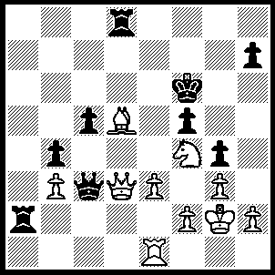
1.Qb5 Ke7 (1.....Qxe1 or Qd2, 2.Qc6+ Kg5 [2.....Kg7, 3.Nh5+ mates], 3.h4+ gxh3+, 4.Nxh3+ Kh5, 5.Bf7++ OR 1.....Kg5, 2.h4+ gxh3+, 3.Nxh3+ Kh5, 4.Qb7 Qh8, 5.Qf7+ Kh6, 6.Qe6+ Kg7 7.Qe7+ Kg6, 8.Qg5++) ,2.Bc4 Qxe1 (2.....Qd2, 3.Re2 OR 2.....R(2)d2, 3.Qxc5+ Kf6 [3.....R2d6, 4.Nd5+ Or 3.....R(8)d6, 4.Qxf5], 4.Qc6+ R(8)d6 [4.....R(2)d6, 5.Nd5+ Kg7, 6.Qxd6 OR 4.....Kg7, 5.Ne6+ Kh8, 6.Nd4 Rf8, 7.Qe6], 5.Qe8 Qb2, [5......Kg5, 6.Ne6+ Kh6, 7.Qf8+ Kg6, 8.Qg8+ Kf6, 9.Qg7++], 6.Qf8+ Kg5, 7.h4+ gxh3+, 8.Nxh3+ Kg4 [8.....Kg6, 9.Bf7+ Kf6, 10.Bg8+ Ke5 (10.....Kg6, 11.Qf7+), 11.Qe7+ OR 8.....Kh4, 9.Qxf5+],9.Qg8+ Rg6, 10.Be2+ Rxe2, 11.Qc4+ mates), 3.Qb7+ Rd7 (3.....Kd6, 4.Qd5+ Kc7, 5.Ne6+ Kb6, 6.Qxd8+ Ka7, 7.Qc7+ Ka8, 8.Bd5++),, 4.Nd5+ Kf8 (4.....Ke8, 5.Nf6+ Ke7, 6.Qxd7+ Kxf6, 7.Qf7+ Kg5, 8.Qg7+ Kh5, 9.Bf7++), 5.Qc8+ Kg7, 6.Qxd7+ Kg6, 7.Qe6+ Kh5 (7.....Kg5, 8.Qe7+ Kh6, 9.Qf6+ Kh5, 10.Nf4++), 8.Nf4+ Kg5, 9.Qe7+ Kh6, 10.Qf6++.
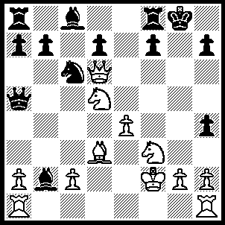1.e5 Re8 (A) (1.....Kg7, 2.Qf6+ Kg8, 3.Bxh7+ Kxh7, 4.Qxh4+ Kg6, 5.Qg5+ Kh7, 6.Nf6+ Kh8, 7.Qh6++ OR 1.....Bxa1, 2.Nf6+ Kg7, 3.Nh5+ Kg8, 4.Qh6 Qb6+, 5.Kf1 Qb1+ 6.Ke2, Nd4+, 7.Nxd4), 2.Qh6 Qc5+, 3.Kf1 Qxd5, 4.Bxh7+ Kh8, 5.Be4+ Kg8, 6.Qh7+ Kf8, 7.Qh8+ Ke7, 8.Qxh4+ Kf8, 9.Qh8+ Ke7, 10.Qf6+ Kf8, 11.Bxd5.
(A) 1.....f5, 2.Nf6+ Rxf6 (2.....Kg7, 3.Nh5+ Kg8 , 4.Bc4+ OR 2.....Kf7, 3.Bc4+ Kg7, Ne8+), 3.exf6 Qb6+ 4.Kf1 Na5,(4.....Nd5, 5.Qe7), 5.Qd5+ Qe3 (5.....Kh8, 6.Qxf5 OR 5.....Kf8, 6.Ng5 Qxf6, 7.Nxh7+), 6.Qxa5 b6 (6.....Bxa1, 7.Qd8+ Kf7, 8.Ng5+ Kg6, 9.Nxe6), 7.Qb5 Bxa1, 8.Bc4 Bxf6, 9.Bxe6.
A passed pawn can be worth more than a piece as white demonstrates next.
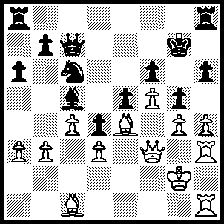1.hxg5 hxg5, 2.Rxh8 Rxh8, 3.Rxh8 Kxh8, 4.Bxg5 fxg5, 5.f6 Kg8, 6.Qh3 Nd8, 7.Qh6 Ne6 (7.....Bf8, 8.Bd5+ Nf7, 9.Qg6+ Kh8, 10.Bxf7), 8.Bd5 Kf7 (8.....Qh7, 9.Bxe6+ Kh8, 10.Qxg5 Bf8 [10.....Bd6, 11.f7 Qg7, 12.Qh4+ Qh7. 13.Qd8+ Kg7, 14.Qxd6], 11.Qxe5 Qg6 [11.....b6, 12.g5], 12.g5 Bd6 [12.....b6 13.Qh2+ Qh7, 14.g6], 13.f7+ Bxe5 [13.....Kh7, 14.f8N+ Bxf8, 15.Bf5], 14.f8Q+ Kh7, 15.Bf5), 9.Qg7+ Ke8, 10.Bxe6 Qc6+, 11.Bd5 Qd6, 12.Bxb7 Kd8 (12.....Bxa6, 13.Qg8+ Qf8, 14.Qe6+ mates), 13.Qxg5 Bxa3, 14.Qg8+ Kc7 (14.....Qf8, 15.Qxf8+ Bxf8, 16.g5), 15.Qc8+ Kb6, 16.g5 Bb4, 17.Qc6+ Qxc6+, 18.Bxc6 Kxc6, 19.g6.
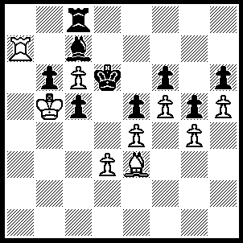1.Bf2 Re8 [A], 2.d4 exd4 (2.....cxd4, 3.Be1 OR 2.....Rc8, 3.dxc5+ Ke7, 4.cxb6), 3.Bg3+ Ke7 (3.....Re5, 4.Bxe5 fxe5, 5.f6), 4.Bxc7 Kf8, 5.Bd6+ Kg8, 6.Rb7 d3, 7.c7 d2, 8.Rb8 Rxb8 (8.....d1Q, 9.Rxe8+ Kh7, 10.Re7+ mates), 9.cxb8Q+ Kh7, 10.Qc7+ Kg8, 11.Qd8+ Kg7, 12.Qe7+ Kg8, 13.Qf8+ Kh7, 14.Qf7+ Kh8, 15.Qxf6+ mates.
[A] 1.....Ke7, 2.Rxc7+ Rxc7, 3.Kxb6 Kd8 (3.....Rc8, 4.Bxc5+ Ke8 [4.....Kd8, 5.Bd6], 5.Kb7 Kd8, 6.Bb6+), 4.Bxc5 Kc8, 5.d4 exd4, 6.Bxd4 Re7, 7.e5 fxe5, 8.f6 Rf7 (8.....Re6, 9.Bxe5), 9.Bxe5 Rf8 (9.....Re7, 10.Bd6 not fxe7 stalemate, Rh7, 11.Be7 Rf7, 12.Kc5 Rh7, 14.Bd6+ Kd8, 15.Ke6 Ke8, 16.c7 Re7, 17.Kf5), 10.Kc5 Kd8, 11.Kd6 Kc8, 12.c7 Rf7, 13.Ke6 Rf8, 14.Ke7 Rh8, 15.f7, Rh7, 16.Ke8.

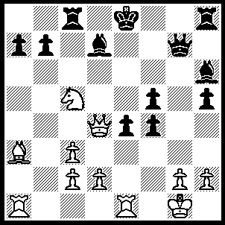1.Rxe4+ fxe4, 2.Qxe4+ Kd8 (2…..Kf8, 3.Ne6+ OR 2…..Kf7, 3.Nxd7 R(h)d8 [3.R(h)e8, 4.Qf5+ Kg8, 5.Nf6+ Kh8, 6.Nxe8 Rxe8, 7.Bc5 Qg5, 8.Bd4+ Kg8, 9.Qxg5+ Bxg5, 10.Rxa7 Bh4, 11.Bf2], 4.Qd5+ Kg6, 5.Qe6+ Kh7, 6.Nf6+ Kh8, 7.Nxh5 Qg5, 8.Be7 Qxh5, 9.Bxd8), 3.Nxb7+ Kc7, 4.Bd6+ Kb6, 5.Be5 Qxe5 (5…..Qh7, 6.Qb4+ Bb5, 7.Qd4+ Rc5, 8.Qxc5+ Kxb7, 9.Rxa7++), 6.Qxe5 Kxb7, 7.Qd4 Bb5, 8.Rxa7+ Kc6, 9.Qd7+ Kc5, 10.d4+ Kc4, 11.Rc7+ Rxc7, 12.Qxc7+ Kd5, 13.Qe5+ Kc6, 14.Qxh8.

