FROM THE TOO HARD BOX 7
By Vern Stannard
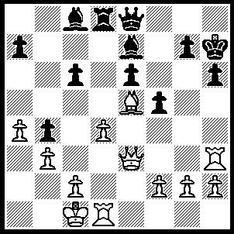1.Bxg7 Kg8 (1…..Kxg7, 2.Qxh6+ Kf7, 3.Qh7+ Kf8, 4.Qh8+ Kf7, 5.Rh7+ Kg6, 6.Qg7++ OR 1…..Qg6, 2.Bxh6 Rd7 [2…..c5, 3.Bg5+ Kg7, 4.Bxe7], 3.Bf4+ Bh4, 4.Rxh4+), 2.Qxh6 e5, 3.Bxe5 Kf7, 4.Rg3 Qg8, 5.Qh5+ Ke6, 6.Rg6+ Qxg6 (6…..Kf7, 7.Rf6+ Kg7, 8.Rf7++ OR 6…..Kd7, 7.Qxf5+ Ke8, 8.Rxg8++ OR 6.Kd5, 7.Qf3++ OR 6…..Bf6,7.Bxf6), 7.Qxg6+ Kd7 (7…..Kd5, 8.Qf7+), 8.d5 cxd5, 9.Rxd5+ Bd6, 10.Rxd6+ Kc7, 11.Rb6+ Rd6, 12.Qxd6++.
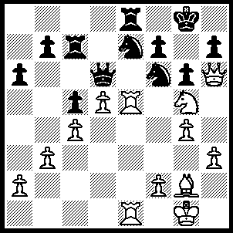1.Ne6 fxe6, 2.Rxe6 Qd8 (2…..Qxe6, 3.Rxe6 Nc6, 4.Rxf6 Nb4, 5.a3, Nc2, 6.d6 Rg7, 7.Bd5+ Kh8, 8.d7 Rd8, 9.Qf4), 3.Rxf6 Nc8 (3…..Rd7, 4.d6 Rxd6, 5.Rxd6 Qxd6, 6.Bd5+ Kh8, 7.Re6 Qc7, 8.Qe3 Kg7, 9.Qc3+ Kh6, 10.Re5 g5 [10…..Qd7, 11.Rh5+ gxh5, 12.Qf6+ Ng6, 13.g5++ OR 10…..Nxd5, 11.g5+ Kh5, 12.Qg3+ Kh4, 13.Qg4++], 11.Re6+ Ng6, 12.Rxe8), 4.Rxe8+ Qxe8, 5.d6 Rf7 (5…..Qe1+, 6.Bf1 Rf7, 8.d7), 6.Rxf7 Kxf7 (6…..Qe1+, 7.Bf1 Kxf7, 8.d7), 7.Qxh7+ Ke6, 8.Qc7 Nxd6, 9.Bd5+ Ke5, 10.Qg7+ Kf4, 11.Qf6+ Nf5, 12.gxf5 Qe1+ (12…..gxf5, 13.Qh6+ Ke5, 14.Qe3+), 13.Kg2 g5, 14.Qe6.
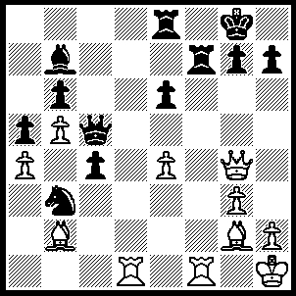1.Bxg7 h5 (1…..Qe7, 2.Bc3+ Rg7, 3.Bxg7 Qxg7, 4.Qxe6+ Rxe6, 5.Rd8+ Qf8, 6.R(8)xf8+ Kg7.R(1)f7+ Kg6, 8.Rxb7 OR 1…..Rxg7, 2.Qxe6+ Rxe6 [2…..Kh8, 3.Qxe8+ Rg8, 4.Qf7 Qg5, 5.Qxb7], 3.Rd8+ Qf8, 4.R(8)xf8++ OR 1…..Rxf1, 2.Rxf1), 2.Qg6 Rxg7 (2…..Qe7, 3.Bc3+ Rg7 [3…..Kf8, 4.Qg7++], 4.Bxg7 Qxg7, 5.Qxe8+ Kh7, 6.Rd7), 3.Qxe8+ Kh7, 4.Rd7 Qe5 (4…..Rxd7, 5.Qxd7+ Kf8, 6.Qe8+ Kg7, 7.Rf7+ Kh6, 8.Qxe6+ Kg5, 9.h5++), 5.Rxg7+ Kxg7 (5…..Qxg7, 6.Rf7), 6.Rf7+ Kh6, 7.Qf8+ Kg5, 8.Rg7+ Kh6, 9.Qh8++.
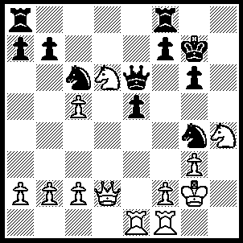1.N(6)f5+ Kf6 (1…..gxf5, 2.Qg5+ OR 1…..Kg8, 2.Qg5 Nf6 [2…..R(f)d8, 3.Qxg4 Kf8, 4.Ne3], 3.Nxg6 OR 1…..Kh7. 2.Qg5 gxf5, 3.Nxf5 Qg6, 4.Rh1+ Kg8, 5.Qxg4, Qxg4, 6.Nh6+ Kg7, 7.Nxg4), 2.f3 gxf5, 3.fxg4 f4 (3,,,,,Ke7, 4.Nxf5+ Ke8, 5.Ng7+ OR 3…..Kg7, 4.Qg5+ Qg6, 5.Nxf5+ Kh7, 6.Rh1 mates), 4.Rxf4+ exf4 (4…..Ke7, 5.Nf5+ Kf6, 6.Rf2 Rh8, 7.Nd5+ OR 4…..Kg7, 5.Rf5 f6, 6.g5 R(a)d8, 7.gxf6+ Qxf6 [7…..Rxf6, 8.Qg5+ Kf7, 9.Qg6+ Ke7, 10.Qg7+ Rf7, 11.Ng6+], 8.Qe2 Qxf5,9.Nxf5 Rxf5, 10.Rd1 Rxd1, 11.Qxd1), 5.Qxf4+ Ke7 (5…..Kg7, 6.Qg5+ Kh7, 7.Rxe6 fxe6, 8.Qg6+ Kh8, 9.Qh6+ Kg8, 10.Qxe6+ Rf7, 11.Nf5 Kf8, 12.Qh6+ Kg8, 13.Qg6+ Kf8, 14,Nh6), 6.Qc7+ Kf6 (6…..Ke8, 7.Nf5), 7.Rxe6+ fxe6, 8.g5+ Kxg5, 9.Qg7+ Kh5, 10.Qg6++.
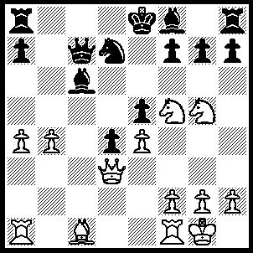1.Nxf7 Kxf7 (1…..Rg8, 2.Qc4 Nf6, 3.Nxf5 Bxb4 [3…..Qxe5, 4.Qxc6+ OR 3…..Rc8, 4.Qe6+ Be7, 5.Nxc6], 4.Bf4 Be7, 5.Qf7+ Kd8, 6.Nxc6+), 2.Qc4+ Kf6 (2…..Kg6, 3..Qe6+ Nf6 [3…..Kh5, 4.Ng3+ Kh4, 5.Qh3++], 4.Nh4+ Kh5, 5.Qf5+ Kxh4, 6.g3++ OR 2…..Ke8, 3.Bg5 Nc5 [3…..Nf6, 4.Qe6+ Be7 {4…..Kd8, 5.Bxf6+} 5.R(a)c1 d7, 6.Rxc6)] 4.bxc5 Qf7, 5.Qc2 Rc8, 6.f4 Bb7 [6.Ba8, 7.fxe5 Rxc5, 8.Qd2 Qd7, 9.e6 Qxe6, 10.Qxd4 Rc8, 11.R(a)c1 Rb8, 12.Nxg7+ Rxg7, 13.Qxg7 Rg8, 14.Qxa7], 7.fxe5 Qg6, 8.Qb3 Ba6, 9..Qd5 Bc4, 10.Qxc4 Qxg5, 11.Qe6+ Kd8, 12.R(a)b1 Qg6, 13.Qd5+ Ke1, 14.e6), 3..Bg5+ Kxg5, 4.Qf7 Bxe4 (4…..g6, 5.h4+ Kh5, 6.f3 Nf6, 7.Qxf6 and 8.g4++ OR 4…..Nf6, 5.h4+ Kg4 [5…..Kf4 6.g3+ Kg4, 7.f3++], 6.f3+ Kf4, 7.g3++), 5.h4+ Kg4 (5…..Kf4, 6.Nxg7+ Kg4, 7.Qh5+ Kf4, 8.g3++), 6.f3+ Bxf3, 7.Nh6+ Kxh4, 8.Qxf3Nf6, 9.Qh3+ Kg5, 11.Qg3+ Ng4, 12.Qxg4+ Kxh6, 13.Qg5++.
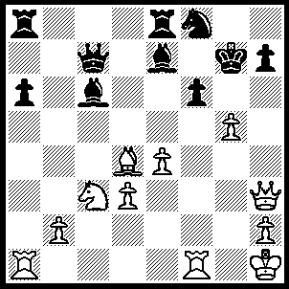1.gxf6+ Kf7 (1…..Kh8 or Kg8, 2.f7 OR 1…..Kg6, 2.Qg4+ Kf7 [2…..Kh6, 3.Be3+], 3.Qg8+ Kxg8, 4.f7++ OR 1…..Bxf6, 2.Rxf6 Re5 [2…..Kg8, 3.Rg1+ Ng6, 4.R(6)xg6 hxg6, 5.Qh8+ Kf7, 6.Qf6+], 3.Qh6+ Kg8 [3…..Kh8, 4.Rxf8+], 4.Rg1+ Ng6, 5.R(1)xg6+ hxg6, 6.Rxg6+ Kf7, 7.Qh7+), 2.Nd5 Bd8 (2…..Qd7, 3.fxe7+ Kg8, 4.exf8(Q)+ Rxf8, 5.Qg4+ OR 2…..Bxd5, 3.Qh5+ Kg8 [3…..Ke6, 4.Qxd5++ OR 3…..Ng6, 4.Qxd5+ Kf8, 5.fxe7+ Kxe7, 6.Rf7++], 4.f7++ OR 2…..Qd8, 3.fxe7+ Kg8, 4.Qg4+ Ng6, 5.Qe6++ OR 2…..Qd6, 3.fxe7+ Kg8, 4.exf8(Q)+ Rxf8, 5.Qg3+ Qxg3, 6.Ne7++), 3.Qh5+ Ng6 (3…..Ke6, 4.f7 Re7, 5.Nxc7+ Kd7 [5…..B or Rxc7, 6.Qf5+ and 7.Bc5++], 6.Nxa8 Bxa8, 7.Rxa6), 4.Qxh7+ Ke6, 5.f7 Qe7, 6.Qxg6+ Kd7, 7.Qg4+ Kd6 (7…..Qe6, 8.fxe8(Q)+ Kxe8, 8.Qxe6+), 8.Rf6+ Qxf6, 9.fxe8(N)+ Bxe8, 10.Nxf6.
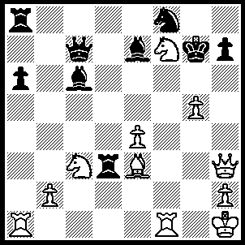1.g6 Kg8 (1…..Nxg6. 2.Bh6+ Kg8, 3.Qxd3 OR 1…..Rxc3, 2.Bd4+ Bf6, 3.Bxf6+Kg6 [3…..Kg8, 4.Nh6++], 4.Nh8++ OR 1…..Rd7, 2.Qh6+ Kg8, 3.gxh7+ Nxh7, 4.Qg6+ Kf8, 5.Nh6+ Bf6, 6.Qg8+ Ke7, 7.Nf5++ OR 1…..Rxe3, 2.Qh6+ Kg8, 3.gxh7+ Nxh7, 4.Qg6+ Kf8, 5.Nd6+ Bf6, 6.Rxf6+ Ke7 [6….Nxf6, 7.Qxf6+ Kg8, 8.Rg1+ Kh7, 9.Qh4++], 7.Rf7+ Kd8, 8.Qg8+ mates), 2.gxh7+ Nxh7, 3.Qe6 Nf6 (3…..Qd7, 4.Qg6+ Kf8, 5.Ne5+ Bf6, 6.Bc5+ Qe7, 7.Qf7++), 4.Ne5+ Kh8, 5.Qh3+ Kg7 (5…..Nh7, 6.Rf7 OR 5…..Kg8, 6.Rg1+ Ng4, 7.Qxg4+ Bg5,8.Qxg5+ Kh8, 9.Qh4+ Qh7, 10.Nf7), 6.Qh6+ Kg8, 7.Qg6+ Kh8, 8.Nf7++.

