FROM THE TOO HARD BOX 8
By Vern Stannard
In the following position Hayden Barber had no hesitation in playing 1.Ba5 and leaving black to try and work out the best defence.
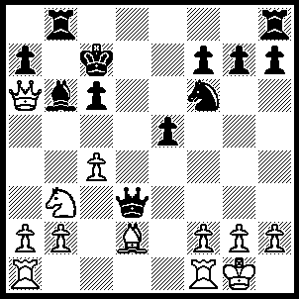1.Ba5 Bxa5 (the game went 1…..Nd7 2.Qxa7---[more exact would be 2.R(a)d1 Qf5, 3.Qxa7+ Kc8 [[3…..Rb7, 4.Rxd7+ Qxd7, 5.Bxb6+ Kc8, 6.Qa6]], 4.Bxb6 Rxb6 [[4…..Nxb6, 5.Rd6 Qd7, 6.Rxd7]], 5.Rxd7 Qxd7, 6.Qxb6]---Rb7 [2…..Kc8, 3.Qa6+ Kc7 [[3…..Kd8, 4.R(a)d1 OR 3…..Rb7, 4.Bxb6+ Nxb6, 5.Qxb7+]], 4.R(a)d1 Qf5, 5.Qa7+ etc], 3.Bxb6+ Nxb6, 4.Qxb7+ Kxb7, 5.Nb5+ resigns),2.Qxa5+ Kc8, 3.Qa6+ Kc7 (3…..Rb7, 4.Nc5), 4.R(a)d1 Qf5, 5.Nc5 Nd5, 6.cxd5 cxd5. 7.Rxd5 Rb6, 8.Qxa7+ Kc6, 9.Ne4 Kxd5 (9…..Qxe4, 10.Qd7++ OR 9…..Rb5, 10.Rd6++ OR 9,,,,,R(h)b8, 10.Rc5++), 10.Rd1+ Kxe4, 11.Qa4+ Rb4, 12.Qxb4++.

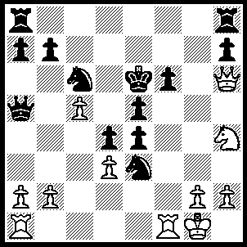1.Rxf6+ Kd5 (1…..Kd7, 2.Rf7+ Kc8 [2…..Ne7, 3.Qd6+ Kc8, 4.Qxe7 mates], 3.Qe6+ Kb8, 4.Qd6+ Kc8, 5.Qd7+ mates), 2.Rxc6 exd3, 3.Qe6+ Ke4, 4.Nf3 R(a)e8 (4…..Nc4, 5.Ng5+ Ke3 [5…..Kf4, 6.Qf6+ Kg4 [6…..Ke3(or g3), 7Qf2++], 7.h3+ Kh4, 8.g3+ Kxg3, [8…..Kh5, 9.Qh6++], 9.Qf2++], 6.Qf5, R(a)f8 [6…..d7, 7.Qe4++], 7.Qe4+ Kd2, 8.Qe1+ mates OR 4…..d2, 5.Qxe5+ Kd3 6.Qxd4+ Ke2 [6…..Kc2, 7.Qe4+ Kxb2, 8.Qb1+ mates], 7.Rd6 d1Q+ 8Rxd1 Qc3, 9.Rd2+ mates mates), 5.Ng5+ Kf4, 6.Nh3+ Ke4, 7.Nf2+ Kf4, 8.Qh6+ Kf5, 9.Rf6++.

In the next position play went 1.Bxh7+ Kxh7, 2.Qh5+ Kg8, 3.Rh3 Kf8, 4.Rf3?? f5?, 5.Qh8+ Kf7, 6.g6+ Kxg6, 7.Rg3+ resigns. White missed a mate here so would he have found his way to victory against Black’s numerous choices of defence?
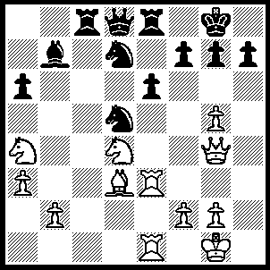1.Bxh7+ Kh8 (1…..Kxh7, 2.Qh5+ Kg8, 3.Rh3 f5 [3…..f6, 4.Qh8+ Kf7, 5.g6+ Ke7[[5…..Kxg6, 6.Qh5++]], 6.Nf5++ OR 3…..Kf8, 4.Qh8+ Ke7, 5.Nf5++], 4.Qh8+ Kf7, 5.g6+ Kf6 [5…..Ke7, 6.Re6++], 6.Qh4+ Kxg6, 7.Qh5+ Kf6 8.Rxe6+ Rxe6, 9.Qxf5+ Ke7, 10.Qxe6+ Kf8, 11.Rh8++ OR 1…..Kf8, 2.Rf3 Nc7, 3.Rxf7+ Kxf7, 4.Qh5+ Kf8 [4…..Ke7, 5.Nf5+ Kf8, 6.Bg6 Nf6, 7.Qh8+ Ng8, 8..Qxg7++], 5.Bg6 Nf6, 6.gxf6 Qxf6, 7.Nf5 Qxg6, 8.Qxg6 exf5, 9.Qxf5+ Kg8, 10.Rxe8+ Nxe8 [10…..Rxe8, 11.Qd7], 11.Nc5), 2.Rh3 Qa5 (2…..N(7)f6, 3.gxf6 Qxf6, 4.Nf5 exf5 [4…..g4, 5.Nd6], 5.Bg6+ Kg8, 6.Rh8+ mates OR 2…..N(5)f6, 3.Be4+ Kg8, 4.Qh4 Kf8, 5.gxf6 Nxf6, 6.Bxb7), 3.Bg6+ Kg8, 4.Bxf7+ Kxf7 (4…..Kf8, 5.Rh8+ Ke7 [5…..Kxf7, 6.Qh5+ Ke7, 7.Rxe6+ Kd8, 8.R(6)xe8+ Kc7, 9.Qh2+ Nf4, 10.Qxf4+ Qe5 or Ne5, 11.Rxe5], 6.Qxe6+ Kd8, 7.Rxe8+ Kc7, 8.Rc1+), 5.g6+ Kg8 (5…..Ke7 [5…..Kf6, 6.Rxe6+ mates], 6.Rxe6+ Kd8, 7.Rxe8+ Kxe8 [7…..Kc7, 8.Qg3+ etc], 8..Rh8+ Nf8 [8…..Ke7, 9.Qe6++], 9.Qe6+ Ne7 [9…..Kd8, 10.Qd6+ mates], 10.Rf8 mates OR 5…..Kf8, 6.Rh8+ Ke7, 7.Rxe6+ Kd8,8.R(8)xe8+ etc) 6.Rh8+ Kxh8, 7.Qh5+ Kg8, 8.Qh7+ Kf8, 9.Qh8+ Ke7, 10.Rxe6+ Kd8, 11.Rxe8+ Kc7, 12.Qh2+ Nf4, 13.Qxf4+ Q or Ne5, 14.Rxe5.

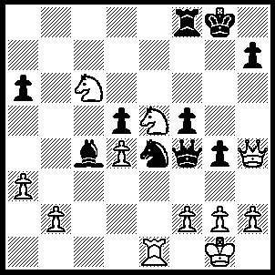1.Ne7+ Kg7, 2.N(7)g6 Qd2 (2…..Qg5, 3.Qxg5 Nxg5, 4.Nxf8 Kxf8, 5.Nxc4 dxc4, 6.Re5 OR 2…..hxg6, 3.Qe7+ Kh6 [3…..Kg8, 4.Qxf8+ Kxf8, 5.Nxg6+}, 4.Qxf8+), 3.Qe7+ Rf7 (3…..Kh6, 4.Qxf8+ Kh5, 5.Qxf5+ Qg5 [5…..Kh6, 6.Qf8+ Kh5, 7.Nf4+ Kg5, 8.Nf7+ Kxf4 [[8…..Kf5, 9.Nd8+ Kg5, 10.N(8)e6+ Kh4, 11.Qh6++]], 9.Qh6+ Kf5, 10.Nd6+ Nxd6, 11.Re5++), 6.Nf4+ Kh6, 7.Qf8+ Qg7, 8.Nf7++), 4.Qxf7+ Kh6, 5.Qf8+ Kh5 (5…..Kg5, 6.f4+ Kh5 [6…..gxf3ep, 7.h4+ Kh5 (7…..Kf4, 8.Qh6+), 8.Qxf5+ Ng5 (8…..Kh6, 9.Qf8+ Kh5, 10.g4++ OR 8…..Qg5, 9.g4+ Kh6, 10.Qf8++] 9.g4+ Kh6, 10.Qf8++], 7.Qxf5+ Kh6, 8.Nxg4+ Kg7, 9.Qf8+ Kxg6, 10.Ne5+ Kh5, 11.g4+ Kh4, 12.Qh6++), 6.Qxf5+ Kh6 (6…..Ng5, 7.Nf4+ Qxf4 [7…..Kh6, 8.Qf6++ OR Kh4, 8.g3++], 8.Qxf4 OR 6…..Qg5, 7.Nf4+ Kh6, 8.Qf8+ Qg7, 9.Nf7++), 7.Qf8+ Kg5 (7…..Kh5. 8.Ng4+ Kg5, 9.Nf7+ Kf5 [9…..Kxf4, 10.Qh6+ Kf5, 11.Nd6+ etc], 10.Nd8+ Kg5, 11.N(8)e6+ Kh4, 12.Qh6++), 8.f4+ Kh5, 9.Qf5+ Kh6, 10.Nxg4+ Kg7, 11.Qf8+ Kxg6, 12.Ne5+ Kh5, 13.g4+ Kh4, 14.Qh6++.

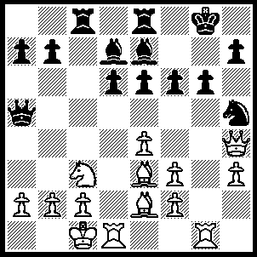1.Bb5 Bxb5, 2.Qxh5 g5 (2…..f5, 3.Rxg6+ hxg6, 4.Qxg6+ Kh8, 5.Qh6+ Kg8, 6.Rg1+ mates OR 2…..e5, 3.Rxg6+ Kf7, 4.Rh6+ Ke6, 5.Qg4+ Kf7, 6.Rxh7+ Kf8, 7.Bh6++ OR 2…..Bf8, 3.Qxb5), 3.Bxg5 fxg5 (3…..Kh8, 4.Bh6 Rg8 [4…..Bf8, 5.Bg7+ Bxg7 [[5…..Kg8, 6.Bxf6+ Bg7, 7.Rxg7+ mates]], 6.Rxg7, Kxg7, 7.Rg1+ Kf8, 8.Qxh7 mates],, 5.Qf7 mates), 4.Rxg5+ Bxg5+ (4…..Kh8, 5.R(1)g1 Bxg5+, 6.Qxb5 mates), 5.Qxg5+ Kf7 (5…..Kf8, 6.Qf6+ mates), 6.Qh5+ Kf8 (6…..Ke7, 7.Qxh7+ Kf6 [7…..Kd8, 8.Rxd6+ mates], 8.e5+ Kxe5 [8…..Kg5, 9.h4+ Kf4, 10.Qe4++], 9.Qg7+ Kf5 [9…..Kf4, 10.Qf6++], 10.Qf7+ Kg5 [10….Ke5, 11.f4++], 11.Rg1+ mates), 7.Qh6+ Kf7 (7…..Ke7, 8.Qg7+ mates), 8.Qxh7+ Kf6 (8…..Kd8, 9.Rxd6+ mates), 9.e5+ mates as before.

