FROM THE TOO HARD BOX 9
By Vern Stannard
Here black has lots of ways to be mated.
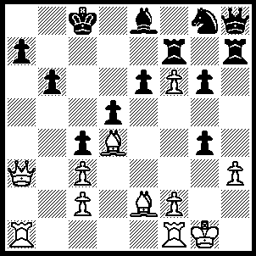1.Qa6+ Kd8 (1…..Rb7, 2.f7 OR 1…..Kb8, 2.Be5+ Rc7, 3.Qxa7+ Kc8, 4.Qa8+ Kd7, 5.Qb8 Kc6, 6.R(f)b1 d4, 7.Qxb6+ Kd5, 8.Qxd4+ mates OR 1…..Kd7, 2.Qxa7+ Kd6 [2…..Kd8, 3.Qb8+ Kd7, 4.Ra7+ Kc6, 5.Qxb6++ OR 2…..Kc8. 3.Qa8+ Kd7, 4.Be5 mates], 3.Qxb6+ Kd7, 4.Ra7+ Kc8, 5.Ra8+ Kd7, 6.Rd8++), 2.Bxb6+ axb6 (2…..Kd7, 3.Qb7+ Kd6, 4.Qb8+ Rc7---[4…..Kc6, 5.Ra6 Rb7 {5…..Kb5, 6.Bc7+ mates OR 5…..axb6, 6.Rxb6+ Kd7 (6…..Kb5, 7.Qd6++), 7.Rd6++}, 6.Qc8+ R(h)c7 {6…..R(b)c7, 7.Bxa7+ Kb5, 8.Rb1++}, 7.Qxe6+ Kb5, 8.Ra5++], ---5.Rxa7 Ke5---[5…..Kc6, 6.Rxc7+ Kb5, 7.Rc5+ Ka6, 8.Ra5++ OR 5…..Nxf6, 6.Bxc7+ Kd7 {6…..Ke7, 7.Bd6++ OR 6……Kc6, 7.Ra6+ mates}, 7.Bd8+ Kc6, 8.Qb6++],---6.Bxc7+ Ke4 ---[6…..Kxf6, 7.Be5+ Kf5 {7…..Kg5, 8.Bf4+ Kh5 (8…..Kh4, 9.Bg3+ Kh5 ((9…..Kxh3, 10.Re1 mates)), 10.hxg4+ Kh6, 11.g5+ Kxg5, 12.Qf4++ OR 8…..Kf5, 9.g4+ mate}, 8.Bxg4+ Kg5 (8…Ke4, 9.Re1++), 9.Bf4+ Kf6, 10.Qe5++ OR 6…..Kf5, 7.Bxg4+ Kg5, 8.Bf4+ Kh4, 9.Bg3+ mates [7…Ke4, 8.Re1++], OR 6…..Rxc7, 7.Qxc7+ Ke4 {7…..Kxf6, 8.Qc4++ OR 7…..Kf5, 8.hxg4+ Kg5, 9.Qe5+ Kh6 (9…..Kh4, 10.Kg2 mates), 10.g5++} 8.Bxg4 d4, 9.Re1+ Kd5, 10.Bf3++],---7.Bd3+ cxd3 [7…..Kf3, 8.Qb6 gxh3, 9.Be2+ mates], 8.Qb4+ d4, 9.Qxd4+ Kf5, 10.Qf4++), 3.Qxb6+ Rc7 (3…..Kd7, 4.Ra7+ Ke8, 5.Ra8+ Kd7, 6.Rd8++), 4.Ra8+ Kd7, 5.Bxc4 Nxf6 (5…..Qxf6, 6.Bb5+ Ke7, 7.Qxc7+ Kf8, 8.Rxe8++OR 5…..dxc4, 6.Rd1++), 6,Bb5+ Ke7, 7.Qxc7+ Kf8 (7…..Nd7, 8.Qd8+ Kf7, 9.Bxd7 Bxd7, 10.Qxd7+ Kf6, 11.Qa4), 8.Qd6+ Kg7 (8…..Re7, 9.Bxe8 Nxe8, 10.Rxe8+ Kxe8, 11Qb8+ wins Q OR 8…..Kf7, 9.Re1 Rxh3, 10.Bxe8+), 9.Bxe8 Rxh3 , (9…..Nxe8, 10.Qxe6 Rxh3, 11.Qe5+ mates). 10.Qe7+ Kh6, 11.Bc6 Qg7, 12.Qxe6 Qc7, 13.Rh8+ Kg7, 14.Rxh3.

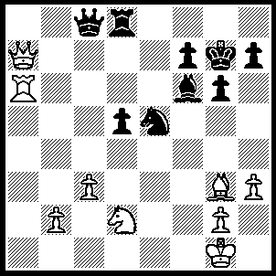1.Rxf6 Kxf3 (1…..Rd7, 2.Qd4), 2.Bxe5+ Kxe5 (2…..Ke6, 3.Nf3 Rd7 *** [3…..Qd7, 4.Qb6+ Ke7 {Kf5, g4+ Ke4, 6.Qd4+ Kxf3, 7.Qd3++} 5.Qf6+ Ke8, 6.Qh8+ Ke7, 7.Bf6+ OR 3…..d4, 4.Qb6 Kd7 -----{4…..Kd5, 5.Bc7 dxc3 , 6.bxc3 Kc4 ((6…..Rd7, 7.Qb5+ Ke4 {{7…..Ke6, 8.Qe5++}} 8.Qc4+ Kf5 {{8…..Ke3, 9.Bf4++}} 9.Qf4+ Ke6, 10.Qe5++)) 7.Qb4+ Kd3 ((7…..Kd5, 8.Qd4+ wins R)) 8.Ne1+ Kd2 ((8…..Ke3, 9.Qf4+ Ke2, 10.Qf2+ Kd1, 11.Qc7+ Kxe1, 12.Bg3++)), 9.Bf4+ Kd1 ((9…..Kxe1, 10.Qb1+ Rd1, 11.Qe4++ OR Ke2, 10.Qe4+ Kd1, 11.Qc2+ mates)), 10.Qb1+Ke2, 11.Qc2+ Kxe1, 12.Bg3++,}-----5.Bf6, dxc3 {5…..Rg8, 6.Ne5+ Ke8, 7.Qb5+ Kf8, 8.Qb4+}, 6.Qb5+ Ke6 {6…..Kd6, 7.Qd3+ Kc6, 8.Bxd8 cxb2. 9.Ne5+ Kb7, 10.Qb3+ Ka8 11.Qa2+}, 7.Qe5+ Kc6, 8.Qxd8, Qxd8, 9.Bxd8 wins],*** 4.Qb6+ Kf5 [4….Ke7, 5.Qf6+ wins Q], 5.g4+ Ke4, 6.Qd4+ Kxf3, 7.Qd3++), 3.Qe7+ Kf4 (3…..Qe6, 4.Nf3+ Kf4 [4…..Ke4, Ng5+ OR 4…..Kf5, Nd4+], 5.Qh4+ Kf5 [5…..Ke3, 6.Qd4+ Ke2, 7.Qd2++], 6.Nd4+ wins Q OR 3…..Kf5, 4.Nf3 f6 [4…..Qb8, 5.Nd4+ Kf4, 6.Ne2+ Kf5, 7.g4++], 5.Nd4+ Kg5 [5…..Kf4, 6.Ne2+ Kf5{6…..Kg5, 7.Qe3+ Kh5 {7…..Kf5, 8.g4++}, 8.Ng3+ Kh4, 9.Qf4 mates} 7.g4+ Kg5, 8.Qe3+ Kh4, 9.Qh6++], 6.Qe3+ Kh5 [6…..Kh4, 7.Qh6+ Kg3, 8.Ne2++], 7.g4+ Kh4, 8.Nf3+ Kg3 [8…..Kxh3, 9.Ne5+ Kh4, 10.Qh6+ Kg3, 11.Qh2++], 9.Ne1+ Kh4, 10.Ng2++), 4.g3+ Kf5 (4…..Kxg3, 5.Qe3+ Kh4, 6.Qh6+ Kg3, 7.Nf1+ Kf3, 8.Qe3++), 5.Nf3 g5, (5…..f6, 6.Nh4++ OR 5…..Qe6, 6.Nd4+ wins Q), 6.Qe5+ Kg3, 7.Qxg5++.

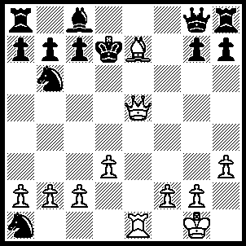1.Qb5+ c6, 2.Qf5+ (2…..Kc7, 3.Bd6+ Kd8 [3…..Kxd6. 4.Qe5+ mates], 4.Qg5+ mates OR 2…..Ke8, 3.Bg5+ Be6, 4.Rxe6+ Qxe6 [4…..Kd7, 5.Re7+ Kd8, 6.Rf7+ mates], 5.Qxe6+ Kf8, 6.Be7+ Ke8, 7.Bd6 mates), 3.Qxe6+ Ke8, 4.Qe5 (see A also) Nd5 (4…..Be6. 5.Bh4 Nd7 [5…..Nd5, 6.Qxg7 Nf6, 7.Bxf6 mates] 6.Qxe6+ Kf8, 7.Be7+ Ke8, 8.Bf6+ Kf8, 9.Qe7+ mates), 5.Qxg7 Kd7 [5…..Be6, 6.Bg5], 6.Bc5+ Kd8, 7.Qxh8+ Kc7 [7…..Kd7, 8.Qf8 mates], 8.Qe5+ Kd8, 9.Qd6+ Bd7, 10.Re8+ Kxe8, 11.Qf8++.
(A) also 4.Qd6 Kf7 (4.Bd7, 5.Bf6+ Kf7, 6.Qe7+ Kg6, 7.Qxg7+ Kf5, 8.Qg5++ OR 4…..Nd7, 5.Bf8+ Kf7, 6.Qe6+ Kxf8, 7.Qe8++), 5.Qf4+ Kg6 (5…..Ke8, 6.Bg5+ Be6, 7.Rxe6+ Kd7, 8.Re7+ Kd8, 9.Qc7++), 6.Qg5+ Kf7, 7.Bf8 Rg8, 8.Qh5+ g6, 9.Qxh7+ Kf6, 10.Be7+ Kf5, 11.Qf7++.

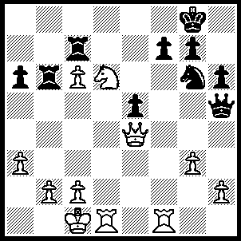1.Nxf7 Rxf7 (1…..R(b)xc6, 2.Rd8+ Nf8, 3.Rxf8+ Kxf8, 4.Nd8+ Rf6, 5.Rxf6+ gxf6, 6.Ne6+OR 1…..R(c)xc6, 2.Rf5 Qh5, 3.Rd8+ Qxd8,4.Nxd8 OR 1…..Rc8, 2.c7 Re6 [2…..Rxc7, 3.Rd8+ Nf8, 4.Rxf8+ Kxf8, 5.Qa8+ Ke7, 6.Qd6+ Kxe6, 7.Qxc7], 3.Qc4 Nf8, 4.Nd6 Qg5+, 5.Kb1 Ra8, 6.Rxf8 Rxf8, 7.Qxe6+, Kh7, 8.c8[Q]), 2.Rxf7 Qg5+ (2…..Kxf7, 3.Qd5+ Kf8 [3…..Kf6, 4.Qd8+ Ke6, 5Rd6+ Kf5, 6.g4+], 4.Qd8+ Kf7, 5.Rd7+ Ke6, 6.Qe8+ Kf6, 7.Rf7+ Kg5,8.Qd8+ Ne7, 9.Qxe7+ Kg6, 10.Rxg7+ Kf5, 11.g4+), 3.Kb1 Kxf7 (3…..Rxc6 4.R(1)d7 wins), 4.Qc4+ Kf6 (4…..Ke7, 5.Rd7+ Kf6, 6.Rf7++ IF 4…..Ke8 or f8, 5.c7), 5.Rd6+ Kf5 (5…..Ke7, 6.Rd7+ mates), 6.g4+ mates.

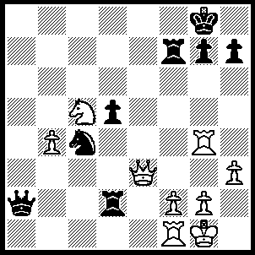1.Qe8+ Rf8, 2.Qe7 Qb2 (2…..Rf7, 3.Rxg7+ Kh8 [3…..Kxg7, 4.Ne6+ mates], 4.Qxf7 mates OR 2…..g6, 3.Ne6 mates), 3.Nd7 Ra8, 4.Nf6+ Qxf6, 5.Qxf6 g6, 6.Re1 Rf8, 7.Rxg6+ hxg6, 8.Qxg6+ Kh8, 9.Re7 mates.

