FROM THE TOO HARD BOX 10
By Vern Stannard
To play over these positions set your computer to play human versus human. If not already set then set it to allow you to take back moves. This lets you go down a variation or sub-variation and back track to continue on.
The first position, an idea I got from an actual game, should be a good test of how good is your computer program. Let it make the first move for white. My (then) Chessmaster and Fritz5 both rejected the following:-

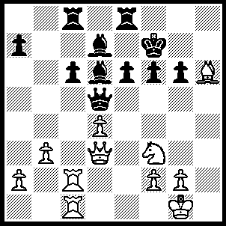
1.Rc5 Bxc5, 2.Rxc5 Qd6, 3.Ne5+ Ke7 (3…..fxe5, 4.Qf3+ Kg8 [4…..Ke7, 5.Bg5++], 5.Qf6 Qe7 {5…..Re7, 6.Rc3, Qb4, 7.Qxg3+ Kh8, 8.Rh3 mates], 6.Qxg6+ Kh8, 7.Bg5 Rg8, 8.Bf6+ Rg7, 9.Qh6+ Kg8, 10.Bxe7), 4.Bf4 fxe5, 5.Bxe5 Qxe5 (5…..Qxc5, 6.dxc5 Ra8 [6…..Rg8, 7.Qd6+ Ke8, 8.Bf6], 7.Qd6+ Kd8, 8.Qc7+ Ke7, 9.Bd6+), 6.dxe5 Rg8, 7.Ra5 Ra8, 8.Qd6+ Ke8, 9.Qa3.

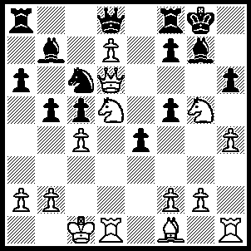
1.cxb5 axb5 (1…..Nd4, 2.Ne7+ Kh8, 3.Bc4 [not 3.Qg6 Ne2+, 4.Bxe2 Bxb2+, 5.Kxb2 fxg6] Nxb5, 4.Qxc5 Bf6, 5.Qxf5 Bxg5+, 6.hxg5 Qb6, 7.Rxh6+ Qxh6, 8.gxh6 Rg8, 9.Nxg8 mates OR 1…..Nb4, 2.Ne7+ Kh8, 3.Bc4 Bd5 [3…..Nd3+, 4.Rxd3 exd3, 5.Bxf7 d2+, 6.Kd1 Qxe7, 7.Qg6 Qxg5+, 8.hxg5+ Rxf7, 9.Qxf7], 4.Bxd5 Nxd5, 5.Qxd5 Qxe7, 6.Qxf5 Bxb2+ 7.Kxb2 f6, 8.Qe6 Qg7, 9.Nf7+ OR 1…..hxg5,2.bxc6 Bxc6, 3.Ne7+), 2.Bxb5 Nb4 (2…..Nd4, 3.Ne7+ Kh8, 4.Qg6 Nb3+, 5.Kc2 Na1+, 6.Kb1 fxg6, 7.Nxg6+ Kg8, 8.Bc4+ mates], 3.Ne7+ Kh8, 4.Bc4 Ra6, 5.Qxc5 Nd3+ (5…..hxg5, 6.hxg5+ Rh6 [6…..Bh6, 7.Bxa6 wins], 7.Rxh6+ Bxh6, 8.Qe5+ Kh7 [8…..Bg7, 9.Rh1++ OR 8…..f6, 9.Qh2 Qxe7, 10.Qxh6+ Qh7, 11.Qxf8+ mates], 9.Qxf5+ Kh8, 10.Qf6+ mates),6.Rxd3 exd3, 7.Qxf5 hxg5, 8.hxg5+ Bh6 (8…..Rh6 9.Rxh6+ Bxh6, 10.Bxd3 wins), 9.Qe5+ Kh7 (9…..f6, 10.Rxh6+ Kg7, 11.Nf5++), 10.Bxa6 f6, 11.Qf5+ Kh8, 12.Rxh6+ mates.

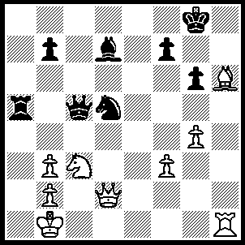
1.Ne4 1.Qb6 (1…..Qa7, 2.Qxd5 Ra1+, 3.Kc2 Rxh1, 4.Nf6+ Kh8, 5.Qe5 Qf2+, 6.Bd2 Qh2 7.f4), 2.Bg7 f6 (2…..f5, [2.Kxg7, 3.Qh6+ mates], 3.Qh2 Ra1+[3…..Kxg7,4.Qh8+ Kf7, 5.Ng5+ Ke7, 6.Qe5+ wins IF 3…..fxe4, 4.Qh7+ Kf7, 5.Bd4+],, 4.Kxa1, Qa6+, 5.Kb1 Qd3+, 6.Kc1 fxe4 [6…..Qe3+, 7.Nd2 IF 6…..Kxg7, 7.Qe5+ mates], 7.Qh7+ Kf7, 8.Bd4+ Ke6, 9.Qxg6+ Ke7, 10.Rh7+ mates),3.Bxf6 Qa6 (3…..Nxf6, 4.Nxf6+ Qxf6, 5.Qxa5), 4.Rh8+ Kf7, 5.Rf8+ Ke6 (5…..Kxf8, 6.Qh6+ Ke8 [6…..Kf7, 7.Qg7+ Ke6, 8.Qg8++], 7.Qh8+ Kf7, 8.Ng5++),6.Ng5+ Kd6, 7.Nf7+ Kc6 (7…..Kc7, 8.Qh2+ Kc6 [8…..Kb6, 9.Qd6+ Bc6, 10.Bd4+ mates], 9.Qd6+ Kb5, 10.Qxd5+ Kb6, 11.Qd6+ Kb5, 12.Qxd7+ OR 7…..Ke6, 8.Qe1+ Ne3 [8…..Kxf6, 9.Qe5++], 9.Qxe3+ Kd5 [9…..Kxf6, 10.Ng5+ mates], 10.Qe4+ Kc5, 11.Bd4+ Kb4, 12.Bc3+ Kc5, 13.Qe5+ Kc6 [13…..Kb6 14.Bd4+ mates], 14.Nd8+ mates OR 7…..Kc5, 8.b4+ Kc6 [8…..Nxb4, 9.Be7+ Kc4 [[9…..Kc6, 10.Qd6+ Kb5, 11.Qc5+ mates]] 10.Qxb4+ Kd3, 11.Qe4+ Kd2, 12.Bb4+ mates IF 8…..Kb6, 9.Qd4+ Kc7 [[9…..Kc6, 10.Nd8+ Kc7, 11.Be5+]], 10.Be5+ Kc6, 11.Nd8+ Kb5, 12.Qxd5+ wins], 9.Nd8+ Kb6 [9…..Kd6, 10.Qh2+ wins], 10.Qd4+, Kc7, 12.Qe5+ wins), 8.Ne5+ Kd6 (8…..Kc7, 9.Bd8+ Kd6, 10.Nc4+ OR 8…..Kb6, 9.Qd4+ Kc7 [9…..Rc5, 10.Nxd7+], 10.Bd8+ Kd6, 11.Nc4+ Kc6, 12.Rf6+ Nxf6, 13.Qxf6+ Kc5, 14.Be7+ Kb5, 15.Qe5+ mates), 9,Nc4+ Ke6 (9…..Kc5, 10.Qxa5+), 10.Qe1+ Ne3, 11.Qe3+ Kd5, 12.Qe4+ Kc5, 13.Be7+ mates.

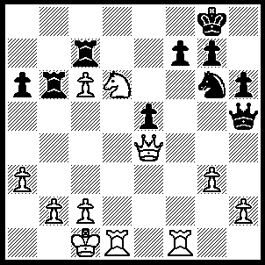
1.Nxf7 Rxf7 (1…..R(b)xc6, 2.Rd8+ Nf8 [2…..Kh7, 3.Rh8++], 3.Rxf8+ Kxf8, 4.Nd8+ Rf6, 5.Rxf6+ gxf6, 6.Ne6+ OR 1…..R(c)xc6, 2.Rf5 Qxh2, 3.Rd8+ Kh7 [3…..Nf8, 4.Nxe5 Rf6 [[4…..Qg1+, 5.Rd1]], 5.Qc4+ Kh7, 6.Rxf6 Rxf6 [[6…..gxf6, 7.Qf7+]], 7.Ng4], 4.Rf1 Rxc2+, 5.Qxc2 OR 1…..Rc8, 2.g4 Qxh2, 3.Nd6 R(8)xc6, 4.Qxg6 Rxd6, 5.Rxd6), 2.Rxf7 Qg5+ (2…..Kxf7, 3.Qc4+ Kf6 [3…..Ke8, 4.Qe6+ Ne7, 5.Rd8+ mates IF 3…..Kf8, 4.Rd8+ Ke7 5.Rd7+ Kf6, 6.Rf7+ Kg5, 7.h4+ Nxh4, 8.gxh4+ Kg6, 9.Rf8 wins Q IF 3…..Ke7, 4.Rd7+ etc], 4.Rd6+ Kf5, [4…..Kg5, 5.Qe4 Rb5, 6.h4+ Nxh4, 7.gxh4+ Qxh4, 8.Rg6+ wins Q], 5.Qd3+ e4 [5…..Kg5, 6.Qe4 etc], 6.Qd5+ Kg4 [6…..Ne5, 7.Qe6+ Kg5, 8.h4+], 7.Qd1+ Kg5, 8.Rd5+), 3.Kb1 Kxf7 (3…..Rxc6, 4.R(1)d7), 4.Qc4+ Kf6 (4…..Ke7, 5.Rd7+ Kf6, 6.Rf7++ OR 4…..Kf8, 5.c7), 5.Rf1+ Ke7 (5…..Nf4, 6.c7), 6.Qf7+ Kd6, 7.Rd1+ Kxc6, 8.Qd7+ Kc5, 9.Qd5++.

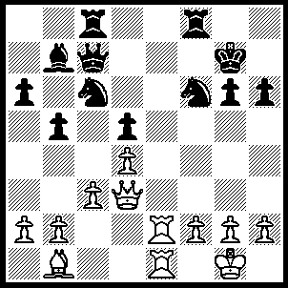
1.Qxg6+ Kh8, 2.Qxh6+ Kg8 (2…..Nh7, 3.Re7 Rf7, 4.Re8+ Rf8, 5.R(1)e7), 3.Bf5Ng4 (3…..Nd8, 4.Re7 Qxe7, 5.Rxe7 Rf7, 6.Re3 Rg7, 7.Qxf6 Nf7, 8.Be6 Bc6, 9.Bxf7+ Rxf7, 10 Qg6+ wins OR 3…..Qg7, 4.Be6+ Rf7, 5.Bxf7 Qxf7 [5…..Kxf7, 6.Re7+ Nxe7, 7.Rxe7+ Kxe7, 8.Qxg7+wins], 6.Re3 Nh5, 7.Rf3 Re8, [7…..Qh7, 8.Qg5+ Qg7 [[8…..Ng7, 9.Qxd5+]], 9.Qxd5+ Kh8, 10.Qxh5+ Qh7, 11.Re8+], 8.Rf1 Qh7, 9.Qxh7+ Kxh7, 10.Rf7+ Kg6, 11.Rxb7), 4.Bxg4 Qh7 (4…..Qg7, 5.Be6+ Rf7, 6.Bxf7+ Qxf7 [6…..Kxf7, 7.Re7+],, 7.Re3), 5.Qg5+ Qg7 (5…..Kh8, 6.Bxc8), 6.Qxd5+ Kh8 6…..Kh7, 7.Qh5+ Kg8 [7…..Qh6, 8.Re7+], 8.Be6+ Rf7, 9.Bxc8 Bc8, 10.Re8+ Rf8, 11.Rxf8+ Qxf8, 12.Re8), 7.Bxc8 Rxc8 (7…..Bxc8, 8.Re8 Bg4, 9.Qxc6), 8.Re8+ Rxe8 (8…..Kh7, 9.Qh5+ Qh6, 10.R(1)e7+),9.Rxe8+ Kh7, 10.Qh5+ Qh6, 11.Rh8+ Kxh8, 12.Qxh6+.

