FROM THE TOO HARD BOX 11

By Vern Stannard
The following position arose in a friendly practice game I played with one of the senior players in the 1999 women’s interstate telephone matches when her opponent failed to turn up. Even though I’ve reversed the colours I’m sure she will remember the position but will be surprised at the volume of tactical play it contained.

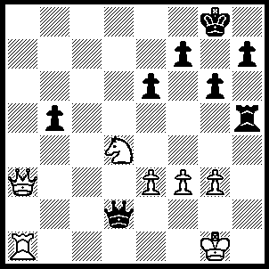1.Qa8+ Kg7, 2.Nxe6+ Kf6 (2…..fxe6, 3.Ra7+ Kf6 [2…..Kh6, 3.Qf6+ mates], 4.Qf8+ Ke5 [4…..Kg5, 5.Qf4++], 5.Qf4+ Kd5, 6.Rd7+), 3.Qh8+ Kxe6 (3…..Kf5, 4.Nd4+[also playable 4.e4+ Kxe6, 5.Ra6+ Kd7 [[5…..Ke7, 6.Qf6+ mates]], 6.Ra7+ Kd6, 7.Qd8+] Kg5, 5.Qe5+ Kh6, 6.Qf4+ Rg5 [6…..Kg7, 7.Ne6+ mates], 7.Nf5+ gxf5, 8.Ra6+ mates), 4.Ra6+ Kd7 (4…..Qd6, 5.Qe8+ Kd5, 6.Qe4+ Kc5, 7.Rc6+ Qxc6, 8.Qd4++ OR 4…..Ke7, 5.Qf6+ mates), 5.Ra7+ Kc6 (5…..Ke6, 6.Qe8+ Kd5 [6…..Kf5, 7.Rxf7+ Kg5, 8.Qe7+ mates], 7.Qd7+ wins Q), 6.Qc8+ Kd5 or d6, 7.Rd7+ Ke5, 8.Qe8+ Kf6, 9.Rxf7+ Kg5, 10.Qe7+ mates

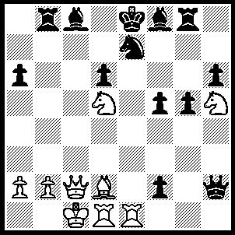1.Qc4 fxe1(Q), 2.Rxe1 Bg7 (2…..Be6 [2…..Qxh5, 3.Nf6+ Kd8, 4.Ba5+ mates OR 2…..Qe5, 3.N(d)f6+ Kd8, 4.Rxe5 Rb5, 5.Qxb5 Be6, 6.Ba5+ Kc8, 7.Qxa6+ mates], 3.N(d)f6+ Kf7, 4.Qxe6+ Kg6, 5.Nxg8+ Kh7 [5…..Kxh5, 6.Nf6+ Kh4 [[6…..Kg6, 7.Ng4+ wins Q]], 7.Re4+ wins], 6.Nxe7 mates), 3.N(h)f6+ Bxf6 (3…..Kf7, 4.Nxe7+ Kxf6, 5.Bc3+ Qe5, 6.Nxg8+ wins OR 3…..Kf8, 4.Nh7+ Kf7 [4…..Ke8, 5.N(d)f6+ mates], 5.Nxe7+ d5 [5…..Ke8, 6.Nxc8+ mates], 6.Qxd5+ Ke8, 7.Ng6+ Qe5 [7…..Be5, 8.Nf6++], Nxe5 wins], 4.Nxf6+ Kf8, (4…..Kd8, 5.Ba5+ mates), 5.Nh7+ Ke8 (5…..Kg7, 6.Rxe7+ Kh8, 7.Bc3+ Rg7 [7…..Qe5, 8.Bxe5 dxe5, 9.Nf6 Rg7, 10.Qg8+ Rxg8, 11.Rh7++], 8.Bxg7+ Kxh7, 9.Bf6+ mates), 6.Qxg8+ Kd7, 7.Nf6+ Kc6 (7…..Kc7, 8.Rxe7+ mates), 8.Qc4+ Kb7, 9.Rxe7+ Ka8, 10.Ne8 Qg1+ Kc2 Bb7, 12.Nc7+ Ka7, 13.Be3+ Qxe3, 14.Qxe3.

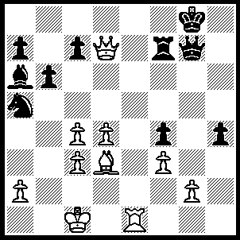1.Re8+ Rf8, 2.Qd5+ Qf7 (2…..Kh8, 3.Rxf8+ Qxf8, 4.Qh5+ Kg7, 5.Qg6+ mates), 3.Re6 Qg7 (3…..Qxe6, 4.Qxe6+ Rf7, 5.Bg6 mates), 4.Rg6+ Rf7, 5.Qd8+ Rf8 (5…..Kh7, 6.Rh6+ Kxh6, 7.Qxh4++), 6.Qe7 Rf7 (6…..Qxg6, 7.Bxg6 forces mate e.g. 7.Rf6, 8.Qh7+ Kf8, 9.Qh8+ Ke7, 10.Qe8+ Kd6, 11.Qd8+ Ke6, 12.d5+ Ke5, 13.Qe7+ mates OR 7…..Rf5, 8.Bh7+ Kh8, 9.Bxf5 Kg8,10.Be6+ Kh8, 11.Qf8+ Kh7, 12.Bf5++), 7.Qe8+ Rf8 (7…..Kh7, 8.Rf6+ wins), 8.Rxg7+ Kxg7, 9.Qg6+ Kh8, 10.Qh7++.

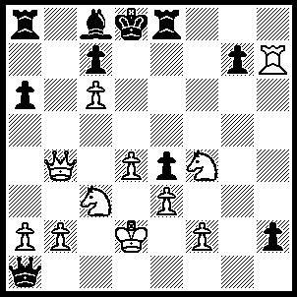1.Rxg7 Qc1+ (1…..h1(Q), 2.Qd6+ mates OR 1…..Ra7, 2.Ne6+ Rxe6 [2…..Bxe6, 3.Qb8+ mates], 3.Qf8+ Re8, 4.Qf6+ mates), 2.Kxc1 h1(Q)+, 3.Kd2 Qh6, 4.Rxc7 Qxf4 (4…..Kxc7, 5.N(3)d5+ Kxc6 [5…..Kd8, 6.Qa5++], 6,Qc5+ Kd7 or b7, 7.Qc7++ OR 4…..Bg4, 5.N(3)d5 Re5, 6.Ne6+ Qxe6 [6…..Bxe6,7.Qe7++ IF 6.Rxe6, 7.Rd7+ Ke8, 8.Nc7++], 7.Qf8+ Qe8, 8.Qd6+mates OR 4…..Re6, 5.Nxe6+ Qxe6, 6.Rh7 Ke8, 7.Rh8+ Kf7, 8.Qf8+ Kg6, 9.Rh6+ mates OR 4…..Qf6, 5.Nxd5 wins), 5.exf4 Kxc7, 6.Nd5+ Kxc6, 7.Qc5+ Kd7, 8.f5 e3+, 9.Kd3 Ra7 (9…..Re6, 10.Qc7+ Ke8, 11.fxe6 mates), 10.Qxa7+ Bb7, 11.Qxb7+ Kd6, 12.Qc7+ Kxd5, 13.Qc5++.

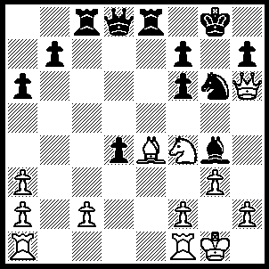 1.Bf5 Be2 1…..Bf3, 2.g4 Kh8, 3.Nh5 Rg8, 4.Bxc8 Qxc8, 5.Nxf6 Rg7 [5…..Nf8. 6.Qf4], 6.R(f)e1 Nf8, 7.Re8 Qc5, 8.h3 Qd6 [to stop Nxh7], 9.Qf4 Rxg4+, 10.hxg4 Qxf4, 11.Rxf8+ Kg7, 12.Nh5+ Kxf8, 13.Nxf4 OR 1…..Nxf4, 2.Bxh7+ mates), 2.g4 Kh8, 3.Nh5 Rg8,4.Bxc8 Bxf1, 5.Kxf1 Qxc8, 6.Nxf6 Rg7 (6…..Nf8, 7.Nxg8 OR 6…..Qc4+, 7.Kg1 Rg7 [7…..Nf8, 8.Ne8 Qc4+, 9.Re2 Ne6, 10.Nxg7 Nxg7, 11.Qf6 Qc8, 12.Qxf7], 8.Re1 Nf8, 9.Re8 as in game), 7.Re1 Qc4+, 8.Kg1 Nf8, 9.Re8 Qc5, 10.h3 Qd6 [to stop Nxh7], 11.Qf4 Qxa3, 12.Nd7 Kg8, 13.Qb8 Rg5 (13…..Rg6, 14.Rxf8+ Kg7, 15.Rg8+ Kh6, 16.Qf4+ mates), 14.Rxf8+ Kg7, 15.Rg8+ Kh6, 16.Qd8 Qc1+ (16…..Rxg8, 17.Qh4+ mates), 17.Kg2 Qf4, 18.Qf8+ mates.

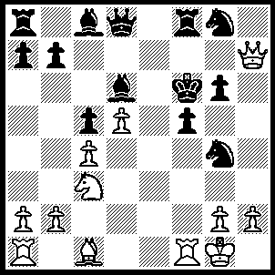
1.Bg5+ Ke5 (1…..Kxg5, 2.Ne4+ fxe4, 3.h4++), 2.Qh8+ N(g8)f6 (2…..N(g4)f6, 3.R(a)e1+ Kd4, 4.Qh4+ Ne4 [4…..Ng4, 5.Qxg4+ fxg4, 6.Re4+ Kd3, 7.Rd1+ Kc2, 8.Re2++], 5.Rxe4+ Kd3 [5…..fxe4, 6.Qxe4++], 6.Re3+ Kc2, 7.Qf2++ OR 2…..Rf6, 3..R(a)d1 f4 [[stops Bf4++]], 4.Bxf4+ Kf5, 5.Bxd6+ Nf2 [5…..Kg5, 6.h4++], 6.Rxf2+ Kg4 [6…..Kg5, 7.Ne4+ Kg4, 8.h3++], 7.Qh3+ Kg5, 8.Ne4++), 3.R(a)d1 Nf2 (3…..f4, 4.Bxf4+ Kf5, 5.Bg3+ Nf2, 6,Rxf2+ Bf4 [6…..Kg5, 7.Qh4++], 7.Rxf4+ Ke5, 8.Rxf6++), 4.Rxf2 f4, 5.Bxf4+ Kf5, 6.Bg3+ Bf4, 7.Rxf4+ Kg5 (7…..Ke5, 8.Rxf6++), 8.Qh4++

