FROM THE TOO HARD BOX 14
By Vern Stannard
The following position arose in a very interesting game as follows.
1.e4 c5, 2.Nf3 d6, 3.d4 cxd4, 4.Nxd4 Nf6, 5.Nc3 a6, 6.Be3 e6, 7.g4 e5, 8.Nf5 g6, 9.g5 gxf5, 10.exf5 d5, 11.gxf6 d4, 12.Bc4 Qc7, 13.Qd3 dxe3, 14.0-0-0 exf2, 15.Bxf7+ Kxf7, 16.Qd5+ Kxf6, 17.Ne4+ Kxf5, 18.R(h)f1 Bh6+ Kb1, Qe7, 20.Rxf2+ Bf4.

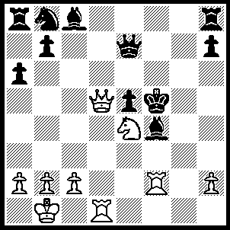
21.Rxf4+ Kxf4 (21…..Kg6, 22.Rg1+ Kh5 [22…..Kh6, 23.Qd6+ Qxd6, 4.Rh4++], 23.Nf6+ Qxf6, 4.Qf3+ Bg4, 5.Qxg4 Kh6, 6.Rxf6++), 22.Rf1+ Kg4, 23.Nf6+ Kg5 (23…..Qxf6, 24.Rxf6 Nc6, 25.Qg2+ Kh5, 26.Qf3+ Kg5 [26…..Bg4, 27.Rf5+], 27.h4+ Kxh4, 28.Rh6+ Kg5, 29.Qf6+ Kg4, 30.Rh1 Bf5, 31.Rh4+ Kg3, 32.Qg5+ Kf2, 33.Qxf5+ mates OR 23…..Kh4, 24.Qf3 Qxf6, 5.Qxf6 mates),24.h4+ Kg6 (24…..Kxh4, 25.Qe4+ mates OR 24…..Kh6, 25.Qd2+ Kg6, 26.Qg5+ Kf7, 27.Ng8+ wins),25.Qg2+ Kf7, 26.Ng6+ Ke8, 27.Nxe7, Kxe7 (27…..Bd7, 28.Qg7+ wins OR 27…..Nc6, 28.Nxc8 wins), 28.Qg7+ Ke6, 29.Qf6+ Kd5, 30.Rd1+ Kc4, 31.Qb6+ Nc6 (31…..Bf5, 32.b3+ Kc3, 33.Qa5++), 32.b3+ Kc3, 33.Rd3++.

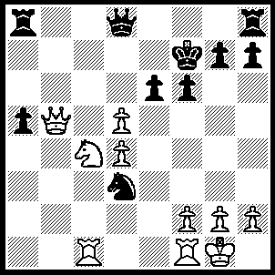
1.dxe6+ Kxe6 (1…..Kg8, 2.e7 wins R OR 1…..Kf8, 2.Qb7 Qe8, 3.Nd6 wins R OR 1…..Ke7, 2.Qb7+ Kxe6, 3.Qe4+ wins N OR 1…..Kg6, 2.Ne3 wins N), 2.Qc6+ Kf7 (2…..Ke7 or Kf5 loses N), 3.Nd6+ Kg6 (3…..Kg8, 4.Qd5+ mates OR 3…..Kf8, 4.Qd5 Ra7, 5.Rc8 wins Q OR 3…..Ke7, 4.Qe4+ Kf8 [4…..Kd7, 5.Nf5 wins N IF 4…..Kxd6, 5.Rc6+ mates], 5.Qe6 Qe7 [5…..Ra7, 6.Rc8], 6.Rc8+ mates), 4.Qe4+ Kh5, 5.Qf3+ Kh6 (5…..Kg6, 6.Qg4+ mates), 6.Qh3+ Kg5, 7.Qf5+ Kh6, 8.Nf7++.

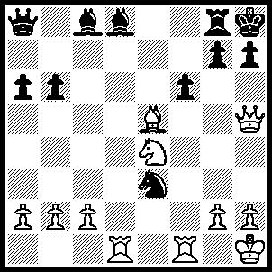
1.Qf3 Nxf1 (1…..Nxd1, 2.Nd6 Qa7, 3.Nxc8 Qd7 [3…..Qf7, 4.Rxd1 Qxa2, 5.Bg3 h6, 6.Qe4 Bc7, 7.Ne7 Rd8, 8.Rxd8 Bxd8, 9.Ng6+ Kh7, 10.Nf4+ Kh8 [[10…..Kg8, 11.Qd5+]], 11.Bf2], 4.Nd6 Nxb2, 6.Bxb2 Be7, 7.Rd1 Rd8, 8.Ba3 Qe2, 9.Qf3 OR 1….fxe5, 2.Rxd8 h6 [2…..Nxf1, 3.Rxg8+ Kxg8, 4.Nf6+], 3.Rxg8+ Kxg8, 4.Qf7+ Kh8 [4…..Kh7. 5.Nf6+ mates], 5.Qe8+ Kh7, 6.Rf8 mates OR 1…..Be7, 2.Ng5 Be6, 3.Qxe3 fxg5, 4.Bd4 Qc8, 5.R(d)e1 OR 1…..Bb7, 2.Nd6 h6 [2…..Re8, 3.Qxb7 Qxb7, 4.Nxb7, Nxf1, 5.Rxf1 fxe5, 6.Nd6 IF 2…..Rf8, 3.Qxb7 Qxb7, 4.Nxb7, Nxd1 5.Rxd1], 3.Qxb7 Qxb7, 4.Nxf7 Nxf1 [4…..Nxd1, 5.Rxd1 Be7, 6.Bg3], 5.Nxd8, Ne3, 6.Rd3), 2.Nd6 Qa7, 3.Nxc8 Qf7, 4.Nd6 Qxa2 (4…..Qe7, 5.Qxf1 Bc7, 6.Qc4 Bxd6, 7.Bxd6 Qd7, 8.Qxa6), 5.b3 h6 (5…..Rf8, 6.Nf7+ Kg8, 7.Nxd8 Ne3, 8.Qxe3 Qxc2 [8…..fxe5, 9.Qxe5 h6, 10.Ne6 Rf7, 11.Rd8+ Kh7, 12.Qe4+ g6, 13.Nf8+ mates], 9.Qf3 h6, 10.Bg3), 6.Nf7+ Kh7, 7.Qf5+ g6, 8.Ng5+ hxg5 (8…..Kh8, 9.Bxf6+ Bxf6, 10.Qxf6+ Rg7, 11.Rd8++ OR 8…..Kg7, 9.Rd7+ Kf8 [9…..Be7, 10.Qxf6++], 10.Rxd8+ Ke7, 11.Bxf6++), 9.Rd7+ Rg7, 10.Qh3+ Kg8, 11.Rxd8+ Kf7, 12.Qd7++.

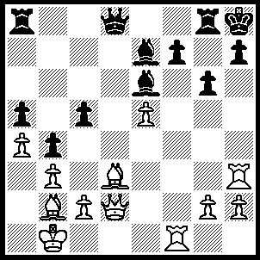
1Rxf7 Bxf7 (1…..Rg7, 2.Rxg7 Kxg7, 3.Qh6+ Kf7, 4.Qxh7+ Kf8 [4…..Ke8. 5.Bb5+ Kf8 [[5…..Bd7, 6.Qxg6+ mates]], 6.Qh8+ Bg8, 7.Qh6+ Kf7, 8.e6+ Kxe6, 9.Re3+ Kd5 [[9…..Kf5, 10.Re5+ Kf6, 11.Qf4+ Kg7, 12.Re7++ IF 9…..Kd6, 10.Qf4+ Kd5, 11.Qe5++]] 10.Qxg6 Bf6, 11.Qe4+ Kd6, 12.Qc6++), 5.Qh8+ Bg8, 6.e6 Bg5 [6…..Bd6, 7.Qxg8+ mates], 7.Qg7+ Ke8, 8.Bxg6+), 2,e6+ Bf6 (2…..Rg7, 3.Bxg7+ Kxg7 [3…..Kg8, 4.Qh6 Bxe6, 5.Qxh7+ Kf7, 6.Bxg6++], 4.Qh6+ Kf6, 5.Qf4+ Kxe6, 6.Bc4+ Kd7, 7.Rd3+), 3.Qh6 Rg7, 4.exf7 Ra7 (4…..Qe7, 5.Bxg6 Rxf7, 6.Bxf7 Qxf7, 7.Bxf6+ OR 4…..Rxf7, 5.Qxg6 R(8)a7, 6.Bxf6+ Qxf6, 7.Rxh7+ OR 4.Bxb2, 5.Bxg6 Qd1+ [5…..Qf8, 6.Qxh7+ mates], 6.Kxb2 Qd4+, 7.Ka2 Rxf7, 8.Bxf7), 5.Bxf6 Qxf6, 6.Rf3 Qxf3, 7.gxf3 R(g)xf7, 8.Qg5.

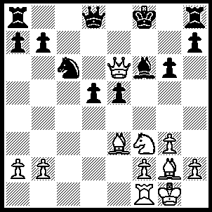
1.Nxe5 Bxe5 (1…..Qe7, 2.Bc5 OR 1.Nxe5, 2.Bh6+ Bg7, 3.Qxe5 Bxh6 [3…..Qd7, 4.Qf6+ Qf7, 5.Qd6+ Qe7, 6.Bxg7+ IF 3…..Qe7, 4.Qf4+ Ke8, 5.Bxg7 Qxg7, 6.Re1+ Kd8 [[6…..Kd7, 7.Bh3+]], 7.Qd6+ Qd7, 8.Qf6+ Kc7, 9.Rc1+ Qc6, 10.Qe7+ Kb6 [[10…..Kb8, 11.Qe5+]], 11.Qe3+ Kc7, 12.Bxd5 Qxc1+, 13.Qxc1+], 4.Qxh8+ Kf7, 5.Bxd5+ Ke7, 6.Re1+ Kd6 [6…..Kd7, 7.Qxh7+ Kd6, 8.Qxb7 Rc8, 9.Re6+ Kc5, 10.Bb3], 7.Qe5+ Kc5 [7…..Kd7, 8.Bxb7 wins], 8.Bg2+ Kb6 [8…..Kc4, 9.Bf1+ Kb4, 10.Re4+], 9.b4 mates), 2.Bxd5 Qc7 (2…..Qe7, 3.Bc5 OR 2.Qe8, 3.Bh6+ Bg7, 4.Qf6+ OR 2…..Qxd5, 3.Qxd5 Re8, 4.Bh6+ Bg7 [4…..Ke7, 5.Rd1 Kf6, 6.f4 Bxb2, 7.Bg5+ Kg7, 8.Qd7+], 5.Qf3+ Kg8, 6.Qb3 Kf8, 7.Bxg7+ Kxg7, 8.Qxb7+ Ne7, 9.Re1 Kf7, 10.Qxa7), 3.Bh6+ Bg7, 4.Qf6+ Ke8, 5.Bxc6+ Qxc6 (5…..bxc6, 6.Re1+ Kd7, 7.Qe6+ Kd8, 8.Rd1+ mates), 6.Re1+ Kd7, 7.Qxg7+ Kd6, 8.Qe7+ Kd5, 9.Qe5+ Kc4, 10.Rc1+ Kb4, 11.Bd2+ Qc3, 12.Bxc3+.

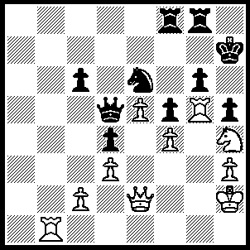
1.Rb7+ Rf7 (1…..Kh8, 2.Rxh5+ mates OR 1…..Rg7, 2.Ng6 Nxf4 [2…..Rxb7, 3.Nxf8+ mates IF 2…..R(8)f7, 3.Qh5+ Kg8, 4.Qh8++], 3.Nxf8+ Kg8, 4.R(7)xg7+ Kxf8, 5.Rg8+ Qxg8, 6.Rxg8+ Kxg8, 7.Qf3 OR 1…..Kh6, 2.Rxh5+ gxh5, 3.Qxh5+ Kxh5, 4.Rh7++), 2.Rxf7+ Rg7, 3.Rxg6 Kg8 (3….Kh8, 4.Qxh5+ Kg8, 5.Nxf5 mates),4.Qxh5 Kxf7, 5.Rxg7+ Kxg7, 6.Nxf5+ Kf8 (6…..Kg8, 7.Ne7+ wins Q), 7.Qh8+ Kf7 8.Qf6+ Kg8, 9.Ne7+ Kh7, 10.Qg6+ mates.
.

