FROM THE TOO HARD BOX 15
by Vern Stannard
In the first position White [a pawn down] can force the win of the exchange. With best play black can end up with a superior position, the two bishops and a pawn as good compensation. Given the chance, White delayed the win of the exchange by keeping up the pressure and controlling the game until a more favourable position was reached.
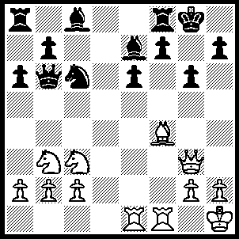
1.Bc7 Qa7 (1…..Qb4, 2.Re4), 2.Na4 Bd8 [better is 2…..f6, 3.Nb6 e5, 4.Nxa8 Qxa8, 5.Bb6 Be6, 6.Nd4 Nxd4, 7.Bxd4 Qc8, 8.Bc3 Qc6], 3.Nb6 Bxc7, 4.Qxc7 Rb8, 5.Rf6 Ne7, 6.R(1)f1 Nf5, 7.Nd4 Ra8, 8.c3 a5, 9.g4 Nh6(9…..Kg7, 10.gxf5 Kxf6, 11.fxe6+ Kg7, 12.Nf5+ gxf5 [12…..Kh8, 13.Qe7], 13.Qe5+ f6, 14.Rg1+ Kh8, 15.Qg3),, 10.h3 a4, 11.Kg1 Qa6, 12.Nxa8 Qxa8, 13.Qf4 Kg7, 14.Qe5 Kg8, 15.Qg5 Kg7, 16.R(6)f3 f5, 17.Qe7+ Nf7, 18.Nxe6+ Bxe6, 19.Qxe6.

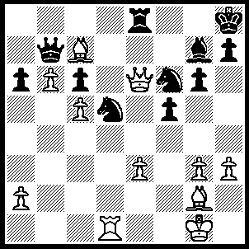
1.Bxd5 Rxe6 (1…..cxd5, 2.c6 Qa8 [2…..Rxe6, 3.cxb7 Nd7, 4.Rxd5], 3.Qd6 Ne4, 4.Qd7 Nf6, 5.Qd6 Ne4, 6.Qxd5 Nc3, 7.Qf7 Rf8, 8.b7 Qa7 [8…..Rxf7, 9.bxa8(Q)+ Rf8 [[9…..Bf8, 10.Be5+]], 10.Rd8], 9.Qxf8+ Bxf8, 10.Rd3 Nb5, 11.b8(Q) Qc5, 12.Ba5 Kg7, 13.c7 Nxc7, 14.Qxc7+), 2.Bxe6 Nd5 (2…..Bf8, 3.Rd8 Kg7, 4.Bc8 Qa8, 5.b7 Qa7, 6.b8(Q) Qxc5, 7.Qb3), 3.Rxd5 cxd5, 4.Bd7 Bh6, 5.c6 Bxe3+, 6.Kg2 Qxb6 (6…..Bxb6, 7.Be5+ Kg8, 8.cxb7 Ba7, 9.Be6+ Kf8, 10.Bxd5), 7.Be5+ Kg8, 8.c7 Qxc7 (8…..Qb1, 9.c8(Q)+ Kf7, 10.Qe8++), 9.Bxc7 d4, 10.Be6+ Kf8, 11.Bc4.

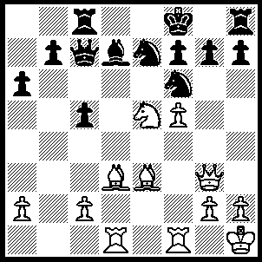
1.Bf4 Qa5 (1…..Nh5, 2.Qg5 Nxf4 [2…..Nf6, 3.Ng6+ IF 2…..f6, 3.Nxd7+], 3.f6 Ke8 [3…..gxf6, 4.Qxf6], 4.Qxg7 Rf8 [4…..N(7)g6, 5.Bxg6 Nxg6, 6.Qxf7+ Kd8, 7.Rxd7+], 5.fxe7 Kxe7, 6.Rxf4 OR 1…..Qb6, 2.Nxd7+ Nxd7, 3.Bd6 Re8 [3…..Rc6, 4.Bxe7+ Kxe7, 5.Bc4 R(8)c8, 6.R(f)e1+ Kf8 [[6…..Kd8, 7.Bxf7]], 7.Rxd7 Rf6, 8.Qe5], 4.R(f)e1 h6, 5.Rxe7, Rxe7, 6.Re1 Kg8, 7.Rxe7 Nf8 [7…..Nf6, 8.Bc4 Rh7, 9.Bxc5 Qd8, 10.Rxb7], 8.Bc4 Qb1+, 9.Re1 Qb2, 10.c3 Kh7, 11.Bxf7 Rg8, 12.Bxg8 OR 1…..Qd8, 2.Bc4 b5, 3.Nxd7+ Nxd7, 4.f6 Ng6 [4…..Nf5, 5.fxg7+ Nxg7 [[5…..Kg8, 6.gxh8(Q)+ Kxh8, 7.Be5+ f6 , 8.Rxf5]], 6.Bd6+ Kg8, 7.Bxf7++], 5.Bd6+ Kg8, 6.fxg7 bxc4, 7.gxh8(Q)+ Kxh8, 8.Rxf7 Qe1, 9.Qc3+ N(d)e5, 10.Bxe5+ Nxe5 [10…..Qxe5, 11.Qh3], 11.R(1)d7), 2.Nxd7+ Nxd7, 3.Bd6, Re8, 4.R(f)e1 h3, 5.Rxe7 Rxe7, 6.Re1 Qd8, 7.Bxe7+ Qxe7, 8.Rxe7 Kxe7, 9.Qxg7 Re8, 10.Qxh6.

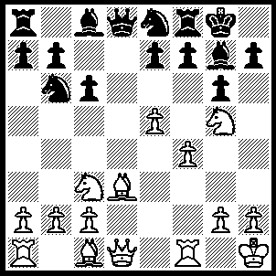
1.Nxh7 Bg4 (1…..Kxh7. 2.Bxg6+ fxg6, 3.Qxd8), 2.Qxg4 Kxh7, 3.f5 Nc7 (3…..Nd7, 4.fxg6+ Kg8, 5.Qh3 fxg6 [5…..N(8)f6, 6.exf6 Nxf6, 7.Rxf6], 6.Bc4+ Rf7, 7.Bxf7+ Kf8, 8.Be6+ N(8)f6, 9.Qh7 mates OR 3…..Kg8, 4.fxg6 fxg6, 5.Qe6+ Kh8, 6.Rxf8+ Bxf8, 7.Qxg6 mates), 4.fxg6+ Kg8,5.gxf7+ Rxf7, 6.Rxf7 Kxf7 6…..Ne8, 7.Bh6 Kxf7, 8.Rf1+ Kg8 [8…..Nf6, 9.e6+ mates], 9.Qe6+ Kh8, 10.Bxg7+ mates), 7.Qg6+ Kg8 (7…..Kf8, 8.Bh6 Ne6 [8…..Bxh6, 9.Rf1+ mates], 9.Rf1+ mates), 8.Bh6 Ne8 (8…..Qf8, 9.Qh7+ Kf7, 10.Bxg7), 9.Qh7+ Kf7 (9…..Kf8, 10.Rf1+ Nf6, 11.Bg6 mates), 10.Rf1+ Nf6, 11.Qxg7+ Ke6, 12.Bf5+ Kxe5, 13.Qg3+ Kd4, 14.Rf4+ Kc5 (14…..Ke5, 15.Re4+ Kxf5, 10.Qg5++), 15.b4+ Kd6, 16.Rd4++.

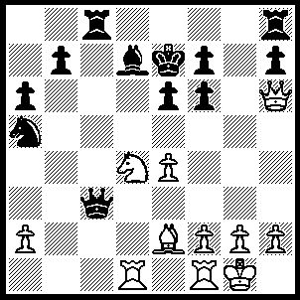
1.e5 fxe5 (1…..R)h(d8, 2.Qxf6+ Kf8, 3.Bh5 Be8, 4.Nxe6+ OR 1…..R(h)g8, 2.Nf5+ Kd8 [2…..Ke8, 3.Nd6+ Kd8, 4.Qxf6+ Kc7, 5.Rc1 IF 2…..exf5, 3.Qxf6+ Ke8,4.Rxd7 Kxd7 [[4…..Rxg2+, 5.Kh1 Rxh2+, 6.Kxh2]] 5.Qxf7+ Kc6, 6.Qe6+ mates], 3.Qxf6+ Kc7, 4.Rxd7+ Kxd7 [4…..Kb8, 5.Ne7 R(g)d8, 6.Nd5], 5.Qe7+ Kc6, 6.Qd6++ OR 1…..R(c)f8, 2.Qxf6+ Ke8, 3.Nxe6 fxe6 [3....Qc8, 4.Ng7++], 4.Bh5+ Rf7, 5.Qxf7+ Kd8, 6.Qxd7++),2.Nf5+ exf5 (2…..Ke8, 3.Nd6+ Kd8 [3…..Ke7, 4.Qg5+] 4.Nxf7+ Ke7 [4…..Kc7, 5.Rc1 IF 4…..Ke8, 5.Qf6], 5.Qg5+ Kxf7, 6.Bh5+ mates OR 2…..Kd8, 3.Qf6+ Kc7, 4.Rxd7 Kb8 [4…..Kxd7, 5.Qe7+ Kc6, 6.Qd6++ IF 4…..Kb6, 5.Ne7, Qb2, 6.Nxc8+], 5.Nd6 Qc6, 6.Qxe5 R(h)g8 [6…..Qxd7, 7.Nxc8+ Kxc8, 8.Qxh8+ IF 6…..R(c)g8, 7.Nxb7+ Ka8 [[7…..Ka7, 8.Nxa5+ Qxd7, 9.Qc5+ wins]], 8.Rd8+ Ka7 [[8…..Rxd8, 9.Nxd8]], 9.Qb8+ Kb6, 10.Rb1+], 7.Ne4+ Ka8, 8.Rd6 Nc4, 9.Rxc6), 3.Qd6+ Ke8, 4.Qxd7+ Kf8, 5.Bh5 Qc7 (5…..Rc7, 6.Qd8+Kg7, 7.Qg5+ mates), 6.Qxf5 Kg7, 7.Rd7 Qc6 (7…..Qxd7, 8.Qxd7 R(h)f8 [8…..R(c)f8, 9.Qg4+ Kh6 [[9…..Kf6, 10.Rd1]], 10.Bxf7], 9.Bxf7 R(c)d8, 10.Qe7 Nc6, 11.Qxb7), 8.Rxf7+ Kh6 (8…..Kg8, 9.Re7 Rf8, 10.Bf7+ Kg7, 11.Bg6+ Kg8, 12.Bxh7+ mates), 9.Bf3 Qg6, 10.Qh3+ Kg5, 11.Qg4+ Kh6, 12.Qh4+ Qh5, 13.Qxh5++.

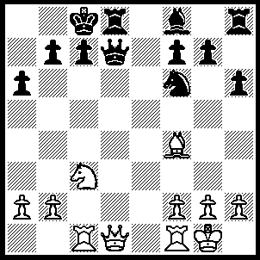
1.Na4 Qe7 (1…..Kb8, 2.Rxc7 Qxd1 [2…..Qd4, 3.Rc4+], 3.Rc8+ Ka7 [3…..Kxc8, 4.Nb6++], 4.Bb8+ Ka8, 5.Nb6++ OR 1…..Qxd1, 2.Rxc7+ Kb8, 3.Rc8+ mates OR 1…..Qxa4, 2.Rxc7+ Kb8, 3.Qxd8+ Ka7, 4.Rc8 mates), 2.Nb6+ Kb8, 3.Rxc7 Rxd1 (3…..Qxc7, 4.Qxd8+), 4.Rxe7+ Ka7, 5.Nc8+ Ka8, 6.Rxd1 Bxe7, 7.Nxe7.

