FROM THE TOO HARD BOX 16
By Vern Stannard
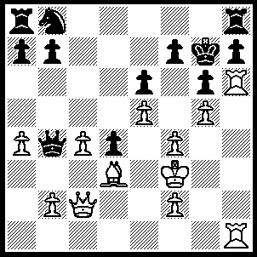
1.Bxg6 Kf8 (1…..fxg6, 2.Qxg6 hxg6 [2…..Kf8, 3.Rxh7 mates], 3.Rxh8 mates OR 1…..Nc6, 2.Rxh7+ Rxh7, 3.Rxh7+ Kf8, 4.Bxf7 returns to main line), 2.Bxf7 Nc6 (2…..Kxf7, 3.Rxh7+ Rxh7, 4.Rxh7+ mates OR 2…..Kg7 3.Rxh7+ Rxh7 [3…..Kf8, 4.Qg6 mates], 4.Qg6+ Kf8, 5.Qg8+ mates OR 2…..Qe7, 3.Rxh7 Rxh7, 4.Rxh7 Qxf7, 5.Rxf7+ Kxf7, 6.Qh7+ Ke8, 7.Qxb7),3.Rxh7 Rxh7, 4.Rxh7 Ke7 (4…..d3, 5.Qxd3 Ke7 [5….Rd8, 6.Qg6 mates], 6.Bxe6+ Kf8, 7.Rh8+ Ke7, 8.Qd7++ or 4…..Ne7, 5.Rh8+ mates), 5.Bxe6+ Kd8, 6.Rd7+ Kc8, 7.Qh7 Qf8, 4.Rd8+ Kxd8, 9.Qd7++.

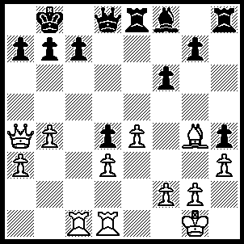
1.Rxc7 Kxc7, 2.Qxa7 Bc5 (2…..Re5, 3.Rc1+ Rc5 [3…..Bc5, 4.bxc5 as in game], 4.bxc5 Qe8 [4…..Qe7, 5.Rb1 wins], 5.c6 wins OR 2…..f5, 3.Rc1+ Kd7 [3…..Kd6, 4.Qc5+ Kd7, 5.Qxf5+ Kd6, 6.Qc5++], 4.Bxf5+ Ke7, 5.Qxb7+ Kf6, 6.Rc8 Qe7 [6…..Qxc8, 7.Bxc8 Bd6, 8.Qd7 Rxc8, 9.Qxd6+ Kf7, 10.Qd7+ Kg6, 11.Qxd4], 7.Qc6+ Qe6 [7…..Kf7, 8.Qd5+ Kf6 [[8…..Qe6, 9.Bxe6+ Rxe6, 10.Rc6 Rh6, 11.f4]], 9.Rc6+ Kg5, 10.Rg6+ Kf4, 11.Rg4++ IF 7…..Kg5, 8.Qg6+ Kf4, 9.g3+ hxg3, 10.Qxg3++], 8.Bxe6 Rxe6, 9.Qd5 Kf7, 10.Qd7+ Kf6 [10…..Re7, 11.Qf5+], 11.f4 wins), 3.Rc1 Re5, 4.bxc5 Kc6, 5.Rb1 Rxc5, 6.Qxb7+ Kd6, 7.Rb6+ Ke5 7…..Qxb6, 8.Qxb6+ Rc6, 9.Qxd4+), 8.Re6+ Kf4, 9.Qxg7 Rc6, 10.g3+ hxg3, 11.Be2 Rc1+ (11…..Rg8, 12.Qh6+ Kg5, 13.h4 mates), 12.Kg2 Rg1+ 13. Kxg1 gxf2+, 14.Kxf2 Rg8, 15.Qh6+ Rg5, 16.Qh4+ Rg4, 17.Qxg4++.

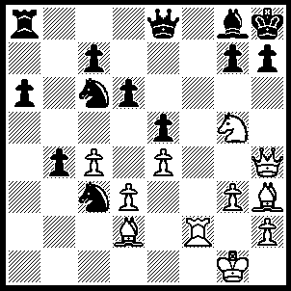
1.Be6 h6 (1…..g6, 2.Nf7+ Bxf7, 3.Qf6+ Kg8, 4.Bxf7+ wins),, 2.Rf6 Bxe6 (2…..Qe7, 3.Rxh6+ gxh6, 4.Qxh6 Bh7, 5.Nf7+ Kg8, 6.Nxe5+ Kh8, 7.Ng6++), 3.Nxe6 Qe7 3…..Qd7, 4.Bxh6 gxf6 [4…..gxh6, 5.Rxh6+ Kg8, 6.Rg6+ mates], 5.Qxf6+ Kh7 [5…..Kg8, 6.Qg6+ Kh8, 7.Bg7+ Kg8, 8.Bf6+ mates], 6.Bf8 Nd4 [6…..Ne2+, 7.Kh1Nf4 [[7…..Nd4, 8.Qh6+ mates]], 8.gxf4 Rf8, 9.Nxf8+], 7.Qh6+ Kg8, 8.Qg6+ mates), 4.Bg5 Re8 (4…..Ne2+, 5.Kg2 N(f)d4, 6.Rxh6+ Kg8, 7.Qh5 mates OR 4…..b3, 5.Rxh6+ gxh6 [5…..Kg8, 6.Qh5 gxh6, 7.Qg6+ mates], 6.Bxe7 mates), 5.Rxh6+ gxh6 (5…..Kg8, 6.Qh5 wins), 6.Bxe7 Rxe7 (6…..Kh7, 7.Nf8+ Rxf8, 8.Bxf8 Kg6, 9.Qxh6+ Kf7, 10.Qg7+ Ke8, 11.Qxc7 Kxf8, 12,Qxc6),7.Qxh6+ Kg8, 8.Qf8+ Kh7, 9.Ng5+ Kg6, 10.Qf5+ Kh6 (10…..Kg7, 11.Qh7+ mates), 11.Qf6+ Kh5, 12.g4+ Kxg4, 13.Qf5+ Kh5, 14.Nf7+ Kh4, 15.Qg5+ Kh3, 16.Qg3++.
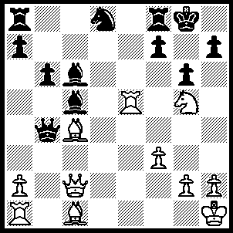
1.Nxh7 Kxh7 (1…..Bd4, 2.Qxg6+ Kh8, 3.Qh6), 2.a3 Qa4 (2…..Ba4, 3.Rh5+ Kg7, 4.Bh6+ Kh8, 5.Qe4 Qc3 [5…..gxh5, 6.axb4 Re8, 7.Qxa8 Bd4, 8.Rf1 IF 5…..Qxc4, 6.Bxf8+ Kg8 [[6…..gxh5, 7.Qe5+]], 7.Rh8+ Kxh8, 8.Qe5+], 6.Bd2+ gxh5 [6….Kg7, 7.Bxc3+ f6, 8.Qh4 gxh5, 9.Qg5+ Kh7,10.Bd3+], 7.Bxc3+ f6, 8.Qg6 mates OR 2…..Qa5, 3.Rh5+ Kg7, 4.Qb2+ Bd4 [4…..f6, 5.Bh6+ Kh8, 6.Bxf8+ gxh5, 7.Qxf6+] 5.Qxd4+ f6, 6.Rxa5), 3.Rh5+ Kg7, 4.Qb2+ f6, 5.Bh6+ Kh7, 6.Bxf8+ gxh5, 7.Qb1+ Kh8, 8.Qg6 mates.

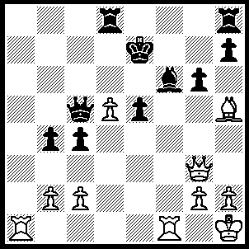
1.Rxf6 Kxf6, 2.Rf1+ Kg7 (2…..Ke7, 3.Qxe5+ Kd7, 4.Bg4++), 3.Bxg6 hxg6 (3…..Qxd5, 4.Be8+ mates OR 3…..g6, 4.Be4++), 4.Qxe5+ Kg8 (4…..Kh6, 5.Rf4 g5, 6.Qf6+ Kh5, 7.Qf7+ Kh6, 8.Rf6++ OR 4…..Kh7, 5.Rf4 g5, 6.Qf5+ mates), 5.Qe6+ Kh7, 6.Rf7+ Kh6, 7.Qh3+ Kg5, 8.Qg3+ Kh5, 9.Qe5+ g5 (9…..Kh6, 10.Rf4 wins), 10.Qe2+ Kh4 (10…..Kh6, 11.Qe6+ Kh5, 12.Rg7 wins), 11.g3+ Kh3, 12.Qf1+ Kg4, 13.Qf3+ Kh3, 14.g4+ Kh4, 15.Qg3++.

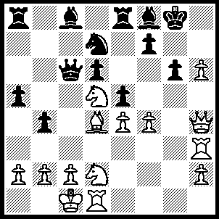
1.Nf3 b3, 2.axb3 exd4, 3.Ng5 (3…..Be7, 4.h7+ Kh8, 5.Nf7+ Kg7, 6.h8(Q)+ Rxh8, 7.Qxh8+ Kxf7, 8.Rh7+ Ke6, 9.Rxe7++), 4.fxe5 Ra7 (4…..Bxh3, 5.Nf6+ mates OR 4…..Be6, 5.Nxf7 Bxf7, 6.Qf6 Kh7, 7.Qxf7+ Kh8, 8.Nf6+ mates) 5.Rf3 f5 (5…..Be6, 6.Nf6+ Kh8, 7.Nxe8 Qxe8, 8.Qf4 Bxh6 [8…..Kg8, 9.Qf6 Bxh6, 10.Rxh6 mates IF 8…..Be7, 9.Nxe6 fxe6, 10.exd6 Bd8, 11.Qf8+ IF 8…..Qe7, 9.exd6, Qd8, 10.Qe5+ f6, 11.Rxf6 wins IF 8…..Qd8, 9.Nxe6 wins], 9.Nxf7+ Qxf7, 10.Qxh6+ Qh7, 11.Rf8+ Bg8, 12.Qxh7+ Kxh7, 13.exd6 wins),6.exf6(ep) Be6 (6…..Bf5, 7.f7+ Kh8 [7…..Rxf7, 8.h7+ Kh8, 9.Nxf7+ Kg7, 10.h8(Q)+ mates], 8.fxe8(Q) Qxe8, 9.exf5 OR 6…..Rf7, h7+ mates), 7.f7+ Bxf7, 8.Nxf7 Rxf7, 9.Rxf7 Qxd5 (9…..Kxf7, 10.Qf6+ Kg8, 11.Qxg6+ Kh8, 12.Nf6 mates), 10.h7+ Kxf7, 11.exd5 Be7 (11…..Bg7, 12.Rf1 mates), 12.Rf1+ Kg7, 13.h8(Q)+ Rxh8, 14.Qxe7+ Kh6, 15.Rf4 g5, 16.Qf6+ Kh7, 17.Qf7+ Kh6, 18Rf6++.
.

