FROM THE TOO HARD BOX 17
By Vern Stannard
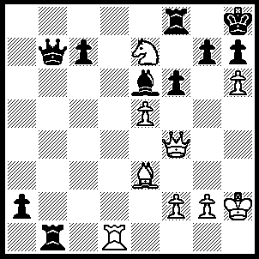
1.Rd8 Rh1+ (1…..Rxd8, 2.hxg7+ mates), 2.Kxh1 a1(Q)+, 2.Kxh2 Qxg2+ (3…..Qb8, 4.hxg7+ Kxg7, 5.Qh6+ Kf7, 6.Qxf8++ OR 3…..Rxd8, 4.hxg7+ Kxg7, 5.Qxf6++), 4.Kxg2 Bd5+, 5.Nxd5 Qa3 (5…..Rxd8, 6.hxg7+ Kg8 [6…..Kxg7, 7.Qxf6+ mates], 7.Ne7+ Kf7, 8.Qxf6+ Ke8, 9.g8(Q)+ Kd7, 10.Q(f)e6++), 6.hxg7+ Kxg7, 7.Qh6+ Kg8 (7…..Kf7, 8.Qxh7+ Ke6, 9.Nxc7+ Kxe5, 10.f4++), 8.Nxf6+ Kf7, 9.Qxh7+ Ke6, 10.Qd7+ Kxe5, 11.Ng4+ Ke4, 12.Qe6++.

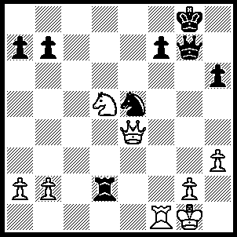
1.Ne7+ Kh8 (1…..Kf8, 2.Nf5 Qg5, 3.h4), 2.Nf5 Qf6, 3.Nxh6 Qxh6, 4.Qxe5+ Qg7, 5.Qe4 Rxb2 (5…..Rd8, 6.Qh4+), 6.Rf4 Rb6, 7.Qe8+ Qg8 (7…..Kh7, 8.Rxf7), 8.Rh4+ Kg7, 9.Qe5+ Kf8 (9.f6, 10.Qe7+), 10.Rd4 Re6, 11.Rd8+ Ke7, 12.Qc7+ Kf6, 13.Rxg8.

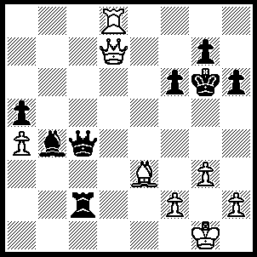
1.h4 Qe4 (1…..Bc5, 2.Rc8 OR 1…..Kh7, 2.Qf5+ mates OR 1…..f5, 2.h5+ Kxh5, 3.Qxf5+ g5, 4.Bxg5 OR 1…..Re2, 2.h5+ Kxh5, 3.Qf5+ g5, 4.Rd4 OR 1…..h5, 2.Qe8+ Kf5, 3.Rd4 Rc1+. 4.Kh2 Qxd4, 5.Bxd4), 2.h5+ Kxh5 (2…..Kh7, 3.Qf7 mates), 3.Qxg7 Qg6, 4.Qb7 Rd2 (4…..Qg4, 5.Qf7+ Qg6, 6.Rd5+ f5, 7.Rxf5+ OR 4…..f5, 5.Qh1+ Kg4, 6.Rd4+ f4, 7.Rxf4+ Kg5, 8.Qh4++), 5.Qf3+ Qg4, 6.Qxf6 Rd1+, 7.Rxd1 Qxd1+, 8.Kh2.

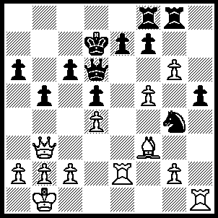
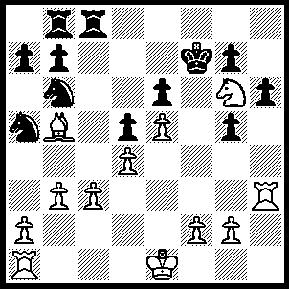
1.gxf7 Rxf7, 2.Re6 Qb8, 3.Bxd5 Rxf5, 4.Bxc6+ Kd8 (4…..Kc7, 5.Be4 R(f)g5, 6.Rxe7+ Kb6 [6…..Kd8, 7.Qe6 Qc7, 8.Rxc7], 7.Qe6+ Ka5, 8.b4+ Kxb4, 9.Qb3+ Ka5, 10.Qa3+ Kb6, 11.Re6+ Ke7, 12.Qe7+ Ke8, 13.Rc6+), 5.R(1)e1 Rg7 (5…..Qc7, 6.R(6)e5 Qxc6, 7.Qxg8+ Qe8
[7…..Kc7, 8.Rxe7+], 8.Qd5+ Qd7, 9.Qa8+ Qc8, 10.Qxc8 + Kxc8, 11.Rxf5), 6.Rxe7 Rxe7, 7.Qg8+ Kc7, 8.Rxe7+ Kxc6 (8…..Kb6, 9.Qxb8+ Ka5, 10.Qc7+ Ka4 [10…..Kb4, 11.c3+ Ka4 [[11…..Kc4, 12.Be4+]], 12.b3+ Ka3, 13.Qa5++], 11.b3+ Kb4, 12.Kb2), 9.Qe6+ Qd6, 10.Qc8+ Kb6, 11.Rb7+ Ka5, 12.a3 Qxd4, 13.Qc7+ Ka4, 14.Rb6 Rf6, 15.Rxf6 Nxf6, 16.b3+ Kxa3, 17.Qa5+.

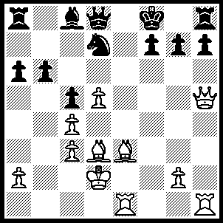
1.Bh6 Rg8 (1…..Nf6, 2.Bxg7+ Kxg7, 3.Qxh6+ Kg8, 4.Re5 OR 1…..gxh6, 2.Qxh6+ Kg8, 3.Bxh7+ mates), 2.Bxh7 Nf6 (2…..gxh6, 3.Qxh6+ Rg7, 4.Qd6+ mates), 3.Qh4 Bf5 (3…..Ne4+, 4.Qxe4 gxh6, 5.Bxg8 Qg5+, 6.Qe3 OR 3…..Rh8, 4.Bxg7+ mates), 4.Bxg8 Kxg8 (4…..Nxg8, 5.Bf4), 5.Bg5 Ne4+, 6.Rxe4 f6, 7.Rf4 Qd7, 8.Bxf6 Kf7, 9.Bxg7 Kg8 (9…..Kxg7, 10.Qg5+ Kf7 [10…..Bg6, 11.Qf6+ IF 10…..Kf8, 11.Qf6+], 11.Rh7+), `10.Be5 Rf8, 11.Qg5+.

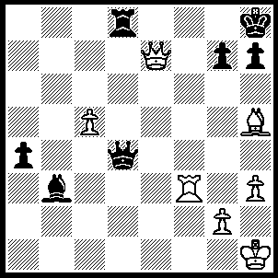
1.Be8 h6, (1…..Bg8, 2.Rf8 Qd5, 3.Bf7 Rxf8, 4.Bxd5 Rf1+, 5.Kh2 Bxd5, 6.Qd8+ Bg8, 7.c6 a3, 8.c7 Rc1. 9.c8(Q)), 2.Rf8+ Kh7 (2…..Bg8, 3.Qe6), 3.Qxd8 {3.Bg6+ Kxg6, 4.Rxd8 also wins as long as black is not allowed to get perpetual check.} Qxd8 (3…..Qa1+ 4.Kh2 Qe5+, 5.Kg1 Qxc5+ [5…..Qe1+ 6.Rf1 Qe3+, 7.Kh1 Qxc5, 8.Bg6+ Kxg6, 9.Qd3+], 6.Rf2 Qc1+, 7.Kh2 Qe3, 8.Rf3 Qe5+, 9.Rg3), 4.Bg6+ Kxg6, 5.Rxd8 a3, 6.c6 a2, 7.Ra8 Bd5, 8.Ra6 Kf5, 9.c7 Bb7, 10.Rxa2 Ke6, 11.Rd2.

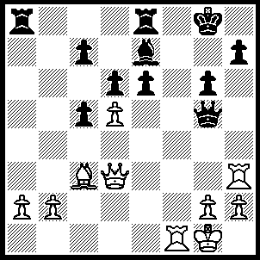
1.Rxh7 Kxh7 (1…..e5, 2.Qh3 Bf6, 3.Be1 e4, 4.Bc3 Re5 [4…..Bxc3, 5.bxc3 Qe3+ [[5…..Qe5, 6.Qd7, Rf8, 7.R(1)f7]], 6.Qxe3 Kxh7, 7.Rf7+ Kg8, 8.Rxc7 R(e)c8, 9.Rxc8 Rxc8, 10.Qe6], 5.Rxc7 Be7, 6.Rc8+ Rxc8, 7.Qxc8 Kg7 [7…..Kh7, 8.Rf7+], 8.Qe6 Bf6, 9.Qxd6 Rf5, 10.Rxf5 gxf5, 11.Qxf6+ Qxf6, 12.a4 Qd4+, 13.Bxd4 cxd4, 14.a5 queens), 2.Qh3+ {not 2.Rf7+ Kg8, 3.Qh3 Qc1+, 4.Rf1 Qxf1+, 5.Kxf1 e5} Qh5, 3.Rf7+ Kh6 (3…..Kg8, 4.Qxe6), 4.Bd2+ g5 (4…..Bg5, 5.Bxg5+ Kxg5, 6.Qe3+ mates), 5.Qxe6+ Qg6, 6.Qh3+ Qh5, 7.Rh7+ Kxh7, 8.Qxh5+ Kg7 (8…..Kg8, 9.Qg6+ Kf8, 10.Bc3 R(d)b8, 11.Bg7+ mates), 9.Bc3+ Bf6, 10.Qxg5+ Kh7, 11.Qf5+ Kh6, 12.Qxf6+ Kh5, 13.Qf7+ Kg5 (13…..Kh6, 14.Bd2+ OR 13…..Kh4, 14.Qf5 OR 13…..Kg4, 14.h3+ Kg5, 15.Qf6+ Kh5, 16.g4++), 14.Bd2+ Kg4, 15.Qg6+ Kh4, 16.Qg5++.

An easy one to fill the page

1.Rf3+ wins the exchange as Kxg6, 2.Bd3+ Kh5, 3.Rh3+ Kg4, 4.f3+ Kf4, 5.Kf2 g4, 3.g3+ Kg5, 7.f4++.

