FROM THE TOO HARD BOX 18
By Vern Stannard
Rare and spectacular are the double bishop sacrifices that leave the opponent’s king at the attacker’s mercy.
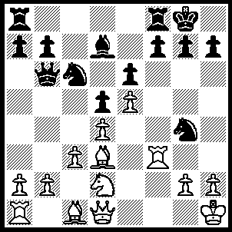
1.Bxh7+ Kxh7 (for1…..Kh8 see A), 2.Rh3+ Kg8 (for 2…..Nh6 see B), 3.Qxg4 f5, 4.Qh5 Be8 (4…..Qa6, 5.Qh7+Kf7, 6.Rg3 Rg8, 7.Nc4 Qxc4 [7…..dxc4, 8.Bh6 Bc8, 9.Bxg7], 8.Bh6 Bc8, 9.Bxg7 Ke8, 10.Qxg8+ Kd7, 11.Qf7+ Ne7, 12.Bf6 Kc6, 13.Qxe7), 5.Qh7+ Kf7, 6.Rg3 Rg8 (6…..Ke7, 7.Rxg7+ Rf7 [7…..Kd8, 8.Rxb7 Qa5, 9.Nb3], 8.Nc4 dxc4, 9.Bg5+ Kd7, 10.Rxf7+ Bxf7, 11.Qxf7+ Kc8, 12.Qxe6+ Kc7, 13.Qd6+ Kc8. 14.e6), 7.Nf3 Kf8 (7…..Qc7, 8.Rxg7+ Rxg7, 9.Ng5+ Ke7, 10.Qxg7+ Kd8, 11.Nxe6+), 8.Bh6 Qc7, 9.Bxg7+ Qxg7 (9…..Rxg7, 10.Qh8+ Ke7, 11.Rxg7+ Bf7, 12.Rxf7+ Kxf7, 13.Qh7+), 10.Rxg7 Rxg7, 11.Qh8+ Rg8 (11…..Kf7, 12.Ng5+ Rxg5, 13.Qf6+ Kg8, 14.Qxg5+ Kf8, 15.g4), 12.Qf6+ Bf7, 13.Ng5 Rxg5, 14.Qxg5.
(A)---1…..Kh8, 2.Bc2 Kg8 (2…..Nh6, 3.Rf6 gxf6, 4.Nc4 dxc4 [4…..Qd8, 5.Qh5 [[Kg8, 6.Bh7+ Kxh7, 7.Qxh6+ Kg8, 8.exf6]], f5, 6.Qxh6+ Kg8, 7.Bg5 f6, 8.Qg6+ Kh8, 9.exf6 Rf7, 10.Nd6 Rh7, 11.f7], 5.Qh5 f5, 6.Bxh6 Qd8, 7.Bg5+ Kg8, 8.Bf6 Qxf6, 9.exf6), 3.Rf6 Ne3 (3…..Nxd4, 4.Qxg4 Nxc2, 5.Nc4 Qd8, 6.Bh6 g6, 7.Rxg6 Kh7, 8.Rf6 Rg8, 9.Qh5 Rg6, 10.Bg5+ Kg7, 11.Rxg6+ fxg6, 12.Qh6+ OR 3…..Nh6, 4.Nc4 dxc4, 5.Bxh6 Qxb2, 6.Rb1 Qxa2 7.Qg4), 4.Qh5 Nxc2, 5.Rh6 gxh6, 6.Nc4 Qd8 (6…..dxc4, 7.Bxh6), 7.Bxh6 Ne7, 8.Bg5 Ng6, 9.Bf6 Qxf6, 10.exf6 Ne3, 11.g4 Nxg4, 12.Qxg4 dxc4, 13.Qh5 Bc6+, 14.Kg1 Nf4, 15.Qh6 Nh5, 16.Qxh5 Be4, 17.Qh6.
(B)---2…..Nh6, 3.Nc4 dxc4, 4.Bxh6 Kg8 (4,,,,,gxh6, 5.Qh5), 5.Bxg7 f5 (5…..Qxb2, 6.Bf6), 6.Qh5 Qxb2 (6…..Rd8, 7.Qg6), 7.Qh7+ Kf7, 8.Bf6+ Ke8, 9.Qg6+ Rf7, 10.Rh8++.

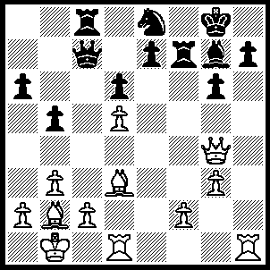
1.Rxh7 Nf6 (1…..Bxb2, 2.Qxg6+ Rg7 [2…..Bg7, 3.Rh8+], 3.Qe6+ Kf8, [3…..Rf7, 4.Bg6], 4.Rh8+), 2.Bxf6 Rxf6 (2…..Bxf6, 3.Bxg6 Rxh7 [3…..Rg7, 4.Qe6+ IF 3…..Bg7, 4.Bxf7+], 4.Bxh7+ Kh8, 5.Bf5 OR 2…..Kxh7, 3.Qxg6+ Kg8, 4.Rh1 Kf8, 4.Bxg7+ Ke8, 6.Rh8+ Kd7, 7.Qe6++ OR 2…..exf6, 3.Qxg6, Kf8, 4.R(d)h1 Rd8 [4…..Qb7, 5.Rxg7], 5.Rh8+ Bxh8 [5…..Ke7, 6.Re1+ Kd7, 7.Bf5++], 6.Rxh8+ Ke7, 7.Qe4+ Kd7, 8.Qe6++), 3.Bxg6 Kf8 (3…..e6, 4.R(d)h1 Kf8, 5.dxe6 d5, 6.e7+ Kg8, 7.Rxg7+ Kxg7, 8.Be8+ OR 3…..e5, 4.R(d)h1 Kf8 [4…..Qd8, 5.Bf7+], 5.Rxg7 Kxg7 [5…..Rxg6, 6.Rxc7 Rxg4, 7.Rh7+ Rg8, 8.Rxc7+], 6.Be8+ Kf8, 7.Rh8+ Ke7, 8.Qxg7+ OR 3…..Qc3, 4.Rxg7+ Kxg7, 5.Bf5+ Kf8, 6.Bxc8 OR 3…..Rxg6, 4.Qxg6 e5, 5.R(d)h1 Kf8, 6.Rh8+ Bxh8, 7.Rxh8+), 4.Rxg7+ Kxg7, 5.Bf5+ Kf8, 6.Rh1 e6 (6…..e5, 7.Rh8+ Kf7, 8.Be6+), 7.Rh8+ Ke7 (7…..Kf7, 8.dxe6+), 8.Qg7+ Rf7, 9.Qg5+ Rf6 (9…..Kd7, 10.Bxe6++), 10.Rh7+ Ke8, 11.Qg8+ Rf8, 12.Qxe6+ Kd8, 13.Rd7+.
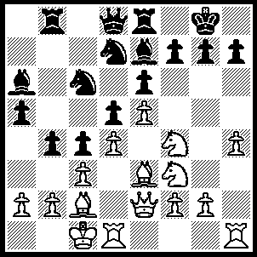
1.Bxh7+ Kf8 1…..Kxh7, 2.Ng5+ Kg8, 3.Qh5 Nf8 [3…..Bxg5, 4.hxg5 Kf8, 5.Qh8+ Ke7, 6.Ng6+ fxg6, 7.Qxg7++], 4.Qxf7+ Kh8, 5.Ng6+ Nxg6, 6.Qxg6 Bxg5, 7.hxg5+ Kg8, 8.Rh8+ Kxh8, 9.Qf7 OR 1…..Kh8, 2.Ng5 Bxg5 [2…..bxc3, 3Qh5 cxb2+, 4.Kb1 Bxg5, 5.hxg5 Qxg5 [[5…..f5, 6.Ng6++]], 6.Qxg5 c3, 7.Bc2+ Kg8, 8.Rh7], 3.hxg5 Qxg5, 4.Nxd5 Qxe3, 5.Qxe3 exd5, 6.Bg6+ Kg8, 7.Rh8+ Kxh8, 8.Bxf7), 2.Nxe6+ fxe6, 3.Ng5 Bxg5 (3…..Qb6, 4.Nxe6+ Kf7, 5.Qh5+), 4.Bxg5 Qb6 (4…..Re7, 5.Qf3+ Rf7, 6.Qh5 Qe8, 7.Bg6 Ne7, 8.Qh8+ Ng8, 9.Bh7 Nf6, 10.exf6 gxf6, 11.Bxg8), 5.Qf3+ Nf6, 6.exf6 Rb7 (6…..bxc3, 7.fxg7+ Kxg7, 8.Qf6+ Kxh7, 9.Qf7+ Kh8, 10.Bf6++), 7.fxg7+ Kxg7, 8.Qh5 Rh8, 9.Qh6+ Kf7, 10.Qf6+ Ke8, 11.Qxe6+ Ne7 (11…..Rd7, 12.Bxd7), 12.Bg6+ Kd8, 13.Bxe7+ Kc7, 14.Qe5+ Kc6, 15.Qd6+ Kb5, 16.Qxd5+ Ka4, 17.Bc2+ b3, 18.axb3+ Qxb3 (18…..cxb3, 19.Kd2), 19.Bxb3+ cxb3, 20.Kd2.

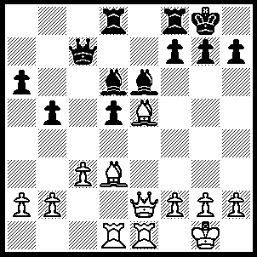
1.Bxh7+ Kxh7 (1…..Kh8, 2.Qh5 Bg4, 3.Qh4 Qe7 [3…..Be7, 4.Qxg4], 4.Bxg7+ Kxg7, 5.Rxe7 Bxe7, 6.Qxg4+ Kxh7, 7.Rd3 Rd6, 8.Rh3+ Rh6, 9.Qf5+ Kg7, 10.Rxh6 Kxh6,11.Qxd5 Rd8, 12.Qf3 Kg7, 13.h4 Rd2, 14.Qe3 Rd1+, 15.Kh2, Bf6 [15…..Bxh4, 16.Qf4], 16.h5), 2.Qh5+ Kg8, 3.Bxg7 Kxg7 (3…..Bxh2+, 4.Kh1 Kxg7, 5.Qg5+ Kh8, 5.Qg5+ Kh8, 6.Rd4 Bf5, 7.Qxf5 f6, 8.Rh4+ Kg8, 9.Qh5 Qg7, 10.Kxh2 f5, 11.Rh3 Rd7, 12.Rg3 Qxg3+ 13.Kxg3 Rh7, 14.Qd1 4.Qg5+ Kh8, 5.Rd4 f6 (5…..Bxh2+, 6.Kh1 Bg3 [6…..Bf5, 7.Qxf5 f6, 8.Rh4+ Kg8, 9.Qh5 Qg7,10.Kxh2 as before IF 6…..Bf4, 7.Qh6+], 7.fxg3 f6, 8.Rh4+ Qh7, 9.Qg6 Qxh4, 10.gxh4 R(d)e8, 11.Re3 Re7, 12.Qh6+ Kg8, 13.Rg3+ Bg4, 14.Rxg4+), 6.Rh4+ Qh7, 7.Rxh7+ Kxh7, 8.Qh4+ Kg7, 9.Rxe6.

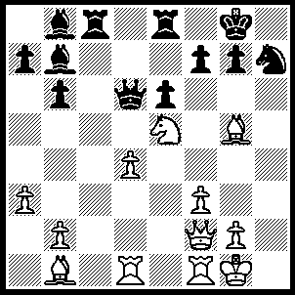
1.Bxh7+ Kxh7, 2.Qh4+ Kg8, 3.Qh5 Rf8 (3…..Qc7, 4.Rc1 OR 3….Rc7, 4.Kf2 Rc2+, 5.Ke3 g6, 6.Qh8+ Kxh8, 7.Bf6+ Kg8, 8.Rh1), 4.Bf6 gxf6, 5.Qg4+ Kh8, 6.Kf2 Rc2+, 7.Ke1 Re2+, 8.Kxe2 Ba6+ 9.Ke3 Bxf1, 10.Rxf1.

