FROM THE TOO HARD BOX 20
By Vern Stannard
The first position is from an Alekhine blindfold simultaneous game published by Dave Ellis in The West. In a one-on-one game, even blindfolded, I am sure Alekhine would have had time to analyse and play the following.
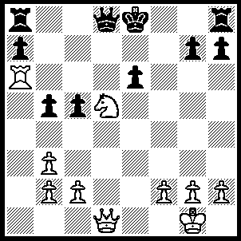
1.Qh5+ g6 (1…..Kd7, 2.Qf7+ Kc8, 3.Qxe6+ Kb8 [3…..Kb7, 4.Qc6+ Kb8, 5.Qxb5+ Kc8, 6.Rc6+ Kd7, 7.Rb6+ Kc8, 8.Qc6+ mates IF 3…..Qd7, 4.Rc6+ Kd8, 5.Rd6 mates], 4.Qc6 Qc8, 5.Qd6+ Kb7, 6.Rb6+ mates OR 1…..Kf8, 2.Qf3+ Ke8 [2…..Kg8, 3.Rxe6 h6, 4.Ne7+ Qxe7, 5.Rxe7], 3.Rxe6+ Kd7, 4.Qf5 Kc8 [4…..g6, 5.Re7+ Kc6, 6.Qe6+ Qd6, 7.Rc7++], 5Re7+ Kb8, 6.Qe5+ Kc8, 7.Rc7+ Kb8, 8.Rd7+ Kc8, 9.Rxd8+ Kxd8, 10.Qe7+ mates), 2.Rxe6+ Kd7 (2…..Kf7, 3.Qe5 Rf8 [3…..Re8, 4.Rxe8 Qxe8, 5.Qf6+ Kg8, 6.Ne7+], 4.Re7+ Qxe7, 5.Qxe7+ Kg8, 6.Nf6+), 3.Qg4 Kc8 (3…..h5, 4.Re7+ Kc6, 5.Qe6+ Qd6, 7.Rc7++ OR 3…..Qa5, 4.Re7+ mates), 4.Re7+ Kb8, 5.Qf4+ Kc8, 6.Rc7+ Kb8, 7.Rd7+ Kc8, 8.Rxd8+ Kxd8, 9.Qd6+ Kc8, 10.Qc7++.

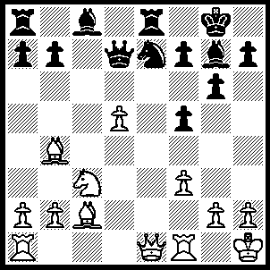
1.Ba4 b5 (1…..Bxc6, 2.Bxc6 Qxa4, 3.Qe5 mates), 2.Bxb5 Qb7, 3.Bxe8 Qxb4, 4.Nb5 Nxd5 (4…..Qxe1, 5.R(f)xe1 Bf6 [5…..Bxb2, 6.R(a)b1 Bf6, 7.Nc7], 6.d6 Be6 [6…..Nd5, 7.Bc6 Rb8, 8.Re8+ Kg7, 9.Nxa7 Nb6, 10.Rd1], 7.Nc7 Rc8, 8.Nxe6 fxe6, 9.Bd7 Rd8, 10.Bxe6+ Kg7, 11.dxe7), 5.Bc6 Rb8, 6.Rd1 Be6 (6…..Qxe1, 7.R(f)xe1 Be6 [7…..Nb4, 8.Re8+ Bf8, 9.Bd7], 8.Bxd5 Rxb5, 9.Bxe6 OR 6…..Rxb5, 7.Qe8+), 7.Bxd5 Qxe1, 8.R(f)xe1 Rxb5, 9.Bxe6 fxe6, 10.b3.
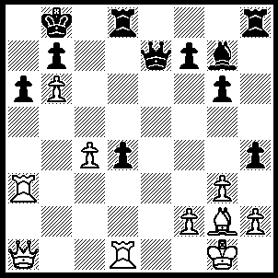
1.Rxa6 Kc8 (1…..bxa6, 2.Qxa6 mates), 2.Qe4 Be5 (2…..bxa6, 3.Qc6+ mates), 3.Re1 Qd6 (3…..d3, 4.Ra8+ Bb8, 5.Rxe7 OR 3…..bxa6, 4.Qc6+ Bc7 [4…..Qc7, 5.bxc7 Bxc7, 6.Qxa6+ Kd7, 7.Bh3+ f5, 8.Qe6++], 5.Qb7+ Kd7, 6.Qxc7+ Ke8, 9.Qxe7++), 4.Ra8+ Qb8, 5.Rxe5 Rd6 (5…..Qxa8, 6.Qxa8+ Kd7, 7.Qxb7+ Kd6, 8.Qc7++), 6.Rxb8+ Kxb8, 7.Re8+ Rd8, 8.Qa7+ Kc8, 9.Qxb7++.

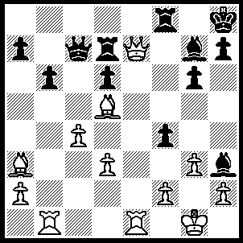
1.Qxf8+ Bxf8, 2.Bb2+ Rg7, 3.Re8 3.Qc8 (3…..Qe7, 4.Rxe7 Bxe7, 5.Re1 OR 3…..h5, 4.Rxf8+ Kh7, 5.Bxg7 Kxg7, 6.Rf7+ Qxf7, 7.Bxf7 Kxf7, 8.gxf4), 4.Re1 h5 [4…..Qf5, 5.R(1)e7 h5, 6.Bxg7+ Kh7, 7.Bxf8+ Kh8, 8.Bg7+ Kh7, 9,Bg8++], 5.Rxc8 Bxc8, 6.Re8 Bf5, 7.Rxf8+ Kh7, 8.gxf4 Bxd3, 9.Bxg7 Kxg7, 10.Rf7+.
The next position is from the game Morozevich v Ljubojevic Monaco 2002

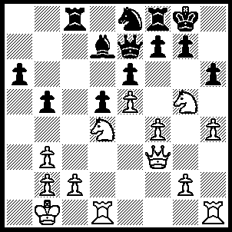
1.Qd3 f5, 2.g4 hxg5, 3.hxg5 g6 (the game went 3…..Qf7, 4.gxf5 exf5, 5.Qh3 Qg6, 6.e6, (resigns) Bxe6, 7.Nf3 Rf6, 8.Qh8+ Kf7, 8.Ne5+ Ke7, 9.Qh3), 4.gxf5 exf5 (4…..gxf5, 5.g6 Qg7 [5…..Nf6, 6.exf6 Qxf6 [[6…..Rxf6, 7.Rdg1 Qg7, 8.Rh7]], 7.R(d)g1 Rfe8, 8.g7 Kf7 [[8…..Re7, 9.Rh8+ Kf7, 10.Rxc8]], 9,g8(Q)+ Rxg8, 10.Rh7+ Rg7 [[10…..Kf8, 11.Rxg8+ Kxg8, 12.Rxd7]], 11.R(1)xg7 IF 5…..Qg7, 6.R(d)g1 Rc7, 7.Rh7, IF 5…..Ng7, Rh7, Be8, 8.Qg3 Nh5, 9.Rxh5 Qg7, 10.Nxe6 IF 5…..Rxf6, 6.R(d)g1 Qg7, 7.Rh7 Rxg6, 8.Rxg7+ ], 6.R(d)g1 Rc7, 7.Rh7 Qxg6, 8.Rxg6+ Kxh7, 9.Qg3 Bc8, 10.Qg5), 5.Qh3 Qg7 (5…..Kf7, 6.Qh7+ Ng7, 7.Rh6 Ke1, 8.Qxf6+ Kd8 [8…..Qf7, 9.Qxa6 Rc7, 10.e6 Nxe6, 11.Re1], 9.Qb6+ Ke8, 10.e6 Bc6, 11.Nxc6 Qc7, 12.e7 Qxb6, 13.exf8(Q)+ Kxf8, 14.Rf6+ Ke8, 15.Re1+ mates), 6.e6 Nc7 (6…..Bxe6, 7.Nxe6), 7.exd7 R(c)d8, 8.Qc3 Rxd7, 9.Rh6 Ne8 (9…..R(8)d8, 10.R(1)h1 Ne8, 11.Qe1 Re7, 12.Rh8+ Kf7, 13.Qb4), 10.R(1)h1 Rc7 (10…..Re7, 11.Qc6), 11.Qa5 Qxd4 (11…..Re7, 12.Qxa6), 12.Qxa6 Kf7 (12…..Rg7, 13.Qe6+), 13.Qxg6+ Ke7, 14.Rh7+ Kd8, 15.Rxc7 Nxc7 (15…..Kxc7, 16.Rh7+), 16.Qd6+ Kc8 (16…..Ke8, 17.Qxc7 Rf7, 18.Qc8+ Ke7, 19.Re1+), 17.Qxf8+ Kb7 (17…..Kd7, 18.g6 Kc6, 19.g7), 18.g6 Qe4, 19.Rh8 Qe1+, 20.Ka2 Qa5+, 21.Qa3.

The next position is a win by Smyslov in 1998 aged 76
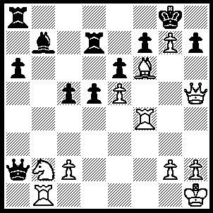
1.R(1)f1 Qxb2, 2.Be7 Rxe7 (2…..f5, 3.exf6(ep) Qc3 [3…..Qxc2, 4.f7+ Kxg7, 5.Qe5+ Kh6, 6.Qg5++ IF 3…..Rxe7, 4.f7+ Kxg7, 5.f8(Q)+ Rxf8, 6.Rg4+ Kh8, 7.Rxf8++], 4.f7+ Kxg7, 5.f8(Q)+ Rxf8, 6.Rg4+ mates), 3.Rxf7 Qxc2 (3….Rxf7, 4.Qxf7+ mates), 4.Rf8+ Kxg7, 5.R(1)f7+ Rxf7, 6.Qxf7+ Kh6, 7.Qf4+ Kg6 (7…..Kh5, 8.Qh6+ Kxg4, 9.Rf4++), 8.Qf6+ Kh5, 9.g4+ Kxg4, 10.Qf3+ Kg5 (10.Kh4, 11.Rf4+ mates), 11.h4+ Kxh4 (11…..Kh6, 12.Qf4+ mates), 12.Rf4+ Kg5, 13.Rg4+ Kh6, 14.Qh3++.

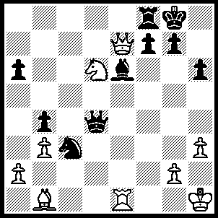
1.Rxe6 g6 (1…..fxe6, 2.Qxe6+ Kh8, 3.Nf7+ mates OR 1…..Qd1+, 2.Kh2 Qxb1, 3.Qxf8+ Kh7, 4.Nxf7 mates OR 1…..Nxb8, 2.Qxf8+ mates), 2.Nxf7 Qg7 (2…..Rxf7, 3.Qe8+ Rf8 [3…..Kg7, 4.Rxg6+ mates IF 3…..Kh7, 4.Bxg6+ mates], 4.Rxg6+ Kh7 [4…..Qg7, 5.Rxg7+ Kxg7, 6.Qg6 mates], 5.Rg7+ Kxg7, 6.Qg6+ mates), 3.Rxg6 Rxf7, 4.Qe8+ Kh7 (4…..Rf8, 5.Rxg7+ mates), 5.Bd3 Rf1+, 6.Kh2 Ne4 (6…..Rf7, 7.Rf6+ IF 6…..Qc7+, 7.Rg3+), 7.Bxe4 Rf4, 8.Bd3 Rd4, 9.Rxg7+ Kxg7, 10.Qe7+ Kg8, 11.Bh7+ Kh8, 12.Bg6 mates.

