FROM THE TOO HARD BOX 21
by Vern Stannard
Set your computer to play human v human and allow the take back of moves and as you explore the variations and sub-variations see if you can work out the next move by White.

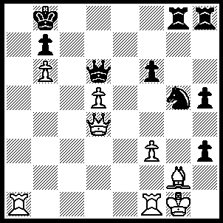
1.Ra8+ Kxa8, 2.Qa4+ Kg8, 3.Qa7+ Kc8, 4.Rc1+ Kd8, 5.Qa8+ Ke7, 6.Qxb7+ Qd7, 7.d6+ Ke6 (7…..Kd1/Ke1, 8.Rc8+ mates OR 7…..Kxd6, 8.Rd1+ as in game), 8.Re1+ Kxd6, 9.Rd1+ Ke5 (9…..Kc5, 10.Qxd7 Nxf3+, 11.Kf2 Rxg2+, 12.Kxf3 Kxb6 [12…..R(8)g8, 13.Rd5+ Kc4, 14.Qb5+ Kc3, 15.Rd3+ mates], 13.Rb1+ Kc5, 14.Rb5+ Kc4, 15.Qc6+ mates), 10.Qxd7 Kf4 (10…..Nxf3+, 11.Kf2 Kf4 [11…..hxg2, 12.Rd5+ mates IF 11…..Rxg2+ 12.Kxf3 R(8)g8, 13.Rd5++], 12.Bxf3 OR 10…..hxg2, 11.Rd5+ Kf4, 12.Qd6+ Ke3 [12…..Kxf3, 13.Qxf6+ Ke3 14.Qd4+ Kf3, 15.Rf5+ Kg3, 16.Qf2+ Kh3, 17.Qxg2+ mates], 13.Rd3+ Ke2, 14.Rd2+ Ke3, 15.Qd4+ Kxf3, 16.Rd3+ Ke2, 17.Re3++), 11.Qd4+ Kf5 (11…..Kg3, 12.Qd6+ Kh4, 13.Qc5++), 12.Bxh3+ Nxh3+, 13.Kh2 Ng5 (13…..Nf4, 14.Qc5+ Kg6 [14…..Ke6, 15.Re1+ Kf7, 16.Qc7+], 15.Rg1+ Kh6, 16.Rxg8 Rxg8, 17.Qe3 Rg2+ [17…..Kg5, 18.Qg1+], 18.Kh1 Kg5, 19.Qxf4+ Kxf4, 20.Kxg2), 14.Qd5+ Kg6, 15.f4 Rb8, 16.fxg5 Rxb6, 17.Qd4 R(8)b8, 18.gxf6 Rb2+ (18…..R(8)b7, 19.Rg1+ Kf7 [19…..Kh7, 20.Qe4+. Kh8, 21.Qe8+ mates], 20.Rg7+ Ke6, [20…..Ke8, 21.Qe5+ Kf8 [[21…..Kd8, 22.Qd5+ mates]], 22.Qc5+ mates], 21.Rxb7), 19.Kh1 Rb1, 20.Qe4+.

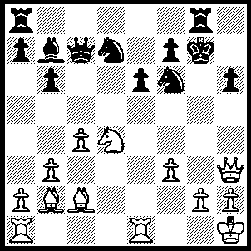
1.Rxe6 Qf4 (1…..fxe6, 2.Nxe6 Kf7, 3.Nxc7), 2.Nf5+ Kf8 (2…..Kh8, 3.Rxf6 Nxf6, 4.Bxf6+ Kh7, 5.Nxh6+ Rg6, 6.Ng4+ OR 2…..Kh7, 3.Bc1 OR 2…..Kf8, 3.Rxf6 Rxg2 [3…..Nxf6, 4.Ba3+ Ke8. 5.Nd6+ Kd8, 6.Nxb7+ Kc7 [[6…..Ke8, 7.Re1]], 7.Bd6+],4.Kxg2 Nxf6 [4…..Qd2+, 5.Kf1 5.Nxf6 [[5…..Qxc2, 6.Qxh6+ Ke8, 7.Re6+ fxe6 (7…..Kd8, 8.Qh8+ Kc7, 9.Be5+ Nxe5, 10.Re7+ Kc6 ((10…..Nd7, 11.Qe5+ mates)), 11.Qf6+ Kc5 12.Qd6++), 8.Qxe6+ Kd8, 9.Qe7+ Kc8 (9…..Kc7, 10.Be5+), 10.Nd6+ Kc7, 11.Nb5+ mates]] 6.Rd1 Qf4 [[6…..Qxc2, 7.Ba3+ mates]], 7.Ba3+ Kg8, 8.Qg2+ Ng4 [[8…..Qg5, 9.Nxh6+]], 9.Qxg4+], 5.Bxf6 Re8, 6.Bg7+ Kg8, 7.Rg1 Re2+ 8.Kf1 Qc1+ 9.Kxe2 Qxg1, 10.Qxh6 Qg2+ 11.Ke1 Qg1+, 12.Kd2 Qf2+, 13.Kc1 Qe1+, 14.Kb2 f6, 15.Qh8+ Kf7, 16.Qf8+ Kg6, 17.Ne7+ Kg5 [17…..Kh5, 18.Qh8+ mates], 18.Qxf6+ Kh5, 19.Bg6++, 3.Rxf6 Qg5 (3…..Nxf6, 4.Ba3+ Ke8, 5.Nd6+ Kf8 [5…..Kd8, 6.Nxb7+ Ke8, 7.Re1+], 6.Nxb7+ Kg7, 7.Bc1 Ng4, 8.Qxg4+ Qxg4, 9.Bb2+ Kf8, 10.fxg4 Rxg4, 11.g3), 4.Rd6 Nc5, 5.Bf6 Qf4, 6.Rd4 Qb8 (6…..Qc7, 7.Qxh6+ Ke8, 8.Ng7+ Kf8, 9.Ne6+ Ke8, 10.Nxc7++), 7.Qxh6+ Ke8, 8.Ng7+ Kf8, 9.Ne6+ Ke8, 10.Qf8+ Rxf8, 11.Ng7++.
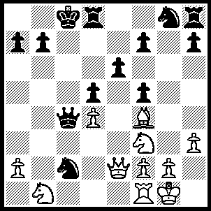
1.Qe5 Nxe1 (1…..Ne7, 2.Rc1 Ng6 [2…..Kd7, 3.Qf6 Kc8 [[3…..Qxa2, 4.Ne5+ Kc8, 5.Qxe7]], 4.Na3 IF 2…..Qc6, 3.Qb8+ Kd7, 4.Ne5+ Ke8, 5.Qxd8+ Kxd8, 6.Nxc6+ Nxc6, 7.Rxc2], 3.Qb8+ Kd7, 4.Qxb7+ Ke8, 5.Bc7 Qb4 [5…..Rd7, 6.Rxc2 Qxc2, 7.Qc8+ Ke7, 8.Bd6+ wins Q], 6.Qc6+ Rd7, 7.Qxc2 Ke7, 8.N(1)d2 Rg8 [8…..Rc8, 9.Bd6+], 9.Rb1 Qa3, 10.Rb3 Qa6, 11.Ne5 Nxe5, 12.Qc5+ Kf6, 13.Bxe5+ Kg6, 14.Rg3+), 2.Qb8+ Kd7, 3.Ne5+ Ke8, 4.Qxb7 Ne7, 5.Nxc4 dxc4, 6.Bc7 Rc8 (6…..Rd7, 7.Qa8+ Nc8, 8.Qxc8+ Ke7, 9.Qxh8 Rxc7, 10.Qe5), 7.Bd6 Nf3+ (7…..Kf8, 8.Qxe7+ Kg7, 9.Qg5++), 8.gxf3 Rg8+, 9.Kf1 Kf8, 10.Qxe7+ Kg7, 11.Qg5+ Kh8, 12.Be5+ f6, 13.Bxf6+ mates.

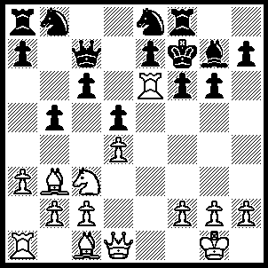
1.Nxd5 cxd5 (1…..Qc8, 2.Rxe7+ Kg8, 3.Nb6+ OR 1…..Qa5, 2.Rxe7+ Kg8, 3.Nf4+ Kh8, 4.Qd3 Rf7 [4…..b4, 5.Qxg6], 5.Qh3+ Kg8, 6.Bxf7+ Kf8, 7.Rxe8+ Kxf7, 8.Qe6++ OR 1…..Qd8, 2.Rxe7+ Kg8, 3.Nf4+ Kh8, 4.Qd3), 2.Bxd5 Nd6 (2…..Kg8, 3.Rxe7+ Kh8, 4.Rxc7 Nxc7, 5.Bxa8), 3.Qe2 Ke8, 4.Bf4 Rf7, 5.Bxa8 a6, 6.Bxd6 Qd8, 7.Re1 Bf8, 8.Bxb8 Qxb8, 9.Bc6+ Kd8, 10.Qf3 Kc8 (10…..Qc7, 11.Qd5+ Kc8, 12.Bd7+ Qxd7 [12…..Kb8, 13.Rxa6 IF 12…..Kd8, 13.Bxb5+ Kc8, 14.Qa8+ Qb8, 15.Rc6+ Kd7, 16.Rc7+ Kxc7, 17.Qc6+ mates], 13.Qa8+ Kc7, 14.R(1)e3), 11.Qd5 Qa7, 12.Bxb5 axb5, 13.Rc6+.

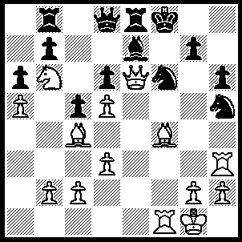
1.Rxh5 Nxh5, 2.Bxd6+ Nf6, 3.Rxf6+ gxf6, 4.Qxf6+ Kg8, 5.Qg6+ Kf8 (5…..Kh8, 6.Be5+ Bf6, 7.Qxh6+ Kg8, 8.d6+ Re6, 9.Bxe6++), 6.Be5 Bf6, 7.Nd7+ {like a properly trained chess player my computer always looks at checks first so finding a quick mate looks no further and fails to find the shorter mate 7.d6 Re6, 8.Bxe6 and mate next move} 7…..Qxd7, 8.Qxf6+ Qf7, 9.Qxh6+ Qg7 (9…..Kg8, 10.Qh8++ OR 9…..Ke7, 10.Qd6++), 10. Qxg7++.

A short and easy? puzzle to fill up the column.

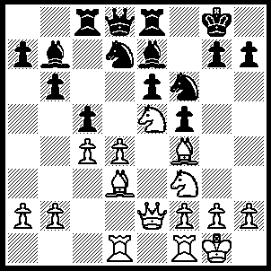
1.Nf7 Kxf7, 2.Qxe6+ Kg6 (2…..Kxe6, 3.Ng5++), 3,Bxf5+ Kh5, 4.g4+ Nxg4, 5.Bxg4++.

