FROM THE TOO HARD BOX 22
By Vern Stannard
The simple way to use these pages is to organise your computer to play human against human and allow you to take back moves, set up the position and play through the game, going down the variations and sub-variations and then backtracking to the main line and continuing on. All the time trying to work out the next move.

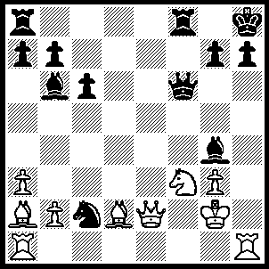
1.Rxh7+ Kxh7, 2.Rh1+ Qh6 (2…..Bh5 3.Rxh5+ Kg6 [3…..Qh6 Kh8, 5.Bxh6], 4.Qe4+ Qf5 [4…..Kxh5, 5.g4++], 5.Ne5+ Kf6, 6.Bg5+ Qxg5, 7.Nd7++ OR 2…..Kg6, 3.Ne5+ Qxe5 [3…..Kf5, 4.Rf1+ Bf3, 5.Rxf3++], 4.Qxg4+ Kf6, 5.Bg5+ Kg6 [5…..Qxg5, 6.Qe6++], 6.Be7+ mates), 3.Ng5+ Kg6 (3…..Kh8, 4.Rxh6+ gxh6, 5.Qe5+ mates), 4.Qd3+ Bf5 (4…..Kf6, 5.Qd6+ Kf5, 6.Be6+ Kg6 [6…..Kf6, 7.Bxg4++], 7.Bf7+ Kf5, 8.Qf4++ OR 4…..Rf5, 5.Bf7+ Kf6, 6.Qd6++), 5.Qd6+ Be6 (5…..Rf6, 6.Bf7++), 6.Qxe6+ Rf6, 7.Qe4+ Rf5, 8.Bf7+ Kf6, 9.Qe6++.

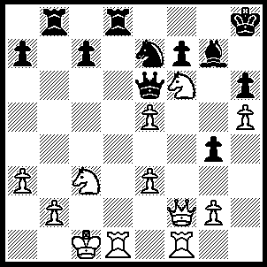
1.Rxd8+ Rxd8, 2.Qc2 Bxf6, 3.Rxf6 Qc4 (3…..Qxe5, 4.Rxh6+ Kg8, 5.Qh7+ Kf8, 6.Qh8+ Qxh8, 7.Rxh8+ Ng8, 8.h6), 4.e6 fxe6 (4…..Ng8, 5.Rxf7 Qd3, 6.Qxd3 Rxd3, 7.Ne2 Rxe3, 8.Nf4 Ne7, 9.Rxe7 OR 4….Qd3, 5.Qxd3 Rxd3, 6.exf7), 5.Rxh6+ Kg7, 6.Qh7+ Kf8, 7.Qh8+ Ng8, 8.Rf6+ Ke7, 9.Rf4 Qc5, 10.Qh7+ Kd6, 11.Rd4+ Kc6, 12.Qe4+ Rd5, 13.Rc4.

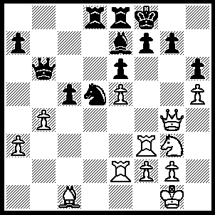
1.Bxh6 gxh6 (1…..Bg5, 2.Bxg7+ Kxg7, 3.Qxg5+ Kf8, 4.h6), 2.Rxf7+ Kxf7, 3.Qg6+ Kf8, 4.Qxh6+ Kg8, 5.Re4 Ne3 (5…..Nf6, 6.exf6 Bxf6, 7.Rg4+ Kf7, 8.Qh7+ mates), 6.fxe3 Rd1+, 7.Kh2 Qd8, 8.Rg4+ Bg5, 9.Rxg5+ Qxg5, 10.Qxg5+ Kf8, 11.Qf6+ Kg8, 12.h6 Rd7, 13.Qg6+ Kf8, 14.Ne4 Rf7, 15.Nd6 R(8)e7, 16.Nxf7 Rxf7, 17.h7.

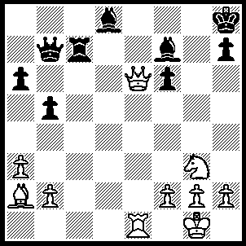
1.Qe8+ Kg7 (1…..Bxe8, 2.Rxe8+ Kg7, 3.Rg8+ Kh6, 4.Nf5+ Kh5, 5.g4++), 2.Nf5+ Kg6, 3.Qe3 Kxf5 (3…..h5, 4.Bxf7+ Rxf7 [4…..Kxf5, 5.Qh3+ Kg5, 6.Qxh5+ Kf4, 7.g3++ IF 4…..Kxf7, 5.Qe6+ mates], 5.Qh6+ Kxf5, 6.Qh5+ Kf4, 7.g3++ OR 3…..Bxa7, 4.Qh6+ Kxf5, 5.Qh5+ Kf4, 6.g3++ OR 3…..Be8, 4.Qh6+ Kxf5, 5.Be6++), 4.Bb1+ Kg4 (4…..Qe4, 5.Qxe4+ Kg5, 6.h4+ Kh5, 7.Qf5+ mates), 5.Qh3+ Kg5, 6.f4+ Kxf4, 7.Qf5++.
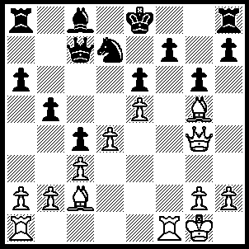
1.Rxf7 Nxe5 (1…..Qb6, 2.Rxh7 Rxh7 [2…..Rg8, 3.Qf4 Nxe5, 4.Bxg6+ Rxg6, 5.Re7+ mates], 3.Bxg6+ Rf7 [3…..Kf8, 4.Rf1+ mates], 4.Bxf7+ Kf8 [4…..Kxf7, 5.Rf1+ Nf6, 6.Rxf6+ mates], 5.Bf6 Nxf6, 6.exf6 mates OR 1…..Kxf7, 2.Rf1+ Nf6 [2.Kg7, 3.Bh6+ Kxh6, 4.Rf7 Qd8 [[4…..Nf6, 5.Qf4+ g5 {5….Kh5, 6.Bd1+ mates} 6.Rxf6+ mates,]] 5.Rxh7+ mates], 3.Rxf6+ Ke8 [3…..Kg7, 4.Bh6+ Kxh6, 5.Rxg6+ mates], 4.Rxe6+ Kf7 [4…..Kf8, 5.Bh6+ Kg8, 6.Bxg6 wins IF 4…..Bxe6, 5.Qxe6+ Kf8, 6.Bh6+ Qg7, 7.Be4 Rd8, 8.Qf6+ Ke8, 9.Bc6+ Rd7 [[9…..Qd7, 10.Qe6++]], 10.Qxg7 mates], 5.Qf4+ Kxe6, 6.d5+ Kxd5, 7.Be4+ Kc5, 8.Qe3++), 2.Rxc7 Nxg4, 3.Re7+ Kf8, 4.Rf1+ Kg8, 5.R(1)f7 Rb8, 6.Rg7+ Kf8, 7.R(e)f7+ Ke8, 8.Be4 Rb6, 9.Rc7 Kf8, 10.R(g)f7+ Kg8, 11.R(f)e7 Bd7, 12.Rxd7 Rb8, 13.Rg7+ Kf8, 14.R(d)f7+ Ke8, 15.Bc6++.

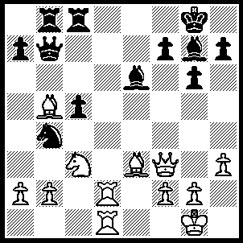
1.Rd8+ Bf8 (1…..Rxd8, 2.Rxd8+ Bf8 [2…..Rxd8, 3.Qxb7], 3.Rxf8+ Kxf8 [3…..Kg7, 4.Bh6+ Kxh6, 5.Qf4+ Kg7, 6.Rxb8], 4.Bh6+ Ke7, 5.Bg5+ Kf8, 6.Qf6 mates), 2.Rxf8+ Kxf8 (2…..Rxf8, 3.Qf6 Bxh3, 4.gxh3 Qb6, 5.Rd6 Qxd6, 6.Qxd6), 3.Qf6 Rc6, 4.Rd8+ Rxd8, 5.Bg5 Rd1+, 6.Nxd1 Kg8, 7.Bh6+ mates.

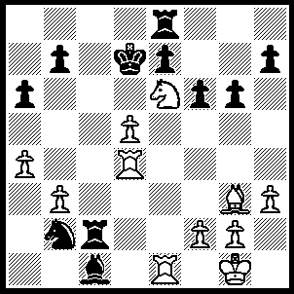
1.d6 Rd2 (1…..b5, 2.dxe7 Kc6, 3.Rd8 Be3, 4.Rxe8 Kd7, 5.Rxe3 OR 1…..exd6, 2.Nc5+ Kc6 [2…..Rxc5, 3.Rxd6+ Kc7 {3…..Kc8, 4.Rxe8+ Kc7, 5.Rd5+ Kc6, 6.Rxc5+ Kxc5, 7.Rc8+}, 4.Rxf6+ Kd7, 5.Rd6+ Kc7, 6.Rxe8], 3.Rxd6+ Kxc5, 4.Rxe8), 2.Nf8+ Rxf8, 3.dxe7+ Ke8, 4.exf8(Q)+ Kxf8, 5.Rd6 Rc2, 6.Rd7 Rc8 (6…..Rd2, 7.Bd6+ Rxd6, 8.Rxd6 Bg5, 9.Re2), 7.Bd6+ Kg8, 8.f4 Nc4, 9.bxc4 Bb2, 10.f5 Bd4+, 11.Kh1 Be5, 12.Rxe5 fxe5, 13.f6, Rf8, 14.Rg7+ Kh8, 15.Bxf8.

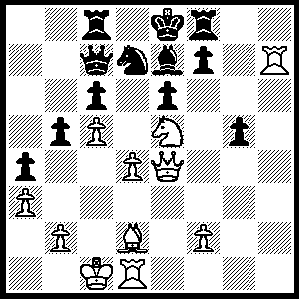
1.Nxf7 Nf6 (1…..Rxf7, 2.Qg6 Nf8 [2….Nf6, 3.Rxf7 Nd5 4.Rxe7+ Kxe7, 5.Bxg5+ Kf8, 6.Rh1), 3.Qxf7+ Kd8, 4.Ba5 Nxh7, 5.Bxc7+ Rxc7, 6.Qxh7), 2.Qxe6 Rd8 (2…..Nxh7, 3.Nd6+ Kd8, 4.Ba5 Bxd6 [4…..Qxa5, 5.Qxc8++], 5.cxd6 Re8, [5…..Rf7, 6.Qxf7], 6.dxc7 Rxc7, 7.Dd6+ mates), 3.Re1 Nxh7 (3…..Nd5, 4.Ba5 Rd7 [4…..Qxa5, 5.Qxc6+ Rd7, 6.Nd Kd8, 7.Qc8++], 5.Bxc7 Rxc7, 6.Qd6 mates), 4.Nd6+ Rxd6, 5.cxd6 Qd7, 6.Qxe7+ Qxe7, 7.Rxe7+ Kd8, 8.Ba5+ Kc8, 9.d7+ Kb8, 10.Re8+.

