FROM THE TOO HARD BOX 23
by Vern Stannard
More from my too hard box for you to play through on your computer that you have set up to play human v. human and allows you to take back moves so you can backtrack after going down a variation or sub-variation and carry on. All the time see if you can work out White’s next move and his objective.
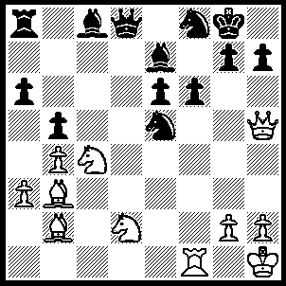
1.Nxe5 Bb7 (1…..fxe5, 2.Qf7+ Kh8, 3.Bxe5 Bf6, 4.Rxf6 gxf6, 5.Bxf6+ Qxf6, 6.Qxf6+ OR 1…..Qxd2, 2.Qf7+ Kh8, 3.Qxe7 Bd7, 4.Nf7+ Kg8, 5.Nd6 Qd3 [5…..Qxb2, 6.Qf7+ Kh8, 7.Nf5 mates], 6.Qf7+ Kh8, 7.Rxf6 Ng6, 8.Qxg7+ Kxg7, 9.Rf3+ e5, 10.Rxd3), 2.Qf7+ Kh8, 3.N(2)f3 Bxf3 (3…..fxe5, 4.Nxe5 Bf6, 5.Qxb7 Qb8, 6.Qe4 Bxe5, 7,Bxe5 Qe1, 8.Bd6 Ng6, 9.Bxe6 Rc8, 10.Bc5), 4.Rxf3 Qd2 (4…..Qe8, 5.Bxe6 Qxf7 [5…..Nxe6, 6.Ng6+ mates], 6.Nxf7+ Kg8, 7.Bb3), 5.Nd3 Ng6 (5…..Bd6, 6.Bxf6 gxf6 [6…..Qh6, 7.Be5 Bxe5, 8.Qxf8++], 7.Qxf6+ Kg8, 8.h3 Qe2, 9.Rf5 h6, 10.Qxh6 Ra7, 11.Rxf8+ Bxf8, 12.Bxe6+ Rf7, 15.Nf4 Qe1+, 16.Kh2 Qe5, 17.Bf5+ Kh8, 18.Qh5+ Kg8, 19.Be6+),6.Qxe6 Rd8, 7.Rg3 Rf8 (7…..Bd3, 8.Bxf6 Rf8 [8…..Bxg3, 9.Bxd8 mates], 9.Rxg6 hxg6, 10.Qh3+ mates), 8.Bc1 Qc3, 9.Rh3 Qc8 (9…..Qd4, 10.Bb2 Nf5, 11.Qxe7), 10.Qe2 h6, 11.Be6 Qe8 (11…..Qb8, 12.Bxh6 gxh6 [12…..Nh4, 13.Bg5 g6 [[13…..fxg5, 14.Qh5++]], 14.Rxh4+ Kg7, 15.Bh6+ mates], 13.Rxh6+ Kg7, 14.Qh5 mates), 12.Bxh6 Nh4 (12…..gxh6, 13.Qh5 mates), 13.Rxh4, gxh6 14.Qg4 Rf7 (14…..Kh7, 15.Bf5+ mates), 15.Bxf7 Qxf7, 16.Rxh6+ Qh7, 17.Qc8+ Kg7, 18.Rxh7+ Kxh7, 19.Qd7.

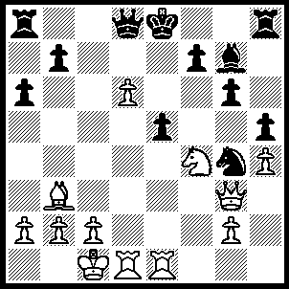
1.Bxf7+ Kd7 (1…..Kxf7, 2.Qb3+ Kf8 [2…..Ke8/f6, 3.Qe6 mates], 3.Nxg6+ Ke8, 4.Qe6+ mates), 2.Be6+ Ke8 (2…..Kc6, 3.Nxg6 Re1, 4.Ne7+ Kb6 [4…..Rxe7, 5.Qc3+ Kb6, 6.dxe7 Qxe7, 7.Rd7 Qxe6, 8.Qb4+ Kc6, 9.Qxb7+ Kc5, 10.b4+ Kc4, 11.Re4+ mates], 6.Qe3+ Ka5, 7.Rd5+ b5, 8.Nc6+ mates), 3.d7+ Ke7 (3…..Kf8, 4.Nxg6++), 4.Qa3+ Kf6, 5.Nd5+ Kxe6, 6.Nf4+ Kf6 (6…..Kf7, 7.Qb3+ Ke7, 8.Nxg6++ OR 6…..Kf5, 7.Qd3+ as in game), 7.Qd6+ Kf5 (7…..Kf7, 8.Qe6+ Kf8, 9.Nxg6++), 8.Qd3+ Kf6 (8…..Kxf4, 9.g3++), 9.Qxg6+ Ke7, 10.Qxg7++.

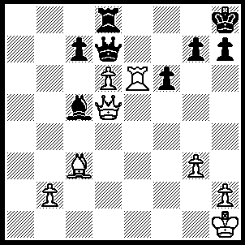
1.Rxf6 Re8 (1…..Qh3, 2.Rf7 Qh6 [2…..Rg8, 3.Bxg7+ Rxg7, 4.Rf8+ Rg8, 5.Qe5++], 3.Bxg7+ Qxg7, 4.Rxg7 Kxg7, 5.Qg5+ OR 1…..Bxd6, 2.Rf7 Qh3 [2…..Qg4, 3.Rxg7 Qxg7, 4.Bxg7+ Kxg7, 5.Qg5+], 3.Bxg7+ Kg8, 4.Re7+ OR 1…..Rg8, 2.Qxc5 gxf6, 3.Bxf6+ Rg7, 4.Bxg7+ Kxg7 [4…..Qxg7, 5.dxc7], 5.Qxc7 Qf7, 6.Kg1), 2.Rf5 Bxd6 (2…..Qxd6, 3.Bxg7+ Kxg7, 4.Qf7+ Kh8, 5.Qxe8+ Kg7, 6.Rf7+ Kh6, 7.Qe4 Qd1+ [7…..Qg6, 8.Qf4+ Qg5, 9.Rxh7+], 8.Kg2 Qg1+, 9.Kh3 Qe3, 10.Qxh7+ Kg5, 11.Rf5++ OR 2…..cxd6, 3.b4 Be3 [3…..Bb3, 4.Rf7 Qg4, 5.Bxg7+ Qxg7, 6.Rxg7], 4.Rf7 Qg4, 5.Re7 Rg8, 6.Rxe3), 3.Rf7 Qe6, 4.Qxe6 Rxe6, 5.Rxg7 Be5, 6.Rxc7 Bxc3, 7.bxc3.

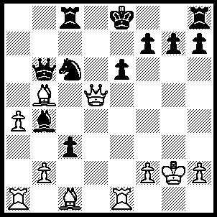
1.Rxe6+ fxe6 (1…..Kf8, 2.Rxc6), 2.Qxe6+ Kd8, 3.Be3 Qb7 (3…..Kc7, 4.Bxb6+ Kxb6, 5.bxc3 R(h)e8 [5…..Bxc3, 6.Rb1], 6.Qc4 Bd6, 7.a5+ Nxa5 [7…..Kb7, 8.Rb1 Nb5, 8.Ba6+], 8.Qa4 Nb7 [8…..Nc6, 9.Qa6+ Kc5 [[9…..Kc7, 10.Qxc6+]], 10.Bxc6 Bc7, 11.Rd1 Rb7, 12.Rd5++], 9.Bxe8), 4.Rd1+ Kc7, 5.Rd7+ Kb8, 6.Rxb7+ Kxb7, 7.Qd7+ Rc7, 8.Bxc6+ Kb8, 9.Bf4 Ba5, 10.b4 g5, 11.Bg3 Bb6 (11.c2, 12.bxa5 Rc8, 14.Bxc7+ Rxc7, 14.Qd8+ mates), 12.a5 Bxa5, 13.bxa5 Rc8, 14.Bxc7+ Rxc7, 15.Qd8+ Rc8, 16.Qb6++.

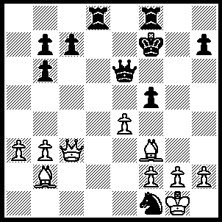
1.Qg7+ Ke8, 2.Bh5+ Rf7, 3.Bf6 [3.Kxf1 fxe4, 4.Qg7+ Ke7, 5.Qg5+ Ke8, 6.Qg8+ is a draw], Rd1 (3…..Ra8, 4.exf5 Qd5, 5.Qg8+ Kd7, 6.Qxa8 Rxf6, 7.Qe8+ Kd6, 8.Qd8+ Kc5 [8…..Ke5, 9.f4+ Kd4, 10.Qxf6+], 9.b4+ Kc4, 10.Be2+ Kd4, 10.Qxf6+ OR 3…..Rc8, 4.exf5 Qd5, 5.Qg8+ Kd7, 6.Qxf7+ Qxf7, 7.Bxf7 Kd6, 8.Be6 Rf8, 9.Bg7), 4.Qg8+ Kd7, 5.Qd8+ Kc6, 6.Qxd1 Rxf6 (6…..Ne3, 7.fxe3 fxe4 [7…..Qxf8, 8.Qd5++ IF 7…..Rxf6, 8.Be8+ mates], 8.Qc2+ Kd7, 9.Qd2+ Kc6, 10.Qc3+ Kd7, 11.Qd4+ Kc6, 12.Bxf7 Qxf7, 13.Qxe4+ OR 6…..fxe4, 7.Bxf7 Qxf7, 8.Be5 Qd5, 9.Qc1+ Kd7, 10.Qxc7+ Ke6, 11.Bc3 Qd1 [11…..Nd2, 12.Qxb6+ Kd7, 13.Bxd2 Qxd2, 14.Qxb7+ Kd6 [[14…..Kd8, 15.Qb6+ Kd7, 16.h4]] 15.Qb4+ ]. 12.Qxb6+ Kf7 {black cannot afford QB5+ OR Qxe4+}, 13.Qxb7+ Kf8, 14.Qg7+ Ke8, 15.Qg8+ Kd7, 16.Qxh7+ Kd6, 17.Qg6+ Kd7, 18.Qf5+ Kd8 [18…..Kd6, 19.Bb4+ Kc7, 20.Ba5+ Kd6, 21.Qf6+ Kc5, 22.Qb6+ IF 18…..Kc7, 19.Ba5+ Kc6, 20.Qxe4+ Kd7, 21.Qe1], ), 7.e5 [7.exf5 Qd6 holds things together], Rh6 (7…..Qxe5, 8.Bf3+ Kc5 [8…..Kb5, 9.Qd3+ Ka5, 10.b4+ Ka4, 11.Bd1++], 9.b4+ Kc4, 10.Be2+ Kc3, 11.Qc1+ Kb3, 12.Bc4+ Ka4, 13.Qc2+ mates OR 7…..Rg6, 8.Bf3+ Kc5, 9.Qc2+ Kd4, 10.Qb2+ Kd3, 11.Kxf1 Rxg2, 12.Be2+ Ke4, 13.Qc3 Rg1+ [13…..f4, 14.Bd3 Kd5 [[14…..Kf3, 15.Bf5++]], 15.Bc4+ Ke4, 16.f3+ Kf5, 17.Bxe6+ IF 13…..Qg8, 14.Bf3+ Kf4, 15.Qe3++], 14.Kxg1 Qg6+, 15.Kf1 f5, 16.Bd3+), 8.Bf3+ Kc5 (8…..Kc4, 9.Qd3+ Ka5, 10.b4+ Ka4, 11.Bd1+ mates), 9.Qc2+ Kd4, 10.Qb2+ Kd3 (10…..Kc5, 11.Qc3+ mates), 11.Kxf1 Rxh2 (11…..f4, 12.Ke1 mates), 12.Be2+ Ke4, 13.f3+ Kf4 (13…..Ke3 14.Qc3 Kf4 15.Qc1+ as in the game), 14.Qc1+ Kxe5, 15.Qxc7+ Kf6, 16.Qxh2.

