FROM THE TOO HARD BOX 24
By Vern Stannard
More from my too hard box for you to play through on your computer that you have set up to play human v. human and allows you to take back moves so you can backtrack after going down a variation or sub-variation and carry on. All the time see if you can work out white’s next move and his objective.

In the first position finding White’s first move is relatively easy, it is all the possible variations and their mating combinations that demonstrate how much easier it is to attack an exposed king than protect it when all its pieces are unable go to its defence.

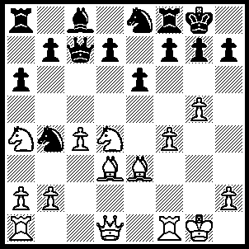
1.Bxh7+ Kxh7, 2.Qh5+ Kg8, 3.Rf3 g6 (3…..f5, 4.Rh3 Nf6 [4…..Rf6, 5.Qxe8+ Rf8, 6.Qh5 Rd8, 7.g6 Kf8, 8.Nxf5 exf5, 9.Qh8+ Ke7, 10.Qxg7+ Ke6, 11.Qf7+ Kd6, 12.Qf6++], 5.gxf6 Rxf6, 6.Nf3 Kf8, 7.Qh8+ Ke7 [7…..Kf7, 8.Ne5+ Ke7, 9.Qxg7+ Kd6, 10.Rd1+ mates], 8.Qxg7+ Rf7 [8…..Kd6, 9.Rd1+ Kc6, 10.Nd4+ Kd6, 11.Nxf5+ Kc6, 12.Ne7++], 9.Qg5+ Ke8, 10.Rh8+ Rf8, 11.Qg6+ Ke7, 12.Rh7+ Kd8, 13.Qg5+ mates), 4.Qh6 f5, 5.Rh3 Kf7, 6.Qh7+ Ng7, 7.Rh6 Ke8 (7…..Rg8, 8.Nxf5 gxf5 [8…..exf5, 9.Qxg6+ Ke7, 10.Bb6 Qc6, 11.Re1+ Ne6, 12.Qf6+ Ke8, 13.Qd8+ Kf7, 14.Rf6+ Kg7, 15.Qe7+ mates], 9.Rf6+ Ke7, 10.Qxg8 Ne8, 11.Rf7+ Kd8, 12.Rf8 d6 [12…..Qc6, 13.Bb6+ Qxb6, 14.Nxb6], 13.Rxe8+ Kd7, 14.Nb6+ Qxb6, 15.Bxb6), 8.Qxg7 Rf7 (8…..Qd6, 9.Rh7 Nd3, 10.Nc6 bxc6 [10…..dxc6, 11.Qxg6+ Kd8, 12.Bb6+ mates], 11.c5 Nxc5, 12.Bxc5 Qxc5+, 13.Nxc5 Rf7, 14.Qxf7+ Kd8, 15.Nxe6+ mates), 9.Qxg6 d6 (9….. d5, 10.Nxf5 exf5, 11.Bb6 Qxb6 [11…..Qxf4 , 12.Rh8+ Kd7 [[12…..Ke7, 13.Bd8+ Kd7, 14.Nb5++]]. 13.Nb5+ Ke7, 14.Bd8++ IF 11…..Qd7, 12.Rh8+ Ke7, 13.Bc5+ mates], 12.Nxb6 Nc6, 13.Rh8+ Ke7, 14.Re1+ Ne5, 15.Rxe5+ mates OR 9…..Nc6, 10 Rh8+ Ke7, 11.Nf5+ exf5, 12.Bc5+ d6, 13.Re1+ mates), 10.Nb6 Rb8, 11.Rh8+ Ke7, 12.Nxf5+ exf5, 13.Re1 Qxb6 (13…..Qxb6, 14.Bxb6+ Kd7, 15.Rd8+ Kc6, 16.Rd6++ OR 13…..Be6, 14.Qxe6+ Kxe6, 15.Bd2++), 14.Bxb6+ Kd7, 15.Rd8+ Kc6, 16.Rxd6++.

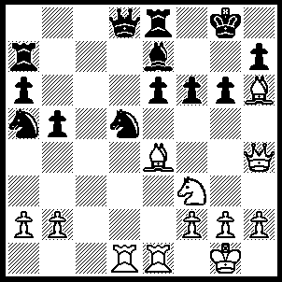
1.Qg4 Bf8 (1…..f5, 2.Bxf5 exf5, 3.Qd4 Nf6 [3…..Bf6, 4.Qxd5+ Qxd5, 5.Rxe8+ Kf7, 6.Rf8+ Ke6, 7.Rxf6+ IF 3…..Bf8, 4.Rxe8 Qxe8, 5.Qxa7 Bxh6, 6.Rxd5 Qc8, 7.Rd1], 4.Qxa7 OR 1…..g5, 2.Qxe6+ OR 1…..Kf7, 2.Bxg6+ hxg6, 3.Qxe6++), 2.Bxg6 hxg6 2…..Bxh6, 3.Bxe8+ Kf8 [3…..Rg7, 4.Qxe6+], 4.Nd4 Nc7 [4…..Qxe8, 5.Nxe6+ Kf7, 6.Qh5+], 5.Nxe6+ Nxe6, 6.Rxd8 Nxd8, 7.Qb4+), 3.Qxg6+ Bg7 (3…..Kh8, 4.Rxd5 Qxd5, 5.Qxe8 Ra8, 6.Qg6 Qf5, 7.Qf7 Qh7 [7…..Bxh6, 8.Nh4], Qxf6+ OR 3…..Rg7, 4.Bxg7 Bxg7, 5.Rxd5), 4.Rxd5 Qxd5 (4…..Qc8, 5.Nd4 R(8)e7 [5…..e5, 6.Nf5], 6.Nxe6 Qe8, 7.Qg4 Nc4, 8.Kf1 Ne5, 9.R(d)xe5 fxe5, 10.Rd8 OR 4…..Qa8, 5.Rd6 Qc8, 6.Nd4 R(8)e7, 7.R(d)xe6 Qf8, 8.Nf5 Qf7, 9.Rxe7 Qxg6, 10.Rxa7 Bf8 [10…..Qxf5, 11.Rxg7+ mates], 11.Bxf8 Qxf5 [11…..Kxf8, 12.Ra8+ mates], 12.Bb4), 5.Qxe8+ Kh7, 6.Bxg7 Rxg7 (6…..Kxg7, 7.Qxe6 Qxe6, 8.Rxe6 Kf7, 9.Re1), 7.Re3 Nc4 7…..Qf5, 8.Qxe6 Qxe6, 9.Rxe6), 8.Ng5+ Rxg5 (8…..Qxg5, 9.Rh3+ Qh6, 30.Rxh6 Kxh6, 31.Qxe6) 9.Qf7+ Kh6, 10.Qxf6+ Kh7 (10…..Rg6, 11.Rh3+ Qh5, 12.Qh8+), 11.Qf7+ Kh6, 12.Rxe6+.

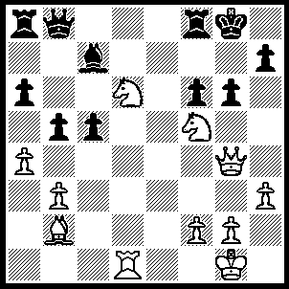
1.Nh6+ Kg7 (1…..Kh8, 2.Qh4 Bd8, 3.N(d)f7+ Rxf7 [3…..Kg7, 4.Rd7 Ra7, 5.Nxd8+ Rxd7, 6.Ne6+ mates], 4.Nxf7+ Kg8, 5.Nxd8), 2.Qd7+ Kxh6 (2…..Kh8, 3.Qe7 Qd8, 4.N(d)f7+ Rxf7 [4…..Kg7, 5.Bxf6++], 5.Nxf7+ Kg8 [5.Kg7, 6.Bxf6+ mates], 6.Nh6+ mates), 3.Bc1+ g5, 4.Nf5+ Kg6, 5.Qg7+ Kxf5, 6.Qxh7+ Ke5, 7.Bb2+ [or 7.f4+ gxf4, 8.Bb2+ Ke7, 9.Qd7++] Kf4, 8.g3+ Kf3, 9.Qd3++.

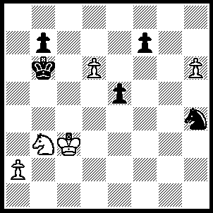
1.h7 Ng6, 2.Na5 Nh8 (2…..f6, 3.Kc4 e4, 4.Kd5 e3, 5.Nc4+ Ka7, 6.Nxe3 Kb8, 7.Ke6 Nf8+, 8.Ke7 OR 2.f5, 3.Nc4+ Kc6, 4.Nxe5+), 3.Kc4 e4 (3…..Ng6, 4.Kd5 Nh8, 5.Nc4+), 4.Kd4 f5 (4…..e3, 5.Kxe3 f6, 6.Ke4 Nf7, 7.Kd5), 5.Kd5 e3 (5…..f4, 6.Nc4+ Ka7, 7.d7), 6.Nc4+ Ka7, 7.Nxe3 Kb8, 8.Nxf5 Kc8, 9.Ke6 Kd8, 10.Kf6 Ke8, 11.Kg7 Nf7, 12.d7+.

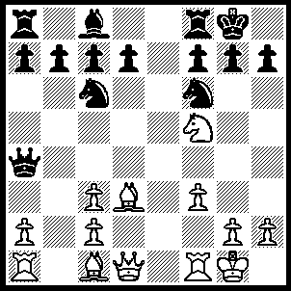
1.Nxg7 Kxg7 (1…..d4, 2.Qd2 Qh4, 3.g3 Ne4, 4.fxe4 Qg4, 5.Nf5 Bxf5, 6.Rxf5 OR 1…..Qh4, 2.g3 Qa4, 3.Qd2 Qa5, 4.Nf5 Qc5+, 5.Kh1 Nh5, 6.Qh6 f6, 7.Nd6 Rf7 [7…..f5, 8.Bc4+], 8.Nxf7 Kxf7, 9.Qxh7+ Ke6, 10.Re1+ Kd6 [10…..Ne5, 11.Qxh5], 11.Bh6 Ng7, 12.Qxg7 Qxc3, 13.R(a)b1 Nb4, 14.Qe7+ Kc6, 15.Rxb4), 2.Bh6+ Kxh6 (2…..Kg8, 3.Qd2 Qh4, 4.Bg5 Qh5, 5.Bxf6 Re8 [5…..h6, 6.Qf4 d6 [[6…..d5, 7.Qg3+ Bg4, 8.fxg4 wins Q]], 7.R(a)e1 Ne5 [[7…..Bd7, 8.Qg3+ Bg4, 9.Re4 Ne7, 10.Rxe7]], 8.Rxe5 dxe5, 9.Qg3+ wins Q], 6.g4 Qc5+, 7.Kh1 Re3, 8.R(a)e1 Qd6, 9.Bxh7+ Kxh7, 10.Qxd6 cxd6, 11.Rxe6 Kg6, 12.g5 b6, 13.Rd1), 3.Qd2+ Kh5 (3…..Kg7, 4.Qg5+ Kh8, 5.Qxf6+ Kg8, 6.Qg5+ Kh8, 7.Qh6 mates), 4.g4+ Nxg4, 5.fxg4 Qxg4 (5…..Kxg4, 6.Be2+ Kh3, 7.Qf3+ Kh4, 8.Qh6++), 6.Kh1 d6 (6…..d5, 7.Rf6 as in game OR 6…..Ne5, 7.Rf6 Qg5 [7…..Ng6, 8.Be2], 8.Be2+ Ng4, 9.Bxg4+ wins), 7.Rf6 Qg5, 8.Be2+ Bg4, 9.Bxg4+ wins

