White’s position (Krasenkow-Adianto !998) seems overwhelming. Black’s queen is out of play & his king is trapped in the centre. Although White has 2 pieces en prise his next move forces resignation. Can you see it?

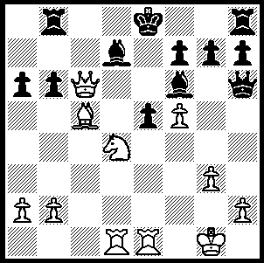 455

Concerns about problems with his intended match with FIDE champion Kasimdzhanov & the unwillingness of world champion Vladimir Kramnik to commit himself to a reunification match against either Kasparov or Kasimdzhanov has certainly not effected Kasparov’s play. He has just won the Russian championship with 7.5/10, unbeaten & 1.5 ahead of runner-up Alexander Grishuk. The tournament, the strongest Russian championship since 1988, was scheduled for 14 players. When Kramnk withdrew organisersrather harshly threw out Khalifman to keep an even number, a decision they must have regretted when ex-world champion Anatoly Karpov withdrew a day before the start.
Englishman Michael Adams has also continued to gain excellent results despite the disappointment of losing the FIDE final to Kasimdzhanov. He led his team to victory in the European teams championship in Turkey & then produced the outstanding Board 1 score at the Majorca Olympiad (10/13). It was hardly surprising that a game between these two produced an amazing game:

Gary Kasparov - Michael Adams
European Teams Championship, Oct 2004
Nimzo-Indian Defence: Classical Variation

1 d4 Nf6 2 c4 e6
3 Nc3 Bb4 4 Qc2 d5
5 a3 Bxc3+ 6 Qxc3 Ne4
7 Qc2 Nc6 8 e3 e5
9 cxd Qxd5 10 Bc4 Qa5+
11 b4 Nxb4!? 12 Qxe4! Nc2+
13 Ke2 Qe1+ 14 Kf3 Nxa1
15 Bb2 0-0 16 Kg3 h6
17 h4!? Re8 18 Kh2 Qxf2!
19 Bxa1 Bf5! 20 Qxb7 exd4!
21 Nf3 Be4! 22 Qxc7 Bxf3
23 Qxf7+ Kh8 24 Qxf3 Qxh4+
25 Kg1 Qe1+ 26 Bf1 Qxa1
27 Rxh6+!! gxh6 28 Qf6+ DRAW

