Diagram 481: Black wins immediately!

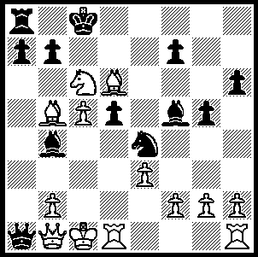 481

Diagram 479: It seems space restrictions caused the omission of last week’s problem (as well as the announcement of the Metro Open) so it’s repeated today:

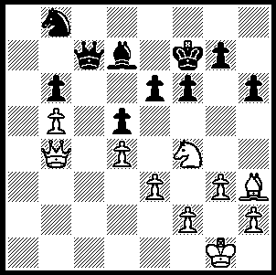 479

Castling on the queenside can be fraught with danger for White in d4 openings with only a 2 pawn shield for his king. I recently came across a game which demonstrated this fact in a very emphatic manner and immediately thought of the most famous example with an idendical opening – Queens Pawn, Nimzo-Indian Defence, Classical Variation. This means you get two games for the price of one today:

1 d4, Nf6 2 c4, e6 3 Nc3, Bb5 4 Qc2, d5 5 cxd, exd 6 Bg5, h6 7 Bh4, c5

Keres - Botvinnik 1941 Rozmbersky - Kubala 1998
8 0-0-0 Bxc3! 8 dxc Nc6
9 Qxc3 g5! 9 e3 g5
10 Bg3 cxd 10 Bg3 Qa5
11 Qxd4 Nc6 11 0-0-0 Be6
12 Qa4 Bf5 12 Nb5 Qxa2!(b)
13 e3 Rc8 13 Nc7+ Ke7
14 Bd3 Qd7! 14 Bd6+ Kd7
15 Kb1 Bxd3+ 15 Nxa8 Rxa8
16 Rxd3 Qf5 16 Bb5 Ne4
17 e4 Nxe4 17 Nf3 Bf5
18 Ka1 0-0!(a) 18 Ne5+ Kc8
19 Rd1 b5! 19 Nxc6(c) Qa1+
20 Qxb5 Nd4 20 Qb1 see below
21 Qd3 Nc2+ White resigns
22 Kb1 Nb4
White resigns

a) Not 18...Nc5? 19 Re3+
b) Not 12...0-0? 13 a3, a6 14 Bc7 winning the queen.
c) 19 Nd3 avoids the devastating finish although Black remains on top with 19...Bd2+! 20 Rxd2, Qa1+ 21 Qb1, Qxb1+ 22 Kxb1, Nxd2+.

The Metropolitan Club’s Open Tournament will be held over 7 successive Thursdays, 19 May to 30 June. Venue Drabble House, Webster St., Nedlands, start time 7.45, time limit 90 mins. Prizes: 1st, 2nd, 3rd + 6 rating prizes. Entry numbers limited to about 64 so get in entries ASAP (17 May at the latest). Enquiries Kelvin Taylor 9381 7854 (h), 9528 0243 (w).

SOLUTIONS: 481 (2nd game): 20...Nd2!! (21 Qxa1, Nb3#). 479: 1 Bxe6+!! Bxe6 2 Qf8+! Kxf8 3 Nxe6+, Kf7 4 Nxc7.

