The position below from Alexander Kotov’s ‘Think Like a Grandmaster’ is a salutary lesson on over-confidence in won positions and the need for accurate analysis throughout a game. Kotov was Black and had an overwhelming material advantage. Impatient at his opponent’s unwillingness to resign Kotov played the obvious 1...Rxf7 and promptly found he was the one to resign (3 moves):

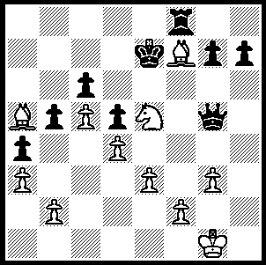 531

Last week we saw a game from the 2006 Amber Rapid; this week we have a spectacular game from the Blindfold. Play through and marvel what the winner, Ukranian veteran Vassily Ivanchuk, is able to visualise without sight of board and pieces:

Vassily Ivanchuk - Loek Van Wely
- Amber Blindfold
Sicilian; English Attack
1 e4 c5 2 Nf3 d6
3 d4 cxd 4 Nxd4 Nf6
5 Nc3 a6 6 Be3 e6
7 f3 Be7 8 Qd2 Nc6
9 0-0-0 0-0 10 g4 Nxd4
11 Bxd4 b5 12 g5 Nd7
13 h4 Bb7 14 a3 Rc8
15 Rg1 Ne5 16 Qe3 Nc4
17 Bxc4 Rxc4 18 h5 Re8
19 Kb1 Qc7? 20 b3!! Rc6
21 Nd5! exd5 22 exd Rxc2
23 g6! hxg 24 hxg Rf8
25 gxf7+ Rxf7 26 Bxg7! Rxg7
27 Qe6+ Kh8 28 Rxg7 Kxg7
29 Rg1+ resigns

If 13...b5 14 Na4, Bb7 Fischer’s 15 Nb6! Nxb6 16 Qxb4 safely wins a pawn.
Slowing Black’s queenside attack. An alternative is the ultra-aggressive 19 g6!? hxg 20 h5.
To enable the bishop to return to f8 to give protection to the king. However pressing on on the queenside with 18...b4 was better.
Restricting the rook’s retreat –again 19...b4.
Unexpected – this leaves the knight with no pawn protection and leaves the c pawn backward.
Declining the sacrifice with 21...Qc8/d8 loses to 22 Nf6+!
If 21...Rc5 22 g6! winning.
25 Rh1 (threat 26 Rh8+!) also wins.
The clever 28..Rb2+ also loses – 29 Kxb2, Bf6+ 30 Kb1! Kxg7 31 Rg1+.

SOLUTION: after 1...Rxf7?? Black was hit by 2 Bd8+!! (2...Kxd8 3 Nxf7+ / 4 Nxg5).

