In our alphabet series S is for Steinitz. To begin, a sparkling finish from an odds game (minus White a1 rook): White to play mates in 4:

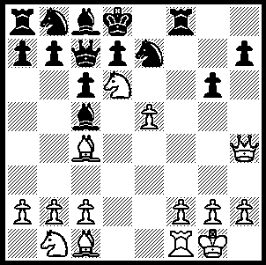 542

Wilhelm Steinitz (1836-1900) was the first official world champion (1886-1894) and was perhaps the most profound thinker the game has ever seen. Before Steinitz everyone believed that winning depended mainly on rapid development in order to attack the opposing king. Steinitz showed that the accumulation of small advantages was a prerequisite of a successful attack. He emphasized the importance of positional factors such as pawn structure (doubled, isolated and weak pawns, queenside pawn majority) and the strength of two bishops against bishop and knight or two knights. Above all he developed the art of defence through stressing the need to avoid structural weaknesses even if this meant accepting cramped positions. Because of his many original ideas he is recognized as the originator of positional chess. ‘He completely changed the game as it was played by Blackburne, Anderssen, Morphy and the other romantic heroes, and … was the foundation upon which all modern chess has been built’ (Harold Schonberg). Naturally it took time for his ideas to develop and his early games have all the adventurous aggression of the romantic masters:

STEINITZ - ROCK
London 1863 (remove White’s a1 rook)
Evans Gambit
1 e4 e5 2 Nf3 Nc6
3 Bc4 Bc5 4 b4 Bxb4
5 c3 Ba5 6 d4 exd
7 0-0 Nf6 8 Ba3 Bb6
9 Qb3 d5 10 exd Na5
11 Re1+ Be6 12 dxe6!! Nxb3
13 exf+ Kd7 14 Be6+ Kc6
15 Ne5+ Kb5 16 Bc4+ Ka5
17 Bb4+ Ka4 18 axb3#

STEINITZ - VAN DER MEDEN
London 1865 (remove White’s b1 knight)
Kings (Muzio) Gambit
1 e4 e5 2 f4 exf
3 Nf3 g5 4 Bc4 g4
5 0-0 gxf3 6 Qxf3 Qf6
7 e5 Qxe5 8 Bxf7+ Kxf7
9 d4 Qxd4+ 10 Be3 Qf6
11 Qh5+ Qg6 12 Rxf4+ Nf6
13 Rxf6+! Kxf6 14 Bd4+ Kf7
15 Rf1+ Kg8 16 Qe5 Bg7
17 Qd5+ Qe6 18 Qg5 Qh6
19 Qd8+ Bf8 19 Qe8 & wins

SOLUTION: 1 Qxe7+!! Kxe7 2 Bg5+, Rf6 3 exf6+! Kxd6 4 Bf4#.

