I haven’t got the source of this position but it has a great finish. Clearly Black’s king is precariously placed but White’s own king seems in even greater danger as well as hindering his attack. White to play and mate in four:

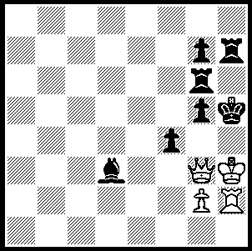

Vladimir Kramnik maintained his comfortable lead to win the Amber Blindfold/Rapid Play Tournament at Monte Carlo, scoring 15.5/22. He topped the Blindfold with 9/11 while overall runner-up Viswanathan Anand won the Rapid with 8.5/11.
Alexander Morozevich, who finished =2nd in the Blindfold with 7/11, is the only top GN who regularly plays the French Defence, a defence that has lost popularity since the time of Botvinnik. Morzevich, who has had excellent results with this defence, may help to restore its popularity. Here is his successful use of the French in the final round of the Amber Blindfold:

Peter Svidler - Alexander Morozevich
2007 Amber Blindfold, Round 11
French: Steinitz Variation
1.e4 e6 2.d4 d5
3.Nc3 Nf6(a) 4.e5(b) Nfd7
5.f4(c) c5 6.Nf3 Nc6
7.Be3 a6 8.Qd2 b5(d)
9.a3 Bb7 10.Bd3(e) Qc7(f)
11.0-0 0-0-0 12.Nd1(g) cxd
13.Nxd4 g5!(h) 14.Nxc6 Qxc6
15.Bd4 gxf 16.Qxf4 Rg8
17.Ne3(i) f6!(j) 18.exf e5!
19.f7(k) Rxg2+! White resigns

a) Botvinnik used to play the Winawer Variation, 3…Bb4.
b) Steinitz’s move which was neglected for so long with players preferring 4.Bg5 when Black has 4…Be7 (Classical), 4…Bb4 (McCutcheon) or 4…dxe (Burns).
c) Alternatives are 4.Nce2 to bolster the centre with c3 or the developing 4.Nf3.
d) Black expands on the queenside to discourage White from castling long.
e) Svidler played 10.dxc at Linares but lost in 28.
f) The queen normally goes to b6 to put pressure on the d pawn but Morozevich has a more ambitious plan.
g) To strengthen the centre with 13.c3 but better is 12.dxc when Black can play 12…Nxc5 or the pawn sacrifice 12…d4 to open lines.
h) Black uses pawn levers (…c5 & …g5) to undermine White’s centre – thematic moves in the French.
i) If 17.Qxf7, Bc5! 18.c3? Nxe5 wins or 18.Qf4, Rdf8 giving Black a strong attacking position.
j) Now the final pawn lever to complete the destruction of White’s once imposing centre.
k) If 19.Bxe5, d4 20.Bxd4, Rxg2+ wins.

The Gufeld Cup (WA Grand Prix) will be held this weekend with rounds 1-3 on Sunday (11am to 6.15pm) and Monday (10.30am – 5.45) with guaranteed 1st prize of $150. Venue Legacy House, 64 Mill Point Rd./Frasers Lane, S. Perth. Entries accepted up to 10.30 Sunday. Enquiries David Ellis 9276 1822.

Forthcoming Events:
Fremantle Open on 7 successive Tuesday evenings beginning on April 10. Enquiries Denis McMahon 9418 4049.
Fischer Random Tournament + barbeque at Legacy House 15 April. Enquiries Andrew Hardegen 0407 421 084.
South West Open at Bunbury April 21/22. Enquiries Andrew Hardegen.

SOLUTION: 1.Qg4+, Kh6 2.Qh5+!! Kxh5 3.g4+, fxg3 4.Kxg3# or 3…Kh6 4.Kg2#.
re game Ray Johnstone – Natalie Maris (24 March 2007)
Gordon Dunlop found a serious flaw in my analysis of move 28:
I was considering 28.a6 (the better 26.Rfc1 was played):

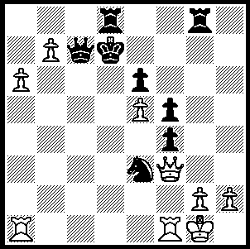

I stated that after 28…Rxg2+ 29.Qxg2, Nxg2 30.Rfd1+, Ke7+ 31.Rxd8, Qxd8 32.a7, Qb6+ 33.Kh1 that 33…Qc6 would draw. However Gordon found the winning 33…Ne3! which mates (34.Kg1, Qb2 or 34.a8/b8=Q, Qg2#).

