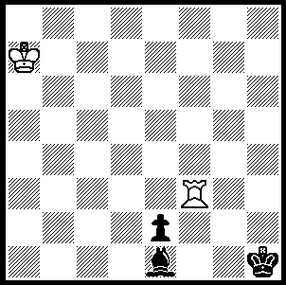
I have selected a second problem from
the 2007 Junior Problem Solving
Championship won by Perth’s
Ganesh Viswanath (published
Australian Chess, Nov/Dec).
White to play and draw (3 moves):

Most readers will be aware that former world champion Gary Kasparov spent five days in jail prior to the recent Russian elections after being convicted of organising an unsanctioned procession and resisting arrest. Leader of the opposition group Other Russia, Kasparov was leading a demonstration of between 1500 and 3000 marchers chanting anti-government slogans. Kasparov was arrested during an attempt to move through a police cordon to deliver a petition protesting against a recent law banning ballot access to parties with less than 50,000 members (previously 10,000). It is claimed the police were given prior instructions to arrest Kasparov, that he was beaten and for safety reasons he refused food during his incarceration.
It’s back 12 years and happier times as Kasparov demolishes the now world champion in 25 moves:

Gary Kasparov - Viswanatham Anand
1995 Super Classic Series, Riga
Evans Gambit Accepted
1.e4 e5 2.Nf3 Nc6
3.Bc4 Bc5 4.b4 Bxb4
5.c3 Be7(a) 6.d4 Na5
7.Be2 exd 8.Qxd4!(b) Nf6
9.e5 Nc6 10.Qh4(c) Nd5
11.Qg3 g6(d) 12.0-0 Nb6
13.c4! d6 14.Rd1 Nd7
15.Bh6 Ncxe5 16.Nxe5 Nxe5
17.Nc3!(e) f6(f) 18.c5 Nf7?
19.cxd cxd 20.Qe3 Nxh6(h)
21.Qxh6 Bf8 22.Qe3+ Kf7
23.Nd5 Be6 24.Nf4 Qe7
25.Re1 resigns(i)

a) 5…Ba5 is more usual.
b) Mere mortals would play 8.cxd strengthening the centre and reject 10.Qxd4 which brings the queen out early where it can be harried by Black’s minor pieces.
c) A Kasparov innovation.
d) 11…0-0 is met by 12.Bh6 but 11…Kf8 was a reasonable alternative.
e) 17.Bg7 is met by 17…Bf6.
f) If 17…Be6 18.c5!
g) 18…Bd7 gives Black excellent chances of weathering the storm.
h) White threatened 21.Nd5 / 22.Nxf6#.
i) If 25…Bh6 26.Bc4: if 25…Bd7 26.Qb3+ Kg7 27.Bb5: if 25…Re8 26.Nxe6 Qxe6 27.Bc4! Qxc4 28.Qxe8+ Kg7 29.Rac1.

SOLUTION: (i) 1.Rb3 Bf2+ 2.Ka8 e1=Q 3.Rb1! Qxb1 stalemate.

