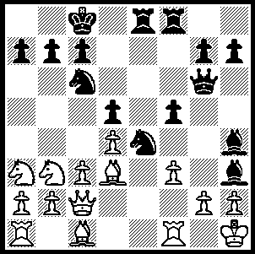

In forthcoming weeks positions
from World Champion Viswanathan
Anand will be presented. First
Ivanchuk – Anand 1989 - Black
to play and win (4 moves):

At time of writing five rounds of the Dresden Chess Olympiad have been completed. With 154 teams competing in the Open section and 116 in the Women’s each round there will be over 500 games played each round. This year placings will be decided on match points rather than game points. Defending champions Armenia and hosts Germany share the lead with Russia, Azerbaijan, Ukraine and England on 4 wins and a draw each. Australia has recovered from losses in Rounds 1 & 2 with three successive wins. Donors to Australia’s Olympiad Appeal have been rewarded with regular bulletins from Australian team captain Manuel Weeks containing news, photos and annotated games. The first bulletin included Zong-Yuan Zhao’s draw on Bd.1 in the 0.5-3.5 loss to the Czech Republic, a game Zhao came close to winning:

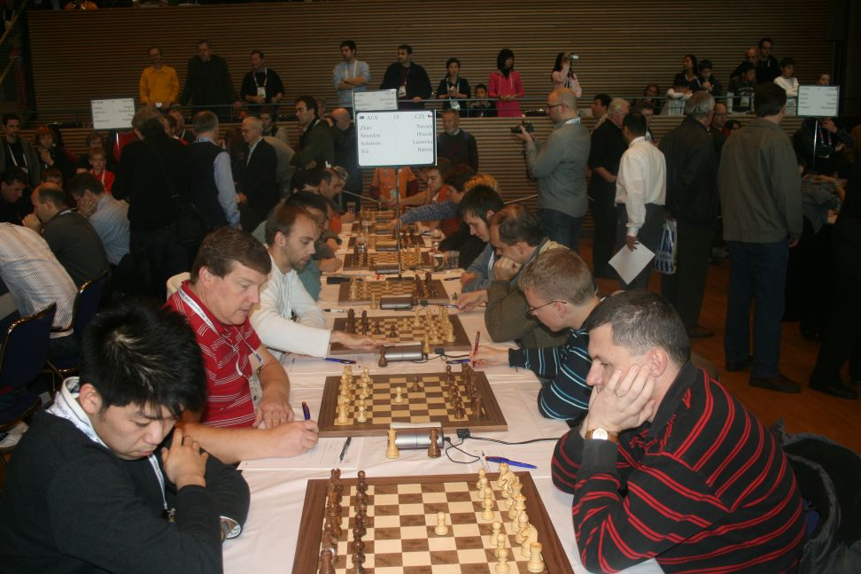

Australia v Czech Rep. Rd.1 – Xie (L foreground), Solomon, Smerdon, Zhao (obscured).

Zong-Yuan Zhao, - David Navara
Dresden Chess Olympiad 2008, Round 1
Nimzoindian Defence, Romanishin Variation
1.d4 Nf6 2.c4 e6
3.Nc3 Bb4 4.Qc2 d5
5.cxd5 Qxd5(a) 6.Nf3 Qf5
7.Qxf5 exf5 8.a3 Bd6(b)
9.Nb5 Be6 10.e3(c) Bd5
11.Bd3(d) Be4 12.Be2 Nc6
13.0–0 0–0–0 14.b4 Rhe8
15.Bb2 f4 16.Nxd6+ Rxd6
17.b5 Nd8 18.Ne5 fxe3
19.fxe3 Nd5 20.Bg4+ f5
21.Rxf5!(e) Bxf5 22.Bxf5+ Kb8
23.Re1(f) g6 24.Bc2 Kc8
25.e4 Nb6 26.Rf1(g) Ne6
27.d5 Nc5 28.Rf7 Ncd7
29.Nf3 Nc4 30.Bd4 Nxa3
31.Bd3 a6(h) 32.bxa6 bxa6
33.Rxh7 Nb5 34.Bf2 Nc3
35.Rh4 a5?(i) 36.Bd4 Na2
37.Bb5 Kb7 38.Ng5(j) Re7
39.Ne6 Rdxe6(k) 40.dxe6 Nb6
41.Bxb6 (l) Kxb6 42.Bd7 Nc3
43.e5 Kc5! 44.Kf1 a4
45.Bxa4 Draw agreed

a) 5...exd5 6.Bg5 c5 7.dxc5 is the main line (Oct 17 column, Ushenina-Kosteniuk, 2008 Womens World Champ.).
b) 8...Be7 is a good alternative - 9.Bf4 c6 10.e3 Be6 Nbd7.
c) White gains no advantage from an immediate swap of knight for bishop.
d) White believes e4 will be an inferior square for Black’s bishop.
e) Rather than the expected 21.Bxf5+ Bxf5 22.Rxf5 Nxe3 23.Rf2= White sacrifices the exchange, gaining a strong centre with a passed pawn and leaving Black’s pieces in something of a tangle.
f) Not 23.e4? Ne3 24.Bh3 Nc2 25.Rd1 ?? Rxe5 !
g) 26.a4 allows 26...Rxe5 ! 27.dxe5 Rd2 28.Rc1 Nxa4. Now this is prevented - 26...Rxe5? 27.dxe5 Rd2 28.Rf2.
h) Providing an escape for the marooned knight and gaining an outside passed pawn.
i) Now the knight remains cut off and out of play on the queenside while White’s bishop has access to b5 pinning the other knight.
j) With Black’s d6 rook unable to move White should play 38.Nd2! heading for c5 winning.
k) Forced but good.
l) Why give up the advantage of the two bishops? Zhao gives the excellent alternative leaving winning chances 41.Rf4! Rxe6 42.e5 Nd5 43.Rf2 c6 44.Bc4 Nab4 45.Rf6!

SOLUTION: 1…Nf2+ 2.Rxf2 Bxf2 3.Qxf2 (3.gxh3 Qg1#) 3…Re1+! 4.Qxe1 Qxg2#.
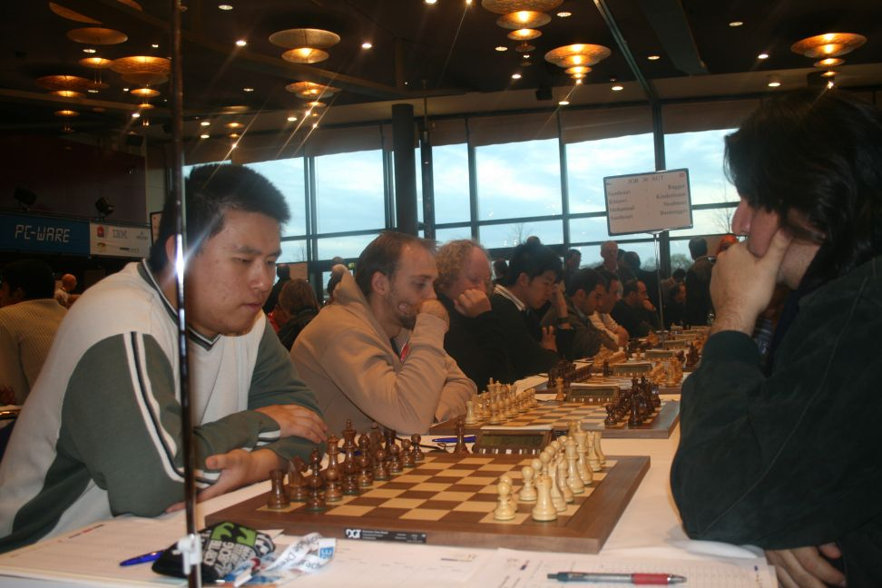

Rd.2 – Australia v El Salvador (from left) Zhao, Smerdon, Johansen, Xie.

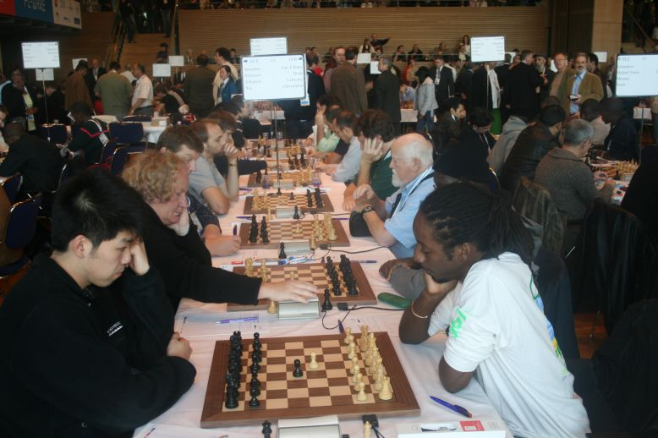

Rd.3 Australia v British Virgin Islands: Xie (L foreground), Johansen, Solomon,
Smerdon

