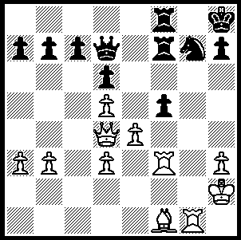
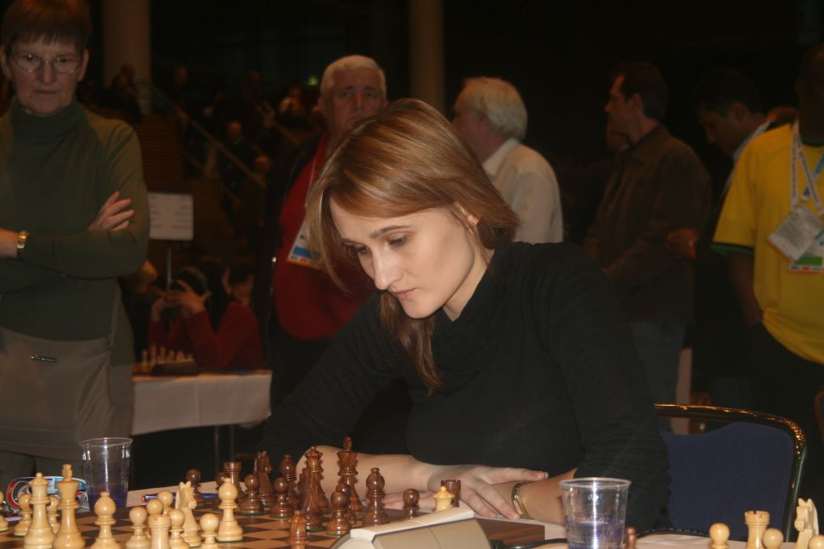

Ciukstye (England) – Veliciano (Brazil),
Dresden WomensOlympiad Rd.2:
why should Black not have played 1…fxe?
England’s Victoria Ciukstye.

Defending champions Armenia has retained the Olympiad title after defeating China in the final round. Ukraine, who were level on match points going into Round 11, lost to USA. Final scores: Armenia 19/22, Israel 18, USA, Ukraine 17. The star-studded Russian team could only manage 16, equal with China and Spain.

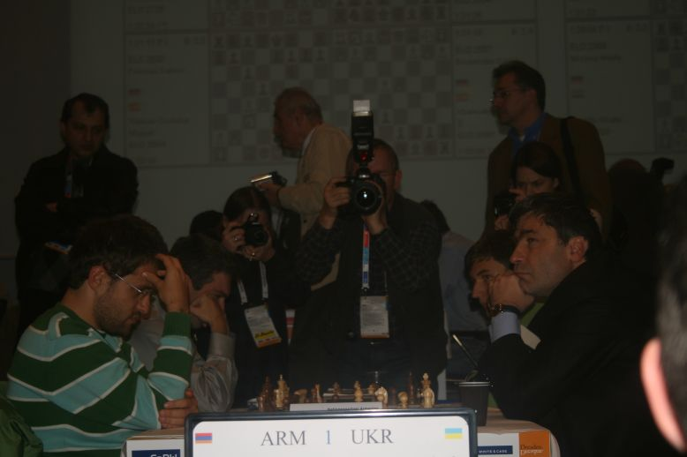

Armenia v Ukraine with Aronian (left) facing Ivanchuk

Australia lost its final round against Cuba and finished with 12 points with 6 matches won and 5 lost. Top board Zhao Zong-Yuan had the privilege of playing two greats of the chess board in successive rounds, defeating the legendary Viktor Korchnoi (Switzerland) in Round 6 and losing to World Number 1 Vaselin Topalov (Bulgaria) in Round 7.

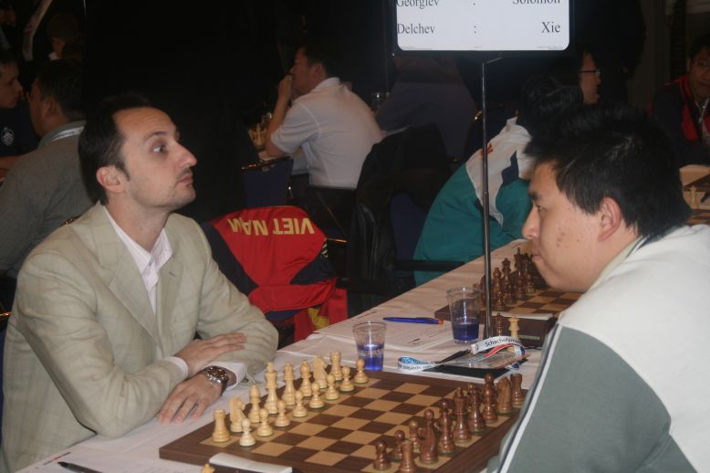
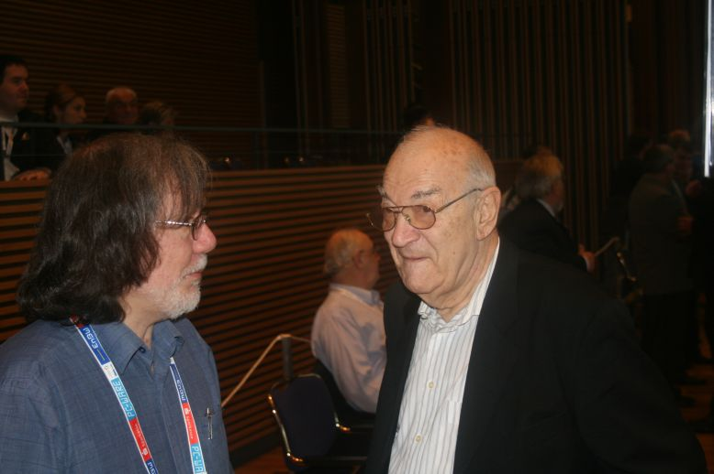

Australia’s former top board Ian Rogers Australia’s present Board 1 Zhao Zong-Yuan
chats with Viktor Korchnoi. faces the world’s top rated player, Veselin Topalov (Bulgaria) in Round 7.

Here is another win from England, this time from their Open team:

L Johannessen (Norway) - D Howell (England)
Chess Olympiad Dresden, Rd.4
English Opening
1.Nf3 Nf6 2.c4 g6
3.Nc3 d5 4.cxd5 Nxd5
5.Qa4+ Bd7 6.Qh4 Bc6
7.Qd4(a) Rg8!(b) 8.Ne5 e6
9.Nxc6 Nxc6 10.Qa4 Qd7
11.e3 0-0-0 12.Be2(c) Ndb4!
13.0-0(d) Nd3(e) 14.b4 Kb8
15.b5 Nce5 16.f4 Nxc1
17.Raxc1 Nd3 18.Bxd3 Qxd3
19.Ne4 f5 20.Ng5 Qxd2
21.Nf7 Rd5! 22.b6 axb6
23.Qe8+ Ka7 24.Nh6 Ba3!
25.Nxg8 Qxe3+ 26.Kh1 Bxc1
27.Ne7 Qxf4! 28.Rg1(f) Ba3!
29.Nxd5 exd5 30.Qd7 Bd6
31.Qxh7 d4 32.g3 Qe4+
33.Rg2 d3 White resigns

a) White tries to improve on 7.Ne5 Bg7 8.Nxc6 Nxc6 – Schandorff – Howell (Denmark - England , Rd.2), another brilliant Howell win.
b) 7...f6 is a reasonable alternative - 8.e4 Nxc3 9.bxc3 Qxd4 10.Nxd4 and not now 10…Bxe4? 11.Ne6! wins.
c)12.Bb5 Ndb4 13.d4 a6 14.a3 axb5 15.Qa8+ Nb8 unclear.
d)13.d4 Nxd4! 14.Qxa7 is a messy position probably better for Black – 14…Ndc2+ 15.Kf1 Nc6 16.Qa8+ Nb8 17.Rb1 Nb4.
e) White's king looks more secure but Black’s control of an outpost on d3 hampers White’s development.
f) Not 28.Rxf4? Rd1+ 29.Rf1 Rxf1#.

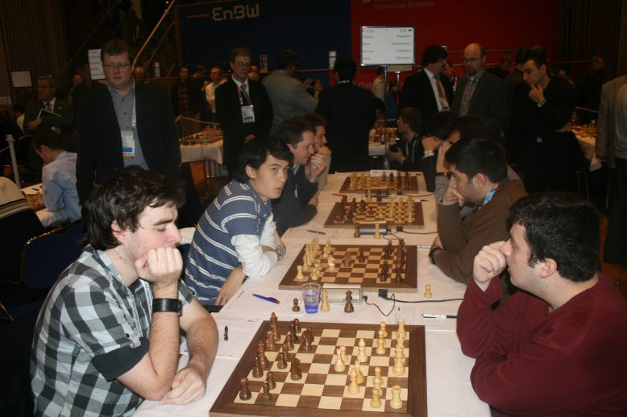
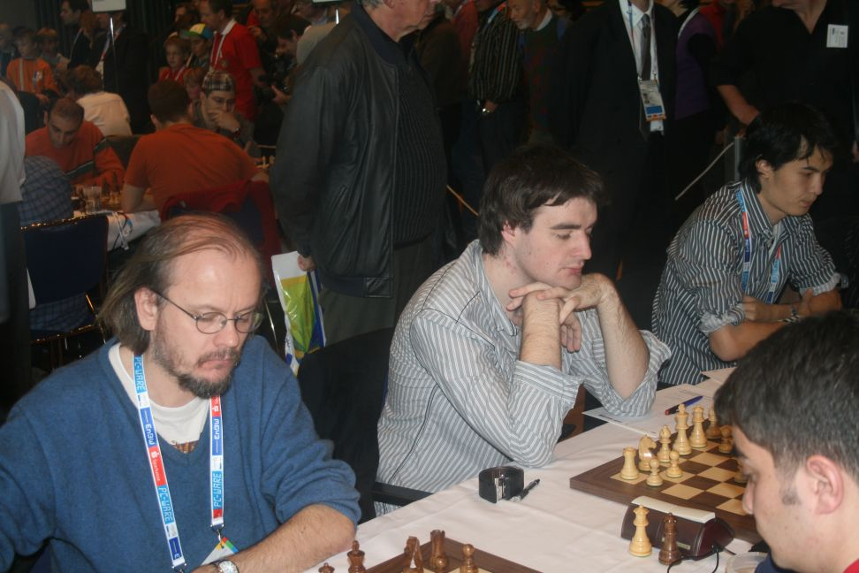

England’s Conquest (left), Jones, Howell. England again – Jones (left), Howell, Short, Adams.

At the State Finals of the Chess Kids Secondary Championships held at Perth Modern on October 24 Seton College just pipped Penrhos College on game points after the two teams finished equal on match points. Medallions were awarded to top boy Chris Boni (Seton) and top girl Amy Brown (Penrhos, whose team also included the Williams sisters, Verity and Veronica). Both teams will represent WA in the Boys and Girls Finals respectively in Melbourne next week.

SOLUTION: 1…fxe?? was met by 2.Qxg7+! and Black resigned (2…Rxg7 3.Rxf8+ Rg8 4.Rxg8#).

