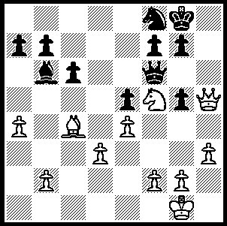
Returning briefly to the Dresden Olympiad,
we start with a position in which a player
from a chess playing minnow nation has a
chance to obtain a winning position against
a player rated almost 240 points above him.
Lim Yee Weng (Malaysia) – Jan Gustaffson
(Germany A) – White to play (3 moves):

England finished 15th in the Olympiad, equal to their ranking. Although top board Michael Adams had a disappointing tournament, both Board 2 Nigel Short, a former challenger to Gary Kasparov for the world title, and 18 year old David Howell on Board 3 had excellent scores. Here is a game of Short’s which helped him to a score of 7/10:

Z Izoria (Georgia) - N Short (England)
2008 Dresden Olympiad
English Opening
1.c4 e5 2.Nc3 d6
3.Nf3 f5 4.g3 Nc6
5.d4 e4 6.d5 Ne5
7.Nd4(a) Nf6 8.Bh3(b) g6
9.f3 exf3 10.exf3 Bg7
11.f4 Neg4 12.0-0 0-0
13.Bg2 Re8 14.h3 Ne3
15.Bxe3 Rxe3 16.Qd2(c) Rxg3!
17.Nde2 Rxg2+ 18.Kxg2 c5!(d)
19.Ng3 Bd7 20.Rf3 a6
21.a4 b6 22.Qd3 Ne8!
23.Ra2 Rb8 24.b3 Nc7
25.Nce2 b5 26.axb5 axb5
27.Ra7 Bf6 28.Qd2 bxc4
29.bxc4 Rb4 30.Qa2 Qb8
31.Raa3(e) Bc8 32.Rfe3(f) Kf8
33.Kf2 Qb6 34.Qc2 Bd4!
35.Kf3(g) Bb7 36.Nxd4(h) cxd4
37.Re2 Nxd5! 38.cxd5 Bxd5+
39.Ne4(i) fxe4+ 40.Kg3 Qc5
White resigns(j)

a) If 7.Nxe5 dxe5 8.Bg2 Bc5 with a very active position.
b) This placement of the bishop achieves nothing and White soon retreats to the more natural g2.
c) Setting a trap into which Black very happily falls.
d) Black has a pawn for the exchange and White's king is permanently in danger. Now 19.dxc exposes his king further, eg 19.dxc6 bxc6 20.Rad1 d5! 21.cxd cxd 22.Nxd5 Nxd5 23.Qxd5+? Qxd5 24.Rxd5 Bb7, while permitting the central block enables Black to prepare a …b5 break a la Benoni.
e) White was ready to meet 31...Rb2 with 32.Rfb3.
f) If 32.Rfb3 Ba6! 33.Rxb4 cxb4 34.Rxa6? b3! wins.
g) Not 35.Nxd4? cxd4 36.Red3 Rb2.
h) 36.Nxf5 can be met effectively with 36…Rxc4! (37.Qxc4? Bxd5+).
i) Not 39.Kf2 d3+.
j) There is no stopping the black pawns.

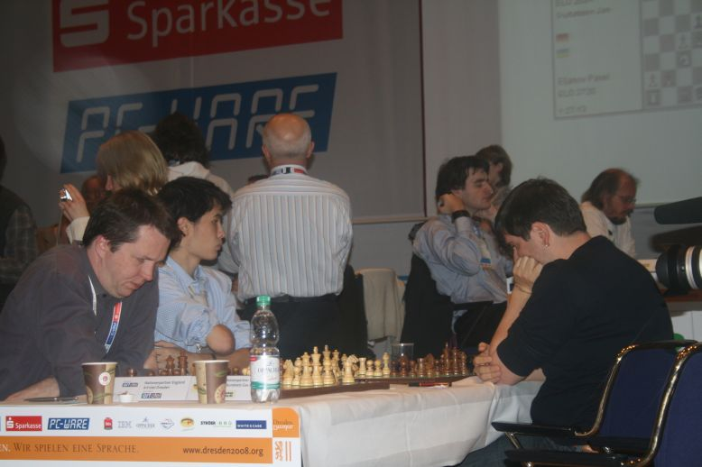

England’s two most successful players Short (left) and Howell in play against Russia

The final Grand Prix event of the year, the Christmas Open, provided a number of unexpected results.The very experienced Mohammad Jahangirian lost to newcomer Aaron Mc Hugh, Dennis Holland to junior Chirag Saroha and Ganesh Viswanathan to Gary Donaldson. Top rated player, Stephanus Kurniawan (5.5/6), finished first, Marc Vliestra (5) second, with 3rd shared between Tom Donaldson, Ganesh Viswanath, Edik Gilmetdinov and Dennis Holland (4). Edik and Dennis shared the Under 1800 prizes while Alex de Heer (3) won the Under 1500 award.

SOLUTION: White can play 1.Qxf7+! Qxf7 2.Ne7+ / 3.Bxf7 with a likely won ending. Gustaffson had offered a draw with his last move which Lim accepted.

