HASTINGS 2008/9
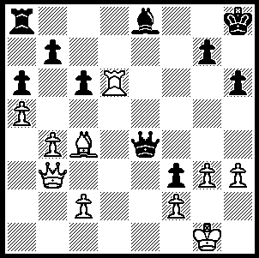
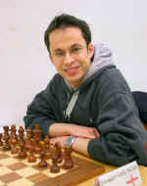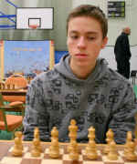
GM Stewart Haslinger Gudmundur Kjartansson - Haslinger-Kjartansson (Hastings 2008/9, Rd 7):
Iceland Black to play and win (4 moves):

It is said that William the Conqueror played chess and once broke a chess board over the head of a nephew, Louis the Fat, after accusing him of cheating. It seems appropriate therefore that Hastings, the site of William’s victory over the English king Harold, should be the venue of the world’s longest running annual tournament. The Hastings tournament of 1885 could be considered one of the strongest tournaments of all time with the top four places filled by Pillsbury, Tchigorin, world champion Lasker and Tarrasch (ex world champion Steinitz was also competing). Regular congresses starting the first week after Christmas began in 1920 and winners have included many of the world champions, Euwe, Capablanca, Alekhine, Botvinnik, Smyslov, Tal, Spassky and Karpov as well as Judit Polgar and such English experts as Yates, Thomas, Golombek, Penrose, Alexander, Nunn and Short.
This year among the 104 players competing in the top event, the 9 round Swiss Hastings Masters, were 13 GMs, 16 IMs and a WGM. Winner was Russian Igor Kurnosov (7/9) who drew his final game with winner of the two previous years, Ukranian Valeriy Neverov, to hold on to his half point lead. Equal third on 6 were top ranked Swede Emmanuel Berg and an English trio of David Howell, Gawain Jones and two-times winner and British champion Stuart Conquest, all members of the English Olympiad team.

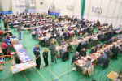  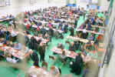 | 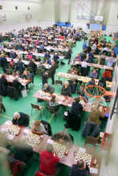

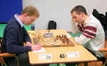
Rd 9 Board 3 Emanuel Berg v Andrew Greet
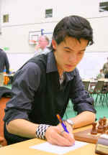
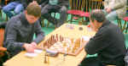
Rd 9 Board 1
Valerij Neverov v Igor Kurnosov
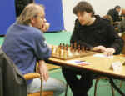
England's boards 4 & 5 at the recent Olympiad held in Dresden commence their round 4 encounter. Stuart Conquest has white against Gawain Jones.
David Howell

Here are two miniatures from the event:

Stephen Gordon - Emanuel Berg
Hastings Masters 2008/9, Round 6
Queens Gambit, Albin Counter Gambit
1.d4 d5 2.c4 e5
3.dxe5 d4 4.Nf3 Nc6
5.a3(a) Nge7 6.b4 Ng6
7.b5(b) Ncxe5 8.Nxd4 Bc5
9.Bb2(c) Qh4(d) 10.e3 Bg4
11.Qc2(e) 0-0-0 12.Be2?(f) Bxe2
13.Qxe2 Bxd4 14.Bxd4 Rxd4!
15.exd4 Qxd4 White resigns(g)

a) Together with 5.g3 one of the main lines.
b) The usual move here is 7.Bb2 (if 7...a5 then 8.b5).
c) 9.e3 is strongly met by 9...Bg4!, when 10.f3? loses to 10...Qh4+ 11.g3
Nxf3+! 12.Nxf3 Qf6, whilst both 10.Be2 Bxe2 11.Kxe2 and 10.Qd2 Nh4 (threat 11…Bxd4 & 12…Nf3+!) give Black a very strong initiative.
d) More emphatic than 9...Nxc4.
e) If 11.Be2 Nxc4.
f) Black had to try 12.Nd2 although 12...Rhe8 leaves Black with the sort of position that would delight any player of gambits.
g) White is defenceless against Black’s many threats.

John Anderson - Stewart Haslinger
Hastings Masters 2008/9, Round 9
Kings Pawn, Three Knights
1.e4 e5 2.Nf3 Nc6
3.Nc3 g6 4.d4 exd4
5.Nxd4 Bg7 6.Be3 Nf6
7.f3 0-0 8.Qd2 Re8
9.0-0-0 d5 10.Nxc6 bxc6
11.Bh6 Bh8 12.Bg5 Qd6
13.h4 Rb8 14.a3 Nd7
15.h5 Nc5 16.hxg6 fxg6
17.exd5 Rxb2! 18.Bc4(a) Nb3+!
19.Bxb3 Qxa3 White resigns

a) If 18.Kxb2 Na5+ wins.

SOLUTION: 1…Bf7! wins a piece (2.Bxf7? Qe1+ 3.Kh2 Qxf2+ 4.Kh1 Qg2#) – an unusual deflection sacrifice involving a pin on a piece of the same kind.

