White to play and mate in 2:
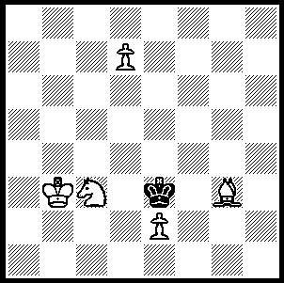
The 2008/09 Australian Championship played
in Sydney and concluded on January 11 resulted
in a tie between two Australian Olympiad
representatives, Aleks Wohl and George Xie,
with scores of 9/11. Equal 3rd were Mark Chapman,
Eugene Schon and Jason Hu (8/11). WA had two
players competing, Dick Lilly, a regular at the
Australian events, and Chris Cuellar. They each
scored 5/11, coming =40th in a field of 74.

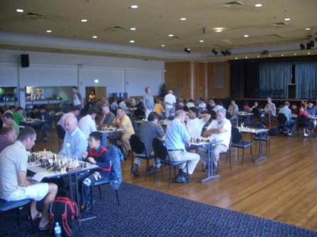

Play at the Australian Open at the Manly Rugby League Club, Sydney

The first round of such an event often produces miniatures when top players have White against players rated over 400 points below them. This certainly happened in Sydney with one of the early losers being one of our own:

Mark Chapman - Dennis Wan
2008/09 Australian Open, Rd 1
Modern Defence
1.e4 d6 2.d4 g6
3.Nc3. Bg7 4.Be3 Nd7
5.Qd2 e5 6.Nf3 b6(a)
7.Bc4 exd 8.Nxd4 Bb7
9.0-0-0 Ngf6 10.Bh6 0-0
11.Bxg7 Kxg7 12.Rhe1 a6
13.Bf1 Re8 14.f3 Nc5?
15.e5 dxe?(b) 16.Nf5+! Kh8(c)
17.Qh6 Ncd7 & Black resigns

a) 6…Ngf6, …c6 and …a6 are better than the text.
b) Black is unaware of the danger to his queen on the now open file.
c) 16…gxf5 loses quickly to 17.Qg5+.

Vladimir Smirnov - Richard Lilly
2008/09 Australian Open, Rd 1
Trompowsky Attack
1.d4 Nf6 2.Bg5 Ne4
3.Bh4 g6(a) 4.f3 Nf6
5.e4 d6 6.Nc3 Nbd7
7.Bc4 Nb6 8.Bb3 Be6(b)
9.Bxe6 fxe6 10.Qd3 Bg7
11.Nge2 0-0 12.0-0 Rc8
13.a4 c5 14.a5 Nbd7?(c)
15.Nf4 Kf7 16.Nxe6! Kxe6
17.Qc4+ d5 18.Nxd5 cxd(d)
19.Nf4+ Ke5 20.Qe6+ Kxf4
21.g3+ Ke3 22.Bg5+ resigns

a) White gains a tempo and a strong centre after this: more challenging is the double-edged 3…g5 (4.f3 gxh4 5.fxe4 e5).
b) This leaves a serious weakness on e6.
c) Blocking the queen’s ability to protect e6: 14…Na8 would allow Black to defend e6 with both queen and knight.
d) If 18…Kd6 19.Bg3+ e5 20.dxe5+ Nxe5 21.Rfd1 wins.

SOLUTION: 1.d8=B! Kd2 2.Bg5# or 1…Kd4 2.Bb6#. 1.d8=Q or R is stalemate. An unusual combinative cooperation involving same coloured square bishops.

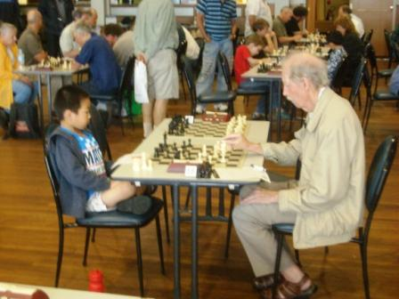

It’s on for young and old at the Under 1600 event.

