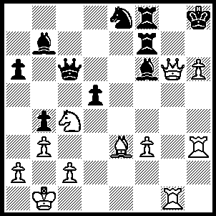
In Karjakin – Morozevich
(Corus A 2009, Rd 1) Black
resigned before White’s attack
finally broke through. Below is
a position of a likely continuation.
White is able to gain a considerable
material advantage with a mate not
far off. Can you see 4 moves ahead
starting with a bolt from the blue?

The final round of the Wijk aan Zee Corus A began with six of the 14 players tied in top spot. Radjabov, Aronian and Movsesian all drew while Magnus Carlsen lost. The decisive match between the other two leaders, Leinier Perez Dominguez and Sergey Karjakin was a real blood and thunder struggle with the Cuban throwing everything at his young Ukranian opponent. Victory might have gone either way but Dominguez faltered in time trouble leaving Karjakin (8/13) victor by a half point.

Leinier Perez Dominguez – Sergey Karjakin
2009 Corus A, Wijk aan Zee, Rd 13
Sicilian Najdorf
1.e4 c5 2.Nf3 d6
3.d4 cxd4 4.Nxd4 Nf6
5.Nc3 a6 6.Be3 Ng4
7.Bc1 Nf6 8.Be3 Ng4
9.Bg5 h6 10.Bh4 g5
11.Bg3 Bg7 12.h3 Nf6
13.Qe2 Nc6 14.Nxc6 bxc6
15.e5 dxe5 16.Bxe5 0-0
17.g4(a) a5 18.h4!?(b) Bxg4
19.f3 Bf5 20.hxg5 hxg5
21.Qe3 a4 22.Qxg5 Bg6
23.Bd3(c) a3 24.b4!?(d) Qb6
25.Rh4?(e) Nh7!(f) 26.Rxh7 Kxh7
27.0-0-0 Qxb4 28.Rh1+ Kg8
29.Bxg7?(g) Kxg7 30.Qh6+ Kf6(h)

a) An aggressive novelty.
b) It’s now all or nothing for Dominguez, there’s no going back.
c) An alternative is 23.Bc4 (threat 24.Qxg6) 23…e6 24.Bxe6 Re8 25.Qxg6 Rxe6 and Black is happy.
d) Looks loosening but it keeps the Black queen from a5 (24.b3 Qa5 25.0-0-0 Ne4! 26.Bxe4 Qxe5 27.Qxe5 Bxe5 with equality)
e) 25.Bxg6 is better giving Black no chance to play …Nh7 - eg 25...fxg6 26.Rh4 Rad8 27.Ke2.
f) An excellent defensive move: not 25...Bxd3? 26.cxd3 Rfd8 27.Rg4.
g) The final mistake. Dominguez had used almost all his time looking for a win. He should play 29.Bxg6 fxg6 30.Qxg6 (30.Rh8+ Kf7!! not 30...Kxh8 31.Qh6+ nor 30...Bxh8 31.Qxg6+) 30...Rf6 31.Qh7+ (31.Bxf6 Qf4+ 32.Kd1 Rd8+ 33.Ke1 Qxf6 =) 31...Kf7 32.Rg1 Qb2+ 33.Kd2 Rd8+ 34.Ke2 and it’s anyone’s game.
h) White’s attack fizzles out: conclusion - 31.Ne4+ Ke6 32.Rd1 Qb2+ 33.Kd2 Kd7 34.Qf4 Rfd8 35.Ke2 Ke8 36.Rh1 Ra5 37.Qc7 Rad5 38.Ke3 Kf8 39.c3?? Rxd3+ 40.Kf4 f6 41.Rh8+ Kf7 White resigns.

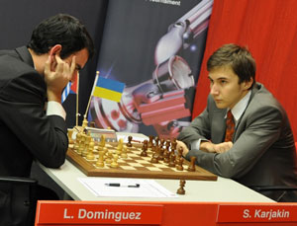
Dominguez v Karjakin in Round 13. Ivanchuk v Movsesian in Round 7.

One of the contestants in the Corus A, Vassily Ivanchuk, played with the threat of a two year ban from the chess board after failing to undergo a drug teat at the Olympiad. Ivanchuk, who is not known for taking defeats kindly, brushed past officials after a loss in the Ukraine-USA match.
However he was cleared on a technicality after it transpired that there was not a designated Doping Control Officer present at the time.

KINGSLEY OPEN (a CAWA Grand Prix & Yulgibar-Think Big Australian Chess Grand Prix event) Sat 21 (12.30 -7.30) and Sun 22 Feb (10.30 – 6.00) at Legacy House. $10 discount if participation confirmed by Fri 20 (Haydn Barber 9398 4242, hadix@vianet.net.au).

SOLUTION: 1.Qg7+!! Rxg7 (1…B/Nxg7 is worse) 2.hxg7+ Kg8 3.Rh8+ Kf7 4.gxf8=Q+ - the power of the double check!

