HEATH LEDGER MEMORIAL

The day after the Heath Ledger posthumous Oscar award as best supporting actor in ‘The Dark Knight’ I visited Perth-based artist Ron Gomboc’s commemorative sculpture incorporating two chessboards and a yin and yang design at Point Heathcote. A West Australian article on Thursday 19 February read, ‘Ledger ….used to relish playing chess at parks around the world when he had down-time from filming…. His mother, Sally Bell, …. said few people knew he was passionate about chess …’

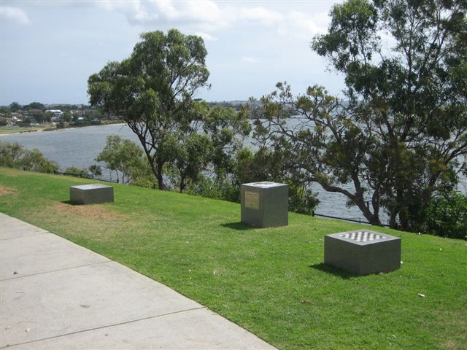
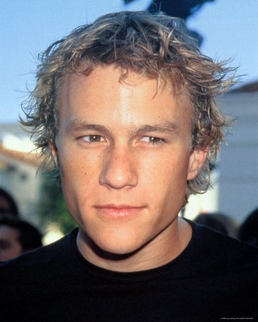

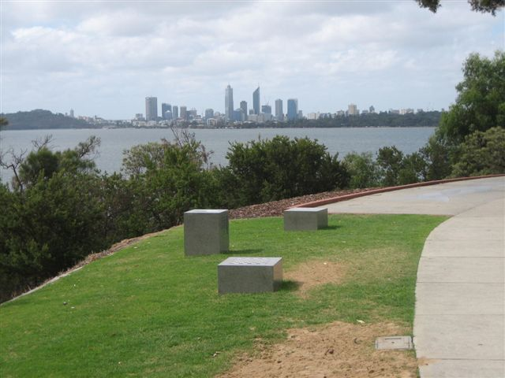
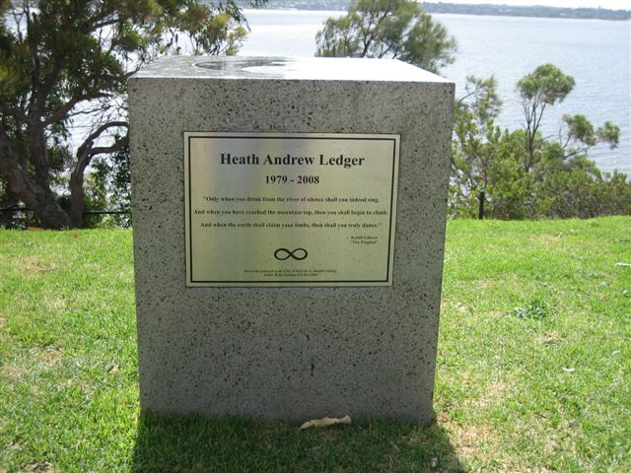

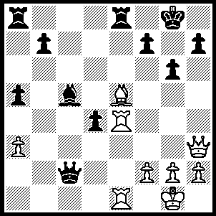

2009 Australian Junior Championship
Rd 9, Ivancic – Zulfic: Black now
played 1…d3? allowing a spectacular
but standard mate. Can you find the
White win (3 moves)?

WA had eight entrants among the 100 plus contestants in the Australian Junior Championships played during January in Athelstone, South Australaia: Under 18s - Yita Choong =7th with 6.5/11, Chris Boni 5.5, Chirag Siroha and William Williams 4.5: Under 12s - Ryan Sam 3rd with 8/11, Caleb Thomas 4/8 before unfortunately having to withdraw: Girls Under 18s - Verity Williams =5th with 5/9, Veronica Williams 4.5. Ryan also came =1st in the Under 12 Rapid Play while Verity was 3rd in both the Girls Rapid Play and Lightning. As mentioned last week Yita won the Problem Solving Competition with Chris 3rd. Not only would our juniors have gained from the experience of competing with the best from around Australia but were privileged to have as coach one of Australia’s three Grand Masters, Daryl Johansen.
Yita Choong was one of the top rated players but if he was hoping the Swiss draw would mean a relatively easy first round victory he was in for a shock as his opponent found a clever combination, making Yita fight hard for victory in a bewilderingly complex game:

Yita Choong - Nicholas Deen-Cowell
2009 Australian Junior Championship, Rd. 1
Benko Gambit
1.d4 Nf6 2.c4 c5
3.d5 b5 4.cxb a6
5.Nc3 axb 6.Nxb5 Ba6
7.Nc3 g6 8.e4 Bxf1
9.Kxf1 d6 10.Nf3 Bg7
11.g3 0-0 12.Kg2 Nbd7
13.Re1 Ra6 14.Qc2 Qa8
15.b3 e6 16.dxe fxe
17.Bb2 d5 18.Nd2 d4
19.Nb5 Qb7 20.a4 Ng4
21.Rf1(a) Rxf2+! 22.Kg1 Rxh2(b)
23.Rf4 Nde5(c) 24.Ba3(d) Bh6(e)
25.Qxc5! Qb8(f) 26.Raf1 Bxf4
27.Rxf4 Rf2(g) 28.Rxf2 Nxf2
29.Nc7 Ned3 30.Qe7 Rc6
31.Bd6 Qc8(h)

a) Necessary was 21.f3 allowing the loss of the exchange after 21…Ne3+ 22.Rxe3.
b) Black has played the opening gambit most energetically, creating pressure on all sides of the board, culminating in a clever ‘destroying the guard’ combination. However he now misses the tempo saving 22…Rg2+! 23.Kh1 (23.Kxg2 Ne3+) 23…Rxh2+.
c) 23…Ne3 and 23…Bh6! are good alternatives.
d) In a desperate position White pinpoints f8 as a target for a counter attack.
e) 24…c4! prevents White’s intended counterplay.
f) Overestimating White’s attack Black errs. The simple 25…Rxd2 wins: if then 26.Nc7 Qc8! 27.Nxa6 Qxc5 28.Nxc5 Bxf4 29.gxf4 Nf3+ mating: better is 26.Rf8+! Kg7 27.Rf4! Ra8 28.Nc7 but would Black then see 28…Qxe4!!! 29.Nxe6+ Kg8 30.Rxe4 Nf3+ again mating.
g) If 27…Ra8 28.Nc7 is strong.
h) Black is lost if he returns the exchange and his attempts to secure a perpetual are thwarted – 32.Ne8 Rc1+ 33.Kg2 Rg1+ 34.Kxg1 Qc1+ 35.Nf1 Nh3+ 36.Kh2 Qc2+ 37.Kxh3 Nf2+ 38.Kg2! Nxe4+ 39.Kf3 Qd3+ 40.Kf4 g5+ 41.Ke5 Qb5+ 42.axb5 resigns

The SW Open planned for March 7/8 has been cancelled.

SOLUTION: 1…d3? 2.Qxh7+!! Kxh7 (2…Kf8 3.Bg7#) 3.Rh4+ Kg8 4.Rh8#.

- |
- Play & Win |
- Tell a Friend |
- Ask Us
Top of Form

Heath Ledger Pictures & Photos

