After last week’s review of WA juniors we move back to Corus Wijk aan Zee to look at world juniors.
Norwegian teenage star Magnus Carlsen went into the final round of Corus A in joint first place but a loss to Wang Yue saw him dropp him to =6th. As Black, Carlsen now played the losing 1…Re5. How did Wang now win and how could Carlsen have drawn?

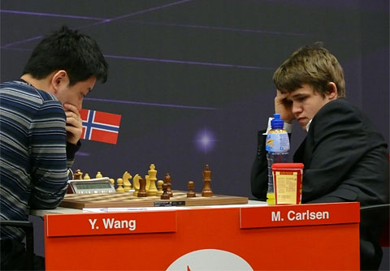
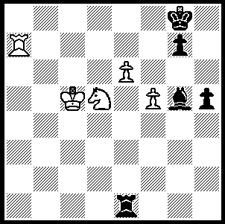

232

While most interest at Wijk aan See
would have been centred on the Corus
A event, a significant achievement
occurred in the C section with the
gaining of the Grandmaster title by
Anish Giri in finishing second. Anish
at 14 years and 7 months becomes the
youngest ever GM, taking the record
from the winner of the section, Wesley
So from the Philippines. Anish, of Russian-Nepalese extraction, was born in St Petersburg on June 28, 1994 but now lives in the Netherlands. Anish speaks four languages, Russian, English, Japanese and Nepalese and is now Wesley So (R) & Anish Giri (L), learning Dutch 1st & 2nd in Corus C .
Eduardo Iturrizaga – Anish Giri
2009 Corus C Wijk aan Zee (Rd 11)
Queens Gambit: Slav Defence
1.d4 d5 2.c4 c6
3.Nf3 Nf6 4.e3 Bf5
5.Nc3 e6 6.Nh4 Bg6
7.Bd2 Nbd7 8.Nxg6 hxg6
9.Qc2 Bd6 10.h3 0-0
11.0-0-0 Qe7 12.g4 dxc4
13.g5 Nd5 14.h4 c5
15.Nxd5 exd5 16.Bg2 cxd4
17.exd4 Nb6 18.h5 c3!
19.bxc3 Ba3+ 20.Kb1 Qd6
21.Rh4 Nc4 22.Bf4 Qb6+
23.Qb3 Qc6 24.Rdh1 Rfe8
25.Bc1 Rad8 26.hxg6 fxg6
27.Qc2 Bxc1 28.Qxc1 Re2!
29.Rh8+ Kf7 30.Rxd8 Qb6+
31.Ka1 Qxd8 32.Qb1 Qd7
33.Bf1 Na3 34.Qd3 Rxf2
35.Bh3 Qe7 36.Rf1 Rxf1+
37.Qxf1+ Ke8 38.Qc1 Nc4
39.Qb1 Qxg5(a) 40.Qb5+ Kf8
41.Qb4+ Qe7 42.Kb1 Qxb4+(b)
43.cxb4 Ke7 44.Kc2 Nd6
45.Kd3 Nf5 46.a4 Ke6
47.Bg4 g5 48.Bh5 Ne7
49.Bg4+ Kd6 50.b5 b6
51.Ke3 g6 52.Bh3 Nf5+
53.Kd3 Nh6 54.Ke3 g4
55.Bf1 Nf5+ 56.Kd3 g3
57.Bh3 g5 White resigns.

a) 39...Qe3 threatening ...Qxc3 and mate would have been faster.

b) Now Anish goes on to win the endgame in convincing fashion.

2009 WA Open will be played over 3 weekends commencing Sat 21 March (2 rounds a day, 60 min + 30 sec) with rating prizes and the top 3 qualifying for the WA Closed Championship. Details cawa.org.au or enquire Haydn Barber 9398 4242

The Kingsley Open (Australian & WA Grand Prix event, Feb. 21/22) was won by Tristan Boyd with 5/6 (draws with David Ellis & Michael Horstmann). Second were Michael Horstmann and Dennis Holland (4) with Dave Dempster & Sean Robertson (4) gaining the under 1800 prizes and Gabriel Nhial and Steve Mijaimovic (3) the Under 1400.

SOLUTION: 2.f6! Bxf6 (2…gxf6 is worse) 3.Kd6 Rf5 4.Nxf6+ Rxf6 5.Kd7 h4 6.e7 Rf7 7.Kd8 Kh7 8.Ra6! (preventing Black’s king from supporting his pawns: not 8.e8=Q? when 8…Rxa7 is
drawn) Black resigns. Black could have gained a simple draw by 1…g6!

