The annual Linares Tournament, Spain, had eight of the world’s top GMs playing a double round-robin and, despite a high number of draws produced some typically fine games. Norwegian teenager Magnus Carlsen, as at Corus Wijk aan Zee earlier this year went into the final round with a chance of first place but finished a half point behind the two leaders after all four games were drawn. Magnus must have regretted his failure to win his 13th round game against Teimour Radjabov in an ending with a rook for knight.

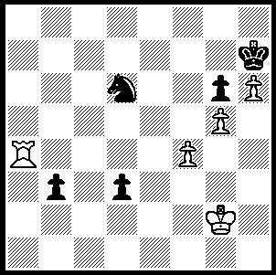

Magnus Carlsen ruefully agrees a draw.
Carlsen now played 1.Kf3? allowing Radjabov to gain an ingenious draw. Can you find the saving line and also suggest a better first move for White?
Muscovite Alexander Grischuk with 8/14 (+3, =10, -1) gained first place ahead of Ukranian Vassily Ivanchuk, also 8 (+2, =12), through winning one more game. Carlsen with 7.5 (+3, =9, -2) was third followed by world champion Viswanathan Anand on 7.
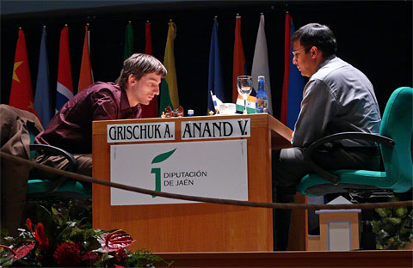
Winner Grischuk battles Anand Ivanchuk deep in thought
One of the best games from the event was Carlsen’s victory against the winner. Carlsen’s almost faultless victory seemed Karpov-like in its seemingly simple inevitability:

Magnus Carlsen - AlexanderGrischuk
2009 Linares, Rd. 12
Sicilian Scheveningen
1.e4 c5 2.Nf3 d6
3.d4 cxd 4.Nxd4 Nf6
5.Nc3 a6 6.Be2 e6
7.0-0 Be7 8.a4 Nc6
9.Be3 0-0 10.f4 Qc7
11.Kh1 Re8 12.Bf3 Bf8(a)
13.Qd2 Rb8 14.Qf2 e5
15.fxe5!(b) dxe5 16.Nb3 Nb4
17.Ba7 Ra8 18.Bb6 Qe7
19.Rad1 Be6(c) 20.Nd5! Bxd5
21.exd5 e4 22.d6!(d) Qe6(e)
23.Nc5 Qf5 24.Be2 Qxf2
25.Rxf2 Nbd5 26.a5 Nxb6(f)
27.axb6 Rab8?(g) 28.Rxf6! gxf6
29.Nd7 f5 30.c4 a5
31.c5 Bg7 32.Nxb8 Rxb8
33.Ba6! Bf6 34.Bxb7! Rxb7
35.c6 Rxb6 36.Rc1! Bxb2
37.d7 Black resigns(h)

a) 12...Rb8 is the most popular move here and was played successfully by Kasparov in the 24th game of the world championship match with Karpov in 1985.
b) A prepared novelty from Carlsen.
c) 19...Bg4 was more challenging.
d) An obvious but strong Zwischenzug. White’s passed pawn marches relentlessly on.
e) After 22...Qe5 23.d7! Nxd7 24.Rxd7 exf3 25.Qxf3 f6 26.Nd4 white has a strong pressure; and after 22...Qd7 23.Nc5 Qc6 24.Nxe4! Rxe4 25.Bxe4 Qxe4 26.d7 White wins.
f) If 26...Bxd6 27.Rxf6! Bxc5 28.Rxd5 winning.
g) This proves a vulnerable square. 27...Rec8 was better although unlikely to save the game.
h) After 37... Bf6 38.c7 wins.

2009 WA Open will be played over 3 weekends commencing Sat 21 March (2 rounds a day, 60 min + 30 sec) with rating prizes and the top 3 qualifying for the WA Closed Championship. Details cawa.org.au or enquire Haydn Barber 9398 4242
SOLUTION: 1.Kf3? (47.Kf1 would have won quite comfortably) 1...Nb5! 2.Rb4 (2.Ke3 b2 3.Rb4 Nc3 is a draw, e.g. 4.Kxd3 - 4.Rxb2 Nd1+ 5.Kxd3 Nxb2+ - 4...b1Q+ 5.Rxb1 Nxb1) 2...Nc3. 3.Rb7+. (not 3.Ke3? Nd5+ and wins). 3...Kg8 4.Rb8+ Kh7 5.Ke3 b2 6.Rb7+ Kg8 7.Rb8+ Kh7 draw. A tragedy for Magnus, who would have joined Ivanchuk and Grischuk at the top of the table and would have won the tournament if he had then finished level through a plus score v Grischuk (equal no. of wins).

