I shall be absent from Perth until early June but articles will appear as usual in both the West Australian and on this site.

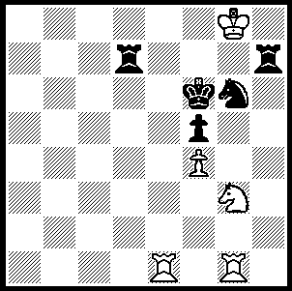
An 9th century problem by the Arabian composer
al-Adli, White to play and mate in 3:

Chess was played in Iran, formerly Persia,
long before the game was known in Europe,
having entered from India in the 6th century.
The oldest chess text is Persian and the
earliest surviving chess set is also Persian.
At the 2008 Dresden Olympiad Iran came
40th out of 100 with 13/22 in the Open while the Iranian Women’s team was 39th of 102 237
with 11/22. Although chess was banned after
the Islamic Revolution in 1979, chess has continued in popularity with chess palaces and parks springing up since the lifting of the ban in 1988. As part of the 30th anniversary celebrations of the revolution former world champion Anatoly Karpov was invited to Tehran to play a 20 game match against Iran’s leading GM, Ehsan Ghaem Maghami (January 26 to February 3). There were to be 4 classical games: (90 min + 30 sec/move), 4 rapid games (25 min + 10 sec/move) and 12 blitz Games (4 min + 2 sec/move). Special rules forbade agreeing draws or resigning. (I wonder if there was an ideolological reason for the games to be played through to mate and for the match to be titled ‘Mate of the King’. Was it to portray the overthrow of the shah?)

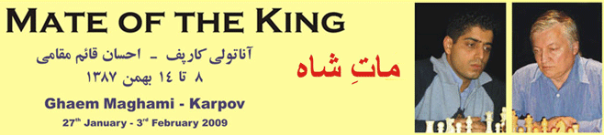

The classical and rapid games were drawn 2-2 with Maghami winning the blitz 6.5-5.5 and therefore the match 10.5-9.5. A disappointing aspect of the match was the lack of variety in the openings with Maghami using the Nimzo-Indian with every Black and Karpov always employing 4.Qc2 while Karpov chose the Caro-Kann in 8 games, facing the Panov-Botvinnik Attack each time. The 26-year old Maghami has an Elo rating of 2604 and was awarded the title of most active and successful chess player in the world in 2004 by FIDE.

Anatoly Karpov - Ghaem Maghami
Mate of the King, Classical Rd 1
Nimzo-Indian, Classical Variation
1. d4 Nf6 2. c4 e6
3. Nc3 Bb4 4. Qc2 O-O
5. a3 Bxc3+ 6. Qxc3 b5
7. cxb5 c6 8. f3 Nd5
9. Qd3 f5(a) 10. Nh3 cxb5
11. e4 fxe4 12. fxe4 Nf6
13. e5 Nd5 14.Ng5 Rf5
15. h4 h6 16. g4 Rxf1+
17. Rxf1 hxg5 18. Qg6 Nf4
19. Bxf4 gxf4 20.Rxf4 Qxh4+
21. Kd2 Qh2+ 22. Ke3 Bb7
23. Raf1 Nc6 24. Rf7 Qh3+
25. Kd2 Qh7 26. Rf8+! Rxf8
27. Rxf8+ Kxf8 28. Qxh7 and wins

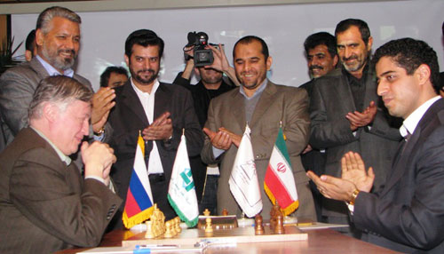

The match commences.

(continued overleaf)

a) Game 9 Blitz (Karpov White) went
9…cxb5 10. e4 Nb6
11. h4 Nc6 12. h5 h6
13. Ne2 b4 14. g4 a5
15. Qe3 Ba6 16. f4 Nc4
17. Qg3 Nd6 18. e5 Ne4
19. Qe3 d5 20. g5 hxg5
21. fxg5 Qb6 22. Bg2 Bxe2
23. Bxe4 dxe4 24. Kxe2 Nxd4+
25. Kf2 Rac8 26. Rd1 Rc2+
27. Rd2 Qc5 28. axb4 axb4
29. h6 Qxe5 30. Kf1 Qf5+
31. Kg2 Rxd2+ 32.Qxd2 Nb3
33. Qd6 Nxc1 34. h7+ Kxh7
35. Rxc1 (White is mated after 35.Qxf8) 35…Kg8
36. Rc5 Qf3+ 37. Kg1 Ra8 and wins

Ghaem Maghami - Anatoly Karpov
Game 3 Rapid
Caro-Kann Defence, Panov-Botvinnik Attack
1. e4 c6 2. c4 d5
3. exd5 cxd5 4. d4 Nf6
5. Nc3 e6 6. Nf3 Bb4
7. cxd5 Nxd5 8. Qc2 Nc6
9. Bd3 Ba5 10. a3 Nxc3
11. bxc3 Nxd4 12. Nxd4 Qxd4
13. Bb5+ Bd7 14. O-O Qe5
15. Bxd7+ Kxd7 16. Qa4+ Ke7
17. Rb1 b6 18. Bf4 Qc5
19. Rb5 Qc8 20. Rg5 g6
21. Rg3 f6 22. Re1 Qd7
23. Rxe6+! Qxe6 24. Re3 Rad8
25. Rxe6+ Kxe6 26. Qc6+ Ke7
27. g4 h6 28. h4 g5
29. Be3 gxh4 30. Bd4 Rhf8
31. Kg2 Rd7 32. Kh3 Rf7
33. Kxh4 Rd6 34. Qa8 Ke6
35. f4 f5 36. Qe8+ Re7
37. gxf5+ Kxf5 38. Qxe7 and wins

SOLUTION: Faced with mate White plays 1.Nh5+! (an obstruction sacrifice) 1…Rxh5 2.Rxg6+! (now a deflection sacrifice) 2…Kxg6 3.Re6#

