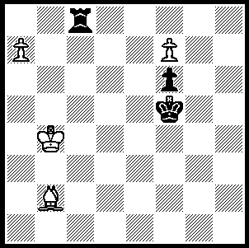

White wins in 5 moves in
the endgame study below:

246

The 10th European Individual Championship played in Montenegro during March was won
by the Russian Evgeny Tomashevsky. Tomashevsky tied with 11 other players before a KO
play-off. The powerful field of 306 players included 139 grandmasters.

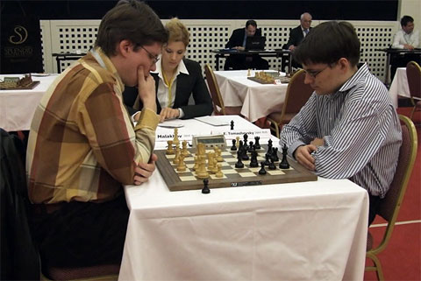

The final with Malakhov (L) and Tomashevsky playing one of their two rapid games.
After each player won one game the title was decided by a blitz Armageddon game when
a draw would win for Black. Malakhov put a rook en prise.

Here is a fine game from the event which is probably due in no small measure to computer
assisted opening preparation:

Peter Vavrak - Valery Popov
2009 Uropean Championship
Nimzo-Indian, Classical Variation
1.d4 Nf6 2.c4 e6
3.Nc3 Bb4 4.Qc2 d5
5.cxd5 exd5 6.Bg5 c5
7.dxc5 h6 8.Bh4 g5
9.Bg3 Ne4 10.Bxb8(a) Qf6!
11.Bg3 Nxc3 12.a3 Bf5
13.Qd2 Ba5 14.e3(b) 0-0-0!
15.Bd6 Bg4!(c) 16.f3?(d) d4!
17.e4(e) Rhe8 18.Ne2?(f) Bxf3!
19.gxf3(g) Qxf3 20.e5(h) d3!(i)
21.bxc3(j) dxe2 22.Qxe2 Bxc3+
23.Kd1 Qxh1 24.Rc1?(k) Rxe5!
White resigned

a) Kasparov's line: alternative 10.e3 Qa5! 11.Nge2 Bf5 12.Be5 0-0 13.Nd4 Re8! is good for Black.
b) Aronian who pioneered 10…Qf6 won quickly v Sokolov (Turin 2006): 14.b4 Ne4 15.Qc1 Rc8
16.Ra2 Rxc5 17.Qa1 Qc6! 18.Qe5+ Kd8! 19.Qxh8+ Kd7 White resigns.)
c) Threatening to win outright with 16...Ne4 17.Qxa5 Qxf2 mate.
d) If 16.Ne2 or 16.Be2 Black has 16...Qxf2+! 17.Kxf2 Ne4+ with an advantage, but 16.Nf3!? keeps
White alive - eg 16...Bxf3 17.gxf3 Qxf3 18.bxc3 Qxh1 19.0-0-0.
e) If 17.fxg4 dxe3 18.Qc2 Nb5+ 19.Ke2 Nd4+ or 17.exd4 Rhe8+ 18.Ne2 Nxe2 19.Qxa5 Ng3+.
f) 18.Bd3! Nxe4 19.Qxa5 Nxd6+ 20.Ne2 keeps White in the game.
g) After 19.e5 Rxe5!! 20.Bxe5 Qxe5 21.gxf3 d3! 22.bxc3 dxe2 23.Qxe2 Bxc3+ 24.Kf2 Rd2 Black wins.
h) If 20.Rg1 Rxe4 21.b4 Nxe2 22.Bxe2 d3; if 20.bxc3 Bxc3 21.Nxc3 dxc3, followed by 22...Rxe4+.
i) Weaker is 20...Qxh1 21.bxc3 dxc3 22.Qc2.
j) If 21.Nxc3 Rxd6! 22.cxd6 Rxe5+ mating.
k) Losing quickly, White had to play 24.Kc2! although after 24...Bxa1 25.Bg2 Qxg2! (not 25...Qg1? 26.Bxb7+!) 26.Qxg2 Bxe5 Black is winning.

The Gufeld Cup (Australian & WA Grand Prix event) played over Easter resulted in a tie between
Eddie Seah & David Ellis (5/6). Equal second were Tim Hare and last year’s winner Yita Choong (4.5). Rating prizes were won by Derek Elkington (1st Under 1900), Ned Tomic & Akef Abdat (=2nd U 1900),
Guy Booth & Chis Cuellar (=1st U 1600), George Carolin-Uncovich & Shyam Balaji (Junior Under 1600).

SOLUTION: 1.Bc1! (threat 2.Bh6) 1…Kg6/e6 2.Bf4 (threat 3.Bb8) 2…Ra8 3.f8=Q! Rxf8 4.Bb8 and queens.

